NAME:……………………………………………………..INDEX NO:…………………………………
SCHOOL:………………………………………………….. CANDIDATE SIGN:…...………………….
DATE...…………………………………….

449/1
DRAWING AND DESIGN
PAPER 1
JULY/ AUGUST- 2014

TIME: 2 ½ HOURS

KISII SOUTH DISTRICT JOINT EVALUATION TEST- 2014
Kenya Certificate of Secondary Education (K.C.S.E)

449/1
DRAWING AND DESIGN
PAPER 1
JULY/ AUGUST- 2014

TIME: 2 ½ HOURS

Instructions to candidates.
- You should have the following for this examination;
- Drawing instruments.
- 3 sheets of drawing paper size A3.
- Scale rule.
- This paper consists of section A, B and C.
- Answer all the questions in section A and B and any TWO questions from section C.
- All the dimensions are in millimetes unless otherwise stated.

This paper consist of 12 printed pages.
Candidate should check the question paper to ascertain all pages are printed as indicated
And no questions are missing.

SECTION A (Answer all question in this section)

1. Define the following properties of materials. (4mks)
i) Compressive strength
……………………………………………………………………………………………………….
ii) Toughness
……………………………………………………………………………………………………….
iii) Ductility
………………………………………………………………………………………………………
iv) Malleability
……………………………………………………………………………………………………….
2. a) Differentiate between thermoplastics and thermosetting plastics. (3mks)
………………………………………………………………………………………………………………………………………………………………………………………………………………………………………………………………………………………………………………………………………………………………………………………………………………………………
b) Draw an internal tangent to two unequal circles. (4mks)

3. With the aid of simple sketches show the following methods of conversion. (4mks)
i) Plain sawing

ii) Quarter sawing

4. State and explain the two methods of timber seasoning (4mks)
………………………………………………………………………………………………………………………………………………………………………………………………………………………………………………………………………………………………………………………………………………………………………………………………………………………………

5. a) What is meant by; (3mks)
i) Ferrous metal
………………………………………………………………………………………………………………………………………………………………………………………………………………
ii) Non-ferrous metal
………………………………………………………………………………………………………………………………………………………………………………………………………………
b) With the aid simple sketches show oblique cavalier and cabinet. (4mks)

6. The template below is drawn to a scale of 1 : 3, measure and dimension the figure. (4mks)
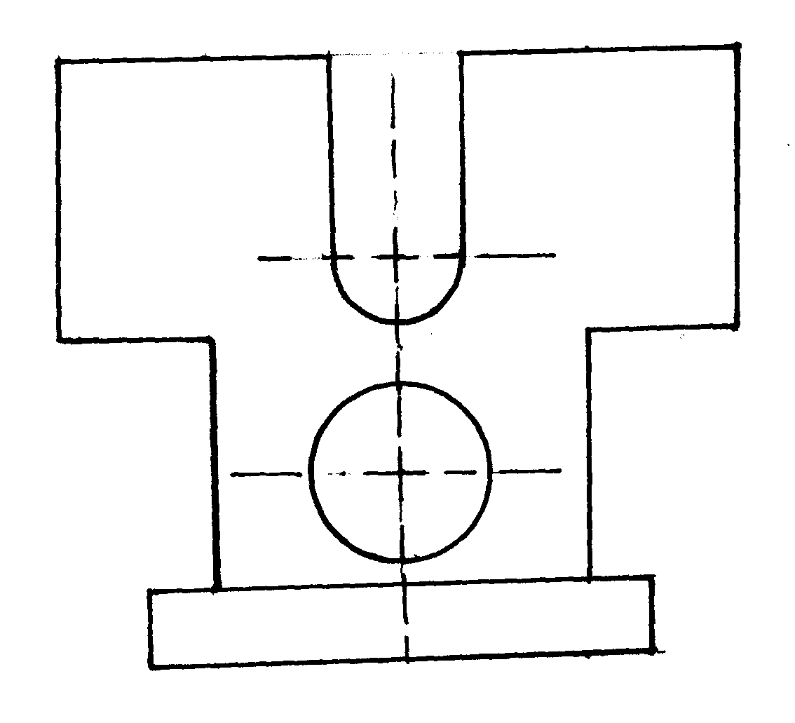

7. Construct a regular hexagon whose distance across flats is 56mm. (4mks)

8. Construct a plain scale on which 4cm represent 1cm with the longest distance represented being 3cm and the shortest distance is 1mm. mark on the scale the following measurements. (5mks)
30mm
29mm
17mm
6mm

9. The figure below shows a pictorial view of a block. In good proposition sketch the block to third angle projection. (4mks)
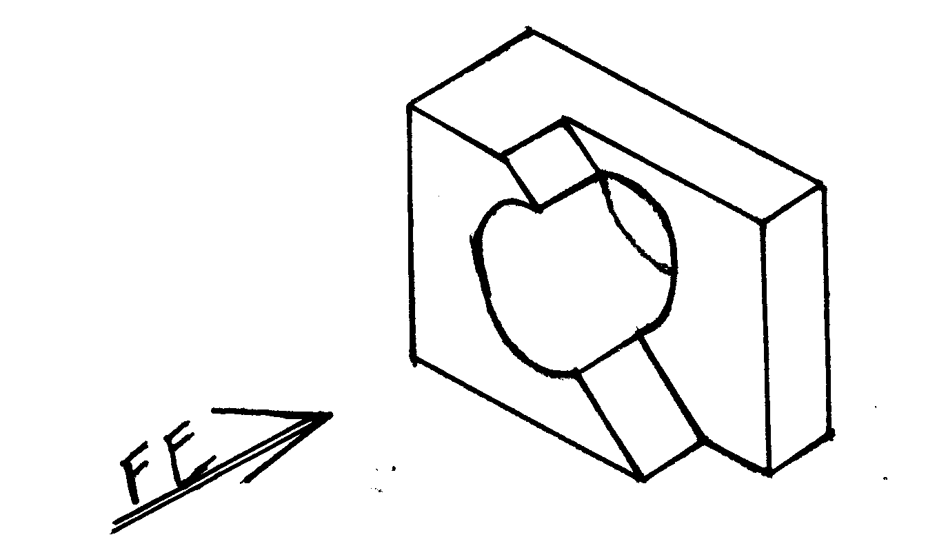

10. The figure below shows a line diagram of a jib crane JKL. The jib JK swivels about centre J as it lifts the load L suspended at the end of chain KL. Plot the locus of the load L as the jib lifts from horizontal position to an angle of 85⁰. (5mks)
JK= 90mm
KL = 30mm
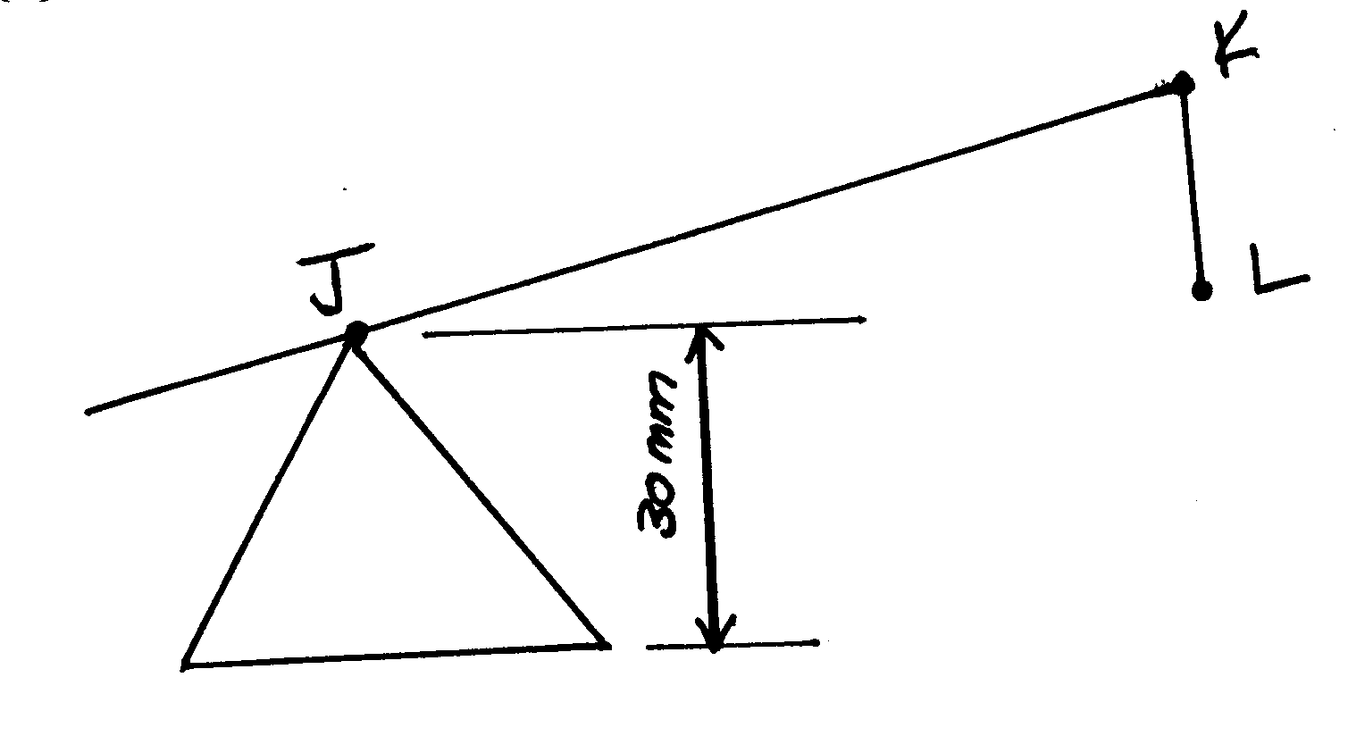

SECTION B (20 marks)
This question is compulsory.

11. Figure 7 shows parts of a machined component drawn in first angle projection.
Assemble the parts and draw the following: (20mks)
- Sectional front elevation through the cutting plane F-F.
- The plan
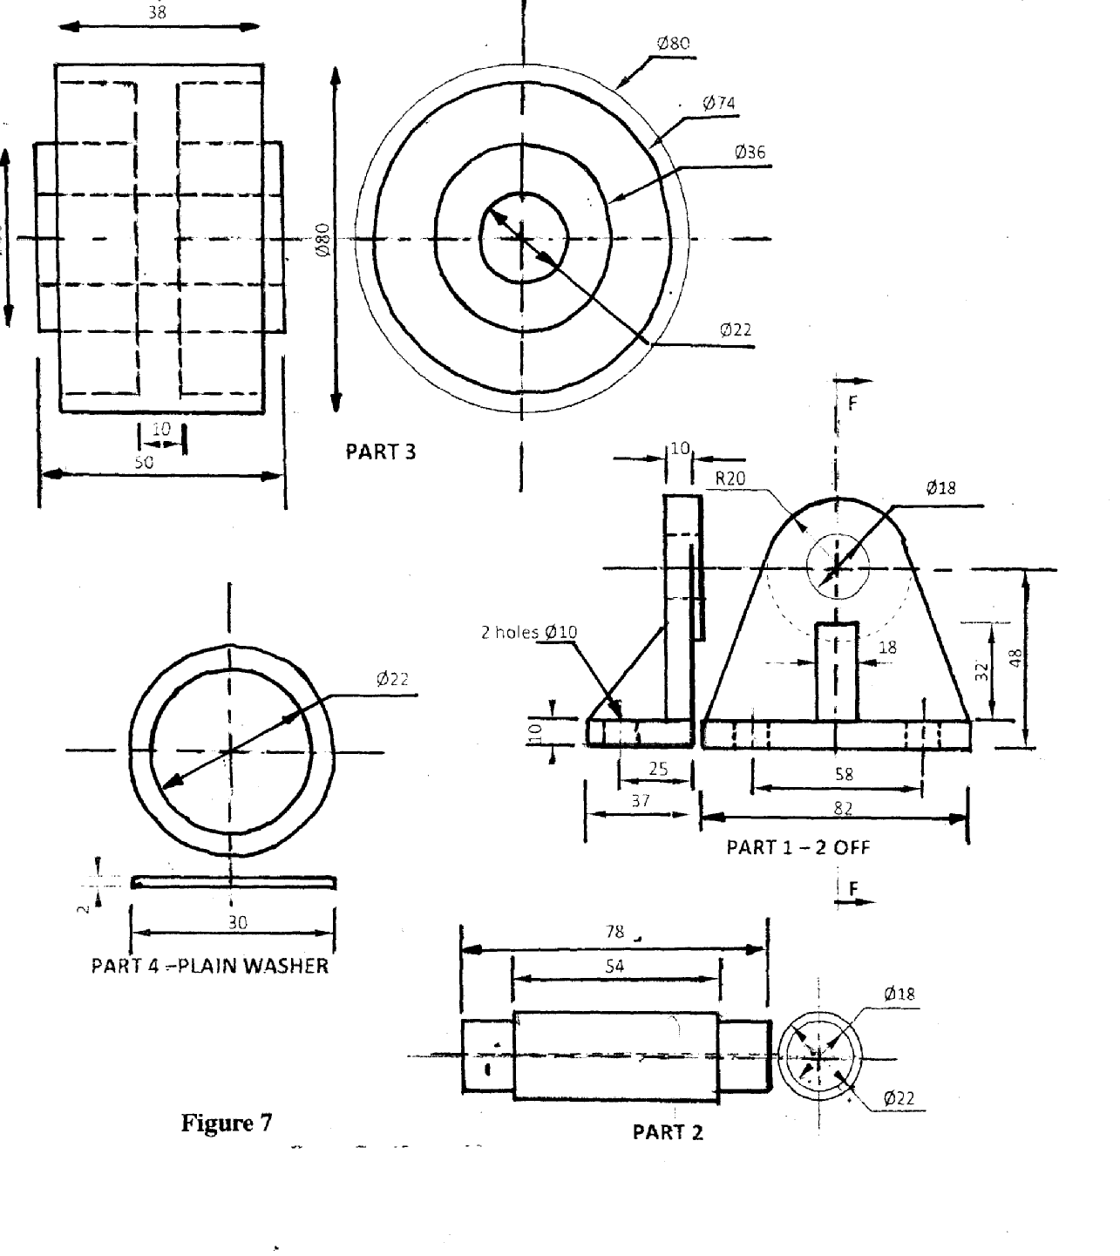

SECTION C (Answer any two questions)

12. The figure below shows a front elevation and uncompleted plan of truncated triangular based right pyramid. (15mks)
Draw; i) Front elevation
ii) A complete plan
iii) End elevation in the direction of Z.
iv) True shape of cut
v) Auxiliary view on front elevation at 30⁰
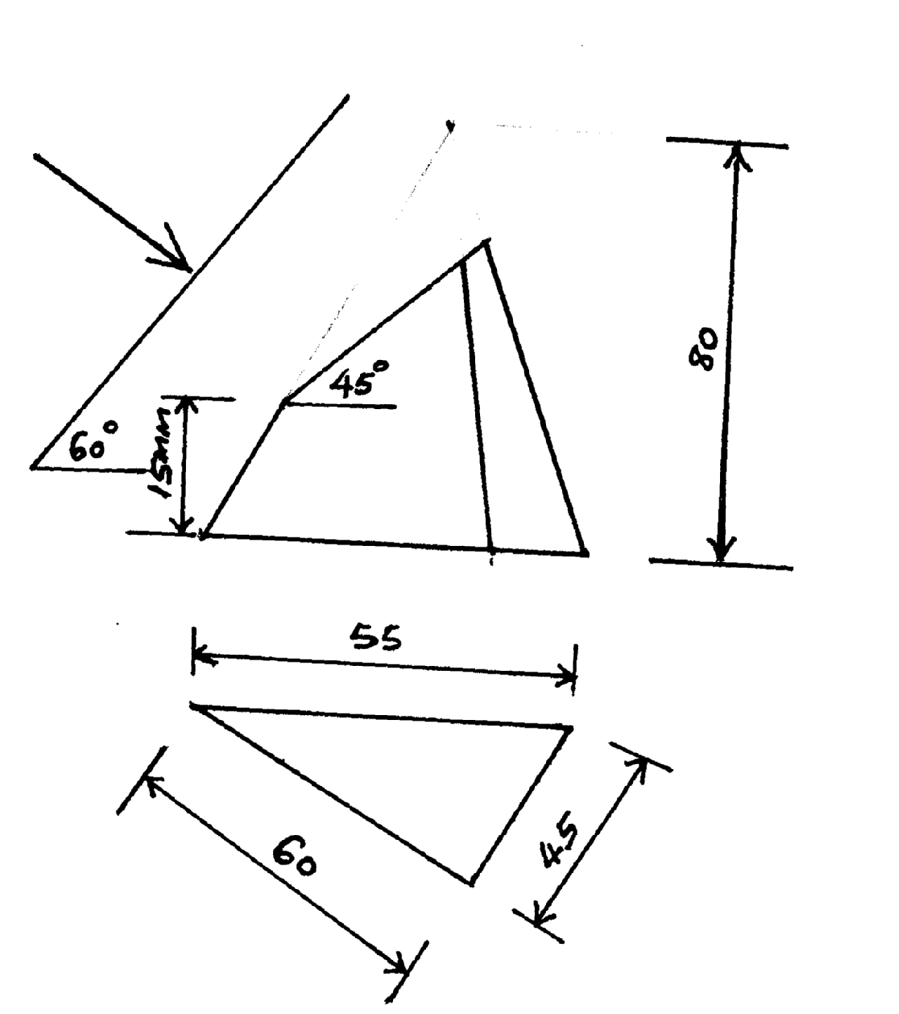

13. The figure below shows a front elevation of two pipes intersecting at an angle. (15mks)
Draw; a) The front elevation
b) Plan
c) End elevation in the direction of arrow X.
d) Curve of intersection.
e) Development of pipe B.
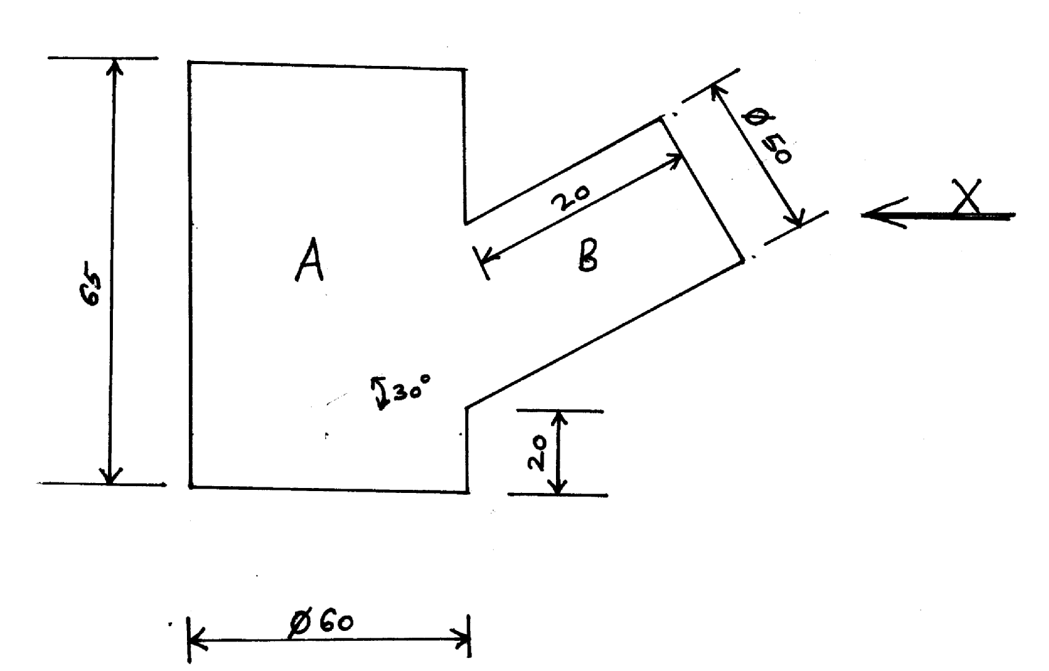

14. The figure below shows three orthographic views of a machined block drawn in first angle orthographic projection. Draw full size isometric view of the block taking X as the lowest corner.
(15mks)
