

**JARAMOGI OGINGA ODINGA UNIVERSITY OF SCIENCE AND TECHNOLOGY**

**SCHOOL OF ENGINEERING AND TECHNOLOGY**

**UNIVERSITY EXAMINATIONS FOR THE DEGREE IN SCIENCE IN CONSTRUCTION MANAGEMENT**

**1ST YEAR 2ND SEMESTER 2016/2017 ACADEMIC YEAR**

**CENTRE: MAIN CAMPUS**

**--------------------------------------------------------------------------------------------------------------------**

**COURSE CODE: TCM 3122**

**COURSE TITLE: ENGINEERING DRAWING II**

**EXAM VENUE: CR STREAM: BSc CONSTRUCTION MGT**

**DATE: 2/05/2017 EXAM SESSION: 9.00 – 11.00 AM**

**DURATION: 3 HOURS**

**------------------------------------------------------------------------------------------------------------------**

**Instructions**

1. **Answer question 1 (Compulsory) and ANY other two questions**
2. **Candidates are advised not to write on question paper**
3. **Candidates must hand in their answer booklets to the invigilator while in the examination room**

**QUESTION ONE (20 MARKS)**

1. Show how you would completely dimension the following solids
2. a truncated pyramid (**2.5Marks**)
3. a hollow cylinder (**2.5Marks**)
4. Differentiate between location dimension and size dimension. illustrate your explanations using any suitable sketch(es) (5Marks)
5. A view “ in section” is obtained by imagining the object to have been cut by a cutting plane and then removing the front section to reveal the interior features
6. List and briefly define any five types of sectional drawings (**5Marks**)
7. Differentiate between revolved section and removed section (**5Marks**)

**QUESTION TWO (15 MARKS)**

Draw sectional views of the objects shown below along the given cutting planes



**QUESTION THREE (15 Marks)**

Free-hand technical sketching is one of the most widely used forms of communication and is a way of producing drawings quickly without the aid of any mechanical instrument. Sketch pictorial views of the objects whose multi-views are given in figures Q3.1, Q3.2 and Q3.3 respectively

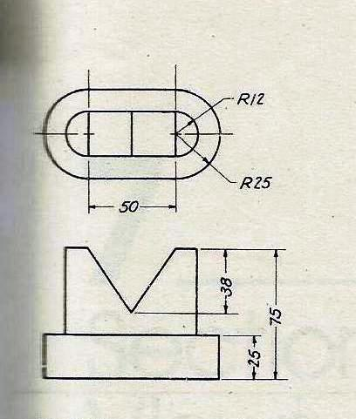

Fig Q3.1



Fig Q3.2



Fig Q3.3

**QUESTION FOUR( 15 Marks)**

Design and draw to scale ahouse plan for a one bedroom self-contained residential unit to be constructed in a rural village within Sinapangavillage in Bondo town. The house is expected to have a bedroom, a living room, a kitchen, bathroom and toilet. Present a floor plan and one suitableelevation view.

**QUESTION FIVE (15Marks)**

Assume suitable dimensions and draw to scale a simple box culvert to be used to convey irrigation water across a road in Nyakalewairrigation scheme in South West Kano Irrigation Scheme. The maximum flow in the scheme is 300l/s and the effective width of the road at the point of crossing is 6.0m. Present a plan, front sectional view and end sectional view. The cutting plane in both cases passes through the center of the culvert.