NAME: ………………………………………………….. INDEX NO: ………………………………….
SCHOOL: ………………………………………………. CANDIDATE SIGN: ………………………
DATE: ………………………………………...
232/2
PHYSICS
PAPER 2
JULY/ AUGUST-2014

TIME: 2 HOURS

KISII SOUTH SUB-COUNTY JOINT EVALUTION EXAM-2014
Kenya Certificate of Secondary Education (KCSE)

232/2
PHYSICS
PAPER 2
JULY/ AUGUST-2014

TIME: 2 HOURS

INSTRUCTIONS TO CANDIDATES:
(a) Write your name and index number in the spaces provided above
(b) Sign and write the date of the examination in the spaces provided above.
(c) This paper consists of two sections A and B.
(d) Answer all questions in section A and B in the spaces provided.
(e) All working must be clearly shown.
(f) Non-programmable silent electronic calculators and KNEC Mathematical tables may be used.
(g) This paper consists of 12printed pages.
(h) Candidates should check to ascertain that all pages are printed as indicated and that no questions are missing.
(i) ALL questions must be answered in English

SECTION | QUESTION | MAX. SCORE | CANDIDATE SCORE
A | 1-13 | 25
B | 14 | 15
 | 15 | 12
 | 16 | 9
 | 17 | 10
 | 18 | 9
 | TOTAL Score | 80

This paper consist of 12 printed pages.
Candidate should check the question paper to ascertain all pages are printed as indicated
And no questions are missing.

SECTION A (25 MARKS)
Answer ALL questions in this section in the spaces provided.
1. The figure below sow a current carrying conductor passing between two cardboards. Show the direction of the deflection on each compass on the cardboard. (2marks)

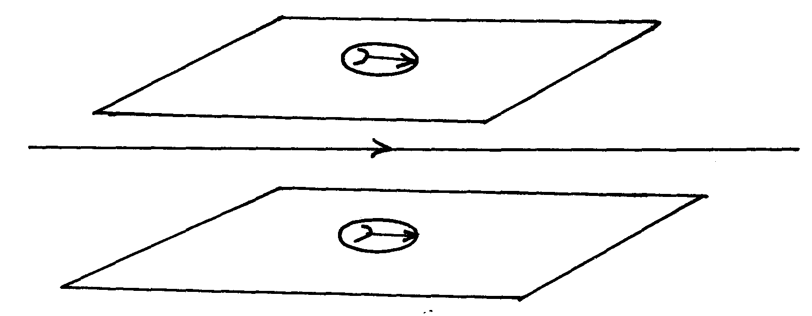
2. The figure below shows a thin wire connected to a charge generator and placed close to a candle flame.
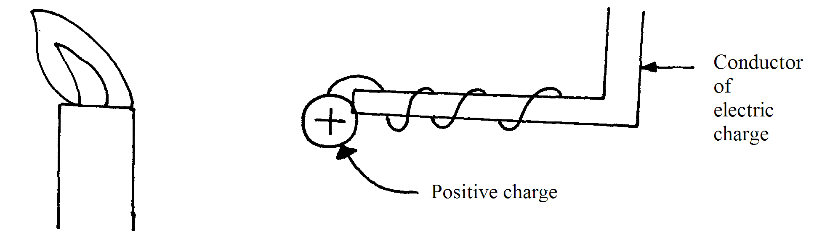

Explain why the candle flame is deflected as shown. (2mks)
………………………………………………………………………………………………………………………………………………………………………………………………………………
3. Why is the metre bridge method a more accurate means of measuring resistance than Ammeter-voltmeter method. (1mark)
………………………………………………………………………………………………………………………………………………………………………………………………………………
4. State one factor which does not change as water waves moves from shallow deep end. (1mark)
………………………………………………………………………………………………………………………………………………………………………………………………………………
5. Calculate the cost of using a electricity iron rated 1200W, for a total of 30hours given that the cost of electricity per KWh is ksh8. (3mks)
………………………………………………………………………………………………………………………………………………………………………………………………………………
………………………………………………………………………………………………………………………………………………………………………………………………………………
6. State one similarity between an image formed in a plane mirror and that in a convex mirror. (1mk)
………………………………………………………………………………………………………………………………………………………………………………………………………………

7. The figure below shows a circular conductor placed closely to a magnet. When the magnet is moved, a current is induced as shown. Indicate the direction of motion of the magnet. (1mark)
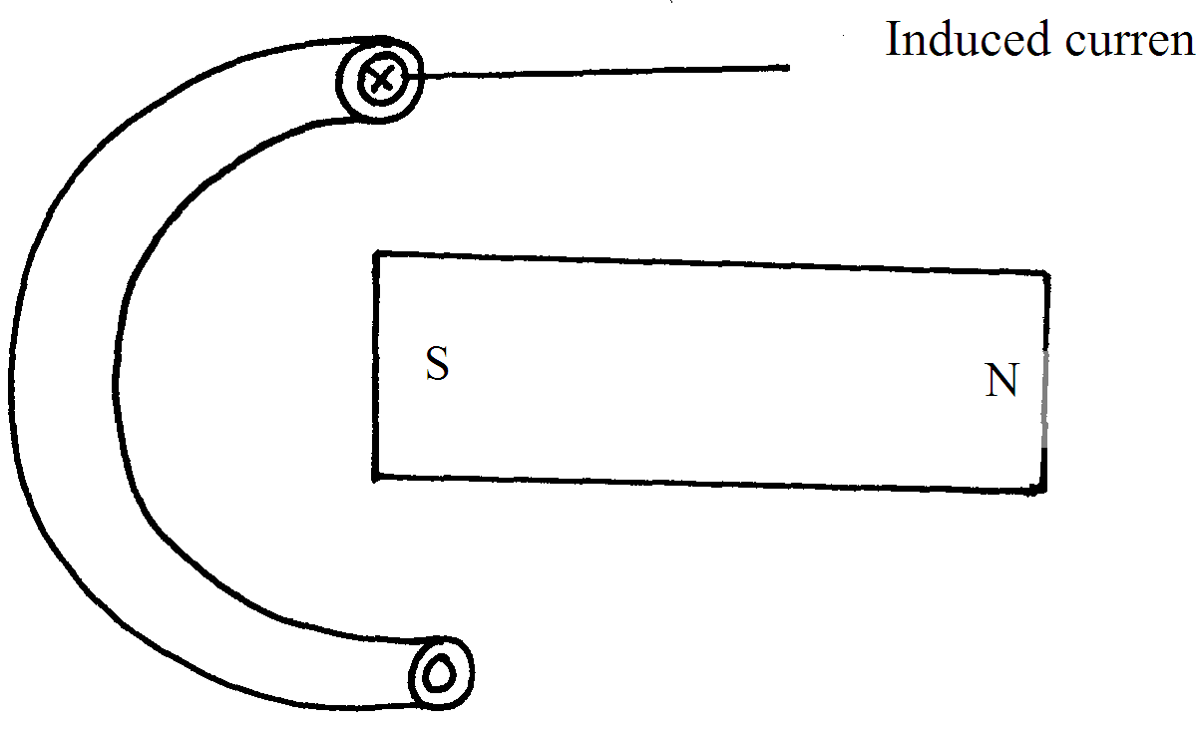

8. The figure below shows a CRO screen display trace when the Y-amplication control and time base setting are 100mV and 0.8ms/cm respectively.
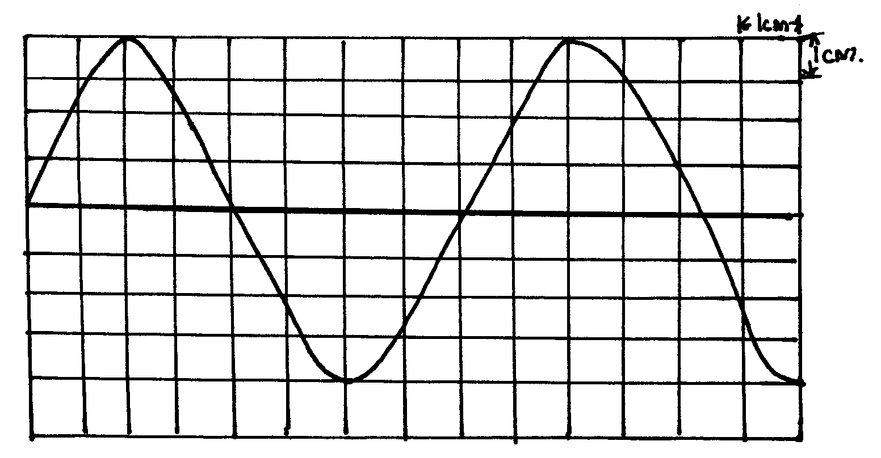

Calculate:
a) The peak potential difference. (2marks)
………………………………………………………………………………………………………………………………………………………………………………………………………………
b) The frequency of the signal. (2 marks)
………………………………………………………………………………………………………………………………………………………………………………………………………………
9. Distinguish between an intrinsic semiconductor and an extrinsic semiconductor and give one example for each. (3marks)
………………………………………………………………………………………………………………………………………………………………………………………………………………
………………………………………………………………………………………………………………………………………………………………………………………………………………
10. You are provided with a long steel rod shown below.
Using a diagram, describe hoe you would magnetise end A to obtain a south pole using an electric current. (2marks)
………………………………………………………………………………………………………………………………………………………………………………………………………………
………………………………………………………………………………………………………………………………………………………………………………………………………………
11. Determine the angle of incidence and angle of reflection in the mirror shown below. (2marks)
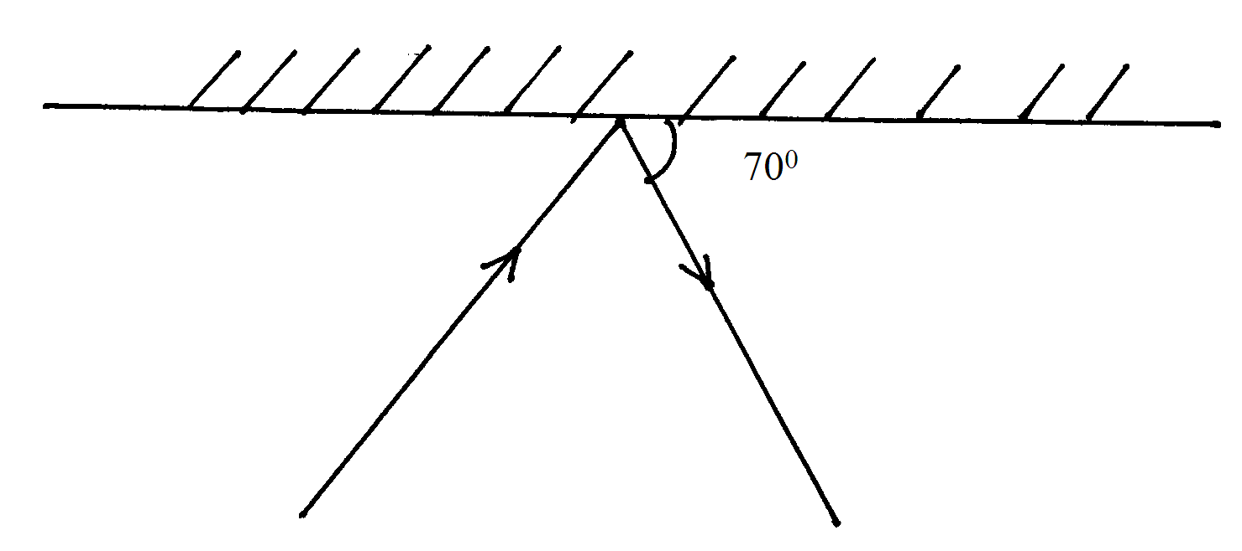
………………………………………………………………………………………………………………………………………………………………………………………………………………
12. Complete the ray diagram below and state one characteristic of the image formed by the following convex base. (3marks)
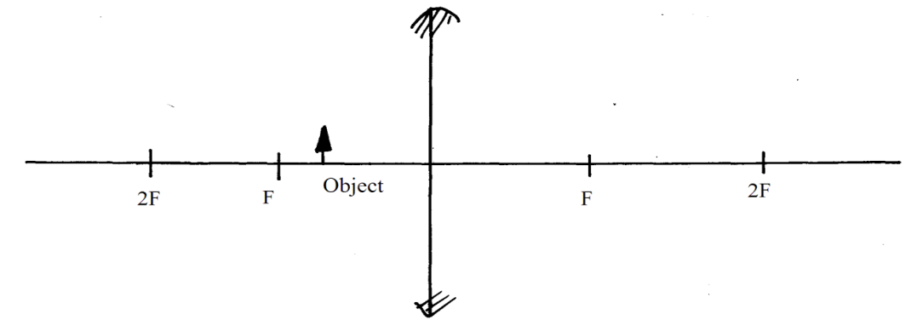

13. Various isotopes of an element X can be distinguished by using the symbol what do the symbols A and Z stand for. (1mark)
………………………………………………………………………………………………………………………………………………………………………………………………………………

SECTION B (55 MARKS)
Answer all the questions in this section in the spaces provided.
14. a) X-rays are used for detecting cracks inside metal beams:
State the type of X-rays used. (1mark)
………………………………………………………………………………………………………………………………………………………………………………………………………………

b) The figure below shows the feature of an X-ray tube.
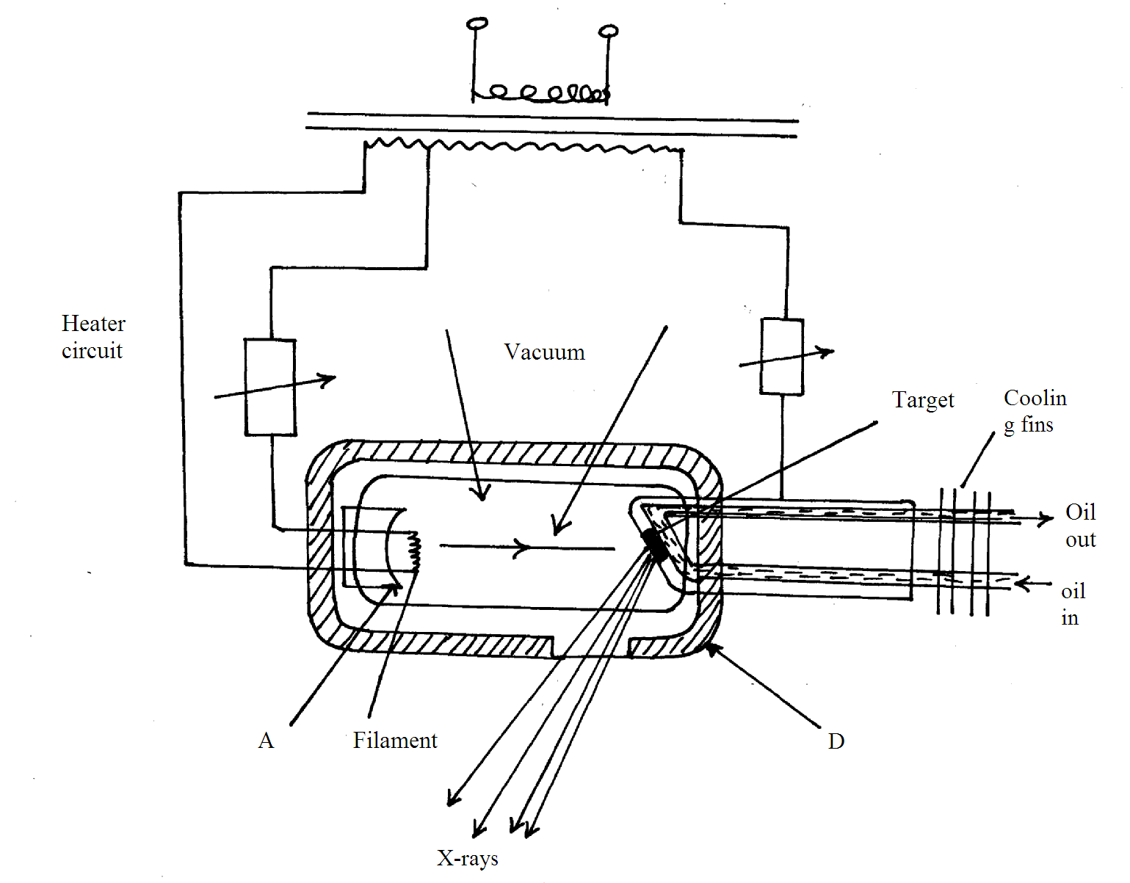
i) Name the parts labelled A,B,C,D. (2marks)
………………………………………………………………………………………………………………………………………………………………………………………………………………
ii) Explain how X-rays are produced in the tube. (3marks)
………………………………………………………………………………………………………………………………………………………………………………………………………………
………………………………………………………………………………………………………………………………………………………………………………………………………………
iii) During the operation of the tube, the target becomes very hot explain. (2marks)
………………………………………………………………………………………………………………………………………………………………………………………………………………
………………………………………………………………………………………………………………………………………………………………………………………………………………
iv) Name one feature of the X-ray tube which makes it possible for heat to be conducted away safely without causing overheating. (1mark)
………………………………………………………………………………………………………………………………………………………………………………………………………………
v) Explain the use of X-ray in textile industries. (3marks)
………………………………………………………………………………………………………………………………………………………………………………………………………………
………………………………………………………………………………………………………………………………………………………………………………………………………………
………………………………………………………………………………………………………………………………………………………………………………………………………………
vi) The frequency of X-rays ranges from 3.0x10¹⁶Hz to 3.0x10¹⁹Hz. determine the range of wavelength . (take C =3.0x10⁸m/s) (3marks)
………………………………………………………………………………………………………………………………………………………………………………………………………………
………………………………………………………………………………………………………………………………………………………………………………………………………………
………………………………………………………………………………………………………………………………………………………………………………………………………………
15. a) What is photoelectric effect? (1mark)
………………………………………………………………………………………………………………………………………………………………………………………………………………

b) Some students used the following setup to show the effect of illuminating an uncharged electroscope with ultra violent radiation.
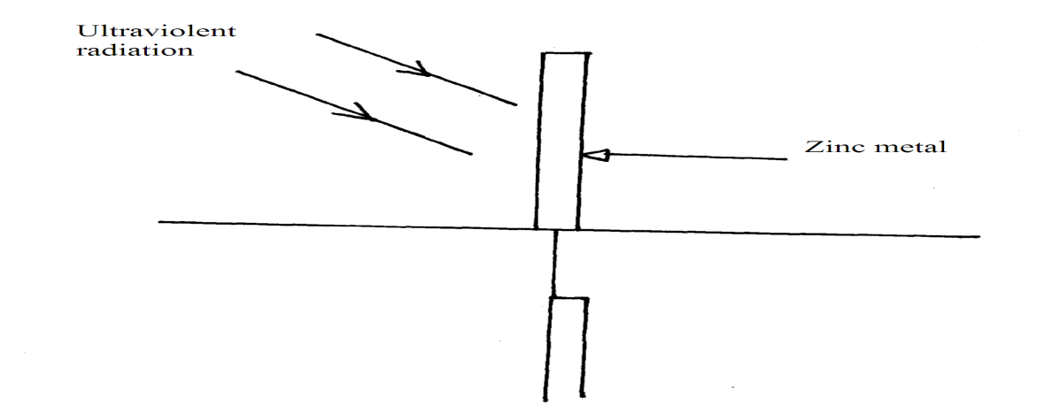
i) Before the students began the experiment, they cleaned the zinc metal. Why was this necessary? (1mark)
………………………………………………………………………………………………………………………………………………………………………………………………………………
ii) Explain briefly what the students observed (3marks)
………………………………………………………………………………………………………………………………………………………………………………………………………………
………………………………………………………………………………………………………………………………………………………………………………………………………………
………………………………………………………………………………………………………………………………………………………………………………………………………………
c) i) Draw a sketch graph of stopping potential against frequency of incident
radiation (2marks)
………………………………………………………………………………………………………………………………………………………………………………………………………………
………………………………………………………………………………………………………………………………………………………………………………………………………………
ii) On the same graph label the threshold frequency (1mark)
iii) Explain what is meant by stopping potential(Vs) (1mark)
………………………………………………………………………………………………………………………………………………………………………………………………………………
d) When electromagnet radiation of wavelength 4.0x10⁻⁷ is incident on a metal surface, a stopping potential of 0.75V is just sufficient to prevent the emission photoelectrons. determine the maximum kinetic energy of the emitted electrons when the stopping potential is zero (3marks)
………………………………………………………………………………………………………………………………………………………………………………………………………………
………………………………………………………………………………………………………………………………………………………………………………………………………………
………………………………………………………………………………………………………………………………………………………………………………………………………………
16. a) State the first law of refraction (1mark)
………………………………………………………………………………………………………………………………………………………………………………………………………………
b) The diagram below shows a glass prism and an incident ray striking the face marked AB
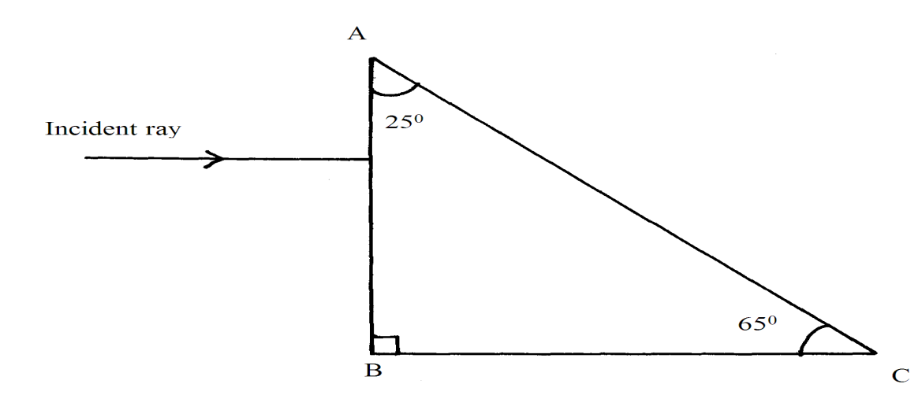
i) Indicate on the diagram the path of the emergent ray. (2marks)
ii) Calculate the angle of refraction(r) of the resultant ray given the refractive index
of glass is 1.5 (3marks)
………………………………………………………………………………………………………………………………………………………………………………………………………………
………………………………………………………………………………………………………………………………………………………………………………………………………………
………………………………………………………………………………………………………………………………………………………………………………………………………………
c) Find the angle through which the ray is deviated. (2marks)
………………………………………………………………………………………………………………………………………………………………………………………………………………
………………………………………………………………………………………………………………………………………………………………………………………………………………
d) Explain why the ray is not totally internally reflected (1mark)
………………………………………………………………………………………………………………………………………………………………………………………………………………
17. a) Sketch a graph of displacement against time for a transverse wave of frequency of 50Hz
of at least two cycles with amplitude 2cm. (4marks)
………………………………………………………………………………………………………………………………………………………………………………………………………………
………………………………………………………………………………………………………………………………………………………………………………………………………………
………………………………………………………………………………………………………………………………………………………………………………………………………………
………………………………………………………………………………………………………………………………………………………………………………………………………………
b) Distinguish electromagnetic waves and mechanical waves (2marks)
………………………………………………………………………………………………………………………………………………………………………………………………………………
………………………………………………………………………………………………………………………………………………………………………………………………………………

c) A pulse-echo sounder is used by fishing boat to locate a shoal of fish in water. The sounder sends sound of frequency 21KHz and wavelength of 7.5cm. if the echo is received after 0.4seconds, determine how far the shoal of fish is from the base of the boat. (4marks)
………………………………………………………………………………………………………………………………………………………………………………………………………………
………………………………………………………………………………………………………………………………………………………………………………………………………………
………………………………………………………………………………………………………………………………………………………………………………………………………………
18. a) The figure below shows how two magnets are stored in pairs with keepers at the ends.

Explain how the keeper keeps the magnets from demagnetisation. (2marks)
………………………………………………………………………………………………………………………………………………………………………………………………………………
………………………………………………………………………………………………………………………………………………………………………………………………………………
b) Explain magnetic saturation using domain theory. (2 marks)
………………………………………………………………………………………………………………………………………………………………………………………………………………
………………………………………………………………………………………………………………………………………………………………………………………………………………
c) The figure below is that of an electric horn.
(Diagram)

i) Explain how it works. (3marks)
………………………………………………………………………………………………………………………………………………………………………………………………………………
………………………………………………………………………………………………………………………………………………………………………………………………………………
………………………………………………………………………………………………………………………………………………………………………………………………………………
ii) Explain how performance of the horn can be improved without changing its material make –up (2marks)
………………………………………………………………………………………………………………………………………………………………………………………………………………
………………………………………………………………………………………………………………………………………………………………………………………………………………

