NAME: ………………………………………………….. INDEX NO: ………………………………….
SCHOOL: ………………………………………………. CANDIDATE SIGN: ………………………
DATE: ………………………………………...
232/1
PHYSICS
PAPER 1
(THEORY)
JULY/AUGUST-2014

TIME: 2 HOURS

KISII SOUTH SUB-COUNTY JOINT EVALUTION EXAM-2014
Kenya Certificate of Secondary Education (KCSE)

232/1
PHYSICS
PAPER 1
(THEORY)
JULY/AUGUST-2014

TIME: 2 HOURS

INSTRUCTIONS TO THE CANDIDATE:
a) Write your name and index number in the spaces provided above.
b) Sign and write the date of examination in the spaces provided above.
c) This paper consists of two sections A and B.
d) Answer all the questions in section A and B in the spaces provided
e) All working must be clearly shown in the spaces provided.
f) Non-programmable silent electronic calculators and KNEC mathematical tables may be used.

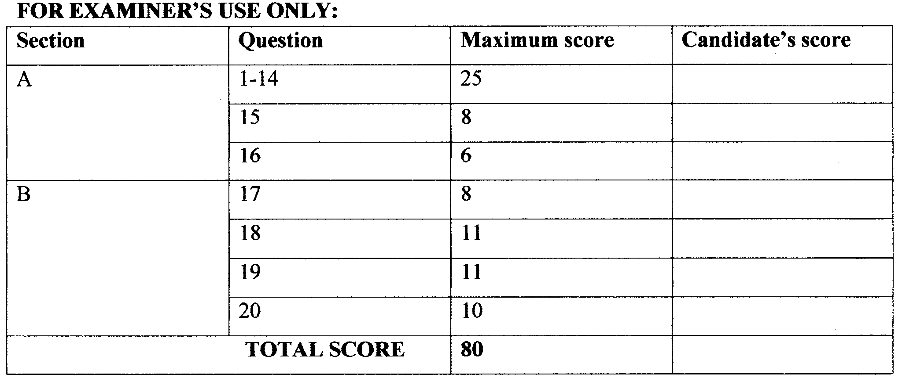

This paper consist of 12 printed pages.
Candidate should check the question paper to ascertain all pages are printed as indicated
And no questions are missing.
SECTION A: (25 MARKS)
1. A student used the measuring instrument shown below to measure the thickness of a cylindrical wire, If the wire is 10cm long, find the volume of the wire. (3mks)
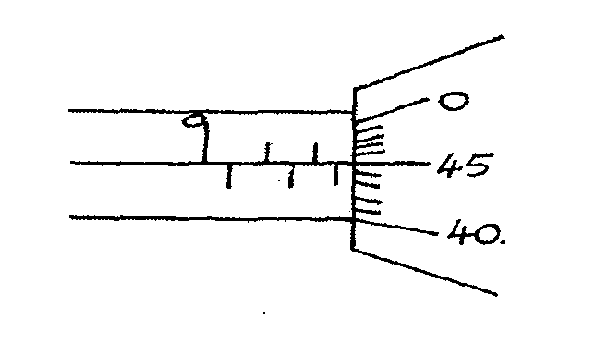

2. The figure below shows two containers of equal volume but of different diameters.

Equal volume of hot water was put in both containers. Explain why it cools faster in the
Wider container than in the narrower one. (lrnk)
……………………………………………………………………………………………………………………………………………………………………………………………………………………………….

3. A body in a uniform circular motion experiences acceleration despite moving at a constant
speed. Explain. – (1mk)
……………………………………………………………………………………………………………………………………………………………………………………………………………………………….

4. The diagram below shows a-metal tube made of iron and copper. The joint is tight at room temperature.
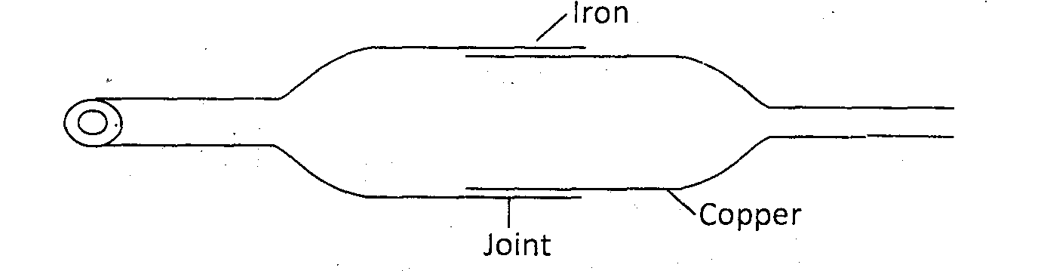

Explain how you would separate the two by changing the temperature given that copper expands more than iron for some change in temperature. (2mks)
……………………………………………………………………………………………………………………………………………………………………………………………………………………………….
……………………………………………………………………………………………………………………………………………………………………………………………………………………………….

5. Figure below shows a pulley system being used to raise a lead.
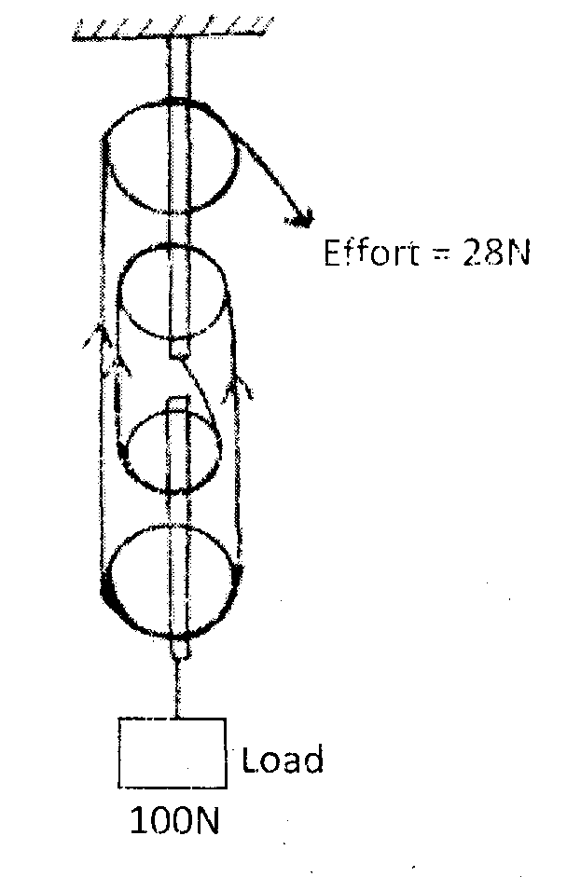

if the effort applied is 28N and the load lifted is l00N, determine the efficiency of the
system. (3mks)
……………………………………………………………………………………………………………………………………………………………………………………………………………………………….
……………………………………………………………………………………………………………………………………………………………………………………………………………………………….
………………………………………………………………………………………………………………
6. (a) What is surface tension? (1mk)
……………………………………………………………………………………………………………………………………………………………………………………………………………………………….

(b) The figure below shows a funnel dipped into a liquid soap solution.
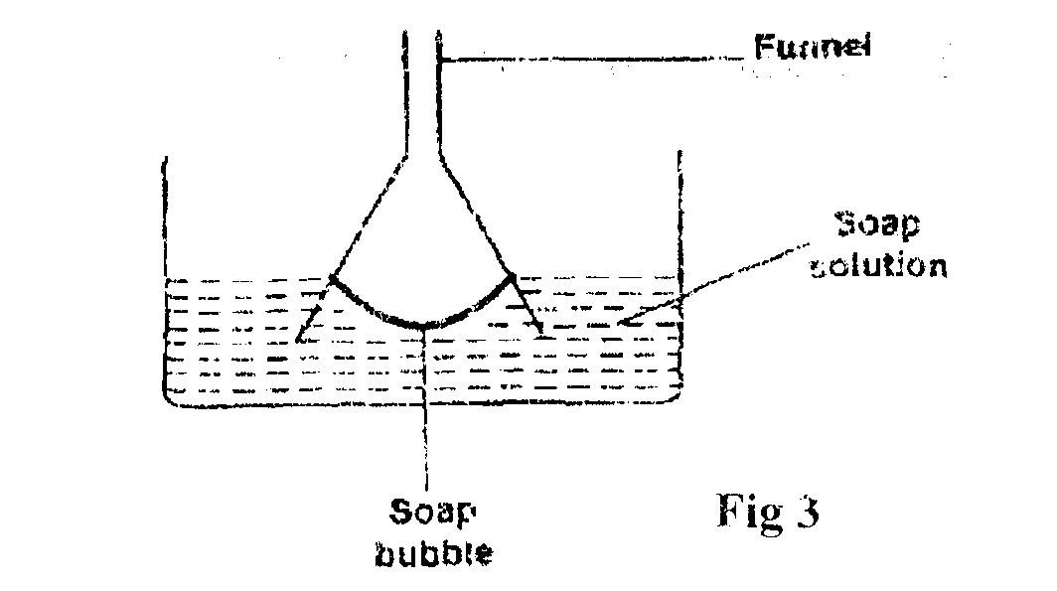

Explain what happens to the soap bubble when the funnel is removed. (1mk)
……………………………………………………………………………………………………………………………………………………………………………………………………………………………….

7. A trolley of mass 0.5kg moving with a velocity of I .2ms⁻¹ collides in elastically with a second trolley of mass 1.5kg moving in the same direction with a velocity of 0.2ms⁻¹ .Determine the
velocity of the trolleys after collision. (2mks)
……………………………………………………………………………………………………………………………………………………………………………………………………………………………….
……………………………………………………………………………………………………………………………………………………………………………………………………………………………….

8. Highlight one fact which shows that heat from the sun does not reach the earth surface by
convection. (1 rnk)
……………………………………………………………………………………………………………………………………………………………………………………………………………………………….
9. State one reason why mercury is preferred as a barometric liquid and not water. (lmk)
……………………………………………………………………………………………………………………………………………………………………………………………………………………………….

10. State one reason why racing cars are stable. (lmk)
……………………………………………………………………………………………………………………………………………………………………………………………………………………………….

11. Find the velocity ratio of the following gear wheels. (2mks)
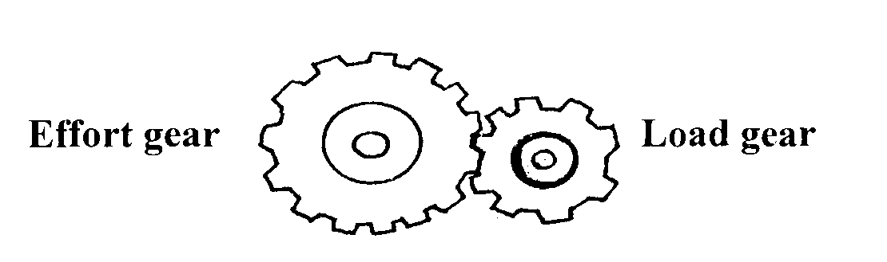
……………………………………………………………………………………………………………………………………………………………………………………………………………………………….
……………………………………………………………………………………………………………………………………………………………………………………………………………………………….

12. A stone and a feather are dropped from rest from a building 20m tall. If they reach the ground at the same time, find.
(a) The velocity with which they reach the ground. (Take g=l0m/s²) (2rnks)
……………………………………………………………………………………………………………………………………………………………………………………………………………………………….
……………………………………………………………………………………………………………………………………………………………………………………………………………………………….

(b) The condition under which they fall. (lmk)
……………………………………………………………………………………………………………………………………………………………………………………………………………………………….

13. The forces act on a trolley as shown below.

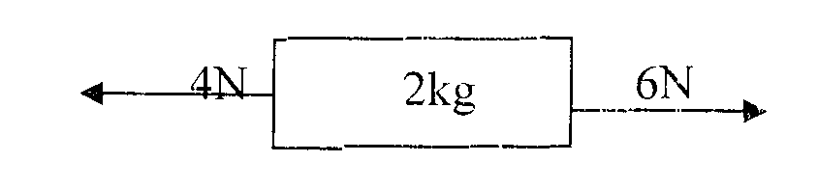
Find the acceleration of the trolley. (2mks)
……………………………………………………………………………………………………………………………………………………………………………………………………………………………….

14. On the axes below, sketch the graph of density of water against temperature. ( 1mk)
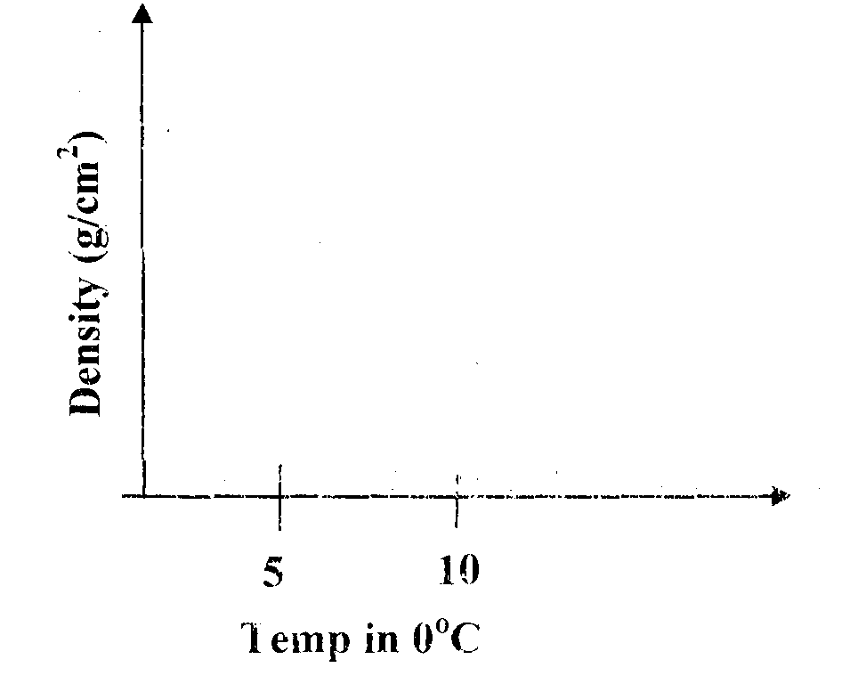

SECTION B (55MKS)
15. (a) A car is negotiating unbanked circular track. State one factor that will determine
the critical speed of the car. (1mk)
……………………………………………………………………………………………………………………………………………………………………………………………………………………………….
(b) Given that the ear above has a mass of 1000kg and the circular path has a radius of 25m. Determine the maximum speed with which the motorist can travel so as not to skip the
frictional force between the tyres and the road is 6500N. (3mks)
……………………………………………………………………………………………………………………………………………………………………………………………………………………………….
……………………………………………………………………………………………………………………………………………………………………………………………………………………………….
……………………………………………………………………………………………………………………………………………………………………………………………………………………………….

(c) A 200g mass tied to a string is being whirled in a vertical circle of radius 32cm with uniform speed, At the lowest position the tension in the siring is 10.5N. Calculate:
(i) The speed of the mass (2mks)
……………………………………………………………………………………………………………………………………………………………………………………………………………………………….
……………………………………………………………………………………………………………………………………………………………………………………………………………………………….

(ii) The tension in the string when the mass is at the uppermost position of the circular path (Take g = 10m/s²) (2rnks)
……………………………………………………………………………………………………………………………………………………………………………………………………………………………….
……………………………………………………………………………………………………………………………………………………………………………………………………………………………….
16. Brownian motion of smoke particles can be studied by using the apparatus shown in figure.7. To observe the motion, some smoke is closed in the smoke cell and then observe through the Microscope.

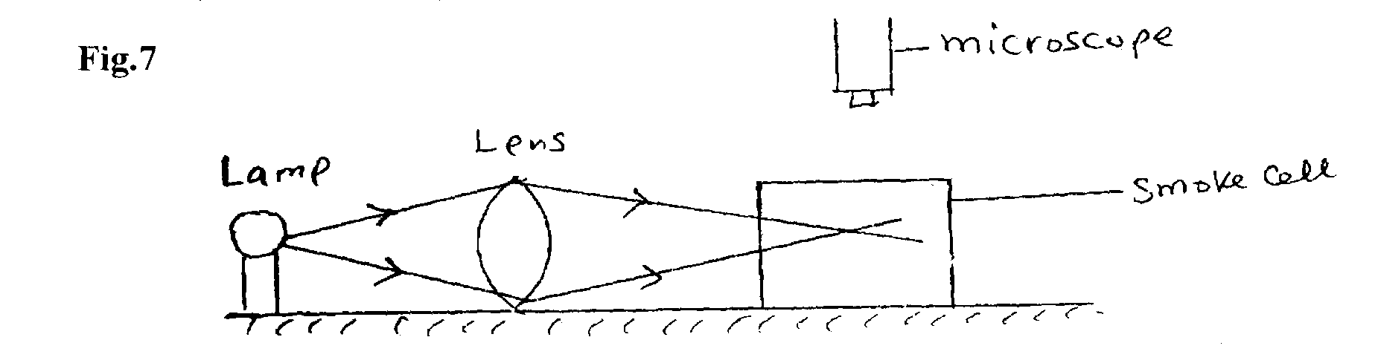

(a) Explain the role of the smoke particles, lens and microscope in the experiment.
(i) Smoke cell. (1 mk)
……………………………………………………………………………………………………………………………………………………………………………………………………………………………….
(ii) Lens (1 mk)
……………………………………………………………………………………………………………………………………………………………………………………………………………………………….
(iii) Microscope (lmk)
……………………………………………………………………………………………………………………………………………………………………………………………………………………………….
(b) State and explain the nature of the observed motion of the smoke particles. (2rnks)
……………………………………………………………………………………………………………………………………………………………………………………………………………………………….
……………………………………………………………………………………………………………………………………………………………………………………………………………………………….
(c) State what will be observed about the motion of the smoke particles if the temperature surrounding the smoke cell is raised slightly. (1 mk)
……………………………………………………………………………………………………………………………………………………………………………………………………………………………….

17. (a) State what is meant by an ideal gas (1mk)
……………………………………………………………………………………………………………………………………………………………………………………………………………………………….
(b) The pressure acting in a gas in a container was changed steadily while the temperature of the gas was maintained constant. The value of volume V of the gas measured various values of pressure. The graph in the figure A shows the relation between the pressure. P1 and the reciprocal of volume 1/V
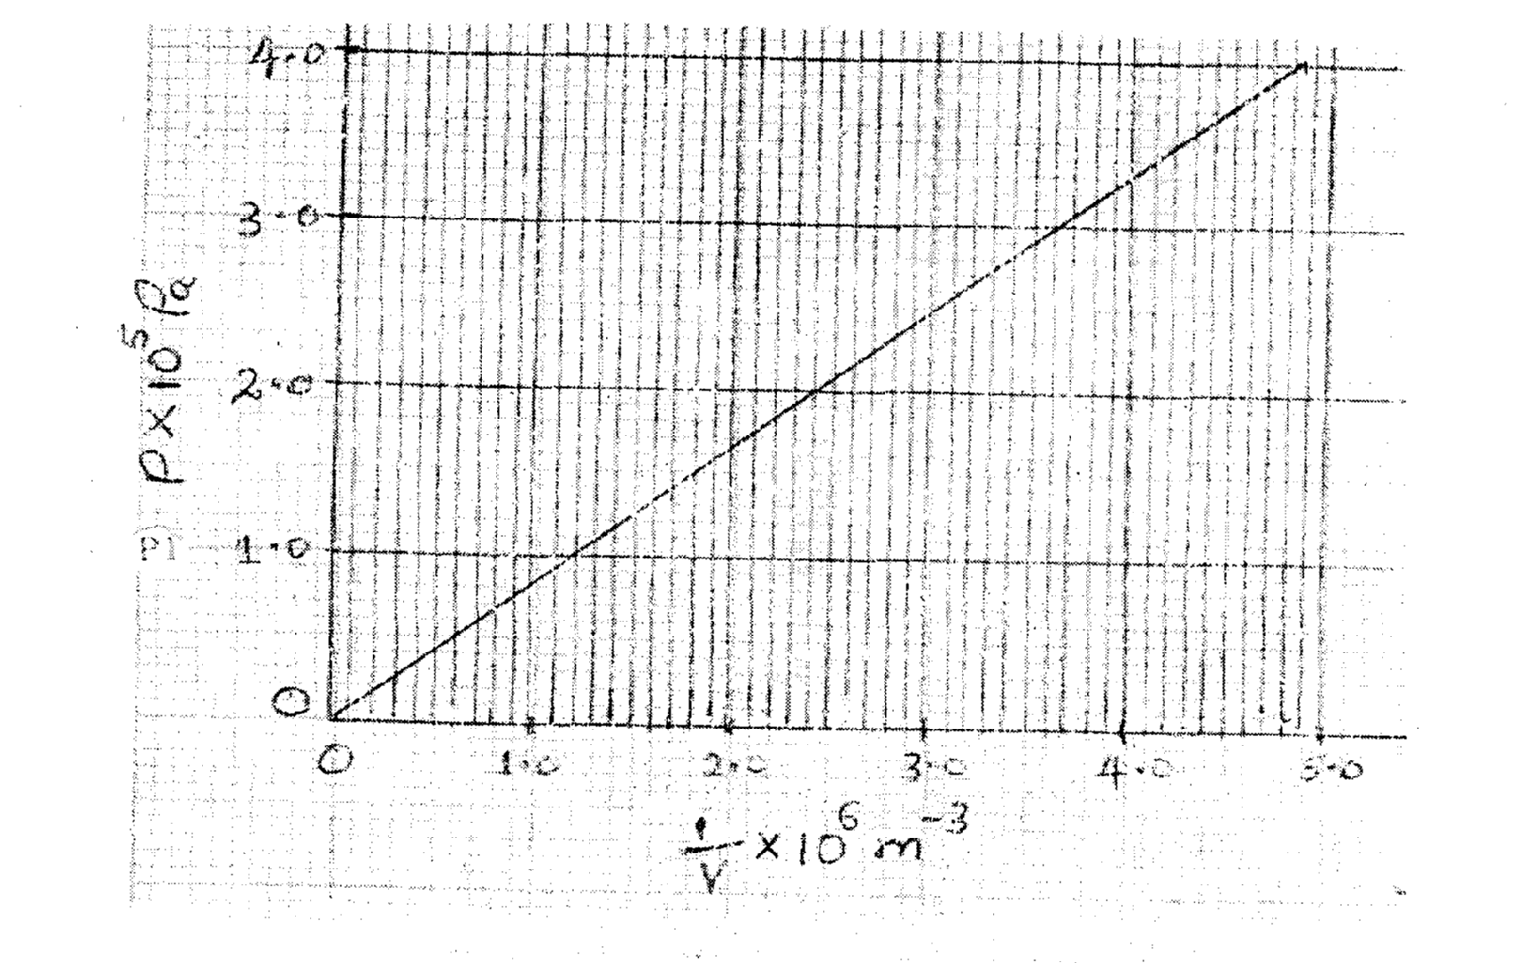

- Given that the relation between the pressure P1 and the value, V1 of the gas is given by PV = k Where k is a constant, use the graph to determine the value (3rnks)
……………………………………………………………………………………………………………………………………………………………………………………………………………………………….
……………………………………………………………………………………………………………………………………………………………………………………………………………………………….
……………………………………………………………………………………………………………………………………………………………………………………………………………………………….
(ii) What physical quantity does K represent? (1mk.)
……………………………………………………………………………………………………………………………………………………………………………………………………………………………….
iv) State one precaution you would take when performing such an experiment. (1mk)
……………………………………………………………………………………………………………………………………………………………………………………………………………………………….

(c) A gas occupies a volume of 4000 litres temperature of 37°C and normal atmosphere pressure. Determine the new volume of the gas if it is heated at constant pressure to a temperature of 67°C (normal atmosphere pressure P = 1.01 x 10⁵pa) (3marks)
……………………………………………………………………………………………………………………………………………………………………………………………………………………………….
……………………………………………………………………………………………………………………………………………………………………………………………………………………………….
……………………………………………………………………………………………………………………………………………………………………………………………………………………………….

18. (a) State Archimedes Principal (lmk)
……………………………………………………………………………………………………………………………………………………………………………………………………………………………….
(b) The figure 9 shows rectangular metal block of density 10500kgm⁻³ and dimensions 30cm x 20cm x 20cm suspended inside a liquid of density 1 200kgm⁻³ by a string attached to appoint above the liquid. The three forces acting on the block are; the tension I. on the string, the weight W, of the block, and the up thrust ,U, due to the liquid.

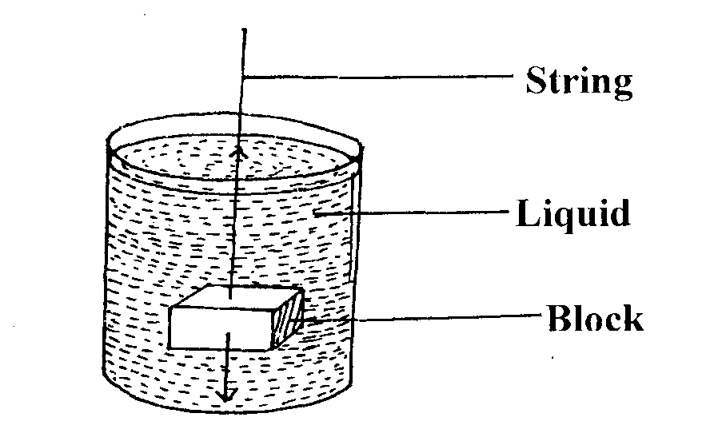

(i) Write an expression relating T, U and W when the block is in equilibrium inside the liquid. (1 mk)
……………………………………………………………………………………………………………………………………………………………………………………………………………………………….
(ii) Determine the weight, W. of the block (3 mks)
……………………………………………………………………………………………………………………………………………………………………………………………………………………………….
……………………………………………………………………………………………………………………………………………………………………………………………………………………………….
……………………………………………………………………………………………………………………………………………………………………………………………………………………………….

(iii) Determine the weight of the liquid displaced by the fully submerged block. (2rnks)
……………………………………………………………………………………………………………………………………………………………………………………………………………………………….
………………………………………………………………………………………………………………
Hence determine the tension, 1, in the string (1mk).
……………………………………………………………………………………………………………………………………………………………………………………………………………………………….

(c) A certain solid of volume 50cm³ displaces 10cm³ of kerosene) (density 800 kgrn⁻³) when
floating. Determine the density of the solid. (3mks)
……………………………………………………………………………………………………………………………………………………………………………………………………………………………….
……………………………………………………………………………………………………………………………………………………………………………………………………………………………….
……………………………………………………………………………………………………………………………………………………………………………………………………………………………….

19. (a) Define angular displacement. (1 rnk)
……………………………………………………………………………………………………………………………………………………………………………………………………………………………….

(b) A mass of 20 g is 14 cm from the centre of a compact disc rotating at 75 revolutions per minute. Determine:
i) the angular speed (2 mks)
……………………………………………………………………………………………………………………………………………………………………………………………………………………………….
……………………………………………………………………………………………………………………………………………………………………………………………………………………………….

ii) the centripetal acceleration (2 rnks)
……………………………………………………………………………………………………………………………………………………………………………………………………………………………….
……………………………………………………………………………………………………………………………………………………………………………………………………………………………….

(c) Shown in the figure below are dots which were made by a ticker timer-tare attached to a trolley. Scale 1. 5

The frequency of the timer was 50 Hz. Determine for the trolley:
- The velocities between AB and BC (3mk)
……………………………………………………………………………………………………………………………………………………………………………………………………………………………….
………………………………………………………………………………………………………………………………………………………………………………………………………………………………

ii) The deceleration of the trolley. (3mks)
………………………………………………………………………………………………………………………………………………………………………………………………………………………………
………………………………………………………………………………………………………………………………………………………………………………………………………………………………
………………………………………………………………………………………………………………………………………………………………………………………………………………………………
20. (a) What is meant by specific heat capacity? (1 mk)
………………………………………………………………………………………………………………………………………………………………………………………………………………………………
b) A heater rated 1 .25 kW is used to heat 3 kg of a substance which is initially in solid state.
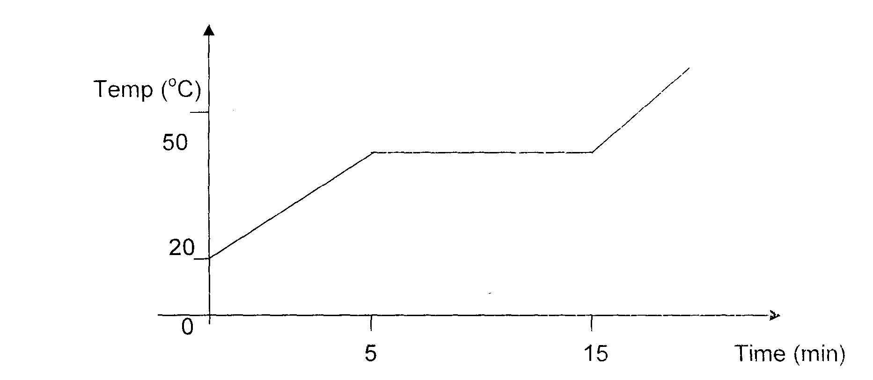

Use the information in the graph to find:
- the specific heat capacity of the substance in solid form. (3 mks)
………………………………………………………………………………………………………………………………………………………………………………………………………………………………………………………………………………………………………………………………………………………………………………………………………………………………………………………………
………………………………………………………………………………………………………………………………………………………………………………………………………………………………

- the latent heat of fusion of the substance. (2 mks)
………………………………………………………………………………………………………………………………………………………………………………………………………………………………
………………………………………………………………………………………………………………………………………………………………………………………………………………………………

iii) The time taken for the temperature to reach 90°C, assuming specific heat capacity
does not change . (3 rnks)
………………………………………………………………………………………………………………………………………………………………………………………………………………………………
………………………………………………………………………………………………………………………………………………………………………………………………………………………………
………………………………………………………………………………………………………………………………………………………………………………………………………………………………

iv) Suggest a reason why the actual time may be longer. (1 mk)
………………………………………………………………………………………………………………………………………………………………………………………………………………………………

