NAME:……………………………………………………..INDEX NO:…………………………………
SCHOOL:………………………………………………….. CANDIDATE SIGN:…...………………….
DATE...…………………………………….
511/3
MUSIC
PAPER 3.
JUNE/JULY- 2014

TIME: 2 ½ HOURS

KISII SOUTH DISTRICT JOINT EVALUATION TEST- 2014
Kenya Certificate of Secondary Education (K.C.S.E)

511/3
MUSIC
PAPER 3.
JUNE/JULY- 2014

TIME: 2 ½ HOURS

INSTRUCTION TO CANDIDATES
I. Answer all the questions in this paper.
II. In question 1, choose either (a) or (b)
III. In question 4 choose any two of the questions numbered a,b,c,or d.
IV. All answers must be written in the spaces provided.
V. This paper consists of questions one to seven

For examiners use only
QUESTION | MAXIMUM SCORE | CANDIDATES SCORE
1 | 12
2 | 20
3 | 14
4 | 14
5 | 10
6 | 10
7 | 20
TOTAL | 100

This paper consist of 4 printed pages.
Candidate should check the question paper to ascertain all pages are printed as indicated
And no questions are missing.

Answer questions from ALL sections
SECTION A: BASIC SKILLS (32mks)
1. Either;
a) Continue the following opening to make a melody of sixteen bars for voice
introducing modulation to the relative minor before returning to the tonic key. Incorporate a duplet and syncopation. Add phrase marks. (l2mks)
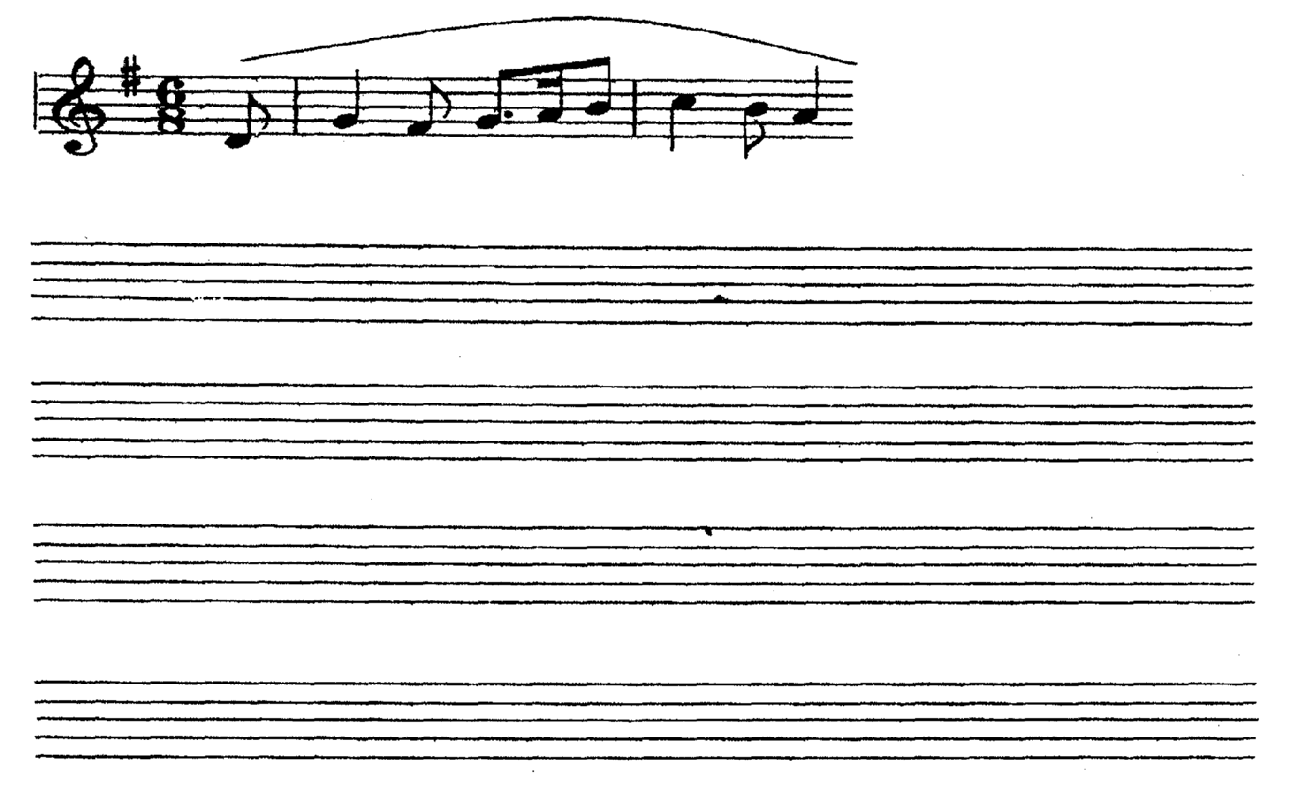
Or:

b) Using staff notation, write a tune to the following words. (12 mks)
Ishall remember while the light lives yet,
And in the night time I shall not forget.

2. Harmonize the following for soprano, alto, tenor and bass (SATB). Choose appropriate chords from the following I, II, IV, V, VI. (20mks)

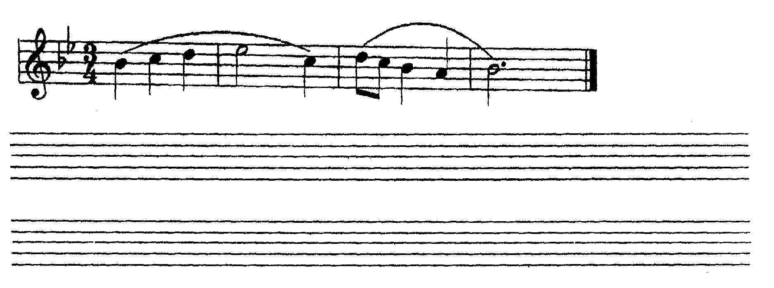
SECTION B: HISTORY ANEANALYSIS (48mks)
3.. AFRICAN MUSIC
a) Identify flutes from the list below (3mks)
Thira Oporo
Murenge Ekeroria
Ebune Nzumari
………………………………………………………………………………………………………………………………………………………………………………………………………………………………………………………………………………………………………………………………………………
b) i. From which community is Jackson Kisika? (lmk)
………………………………………………………………………………………………………………………………………………………………………………………………………………………………
ii. With which instrument is Charo Washutu associated? (1 mk)
………………………………………………………………………………………………………………………………………………………………………………………………………………………………
iii. Name the main person from whom Tungu Mamwacha acquired music skills (1mk)
………………………………………………………………………………………………………………………………………………………………………………………………………………………………
c) Outline three ways by which language influences music (3mks)
………………………………………………………………………………………………………………………………………………………………………………………………………………………………………………………………………………………………………………………………………………………………………………………………………………………………………………………………
………………………………………………………………………………………………………………………………………………………………………………………………………………………………
d)i State two roles of make-ups in African dances (2mks)
………………………………………………………………………………………………………………………………………………………………………………………………………………………………………………………………………………………………………………………………………………
ii. Outline three causes of evolution of African dances in the Twenty First Century. (3mks)
………………………………………………………………………………………………………………………………………………………………………………………………………………………………………………………………………………………………………………………………………………………………………………………………………………………………………………………………

4. WESTERN MUSIC
Answer any two of the following questions (a),(b),(c) and (d).
a) William Byrd
i. What is an elegy? (l mk)
………………………………………………………………………………………………………………………………………………………………………………………………………………………………
ii. Outline three characteristics of the elegy for Talus which was composed by
William Byrd. (3mks)
ii. Outline three contributions of Byrd to instrumental music. (3rnks)
………………………………………………………………………………………………………………………………………………………………………………………………………………………………
………………………………………………………………………………………………………………………………………………………………………………………………………………………………
b) Alessandro Scarlatti
i. Name the period of music history in which A. Scarlatti lived. (lmk)
………………………………………………………………………………………………………………………………………………………………………………………………………………………………

ii. Outline three contributions of A. Scarlatti to sacred music, (3mks)
………………………………………………………………………………………………………………………………………………………………………………………………………………………………………………………………………………………………………………………………………………………………………………………………………………………………………………………………………………………………………………………………………………………………………………………………………………………………………………………………………………………………
iii. Outline three major achievements of A. Scarlatti as a musician. (3mks)
………………………………………………………………………………………………………………………………………………………………………………………………………………………………………………………………………………………………………………………………………………………………………………………………………………………………………………………………
c) Joseph Haydn
i. For what purpose did Haydn write each of the following? (2mks) Emperor quartet
………………………………………………………………………………………………………………………………………………………………………………………………………………………………
Creation Oratorio
………………………………………………………………………………………………………………………………………………………………………………………………………………………………
ii. Outline three opportunities which enhanced Haydn’s Musical development. (3mks)
………………………………………………………………………………………………………………………………………………………………………………………………………………………………
………………………………………………………………………………………………………………………………………………………………………………………………………………………………
iii. What type of work is the Limping Devil? (lmk)
………………………………………………………………………………………………………………………………………………………………………………………………………………………………

iv. For whom did Haydn write the Limping Devil? (lmk)
………………………………………………………………………………………………………………………………………………………………………………………………………………………………

d) Antonin Dvorak
i. Define tone poem. (lmk)
………………………………………………………………………………………………………………………………………………………………………………………………………………………………
ii. Name two tone poems by Dvorak. (2mks)
………………………………………………………………………………………………………………………………………………………………………………………………………………………………
iv. Outline four experiences which enhanced Dvoraks musical development. (4mks)
………………………………………………………………………………………………………………………………………………………………………………………………………………………………
………………………………………………………………………………………………………………………………………………………………………………………………………………………………
………………………………………………………………………………………………………………………………………………………………………………………………………………………………

5. PRESCRIBED AFRICAN MUSIC
Borana Folksong by Gitabini Secondary School

i. For what media is the music in the recording? (2mks)
………………………………………………………………………………………………………………………………………………………………………………………………………………………………
ii. Describe four different singing styles displayed in the main section. (4mks)
………………………………………………………………………………………………………………………………………………………………………………………………………………………………
………………………………………………………………………………………………………………………………………………………………………………………………………………………………
………………………………………………………………………………………………………………………………………………………………………………………………………………………………
iii. State four roles of vocal embellishments in the performance. (4rnks)
………………………………………………………………………………………………………………………………………………………………………………………………………………………………………………………………………………………………………………………………………………………………………………………………………………………………………………………………………………………………………………………………………………………………………………………………………………………………………………………………………………………………………………………………………………………………………………………………………………………………………………………………………………………………………………………………
6. PRESCRIBED WESTERN MUSIC
Contrapunctus 4 from “The Art of Fugue by J.S. Bach”
- Name the voices in order of entry in the middle section between bars 60 to 80. (2mks)
………………………………………………………………………………………………………………………………………………………………………………………………………………………………
- Outline six compositional devices used in Contrapunctus iv. (6mks)
………………………………………………………………………………………………………………………………………………………………………………………………………………………………………………………………………………………………………………………………………………………………………………………………………………………………………………………………………………………………………………………………………………………………………………………………………………………………………………………………………………………………………………………………………………………………………………………………………………………………………………………………………………………………………………………………
iii. Analyse Contrapunctus 4 in terms of rhythm from the first to the fourth bar. (2mks)
………………………………………………………………………………………………………………………………………………………………………………………………………………………………

SECTION C: GENERAL MUSIC KNOWLEDGE
a) i. Name four instruments of the string family of orchestra. (2mks)
………………………………………………………………………………………………………………………………………………………………………………………………………………………………
ii. What is chamber Ensemble? (lmk)
………………………………………………………………………………………………………………………………………………………………………………………………………………………………
iii. Define each of the following chamber ensemble. (2mks) String Quartet
………………………………………………………………………………………………………………………………………………………………………………………………………………………………
Piano trio
………………………………………………………………………………………………………………………………………………………………………………………………………………………………
b) Outline any five characteristics of African Music. (5mks)
………………………………………………………………………………………………………………………………………………………………………………………………………………………………………………………………………………………………………………………………………………………………………………………………………………………………………………………………………………………………………………………………………………………………………………………………………………………………………………………………………………………………………………………………………………………………………………………………………………………………………………………………………………………………………………………………………………………………………………………………………………………………………………………………………………………………………………………………………………………………

- i. In the following passage, explain Andantino; ben legato. (2mks)

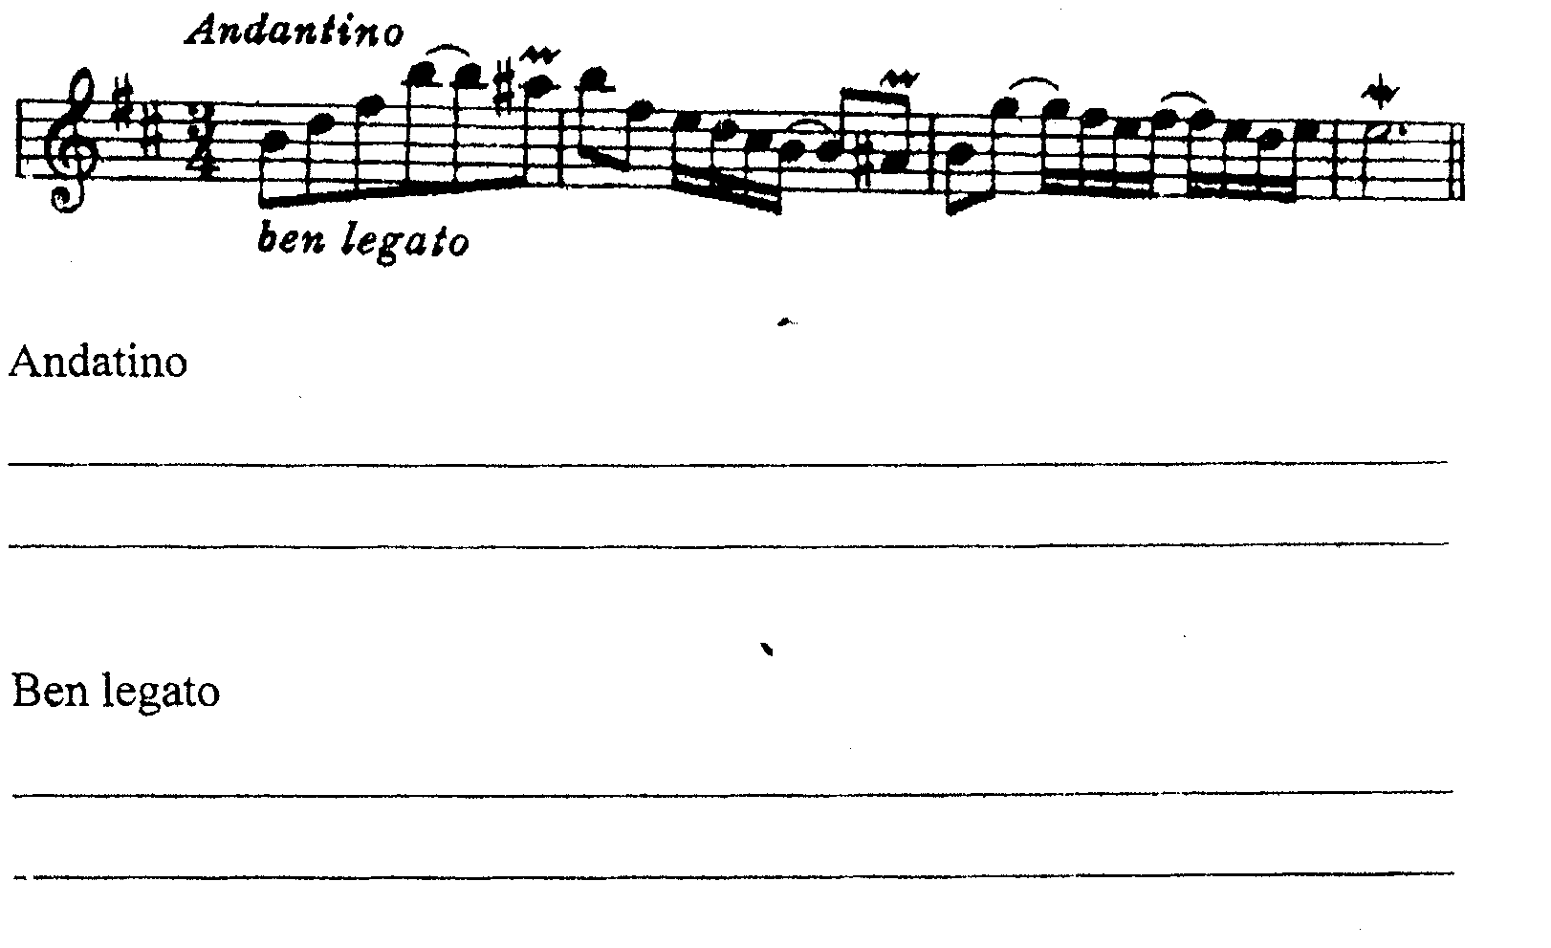
iii. Write out the ornaments in bars 2 and 4 in full, showing how they should be played. (3mks)
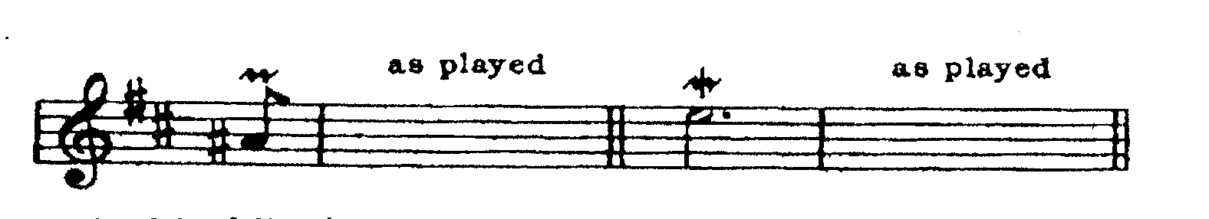
d. Define each of the following terms. (5marks)
i. A transverse flute
ii. Double headed membranophone
iii. Terraced dynamics
iv. Melismatic Style
v. Coloratura.

