**SUNSHINE SECONDARY SCHOOL**

**FORM 4**

**BIOLOGY**

**PAPER 2**

**PRE- MOCK EXAMS - MARCH / APRIL 2014**

**TIME: 2 HRS**

**NAME ……………………………………………….…. CLASS………..ADMIN NO :……..**

**INSTRUCTIONS**

1. Answer **ALL** questions in the spaces provided.
2. Sign and write the date of examination in the spaces provided.
3. Answer **ALL** the questions in section **A**.
4. In section **B,** answer question **6 (compulsory)** and either question **7** or **8** in the spaces provided after question **8**.
5. Candidates should check the question paper to ascertain that all pages are printed as indicated and that no questions are missing.

**For examiners use only**

|  |  |  |  |
| --- | --- | --- | --- |
| **SECTION** | **QUESTION** | **MAXIMUM SCORE** | **CANDIDATES SCORE** |
| **A** | **1** | **8** |  |
| **2** | **8** |  |
| **3** | **8** |  |
| **4** | **8** |  |
| **5** | **8** |  |
| **B** | **6** | **20** |  |
| **7** | **20** |  |
| **8** | **20** |  |
|  | **TOTAL SCORE** | **80** |  |

*This paper has 10 printed pages.*

**SECTION A (40 MARKS)**

**Answer ALL the questions in this section in the spaces provided.**

1. In a certain family where the fathers had blood group **A** and the mother had blood group **B**, one of the children had blood group **O**.
2. Work out the possible genotype of the children obtained in the F1 generation. (4 mks)
3. What is the phenotypic ratio of F1 generation? (1 mk)

………………………………………………………………………………………………

………………………………………………………………………………………………

1. (i) Which child can receive blood from all other members of the family? (1 mk)

………………………………………………………………………………………………

………………………………………………………………………………………………

(ii) Give a reason for your answer in (a) above. (1 mk)

………………………………………………………………………………………………

………………………………………………………………………………………………

1. What is the haemolytic disease of the new born (Erythroblastosis foetalis)? (1 mk)

………………………………………………………………………………………………

………………………………………………………………………………………………

1. The diagram below illustrates an experiment to determine the rate of respiration in a small insect.

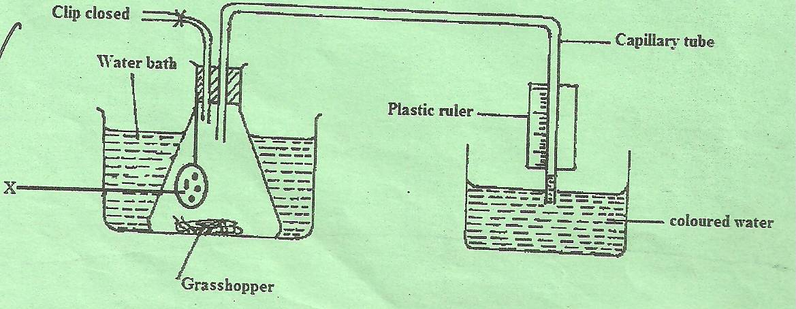

1. Name the chemical compound labeled X and state its function. (2 mks)

………………………………………………………………………………………………

………………………………………………………………………………………………

………………………………………………………………………………………………

………………………………………………………………………………………………

1. Why is it necessary to place the flask in a water bath? (1 mk)

………………………………………………………………………………………………

………………………………………………………………………………………………

1. What changes would you expect to observe in the level of coloured water in the capillary tube after the experiment has run for five minutes? (1 mk)

………………………………………………………………………………………………

………………………………………………………………………………………………

1. Explain the changes you have stated in (c) above. (3 mks)

………………………………………………………………………………………………

………………………………………………………………………………………………

1. State how you can set up a control experiment. (1 mk)

………………………………………………………………………………………………

………………………………………………………………………………………………

1. The diagram below shows a mammalian eye.

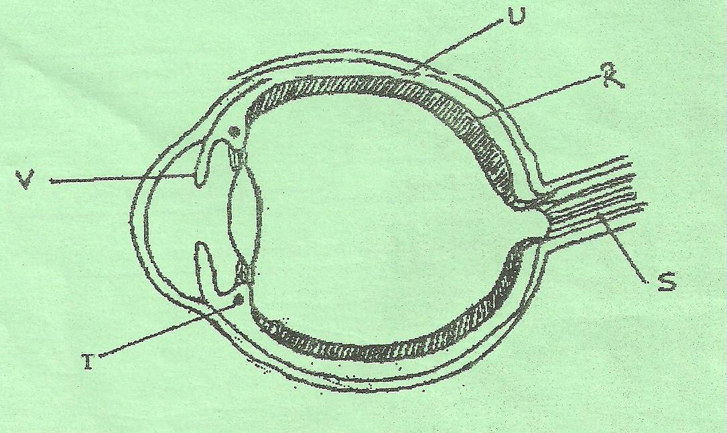

1. Name the parts labeled R, S and T. (3 mks)

R……………………………………………………………………………………………

S……………………………………………………………………………………………

T……………………………………………………………………………………………

1. Give two adaptation of part labeled U. (2 mks)

………………………………………………………………………………………………

………………………………………………………………………………………………

………………………………………………………………………………………………

………………………………………………………………………………………………

1. Describe the changes that occur to part V when one moves from a bright room to a dark room. (3 mks)

………………………………………………………………………………………………

………………………………………………………………………………………………

………………………………………………………………………………………………

………………………………………………………………………………………………

………………………………………………………………………………………………

………………………………………………………………………………………………

………………………………………………………………………………………………

………………………………………………………………………………………………

………………………………………………………………………………………………

1. In an experiment to investigate an aspect of digestion, two test tubes P and Q were set up as shown in the diagram below.

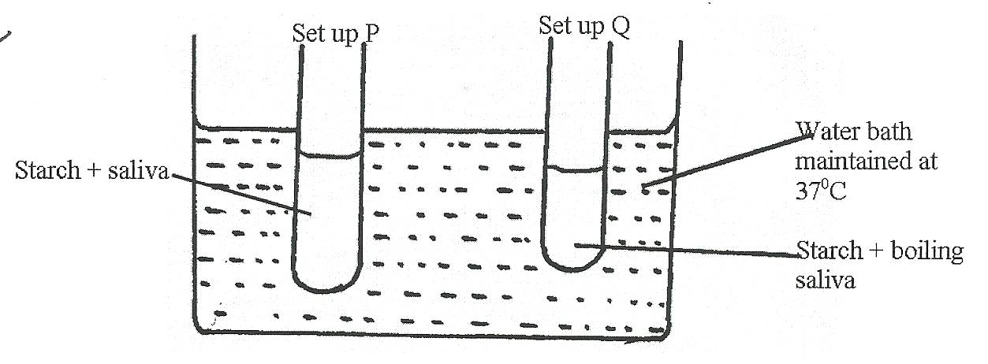

The test tubes were left in the bath for 30 minutes. The content of each test tube was then tested for starch using iodine solution.

1. What was the aim of experiment? (1 mk)

………………………………………………………………………………………………

………………………………………………………………………………………………

1. What results were expected in test tube P and Q? (2 mks)

………………………………………………………………………………………………

………………………………………………………………………………………………

………………………………………………………………………………………………

………………………………………………………………………………………………

1. Account for the results you have given in (b) above in test tube P and Q. (2 mks)

………………………………………………………………………………………………

………………………………………………………………………………………………

………………………………………………………………………………………………

………………………………………………………………………………………………

1. Why was the set up left at 370c? (1 mk)

………………………………………………………………………………………………

………………………………………………………………………………………………

1. Name the carbohydrate stored in: (2 mks)
2. Mammalian liver……………………………………………………………………
3. Potato tuber…………………………………………………………………………
4. Below is a representation of a biogeochemical cycle.

T

Free Nitorgen (N2)

P

Plant Protein

Animal Protein

Nitrites (NO2)

B

Q

U

S

Z

R

1. Name the above cycle. (1 mk)

………………………………………………………………………………………………

………………………………………………………………………………………………

1. What is: (2 mks)

B……………………………………………………………………………………………

P……………………………………………………………………………………………

1. Name the micro-organisms labeled: (2 mks)

T……………………………………………………………………………………………

R……………………………………………………………………………………………

1. Name process: (2 mks)

U……………………………………………………………………………………………

Z……………………………………………………………………………………………

1. Give specific name of a free living bacteria. (1 mk)

………………………………………………………………………………………………

**SECTION B (40 MARKS)**

**Answer question 6 (compulsory) and wither 7 and 8 in the spaces provided.**

1. The menstrual cycle if a sequence of events repeated monthly in the female production system. The table below shows the concentration of oestrogen and progesterone hormones and body temperatures of female against time.

|  |  |  |  |
| --- | --- | --- | --- |
| Time in days | Oestrogen mg/100 cm of blood | Progesterone mg/100 cm3 of blood | Temperature in 00c |
| 1 | 20 | 0 | 36.4 |
| 3 | 25 | 0 | 36.7 |
| 5 | 30 | 0 | 36.7 |
| 7 | 35 | 0 | 36.8 |
| 9 | 48 | 0 | 36.6 |
| 11 | 64 | 0 | 36.7 |
| 13 | 80 | 0 | 36.4 |
| 15 | 140 | 50 | 36.6 |
| 17 | 70 | 130 | 37.2 |
| 19 | 60 | 160 | 37.1 |
| 21 | 130 | 130 | 37.2 |
| 23 | 130 | 90 | 37.0 |
| 25 | 80 | 50 | 37.2 |
| 27 | 20 | 0 | 36.4 |

1. Using the same axis draw graphs of oestrogen and progesterone against time. (8 mks)



1. State the possible event taking place in the uterus during the first week. (1 mk)

………………………………………………………………………………………………

………………………………………………………………………………………………

1. State the events taking place in the ovary between day 1 and day 13. (2 mks)

………………………………………………………………………………………………

………………………………………………………………………………………………

………………………………………………………………………………………………

………………………………………………………………………………………………

………………………………………………………………………………………………

1. Account for the sudden increase in the progesterone concentration between day 14 and day 18. (2 mks)

………………………………………………………………………………………………

………………………………………………………………………………………………

………………………………………………………………………………………………

………………………………………………………………………………………………

………………………………………………………………………………………………

1. Account for the change in temperature between day 14 and 17. (1 mk)

………………………………………………………………………………………………

………………………………………………………………………………………………

1. Account for the change of the curve of progesterone between day 19 and 27. (2 mks)

………………………………………………………………………………………………

………………………………………………………………………………………………

………………………………………………………………………………………………

………………………………………………………………………………………………

………………………………………………………………………………………………

1. State the function of the following:

(i) Ovary (1 mk)

………………………………………………………………………………………………

(ii) Progesterone (1 mk)

………………………………………………………………………………………………

1. Oestrogen (1 mk)

………………………………………………………………………………………………

1. (a) Describe how herbaceous plants are able to maintain an erect posture. (10 mks)

(b) Describe the structure and functions of various supportive issues in Woody plants.

(10 mks)

1. Describe estimation of a population in an ecosystem based on the following: (20 mks)
2. Capture-recapture method.
3. Quadrat method
4. Belt transect

………………………………………………………………………………………………………

………………………………………………………………………………………………………

………………………………………………………………………………………………………

………………………………………………………………………………………………………

………………………………………………………………………………………………………

………………………………………………………………………………………………………

………………………………………………………………………………………………………

………………………………………………………………………………………………………

………………………………………………………………………………………………………

………………………………………………………………………………………………………

………………………………………………………………………………………………………

………………………………………………………………………………………………………

………………………………………………………………………………………………………

………………………………………………………………………………………………………

………………………………………………………………………………………………………

………………………………………………………………………………………………………

………………………………………………………………………………………………………

………………………………………………………………………………………………………

………………………………………………………………………………………………………

………………………………………………………………………………………………………

………………………………………………………………………………………………………

………………………………………………………………………………………………………

………………………………………………………………………………………………………

………………………………………………………………………………………………………

………………………………………………………………………………………………………

………………………………………………………………………………………………………

………………………………………………………………………………………………………

………………………………………………………………………………………………………

………………………………………………………………………………………………………

………………………………………………………………………………………………………

………………………………………………………………………………………………………

………………………………………………………………………………………………………

………………………………………………………………………………………………………

………………………………………………………………………………………………………

………………………………………………………………………………………………………

………………………………………………………………………………………………………

………………………………………………………………………………………………………

………………………………………………………………………………………………………

………………………………………………………………………………………………………

………………………………………………………………………………………………………

………………………………………………………………………………………………………

………………………………………………………………………………………………………

………………………………………………………………………………………………………

………………………………………………………………………………………………………

………………………………………………………………………………………………………

………………………………………………………………………………………………………

………………………………………………………………………………………………………

………………………………………………………………………………………………………

………………………………………………………………………………………………………

………………………………………………………………………………………………………

………………………………………………………………………………………………………

………………………………………………………………………………………………………

………………………………………………………………………………………………………

………………………………………………………………………………………………………

………………………………………………………………………………………………………

………………………………………………………………………………………………………

………………………………………………………………………………………………………

………………………………………………………………………………………………………

………………………………………………………………………………………………………