SUNSHINE SECONDARY SCHOOL

233/1
FORM 4
CHEMISTRY
PAPER 1
PRE MOCK EXAM – MARCH 2014
TIME: 2 HOURS

NAME: ……………………………………………..…….CLASS:……. ADM NO:…………..

INDEX NUMBER ………………………………………….CANDIDATES SIGN:…………..

Instructions to candidates

- Attempt all the questions in the spaces provided.
- All workings must be clearly shown where necessary..
- Fx 82-ms calculators or mathematics table might be used in the working.

80

- Study the diagram and answer the questions that follow. The diagram shows the method of separating components of mixture Q.

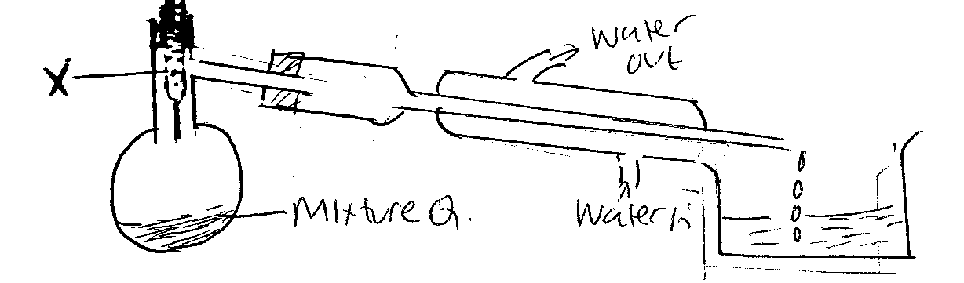

- State the role of the part labeled X. (1 mk)

…………………………………………………………………………………………………..
…………………………………………………………………………………………………..
- State what would happen if the water inlet and water outlet in the Liebig condenser is interchanged. (1 mk)

…………………………………………………………………………………………………..
…………………………………………………………………………………………………..
- (a) Define Gay – Lussac’s law. (1 mk)

…………………………………………………………………………………………………..
…………………………………………………………………………………………………..
(b) 30 cm³ of ethane were mixed with 100 cm³ of oxygen and the mixture was sparked to
complete reaction all the volume were measured at a pressured of one atmosphere and a temperature of 25⁰C, calculate the volume the residual gas under room temperature. (2 mks)

…………………………………………………………………………………………………..
…………………………………………………………………………………………………..
…………………………………………………………………………………………………..
…………………………………………………………………………………………………..

- The diagram below shows a diagram of non-luminous flame. A piece of white paper is slipped into the region of the flame as shown in the diagram and quickly removed before it catches fire.
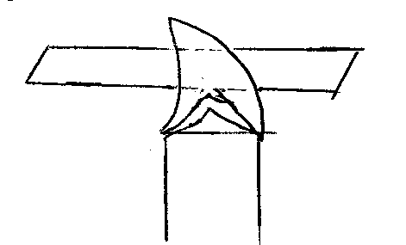

- Draw and label the piece of paper to show affected by the above flame. (1 mk)

- Explain why a luminous flame of a Bunsen burner produces bright yellow light. (1 mk)
…………………………………………………………………………………………………..
…………………………………………………………………………………………………..
…………………………………………………………………………………………………..
- A student added 50 cm³ of 1.0M aqueous sulphuric acid to 50cm³ of 2.0M potassium hydroxide and the temperature rose by 4⁰C.
- Define the term molar heat of neutralization. (1 mk)

…………………………………………………………………………………………………..
…………………………………………………………………………………………………..
- Calculate the molar heat of neutralization (C = 4.2 J/gk⁻¹ density of solution – 1 g/cm³) (2 mks)

…………………………………………………………………………………………………..
…………………………………………………………………………………………………..
…………………………………………………………………………………………………..
…………………………………………………………………………………………………..
…………………………………………………………………………………………………..
- Study the set up below and answer the questions the follow.

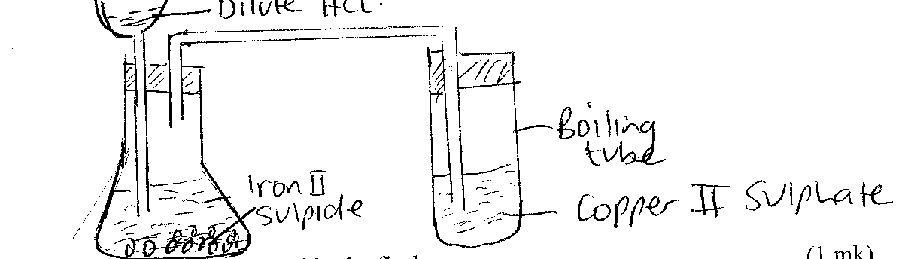

- Identify the gas produced in the flask. (1 mk)

…………………………………………………………………………………………………..
- Using an equation explain the observation made in the boiling tube. (2 mks)

…………………………………………………………………………………………………..
…………………………………………………………………………………………………..
…………………………………………………………………………………………………..
- Hydration energy of the magnesium gaseous ion is -1920kJ/mol while the lattice energy and the heat of solution of magnesium chloride +2493 and -155 kJ/mol respectively. Using an energy cycle diagram, work out the hydration energy of the chloride gaseous ion. (2 mks)

- The formula given below represents a portion of a polymer.

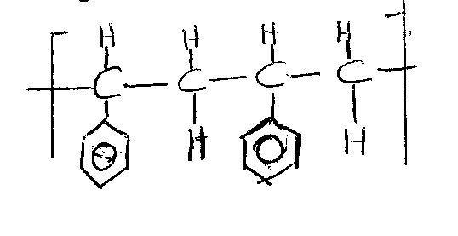

- Draw the structure of the monomer of the polymer. (1 mk)

- Give the name of the polymer. (1 mk)
………………………………………………………………………………………………
- When potassium nitrate is heated, it produces potassium nitrite and gas C.
- Identify gas C. (1 mk)

…………………………………………………………………………………………………..
- Name the type of reaction undergone by the potassium nitrate. (1 mk)

…………………………………………………………………………………………………..

- The chromatogram below shows the constituents of ink sample M using methylated spirit as solvent.

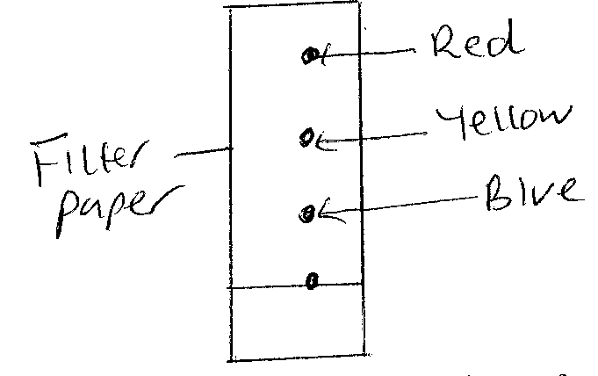

- Describe how you would obtain a solid sample of the pigment from the chromatogram above. (2 mks)

…………………………………………………………………………………………………..
…………………………………………………………………………………………………..
…………………………………………………………………………………………………..
…………………………………………………………………………………………………..
…………………………………………………………………………………………………..
- State one property of the red dye. (1 mk)

…………………………………………………………………………………………………..
…………………………………………………………………………………………………..
- Calculate the number of hydrogen ions in 5 cm³ of 0.5 molar phosphoric acid. (L =6.0 x 10²³)
(2 mks)

…………………………………………………………………………………………………..
…………………………………………………………………………………………………..
…………………………………………………………………………………………………..
…………………………………………………………………………………………………..
…………………………………………………………………………………………………..
- The following table shows the pH values of solutions A, B, C and D.

Solution | A | B | C | D
pH | 3 | 7 | 10 | 14

- Which solution is likely to be that of iron (III) chloride? (1 mk)

…………………………………………………………………………………………………..
…………………………………………………………………………………………………..
- Which solution has the highest concentration of hydroxide? Explain. (2 mks)

…………………………………………………………………………………………………..
…………………………………………………………………………………………………..
…………………………………………………………………………………………………..
- The diagram below shows a structure (i) of water molecules.

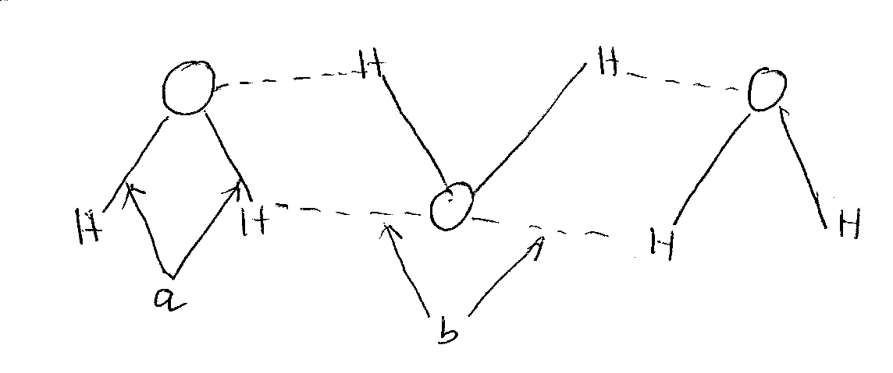
- Name the bonds labeled. (1 mk)

a………………………………………… b…………………………..
- Using dots (.) and cross(x) diagram show the bonding in the compound phosphonium ion. PH₄⁺ (H = 1, P = 15) (1 mk)

- A dynamic equilibrium between chromate (CrO₄²⁻) and dichromate (Cr₂O₇²⁻) is established as shown in the equation below.

2CrO₄²⁺_{(aq)} + 2Hl^{r}_{(aq)} Cr₂O₇²⁻_{(aq)} + H₂O_{(l)}
yellow orange

- What is mean by a dynamic equilibrium? (1 mk)

…………………………………………………………………………………………………..
…………………………………………………………………………………………………..
- State and explain the observation that would be made if a few drops of concentration sulphuric (VI) acid added to the equilibrium mixture. (1 mk)

…………………………………………………………………………………………………..
…………………………………………………………………………………………………..
…………………………………………………………………………………………………..
- The table below shows properties of some elements. Study it carefully and answer the questions that follow.

Element | Sodium | Magnesium | Phosphorus
Electrical conductivity | Good | Good | Poor
Melting point | 98 | 660 | 44 44 of 115

- Suggest why phosphorus has been assigned tow melting point values. (1 mk)

…………………………………………………………………………………………………..
…………………………………………………………………………………………………..
- Explain why the melting point of magnesium is higher than that of sodium.(1 mk)

…………………………………………………………………………………………………..
…………………………………………………………………………………………………..
- 1.512g of metal carbonate XCO₃ reacts with 20cm³ of 1.8M hydrochloric acid completely. Calculate the relative atomic mass of element X. (C = 12, O = 16). (3 mks)

- A wooden splint glowing on both ends was fixed as shown in the diagram. The experiment was carried as indicated.

- What will be observed on the glowing splint end A and B if heating is done at the same time? (1 mk)

…………………………………………………………………………………………………..
…………………………………………………………………………………………………..
…………………………………………………………………………………………………..
- Explain the observation in (a) above. (1 mk)

…………………………………………………………………………………………………..
…………………………………………………………………………………………………..
- One of the products in this experiment is useful to rocket scientist is useful to rocket when going into space. State two ways in which the scientists use this product. (1 mk)

…………………………………………………………………………………………………..
…………………………………………………………………………………………………..
- 30 cm³ of Hydrogen gas diffuse through a porous plug in 2 minutes. How long will 90 cm³ of hydrocarbon gas of molecular mass 72 taken to diffuse through the same plug under same conditions. (H = 1, C = 12). (2 mks)

- The peak below show the mass spectrum of element Q.

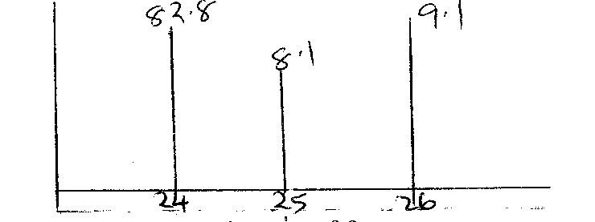

Calculate the relative atomic mass of Q. (2 mks)

…………………………………………………………………………………………………..
…………………………………………………………………………………………………..
…………………………………………………………………………………………………..
- (i) Define solubility. (1 mk)

…………………………………………………………………………………………………..
…………………………………………………………………………………………………..
(ii) Salt Q has a solubility of 30g / 100g of water. 55g of salt Q is stirred in 65g of a solution
which contains 10g of salt Q. how much more of salt Q will dissolve in the solution.
(2 mks)

…………………………………………………………………………………………………..
…………………………………………………………………………………………………..
…………………………………………………………………………………………………..
…………………………………………………………………………………………………..
- Study the flow chart below and answer the questions that follow.

Solid P
Brown gas
Solid A
Colourless solution C
Colourless solution B
Colourless solution

Heat

Add Dilute
HNO₃
Add excess
Add NH₃ (aq)
Dilute Hcl

- Write the two ions present in P. (1 mk)
…………………………………………………………………………………………………..
…………………………………………………………………………………………………..
- Write the equation for the reaction that forms solution B. (1 mk)
…………………………………………………………………………………………………..
- Write equation for thermal decomposition of P. (1 mk)
…………………………………………………………………………………………………..
- The table below gives information of four elements by letters A, B, C and D. study it and answer the questions that follow. The letters do not represent the actual symbol of the elements.

Element | Electron arrangement | Atomic radius (nm) | Ionic radius nm
A | 2.8.2 | 0.136 | 0.065
B | 2.8.7 | 0.097 | 0.181
C | 2.8.8.1 | 0.203 | 0.133
D | 2.8.8.1 | 0.174 | 0.097

- Which two elements have similar properties? Explain. (2 mks)

…………………………………………………………………………………………………..
…………………………………………………………………………………………………..
- Why is the ionic radius any element B greater than its atomic radius? (1 mk)

…………………………………………………………………………………………………..
…………………………………………………………………………………………………..
- In an experiment soap solution was added to three samples of water. The table below shows the soap solution required to form lather with 500cm³ of water before and after boiling.

 | Sample A | Sample B | Sample C
Volume of soap before water is boiled | 12.4 | 4.0 | 29.0
Volume of water after water is boiled | 4.0 | 4.0 | 29.0

- Which sample is likely to be:
- Temporary hard water (1 mk)
…………………………………………………………………………………………………..
- Permanent hard water (1 mk)
…………………………………………………………………………………………………..
- Write the formula of a compound that could be present in sample A but not in sample C.
(1 mk)

- Starting with Lead (II) oxide, describe how you can prepare a sample of lead (II) sulphate.
(3 mks)

…………………………………………………………………………………………………..
…………………………………………………………………………………………………..
…………………………………………………………………………………………………..
…………………………………………………………………………………………………..
…………………………………………………………………………………………………..
…………………………………………………………………………………………………..
…………………………………………………………………………………………………..
- Use the electrode potentials below to answer the questions that follow:

Mn²⁺_{(aq)} + 2e- Mn(s) E^{θ} = -1.19V

Cd²⁺_{(aq)} + 2e- Cd(s) E^{θ} = -0.40V

- Determine the e.m.f. of the cell. (1 mk)

- Write the cell representation of the cell above. (1 mk)
…………………………………………………………………………………………………..
- Study the reaction below and answer the questions that follow.
RNH₂ + H₂O ⇌ RNH₃ + OB –

Identify the base in the forward reaction. Explain. (1 mk)

…………………………………………………………………………………………………..
…………………………………………………………………………………………………..
…………………………………………………………………………………………………..
- When hydrogen gas is passed over Lead (II) oxide in a combustion tube, Lead (II) oxide is reduced.
- Write an equation for the above reaction. (1 mk)

…………………………………………………………………………………………………..
- What observation was made in the combustion tube when the reaction was complete? (1 mk)

…………………………………………………………………………………………………..
…………………………………………………………………………………………………..
- Name another gas which can be used to reduce Lead (II) oxide. (1 mk)

…………………………………………………………………………………………………..
- Some average are bond energies given below.

Bond | Bond Energy  kJ/mol
C – C | 348
C – H | 414
C = C | 610
C – Br | 28
Br – Br | 193

- Calculate the enthalpy of the following reaction. (2 mks)

C₂H₄(g) + Br_{2 (g)} CH₂Br CH₂Br

…………………………………………………………………………………………………..
…………………………………………………………………………………………………..
…………………………………………………………………………………………………..
…………………………………………………………………………………………………..
- Name the type of reaction that took place in (a) above. (1 mk)

…………………………………………………………………………………………………..
- In the last state of the Solvay process a mixture of sodium hydrogen carbonate and ammonium chloride is formed.
- State the method of separation used. (1 mk)
…………………………………………………………………………………………………..
- Write an equation showing how lime is slaked. (1 mk)
…………………………………………………………………………………………………..
- Name the by product recycled in the above process. (1 mk)
…………………………………………………………………………………………………..
- A compound X is made of carbon, hydrogen and oxygen whose percentage composition by mass are 62.1%, 10.3% and the rest oxygen respectively. The relative molecular mass of X is 58 (H = 1, O = 16, C = 12)
- Determine the empirical formula of the compound. (3 mks)

…………………………………………………………………………………………………..
…………………………………………………………………………………………………..
…………………………………………………………………………………………………..
…………………………………………………………………………………………………..
…………………………………………………………………………………………………..
…………………………………………………………………………………………………..
…………………………………………………………………………………………………..
- Determine the molecular formulae of the compound. (1 mk)

…………………………………………………………………………………………………..
…………………………………………………………………………………………………..
…………………………………………………………………………………………………..
- (i) What is half life? (1 mk)

…………………………………………………………………………………………………..
…………………………………………………………………………………………………..
(ii) Complete the following nuclear equation by finding the values of X and Y. (2 mks)

$${}_{y}^{x}Z {}_{82}^{208}{Pb} + 2∝ +2β$$

…………………………………………………………………………………………………..
…………………………………………………………………………………………………..
…………………………………………………………………………………………………..
(iii) Element Z has initial mass of 80g. After 5 years the remaining mass is 5g. What is the
half life of Z? (2 mks)

…………………………………………………………………………………………………..
…………………………………………………………………………………………………..
…………………………………………………………………………………………………..
…………………………………………………………………………………………………..

