SUNSHINE PREMOCK 1: SUPLEMENTARY PRACTICAL

1. (a) You are provided with substance P, carry out food tests using the reagents provided and fill the table below. (12mks)
Food test | Procedure | Observation | Conclusion
(b) State the importance of the food substances indicated in P in the human diet. (5mks)
……………………………………………………………………………………………………..
……………………………………………………………………………………………………..
……………………………………………………………………………………………………..
……………………………………………………………………………………………………..
……………………………………………………………………………………………………..

2. A student observed and drew a flower as shown.
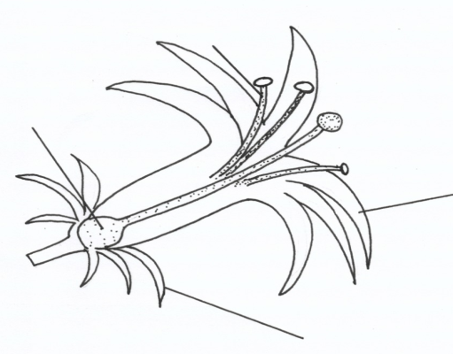
X

Ovary

Petal

Y

(a) Name the following parts and state their functions. (4mks)

X……………………………………………………………..
Function
………………………………………………………………………………………………
………………………………………………………………………………………………

Y……………………………………………………….
Function
………………………………………………………………………………………………
………………………………………………………………………………………………
(b) Briefly describe the nature of the corolla of the flower drawn. (2mks)
………………………………………………………………………………………………
………………………………………………………………………………………………
(c) Briefly describe the nature of the calyx of the flower drawn. (1mk)
………………………………………………………………………………………………
………………………………………………………………………………………………
(d) What type of ovary does the flower have? (1mk)
……………………………………………………………………………………………………..
……………………………………………………………………………………………………..
(e) (i) To which class does a plant with this type of flower belong? (1mk)
……………………………………………………………………………………………………..
……………………………………………………………………………………………………..
(ii) Give one reason to support your answer in e (i) above. (1mk)
……………………………………………………………………………………………………..
……………………………………………………………………………………………………..
3. Answer the questions that follow based on the drawing of vertebrae obtained from a mammal as indicated.

K- Anterior view of a certain vertebra
L-Lateral view of a certain vertebra
M- Anterior view of a certain vertebra
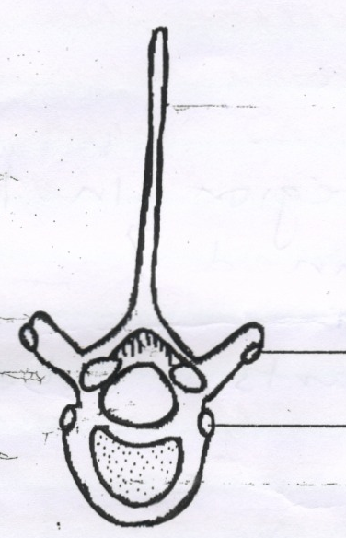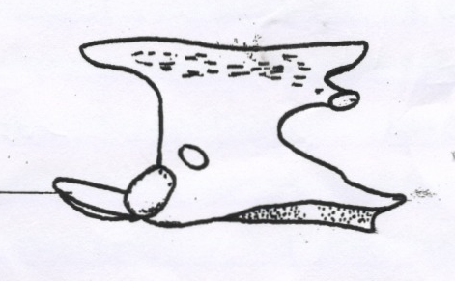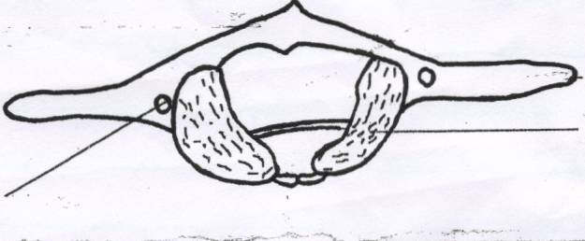
S
U
t
K
L
M
V
W

(a) Identify each bone (vertebra) and give one reason to support your answer, based on visible features.
K Name………………………………………………………..(1mk)
Reason: ………………………………………………………………………………………………..
L Name ……………………………………………………….. (1mk)
Reason: ………………………………………………………………………………………………..
M Name ……………………………………………………….(1mk)
Reason: ………………………………………………………………………………………………..
(b) (i) From which region in the mammal’s body was L obtained? (1mk)

………………………………………………………………………………………………
(ii) Name the parts labeled:- (2mks)
S…………………………………………………………………………
t…………………………………………………………………………
(c) State the functions of the parts:- (4mks)
t……………………………………………………………………………………………
U…………………………………………………………………………………………
V……………………………………………………………………………………………
W……………………………………………………………

