SUNSHINE SECONDARY SCHOOL

312/2
FORM 4
GEOGRAPHY PAPER 2
PREMOCK EXAMS - MARCH 2014
TIME: 2$\frac{1}{2}$ HRS

NAME……………………….………………………………ADMIN NO……….CLASS……

INSTRUCTIONS
- The paper comprises of two sections A & B
- Attempt all the questions in Section A
- In Section B answer question 6 and 9 and choose any other one question
- Use separate foolscap to answer questions in Section B

SCORE SHEET

SECTION A

QUESTION 6

QUESTION 7

QUESTION 8

QUESTION 9

QUESTION 10

TOTAL

SECTION A
- a) State three physical factors that influence the growing of sugar cane (3mks)
………………………………………………………………………………………………………………………………………………………………………………………………………………………………………………………………………………………………………………………………………………………………………………………………………………………………
………………………………………………………………………………………………………
………………………………………………………………………………………………………
b) State two differences between dairy farming in Kenya and Denmark (2mks)
………………………………………………………………………………………………………………………………………………………………………………………………………………………………………………………………………………………………………………………
………………………………………………………………………………………………………
2. a) Identify two methods of underground mining (2mks)
………………………………………………………………………………………………………………………………………………………………………………………………………………
b) State three causes of land derelitiction (3mks)
………………………………………………………………………………………………………………………………………………………………………………………………………………………………………………………………………………………………………………………………………………………………………………………………………………………………
………………………………………………………………………………………………………
3. a) State two factors influencing linear settlement (2mks)
………………………………………………………………………………………………………………………………………………………………………………………………………………………………………………………………………………………………………………………
b) Describe three characteristics of central Business District (CBD) (3mks)
………………………………………………………………………………………………………………………………………………………………………………………………………………………………………………………………………………………………………………………………………………………………………………………………………………………………………………………………………………………………………………………………………
4. a) State three physical problems facing transport and communication in Africa (3mks)
………………………………………………………………………………………………………………………………………………………………………………………………………………………………………………………………………………………………………………………
………………………………………………………………………………………………………
………………………………………………………………………………………………………
………………………………………………………………………………………………………
b) State two disadvantages of audio-visual communication (2mks)
………………………………………………………………………………………………………………………………………………………………………………………………………………………………………………………………………………………………………………………………………………………………………………………………………………………………
- a) (i) What is environment? (1mk)
………………………………………………………………………………………………………………………………………………………………………………………………………………
(ii) Give two measures of controlling pests and diseases as an environmental hazard.
(2mks)
………………………………………………………………………………………………………………………………………………………………………………………………………………………………………………………………………………………………………………………
b) State two methods of controlling floods in Budalangi (2mks)
………………………………………………………………………………………………………………………………………………………………………………………………………………

SECTION B

- a) (i) Differentiate between i) Multilateral trade and Bilateral trade (2mks)

(ii) Balance of trade and Balance of Payment (2mks)

(iii) Visible trade and invisible trade (2mks)

b) Explain four factors that inhibit trade between the countries in COMESA region. (4mks)

c) Study the figures below and answer the questions that follow

Volume of trade of country x in million shillings
Commodity | Export | Import
Maize | 2000 | 3500
Horticulture | 5000 | 100
Tourism | 7000 | 50
Petroleum | 50 | 10,000
Vehicles | 10 | 5,000

- Draw a divided rectangle to represent the imports (7mks)
(ii) Citing evidence from the above data, give four reasons for the trend in trade of country X (8mks)

- a) (i) State three factors that determine the amount of water required to irrigate land (3mks)

(ii) Explain three physical factors which influenced location of Mwea Tebere scheme
(6mks)
b) Explain three problems facing Perkerra Irrigation Scheme (6mks)

c) (i) Distinguish horticultural farming from market gardening (2mks)

(ii) State two problems facing horticultural farming in Kenya (2mks)

d) Explain three factors that have made horticulture in Netherlands successful (6mks)

- a) (i) Define Wildlife (1mk)

(ii) Distinguish between Game sanctuary and a game ranch (2mks)

b) Use the outline map of E. Africa to answer question (i) and (iii)
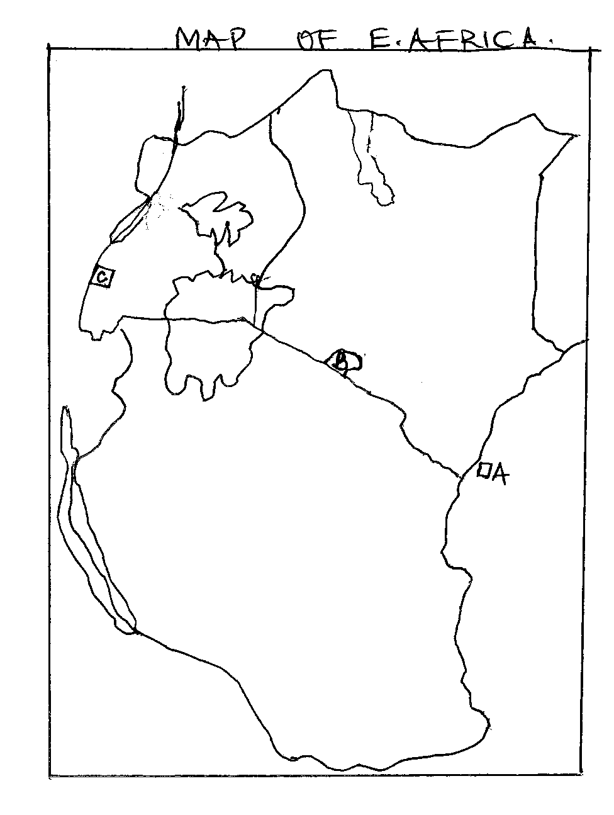
- Name the national parks marked A, B, C (3mks)

ii) Locate and name the following (3mks)
- Murchison falls National Park
- Selous Game Reserve
- Sibiloi National Park

iii) Explain how the following factors have influenced wildlife
- Vegetation (2mks)

- Altitude (2mks)

c) i) State three factors determining the future of tourism in Kenya (3mks)
ii) Apart from wildlife and scenery, identify three inland tourist attraction in Kenya.
(3mks)

d) Explain three measures taken by the Kenya Government to conserve wildlife. (6mks)

- a) The world map below shows major fishing grounds in the world.
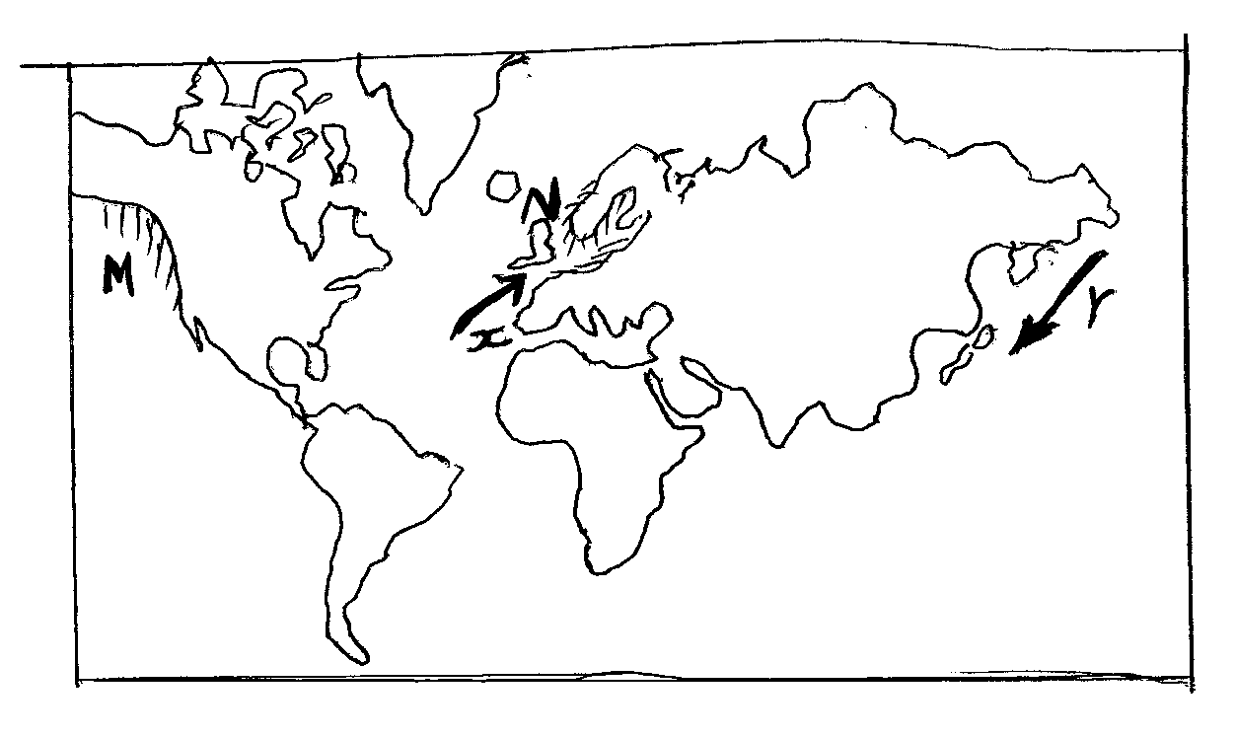
- Name the fishing grounds marked M and N (2mks)

- Identify two major type of fish species in the NW Pacific fishing grounds (2mks)

- Name the ocean currents X and Y (2mks)
b) Explain how the following factors influence fishing
i) Climatic conditions (2mks)
ii) Nature of the coastline (2mks)
c) (i) Describe trawling as a method of fishing (4mks)
(ii) Name two fresh water fisheries in Kenya (1mk)
(iii) Explain three reasons why fresh water fishing is more popular than marine fishing in
East Africa (6mks)

d) State four differences between fishing in Japan and Kenya (4mks).

- (a) (i) Name two types of coffee grown in Kenya. (2 mks)

(ii) Identify two districts in Kenya where coffee is grown in large scale. (2 mks)

(b) (i) State four factors favoring growing of coffee in Kenya. (4 mks)

(ii) Describe the stages of coffee processing once it is delivered to the factor. (9 mks)

(c) (i) Explain 3 benefits of coffee farming in Kenya. (6 mks)

(ii) State 4 problems facing coffee farmers in Brazil. (4 mks)

