SUNSHINE SECONDARY SCHOOL
NAME: ------------------------------------------------CLASS---- --------INDEX NO. -----------------------------
DATE: -------------------------
232/1
FORM 4
PHYSICS
PAPER 1
PRE MOCK EXAM - MARCH 2013
TIME: 2 HOURS

INSTRUCTIONS

i) Answer all questions in the spaces provided
ii) Non programmable scientific calculators and mathematical tables may be used
iii) All numerical answers must be expressed in decimal notation
iv) This paper has 10 printed pages .it is the responsibility of the candidates to ensure that there are no missing pages.

Constant: g=10n/kg

Section | Questions | Maximum score | Candidate’s score
Section A | 1-15 | 25
Section B | 16-20 | 55
Total | 20 | 80

SECTION A (25 MARKS)
ANSWER ALL THE QUESTIONS IN THIS SECTION
1) State the reading on the micrometer screw gauge shown below.
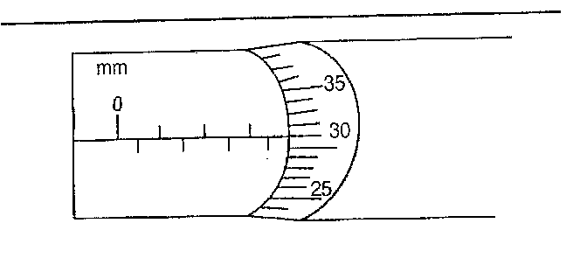
-------------------------------------------------------------------------------------------------------------------------------------------------------------------------------------------------------------------------------(1mark)
2) An oil drop forms a circular patch of area 5x10⁻³ m².If the oil drop has a volume 9x10⁻¹² m³, calculate the thickness of the oil molecule
------------------------------------------------------------------------------------------------------------------------------------------------------------------------------------------------------------------------------------------------------------------------------------------------------------------------------------------------------------------------------------------------------------------------------------------------------------------------(2marks)
3) Name one non contact force-------------------------------------------------------------------------------------------------------------------------------------------------------------------------------------------(1mark)
4) A crane just lifts 9940N when an effort of 116N is applied and its efficiency is 75%. Find it’s velocity ratio.
-----------------------------------------------------------------------------------------------------------------------------------------------------------------------------------------------------------------------------------------------------------------------------------------------------------------------------------------------------------------------------------------------------------------------------------------------------------------(3marks)

5) The mass of a vessel is 90g and its specific heat capacity is 420J/Kgk. Calculate its heat capacity
-----------------------------------------------------------------------------------------------------------------------------------------------------------------------------------------------------------------------------------------------------------------------------------------------------------------------------------------------------------------------------------------------------------------------------------------------------------------(3marks)
6) Explain the term absolute zero temperature--------------------------------------------------------------------------------------------------------------------------------------------------------------------------------------------------------------------------------------------------------------------------------------------------------------------------------------------------------------------------------------------------------------(1mark)
7) Two table tennis balls are suspended from a support by thin string and air is blown between them. Explain the consequent motion of the balls.
------------------------------------------------------------------------------------------------------------------------------------------------------------------------------------------------------------------------------------------------------------------------------------------------------------------------------------------------------------------------------------------------------------------------------------------------------------------------(2marks)
8) State the Hooke’s law. ---------------------------------------------------------------------------------------------------------------------------------------------------------------------------------------------------------------------------------------------------------------------------------------------------------------(1mark)
9) Give a reason why heat transfer by radiation is faster than heat transfer by conduction.
----------------------------------------------------------------------------------------------------------------------------------------------------------------------------------------------------------------------------------------------------------------------------------------------------------------------------------------------------(1mark)
10) The moment of the weight of vertical door does not significantly affect the moment of the force to the door .Give a reason for this---------------------------------------------------------------------
-----------------------------------------------------------------------------------------------------------------------------------------------------------------------------------------------------------------------(1mark)
11) In the Brownian motion experiment, smoke particles are observed to move randomly. Explain how this motion is caused.-----------------------------------------------------------------------------------------------------------------------------------------------------------------------------------------------------------------------------------------------------------------------------------------------(2marks)
12) Give reason why weight of a body varies from place to place---------------------------------------------------------------------------------------------------------------------------------------------------------------------------------------------------------------------------------------------------------------------(1mark)
13) The figure below shows a fire alarm circuit. Explain how the alarm functions.
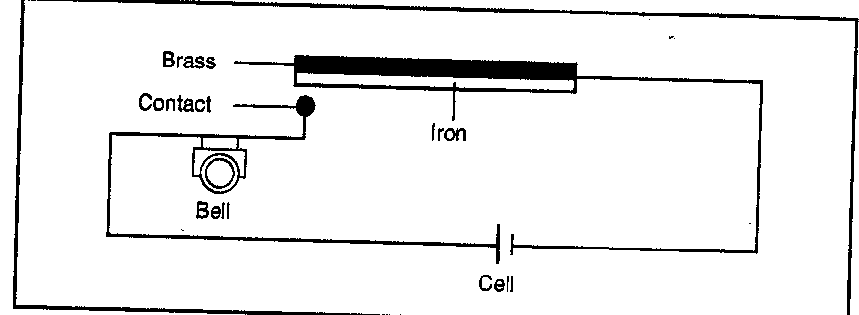
------------------------------------------------------------------------------------------------------------------------------------------------------------------------------------------------------------------------------------------------------------------------------------------------------------------------------------------------------------------------------------------------------------------------------------------------------------------------(2marks)
14) State the reason why water spilled on a glass surface wets the surface.
-----------------------------------------------------------------------------------------------------------------------------------------------------------------------------------------------------------------------(1mark)
15) Two liquids of density 1100kg/m³ and 850kg/m³ are mixed in equal volumes .The mixture fills a tank of 300cmx40cmx50cm to the brim. Calculate the mass of each liquid.
-----------------------------------------------------------------------------------------------------------------------------------------------------------------------------------------------------------------------------------------------------------------------------------------------------------------------------------------------------------------------------------------------------------------------------------------------------------------(3marks)
SECTION B (55 MARKS)
ANSWER ALL THE QUESTIONS IN THIS SECTION
16) The figure below shows a hydraulic press system using a lever of negligible mass, on the side of the small piston, pivoted at point P. A force of 50N is applied.
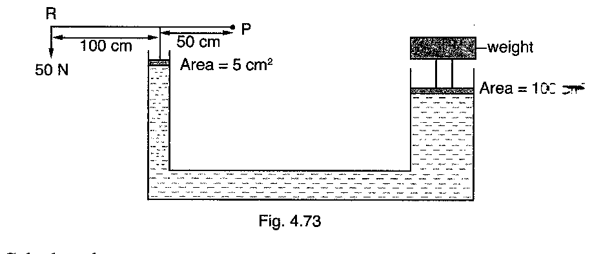
a) Calculate the:
i) Force exerted by the small piston on the liquid
-----------------------------------------------------------------------------------------------------------------------------------------------------------------------------------------------------------------------------------------------------------------------------------------------------------------------------------------------------------------------------------------------------------------------------------------------------------------------------------------------------------------------------------------------------------------------------------------------------------------------------------------------------------------------------------------------------------------(3 marks)
ii) Pressure of the liquid below the small piston.
-----------------------------------------------------------------------------------------------------------------------------------------------------------------------------------------------------------------------------------------------------------------------------------------------------------------------------------------------------------------------------------------------------------------------------------------------------------------------------------------------------------------------------------------------------------------------------------------------------------------------------------------------------------------------------------------------------------------(3 marks)

iii) Weight of the object supported on the larger piston
-----------------------------------------------------------------------------------------------------------------------------------------------------------------------------------------------------------------------------------------------------------------------------------------------------------------------------------------------------------------------------------------------------------------------------------------------------------------------------------------------------------------------------------------------------------------------------------------------------------------------------------------------------------------------------------------------------------------(3 marks)
b) State two properties of the fluid used in the hydraulic press.
---------------------------------------------------------------------------------------------------------------------------------------------------------------------------------------------------------------------------------------------------------------------------------------------------------------------------------------------------(2marks)
17) a) State Newton’s second law of motion
---------------------------------------------------------------------------------------------------------------------------------------------------------------------------------------------------------------------------------------------------------------------------------------------------------------------------------------------------(1mark)
b) A body accelerates uniformly from rest to 30m/s in 10s.Find its acceleration
---------------------------------------------------------------------------------------------------------------------------------------------------------------------------------------------------------------------------------------------------------------------------------------------------------------------------------------------------(2marks)
c) A car of mass 800kg moving with a speed of 15m/s crashes into a wall and comes to rest in 0.4 s. Find the :
i) Impulse-----------------------------------------------------------------------------------------------------------------------------------------------------------------------------------------------------------------------------------------------------------------------------------------------------------------------------------------------------------------------------------------------------------------------------------------------------------------------------------------------------------------------------------------------------------------------------(3 marks)
ii) Average force by the wall
-----------------------------------------------------------------------------------------------------------------------------------------------------------------------------------------------------------------------------------------------------------------------------------------------------------------------------------------------------------------------------------------------------------------------------------------------------------------------(3 marks)
d) A steel ball is released at the top of a tall glass cylinder containing a viscous liquid. Sketch the velocity –time graph for this motion (2 marks)

18) a) State the law of flotation
---------------------------------------------------------------------------------------------------------------------------------------------------------------------------------------------------------------------------------------------------------------------------------------------------------------------------------------------------(1mark)
b) A uniform glass test tube of diameter 1.62cm containing lead shots floats in water with 14.9 cm in water.
i) State the function of the lead shots
------------------------------------------------------------------------------------------------------------------------------------------------------------------------------------------------------------------------------(1mark)

ii) Calculate the total mass of tube and its contents
------------------------------------------------------------------------------------------------------------------------------------------------------------------------------------------------------------------------------------------------------------------------------------------------------------------------------------------------------------------------------------------------------------------------------------------------------------------------(4 marks)
iii) Find the length immersed in a liquid of relative density of 1.6
------------------------------------------------------------------------------------------------------------------------------------------------------------------------------------------------------------------------------------------------------------------------------------------------------------------------------------------------------------------------------------------------------------------------------------------------------------------------------------------------------------------------------------------------------------------------------------------(3marks)
C) A solid displaces 5cm³ of paraffin when floating and 25cm³ when fully immersed. Determine the density of the solid (Density of paraffin =800kg/m³)
------------------------------------------------------------------------------------------------------------------------------------------------------------------------------------------------------------------------------------------------------------------------------------------------------------------------------------------------------------------------------------------------------------------------------------------------------------------------------------------------------------------------------------------------------------------------------------------(4marks)
19) a) A ball of mass 200g tied to a spring is being whirled in a vertical circle of radius 0.4m with uniform speed. At the lowest position, the tension in the string is 2.8N.Calculate the:
i) Uniform speed of the ball
-----------------------------------------------------------------------------------------------------------------------------------------------------------------------------------------------------------------------------------------------------------------------------------------------------------------------------------------------------------------------------------------------------------------------------------------------------------------------(3marks)

ii) Tension in the string when the ball is at the upper most position of the circular path
---------------------------------------------------------------------------------------------------------------------------------------------------------------------------------------------------------------------------------------------------------------------------------------------------------------------------------------------------------------
------------------------------------------------------------------------------------------------------------------------------------------------------------------------------------------------------------------------------------------------------------------------------------------------------------------------------------------------------------------------------------------------------------------------------------------------------------------------(3marks)
b) A metal ball of mass 10kg is rotated horizontally by means of a rope 4m long .If its linear speed is 30m/s, find the force that will break the rope.
------------------------------------------------------------------------------------------------------------------------------------------------------------------------------------------------------------------------------------------------------------------------------------------------------------------------------------------------------------------------------------------------------------------------------------------------------------------------(3marks)
c) A body moving with uniform speed in a circular path is accelerates. Explain
-----------------------------------------------------------------------------------------------------------------------------------------------------------------------------------------------------------------------------------------
---------------------------------------------------------------------------------------------------------------------------------------------------------------------------------------------------------------------------------------------------------------------------------------------------------------------------------------------------(1mark)
20) a) State the principle of moments
------------------------------------------------------------------------------------------------------------------------------------------------------------------------------------------------------------------------------------------------------------------------------------------------------------------------------------------------------------------------------------------------------------------------------------------------------------------------(1mark)
b) A uniform wooden lath measuring 200cm by 25cm by 15cm is suspended at the 150cm mark and balanced horizontally by hanging a mass of 14 kg at the 200cm mark. Calculate the:
i) Mass of the wooden lath
------------------------------------------------------------------------------------------------------------------------------------------------------------------------------------------------------------------------------------------------------------------------------------------------------------------------------------------------------------------------------------------------------------------------------------------------------------------------(3marks)
ii) Density of the material of the wooden lath
------------------------------------------------------------------------------------------------------------------------------------------------------------------------------------------------------------------------------------------------------------------------------------------------------------------------------------------------------------------------------------------------------------------------------------------------------------------------(3marks)
iii) Tension in the rope supporting the system
-----------------------------------------------------------------------------------------------------------------------------------------------------------------------------------------------------------------------------------------------------------------------------------------------------------------------------------------------------------------------------------------------------------------------------------------------------------------(3marks)

