NAME……………..……………………………………………… INDEX NO……........………………..…..

SCHOOL…………………………………………………………. CANDIDATE’S SIGNATURE…….…..

DATE………..…………………………..

232/1

PHYSICS

PAPER 1
(THEORY)

JULY/AUGUST 2014

TIME: 2 HOURS

KURIA WEST SUB-COUNTY JOINT EXAMINATION - 2014

Kenya Certificate of Secondary Education

PHYSICS

PAPER 1
(THEORY)

TIME: 2 HOURS

INSTRUCTIONS TO THE CANDIDATE:
(a) Write your name and index number in the spaces provided above.
(b) Sign and write the date of examination in the spaces provided above.
(c) This paper consists of two Sections A and B.
(d) Answer all the questions in sections A and B in the spaces provided.
(e) All working must be clearly shown in the spaces provided.
(f) Non-programmable silent electronic calculators and KNEC Mathematical tables may be used.

FOR EXAMINER’S USE ONLY:
Section | Question | Maximum  Score | Candidate’s  Score
A | 1 – 14 | 25
 | 15 | 9
 | 16 | 11
B | 17 | 10
 | 18 | 11
 | 19 | 14
Total Score |  | 80

Physics Paper 1 Turnover
SECTION A: (25 MARKS)

Answer all questions in this section in the spaces provided:

- The figure below shows a uniform triangular lamina.

Locate the centre of gravity of lamina. (2mks)

2. The figure below shows two containers of equal volume but of different diameters.

Equal volume of hot water was put in both containers. Explain why it cools faster in the wider
container than in the narrower one. (1mk)

__________________________________________________________________________________

__________________________________________________________________________________

__________________________________________________________________________________

__________________________________________________________________________________

3. State one advantage of hydraulic brakes over mechanical brakes. (1mk)

__________________________________________________________________________________

__________________________________________________________________________________

__________________________________________________________________________________

4. A body in a uniform circular motion experiences acceleration despite moving at a constant speed. Explain. (1mk)

__________________________________________________________________________________

__________________________________________________________________________________

__________________________________________________________________________________

Use the information below to answer question 5 and 6:

In an experiment to determine the density of a liquid, the following readings were made.
Mass of empty density bottle = 20g
Mass of bottle filled with water = 70g
Mass of bottle filled with a liquid = 695g

Physics Paper 1 2
5. Find the density of the liquid, given that density of water is 1000kgmˉ³. (3mks)

6. Find the mass of the liquid. (3mks)

7. The diagram below shows a metal tube made of iron and copper. The joint is tight at room temperature.
Copper
Iron
Joint

Explain how you would separate the two by changing the temperature given that copper expands
more than iron for some change in temperature. (2mks)

_________________________________________________________________________________

_________________________________________________________________________________

_________________________________________________________________________________

_________________________________________________________________________________

8. State one assumption made when estimating the size of an oil molecule in the oil drop experiment. (1mk)

_________________________________________________________________________________

_________________________________________________________________________________

_________________________________________________________________________________
Physics Paper 1 3

9. The figure below shows a load-extension graph for various loads hung from a single spring.
Extension (m)
Load (N)

On the same axes sketch a graph for a spring double the diameter and half the length of the first one.
(1mk)

Use the information below which represents hydraulic braking system to answer questions 10 and 11.

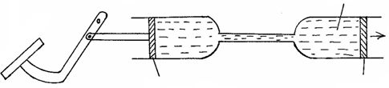
Fluid
Force
produced
Slave piston
Master piston
Pivot
Brake pedal

10. State one property the fluid should have. (1mk)

__________________________________________________________________________________

11. Explain briefly how the system operates. (3mks)

__________________________________________________________________________________

__________________________________________________________________________________

__________________________________________________________________________________

__________________________________________________________________________________

12. Figure below shows a pulley system being used to raise a load.
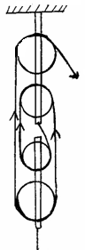
Effort = 28N
Load
100N

Physics Paper 1 4
If the effort applied is 28N and the load lifted is 100N, determine the efficiency of the system. (3mks)

13. Figure below shows a section of a pipe XY. A constant pressure difference maintains a streamline flow of a liquid in the pipe.
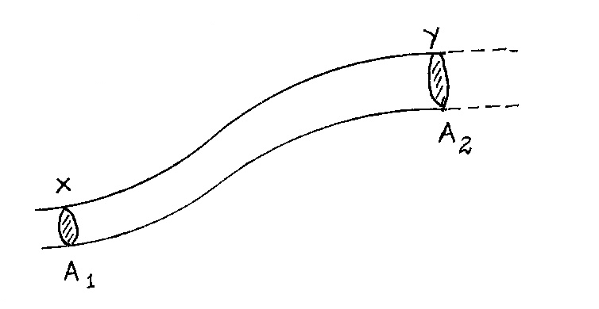

If the cross-sectional area A₁ at X is less than A₂ ay Y, state how the liquid velocity V₂ at Y compares with V₁ at X. (1mk)

__________________________________________________________________________________

14. Explain the cause of random motion of smoke particles as observed in Brownian motion experiment using a smoke cell. (2mks)

_________________________________________________________________________________

_________________________________________________________________________________

_________________________________________________________________________________

_________________________________________________________________________________

SECTION B: (55 MARKS)

Answer question in this section in the spaces provided.

15. (a) State what is meant by centripetal acceleration. (1mk)

___________________________________________________________________________

___________________________________________________________________________

___________________________________________________________________________

___________________________________________________________________________
Physics Paper 1 5
- The figure shows masses X, Y and Z placed at different points on a turn table. The turn table is rotated at different angular velocities.
X
Y
Z

(i) State two factors that would cause the masses to slide. (2mks)

______________________________________________________________________

______________________________________________________________________

- At the time that start sliding off, state the mass with the highest angular velocity,
give reason for your answer. (2mks)

______________________________________________________________________

______________________________________________________________________

______________________________________________________________________

______________________________________________________________________

(c) (i) If the centripetal for is 2N and the mass and radius of the path for mass Y are 100g
and 0,03m respectively. Calculate the angular velocity of the mass when the system
is in equilibrium. (3mks)

- Indicate on the same diagram the direction of velocity of mass Z at that position.
(1mk)

- The figure below shows an inclined plane, a trolley of mass 30kg is pulled up a slope by a force of 100N, parallel to the slope. The trolley moves so that the centre of mass C travels from points A to B.
•
A
C
100N
B
10m
15º

Physics Paper 1 6
- What is the work done on the trolley against the gravitational force in moving from A to B.? (2mks)

____________________________________________________________________________

____________________________________________________________________________

____________________________________________________________________________

____________________________________________________________________________

(ii) Determine the work done by the force in moving the trolley from A to B. (2mks)

(iii) Determine the efficiency of the system. (3mks)

(iv) Determine the work done in overcoming the frictional force. (1mk)

(v) Determine the mechanical advantage of the system. (3mks)

Physics Paper 1 7
- The graph represents displacement-time graph for a car moving with uniform acceleration along a straight horizontal road.



From the graph determine:
(i) the velocity of the car at the 20th second. (2mks)

Physics Paper 1 8
(ii) the velocity at the 50th second. (2mks)

(iii) the acceleration of the car between the 20th second and 50th second. (3mks)

(b) A bullet is fired horizontally from a storey building 15m high. If the initial speed is 350msˉ¹, determine the maximum horizontal distance covered by the bullet. (3mks)

Physics Paper 1 9
18. (a) A cylindrical block of metal of mass 500g and density 5.0 × 10³kg/m³ rests on the
bottom of a beaker containing a liquid of density 2.5 × 10³kgmˉ³, standing on a compression balance. The metal is attached to a spring balance by a light inextensible string and to begin with the string is slack as shown in the figure below.
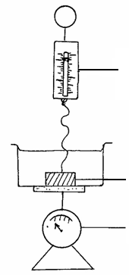
Spring balance
Metal
Compression balance

The metal is slowly raised by raising the spring balance vertically until the metal is
well above the surface of the liquid. The mass of the beaker and liquid, without the metal is 1.5kg. Determine the readings, in Newton’s, that will be recorded on each
of the balances when
(i) the string is slack as shown the diagram. (3mks)

______________________________________________________________________

______________________________________________________________________

______________________________________________________________________

______________________________________________________________________

(ii) the string is taut with the metal fully immersed in the liquid. (5mks)

Physics Paper 1 10
(b) The weight of a stone in air is 7.5N. When fully immersed in paraffin of density 0.8g/cm³ its weight is 6.3N. Determine the;
(i) up thrust in the paraffin. (1mk)

(ii) volume of the stone. (2mks)

19. (a) What is meant by specific latent heat of vaporization of a substance? (1mk)

____________________________________________________________________________

____________________________________________________________________________

____________________________________________________________________________

(b) In an experiment to determine the specific latent heat of vaporization of water, steam at
100ºC was passed into water contained in a well-lagged copper calorimeter. The following measurements were made:
- Mass of calorimeter = 55g
- Initial mass of water = 75g
- Final mass of calorimeter + water + condensed steam = 133g
- Final temperature of the mixture = 30ºC
[Specific heat capacity of water = 4200JKgˉ¹kˉ¹ and specific heat capacity of copper
= 390JKgˉ¹kˉ¹]
Determine the
(i) mass of condensed steam. (1mk)

______________________________________________________________________

______________________________________________________________________

- heat gained by the calorimeter and water if the initial temperature of the
calorimeter + water = 20ºC. (2mks)

______________________________________________________________________

______________________________________________________________________

______________________________________________________________________

Physics Paper 1 11
- given that L is the specific latent heat of vaporization of steam,
(I) Write an expression for the heat given out by steam. (2mks)

______________________________________________________________________

______________________________________________________________________

______________________________________________________________________

______________________________________________________________________

(II) Determine the value of L. (2mks)

______________________________________________________________________

______________________________________________________________________

______________________________________________________________________

______________________________________________________________________

(c) (i) In verifying the Charles’ law of gases, the volume and the temperature of a gas are
varied at constant pressure, State the condition necessary for the law to hold. (1mk)

______________________________________________________________________

______________________________________________________________________

______________________________________________________________________

- With an aid of a labeled diagram, describe an experiment to verify Charles’ law. (5mks)

Physics Paper 1 12

