**NAME ……………………………………..……………….. DATE …………………………………**

**INDEX NO. …………….……….……..…..… CANDIDATE’S SIGNATURE …………..…..………..**

443/1

AGRICULTURE

PAPER 1 (THEORY)

TIME: 2 HOURS

**MAKINDU DISTRICT INTER – SECONDARY SCHOOLS EXAMINATION**

***Pre - Kenya Certificate of Secondary Education***

443/1

AGRICULTURE

PAPER 1 (THEORY)

JULY/AUGUST 2014

TIME: 2 HOURS

**INSTRUCTIONS TO CANDIDATES**

1. Write your name and index number in the spaces provided above.
2. This paper has **THREE** sections: A , B and C
3. Answer **ALL** the questions in section A and B and any **TWO** questions in section C
4. ALL answers **MUST** be written in the spaces provided.
5. Do not remove any pages from this booklet.
6. This paper consists of 11 printed pages. Candidates should check to ensure that all pages are printed as indicated and no questions are missing

**FOR EXAMINER’S USE ONLY**

|  |  |  |  |
| --- | --- | --- | --- |
|  | **Questions** | **Maximum score** | **Candidate’s score** |
| A | **01 - 20** | **30 marks** |  |
| B | **21 - 24** | **20 marks** |  |
| C | **25- 27** | **40 marks** |  |
|  | | **Total score** |  |

© 2014, Makindu district inter – secondary schools examination

443/1

Agriculture

Paper 1 (theory)

**SECTION A (30 MARKS)**

Answer ***all*** the questions in this section in the spaces provided.

1. Give four factors which characterize large scale farming. (2 marks)

................................................................................................................................................................................................................................................................................................................................................................................................................................................................................................................................................................................................................................................................................................

1. State any four effects of rainfall on Agriculture. (2marks)

................................................................................................................................................................................................................................................................................................................................................................................................................................................................................................................................................................................................................................................................................................

1. Give two disadvantages of landlordism tenancy tenure system as practiced in Kenya (1mark)

................................................................................................................................................................................................................................................................................................................................................

1. Give two reasons for adding well rotten organic manure to a compost heaps. (1marks)

................................................................................................................................................................................................................................................................................................................................................

1. i) Why is it advisable to apply straight nitrogenous fertilizer to a crop of maize at a height of 30-45cm? (2marks)

........................................................................................................................................................................................................................................................................................................................................................................................................................................................................................................................

ii). Suppose the farmer has to apply 30kg P2O5 per hectare and has the following at his disposal

21:15:60.

Calculate the amount of P205 he will require for 2 hectares. (2marks)

................................................................................................................................................................................................................................................................................................................................................................................................................................................................................................................................................................................................................................................................................................

1. How does proper spacing reduce pests and diseases in crops? (1mark)

........................................................................................................................................................................................................................................................................................................................................................................................................................................................................................................................

1. Mention four advantages of using polythene sleeves in the establishment of seedlings. (2marks)

................................................................................................................................................................................................................................................................................................................................................................................................................................................................................................................................................................................................................................................................................................

1. List four environmental conditions that may lead to low crop yields. (2 marks)

................................................................................................................................................................................................................................................................................................................................................................................................................................................................................................................................................................................................................................................................................................

1. State two main causes of silage losses. (1mark)

........................................................................................................................................................................................................................................................................................................................................................................................................................................................................................................................

1. State four methods used for collecting agro forestry seeds for planting. (2marks)

................................................................................................................................................................................................................................................................................................................................................................................................................................................................................................................................................................................................................................................................................................

1. List four examples of joint products in livestock production. (2marks)

................................................................................................................................................................................................................................................................................................................................................................................................................................................................................................................................................................................................................................................................................................

1. Outline two ways through which rain drop erosion initiates the process of soil erosion. (1mark)

................................................................................................................................................................................................................................................................................................................................................

1. State two reasons why subsoiling is important as an operation of land preparation. (1mark)

........................................................................................................................................................................................................................................................................................................................................................................................................................................................................................................................

1. List two benefits of packaging agricultural commodity (1mark)

........................................................................................................................................................................................................................................................................................................................................................................................................................................................................................................................

1. Give four conditions that have led to fragmentation and sub-division of agricultural land in Kenya. (2marks)

................................................................................................................................................................................................................................................................................................................................................................................................................................................................................................................................................................................................................................................................................................

................................................................................................................................................................................................................................................................................................................................................ ................................................................................................................................................................................................................................................................................................................................................

1. Give three benefits of micro-catchments in water conservation (1½ marks)

........................................................................................................................................................................................................................................................................................................................................................................................................................................................................................................................

1. State two cultural methods of soil conversation (1mark)

................................................................................................................................................................................................................................................................................................................................................

1. Give two reasons for proper drying of grains before storage. (1mark)

........................................................................................................................................................................................................................................................................................................................................................................................................................................................................................................................

1. State two effects of aphids on plants. (1 marks)

................................................................................................................................................................................................................................................................................................................................................

1. Give three reasons for forage conservation. (1½ marks)

........................................................................................................................................................................................................................................................................................................................................................................................................................................................................................................................

**SECTION B (20 MARKS)**

Answer ***all*** the questions in this section in the spaces provided.

1. The diagram below illustrates a field management practice carried out to a fruit crop
   * + - 1. i) Identify the practice illustrated above. (1mark)

................................................................................................................................................................................................................................................................................................................................................

ii) Give two reasons for carrying out the practice illustrated in the above diagram. (2marks)

........................................................................................................................................................................................................................................................................................................................................................................................................................................................................................................................

* + - * 1. Give a reason why it is not advisable to use manure in carrot production. (1mark)

........................................................................................................................................................................................................................................................................................................................................................................................................................................................................................................................

1. Diagram X and Y represent two weeds

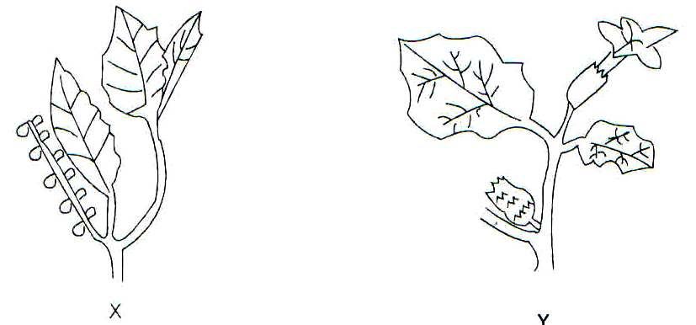

1. Identify weeds:

X

..................................................................................................................................

Y

................................................................................................................................ (1mark)

1. Give two economic importance’s of each of the weeds above. (2 marks)

........................................................................................................................................................................................................................................................................................................................................................................................................................................................................................................................

1. Name two kinds of herbicides used to control the above weeds C. (2marks)

........................................................................................................................................................................................................................................................................................................................................................................................................................................................................................................................

1. 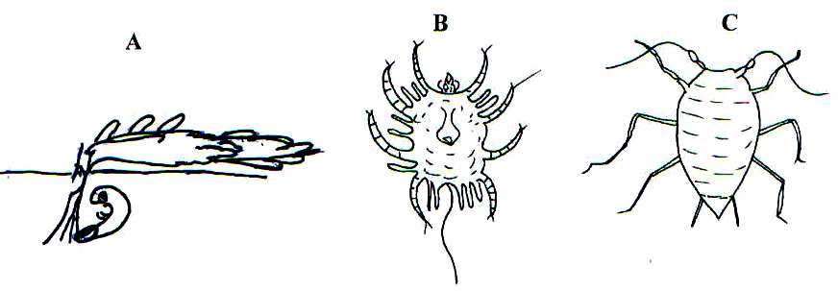The diagram labeled A, B and C below illustrates some vegetable pests. Study the diagrams carefully and then answer the questions that follow.
2. Identify each of the pests illustrated in the diagrams A, B and C. (1½ marks)

A.

....................................................................................................................................................................

B.

.....................................................................................................................................................................

C.

....................................................................................................................................................................

1. State the damage caused by each of the pests labeled A and C on the host plants. (1mark)

A

....................................................................................................................................................................

C

.................................................................................................................................................................

1. Give one cultural control measure for the pest labeled C (½ mark)

................................................................................................................................................................................................................................................................................................................................................

1. Explain the following practices as used in crop production
2. Integrated Pest management. (1mark)

................................................................................................................................................................................................................................................................................................................................................

1. Economic injury level (1mark)

................................................................................................................................................................................................................................................................................................................................................

1. Close season (1mark)

................................................................................................................................................................................................................................................................................................................................................

1. a) The diagram below shows a method of forage preservation

**Ground**

**Soil Layer**

**Drainage**

**Forage material**

**Polythene sheet**

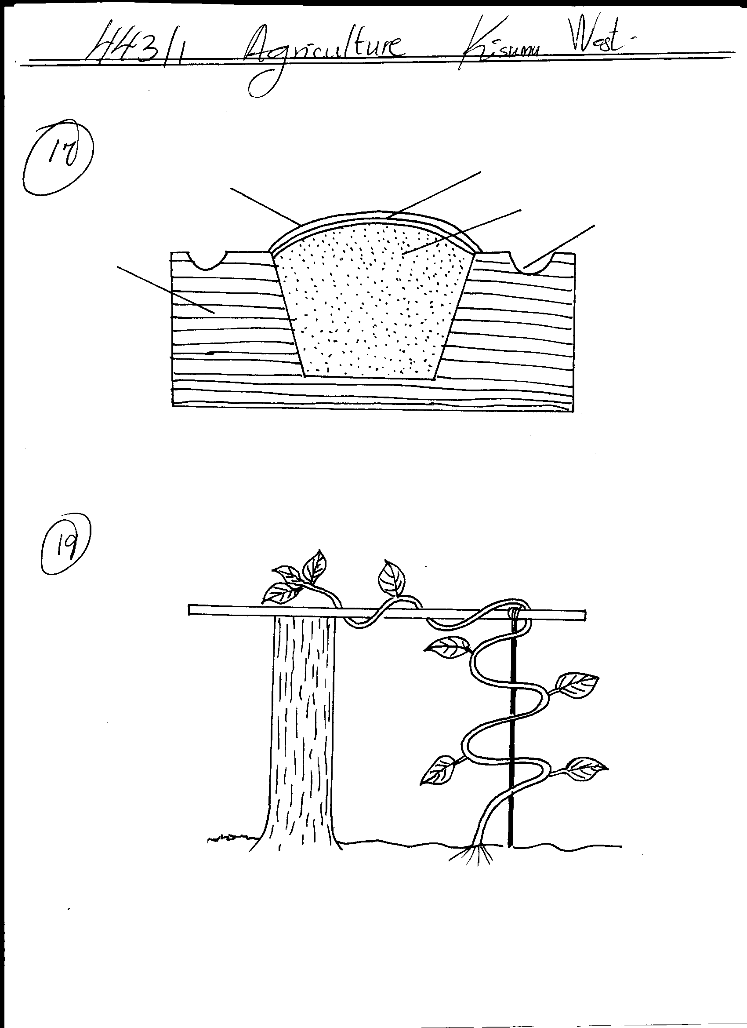

1. Identify the structure illustrated above. (1mark)

................................................................................................................................................................................................................................................................................................................................................................................................................................................................................................................................................................................................

1. State the form in which the forage is preserved as illustrated above (1mark)

................................................................................................................................................................................................................................................................................................................................................

1. Give the role of each of the following in the structure above (2marks)
2. Polythene sheet

................................................................................................................................................................................................................................................................................................................................................

1. Drainage

................................................................................................................................................................................................................................................................................................................................................

b) Name one other method of forage conservation (1mark)

........................................................................................................................................................................................................................................................................................................................................................................................................................................................................................................................

**SECTION C (40 MARKS)**

Answer ***only two*** questions in this section in the spaces provided.

1. a) Describe the methods used in preparing materials in readiness for planting. (8 marks)
2. Explain the factors that may determine spacing of crop in the farm (8 marks)
3. Explain briefly the factors that influence timely planting. (4marks)
4. a) State the law of Diminishing Returns (2marks)
5. Illustrate the above stated law by use of the graph and indicate the three important zones of

production. (3marks)

1. Explain eight ways how a farmer can adjust to risks and uncertainties (8marks)
2. Give four advantages of budgeting in farm business. (4marks)
3. Outline three uses of a balance sheet in farm accounts. (3marks)
4. a) Describe ten safety precautions that should be taken when using herbicides to control weeds. (10marks)
5. Explain ten farming practices which help to conserve soil on a farm. (10marks)

....................................................................................................................................................................................................................................................................................................................................................................................................................................................................................................................... ....................................................................................................................................................................................................................................................................................................................................................................................................................................................................................................................... ....................................................................................................................................................................................................................................................................................................................................................................................................................................................................................................................... .......................................................................................................................................................................................................................................................................................................................................................................................................................................................................................................................

....................................................................................................................................................................................................................................................................................................................................................................................................................................................................................................................... ....................................................................................................................................................................................................................................................................................................................................................................................................................................................................................................................... ....................................................................................................................................................................................................................................................................................................................................................................................................................................................................................................................... ....................................................................................................................................................................................................................................................................................................................................................................................................................................................................................................................... ....................................................................................................................................................................................................................................................................................................................................................................................................................................................................................................................... ....................................................................................................................................................................................................................................................................................................................................................................................................................................................................................................................... ....................................................................................................................................................................................................................................................................................................................................................................................................................................................................................................................... ....................................................................................................................................................................................................................................................................................................................................................................................................................................................................................................................... ....................................................................................................................................................................................................................................................................................................................................................................................................................................................................................................................... ....................................................................................................................................................................................................................................................................................................................................................................................................................................................................................................................... ....................................................................................................................................................................................................................................................................................................................................................................................................................................................................................................................... ....................................................................................................................................................................................................................................................................................................................................................................................................................................................................................................................... ....................................................................................................................................................................................................................................................................................................................................................................................................................................................................................................................... ....................................................................................................................................................................................................................................................................................................................................................................................................................................................................................................................... ....................................................................................................................................................................................................................................................................................................................................................................................................................................................................................................................... ....................................................................................................................................................................................................................................................................................................................................................................................................................................................................................................................... ........................................................................................................................................................................................................................................................................................................................................................................................................................................................................................................................ ........................................................................................................................................................................................................................................................................................................................................................................................................................................................................................................................ ........................................................................................................................................................................................................................................................................................................................................................................................................................................................................................................................ ........................................................................................................................................................................................................................................................................................................................................................................................................................................................................................................................ ....................................................................................................................................................................................................................................................................................................................................................................................................................................................................................................................... ........................................................................................................................................................................................................................................................................................................................................................................................................................................................................................................................ ........................................................................................................................................................................................................................................................................................................................................................................................................................................................................................................................ ........................................................................................................................................................................................................................................................................................................................................................................................................................................................................................................................ ........................................................................................................................................................................................................................................................................................................................................................................................................................................................................................................................ ........................................................................................................................................................................................................................................................................................................................................................................................................................................................................................................................ ........................................................................................................................................................................................................................................................................................................................................................................................................................................................................................................................ ........................................................................................................................................................................................................................................................................................................................................................................................................................................................................................................................ ........................................................................................................................................................................

........................................................................................................................................................................................................................................................................................................................................................................................................................................................................................................................ ........................................................................................................................................................................................................................................................................................................................................................................................................................................................................................................................ ........................................................................................................................................................................................................................................................................................................................................................................................................................................................................................................................ ........................................................................................................................................................................................................................................................................................................................................................................................................................................................................................................................ ........................................................................................................................................................................................................................................................................................................................................................................................................................................................................................................................ ........................................................................................................................................................................................................................................................................................................................................................................................................................................................................................................................ ........................................................................................................................................................................................................................................................................................................................................................................................................................................................................................................................ ........................................................................................................................................................................................................................................................................................................................................................................................................................................................................................................................ ........................................................................................................................................................................

........................................................................................................................................................................................................................................................................................................................................................................................................................................................................................................................ ........................................................................................................................................................................................................................................................................................................................................................................................................................................................................................................................