NAME ………………………………………… INDEX NO …….…………………..
SCHOOL ………………………………………… SIGNATURE …………..……....…….
DATE ……………….………..
231/2
BIOLOGY
PAPER 2
(THEORY)
JULY/AUGUST, 2014
2 HOURS

MAKINDU DISTRICT INTER – SECONDARY SCHOOLS EXAMINATION

Kenya Certificate of Secondary Education (K.C.S.E)

231/2
BIOLOGY
PAPER 2
(THEORY)
JULY/AUGUST, 2014
2 HOURS

INSTRUCTIONS TO CANDIDATES
- Write your name and Index Number in the spaces provided above.
- This paper consists of two sections. Section A and section B.
- Answer ALL questions in section A in the spaces provided. In section B answer question 6 (compulsory) and either question 7 or 8 in the spaces provided after question 8
- This paper consists of 11 Printed pages. Candidates should check the question paper to ensure that all the papers are printed as indicated and no questions are missing
For Examiners use only.
Section | Question | Maximum score | Candidates score
A | 1 | 8
 | 2 | 8
 | 3 | 8
 | 4 | 8
 | 5 | 8
B | 6 | 20
 | 7 | 20
 | 8 | 20
 | Total score | 80

© 2014, Makindu district inter – secondary schools examination
231/2
Biology
Paper 2 (Theory)

- a) What is diffusion (2marks)
........................................................................................................................................................................................................................................................................................................................................................................................................................................................................................................................
- How do the following factors affect the rate of diffusion?
    - Diffusion gradient (1mark)
........................................................................................................................................................................................................................................................................................................................................................................................................................................................................................................................
    - Surface area volume ratio (1mark)
........................................................................................................................................................................................................................................................................................................................................................................................................................................................................................................................
iii.Temperatures (1mark)
........................................................................................................................................................................................................................................................................................................................................................................................................................................................................................................................
c) Outline three roles of active transport in human body? (3marks)
...............................................................................................................................................................................................................................................................................................................................................................................................................................................................................................................................................................................................................................................................................................................................................................................................................................................................................................................................................................................................................................................
- a) Give the differences between the following structures in wind and insect pollinated flowers? (3marks)
- Anther
........................................................................................................................................................................................................................................................................................................................................................................................................................................................................................................................
........................................................................................................................................................................
- Pollen grains
........................................................................................................................................................................................................................................................................................................................................................................................................................................................................................................................
........................................................................................................................................................................
- Stigma
................................................................................................................................................................................................................................................................................................................................................................................................................................................................................................................................................................................................................................................................................................
b) What is the importance of pollination (1mark)
........................................................................................................................................................................................................................................................................................................................................................................................................................................................................................................................
c) Explain how a seed is formed after an ovule is fertilized (4marks)
........................................................................................................................................................................................................................................................................................................................................................................................................................................................................................................................................................................................................................................................................................................................................................................................................................................................................
- A cross between a red flowered plant and white flowered plant produces plants with pink flowers .Using letter R to represent the gene for red colour and W for white colour,
- What were the parental genotypes? (1mark)
................................................................................................................................................................................................................................................................................................................................................
- Work out a cross between F1 plants. (4marks)
................................................................................................................................................................................................................................................................................................................................................................................................................................................................................................................................................................................................................................................................................................................................................................................................................................................................................................................................................................................................................................................

- Give the phenotypic ratio of F2 plants
........................................................................................................................................................................................................................................................................................................................................................................................................................................................................................................................

- Genotypic ratio of F2 plants (1mark)
........................................................................................................................................................................................................................................................................................................................................................................................................................................................................................................................
- Name a characteristic in humans which is controlled by multiple alleles (1mark)
........................................................................................................................................................................................................................................................................................................................................................................................................................................................................................................................
- The diagram below shows a vertical section through a mammalian heart.
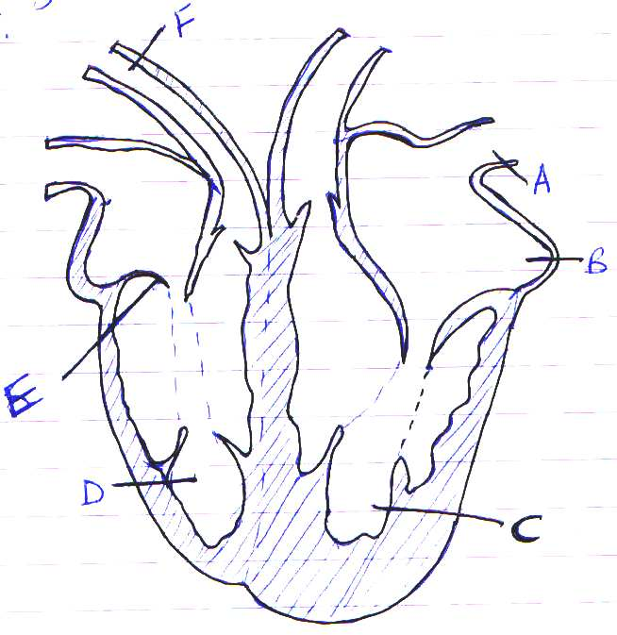

- Name the parts labeled A, B, E, and F (4marks)
A.............................................................................................................................
B.............................................................................................................................
E..............................................................................................................................
F..............................................................................................................................
- Use arrows to show the direction in which blood flows in the heart (2marks)
- Give a reason why the wall of chamber C is thicker than chamber D (2marks)
........................................................................................................................................................................................................................................................................................................................................................................................................................................................................................................................

- What is the difference between Darwinian and Lamarckian theories of evolution (2marks)
.......................................................................................................................................................................................................................................................................................................................................................................................................................................................................................................................................................................................................................................................................................................................................................................................................................................................................
- What is meant by the following terms. Give an example in each case.
- Homologous structures (1mark)
................................................................................................................................................................................................................................................................................................................................................................................................................................................................................................................................................................................................................................................................................................
Example
................................................................................................................................................................................................................................................................................................................................................
- Analogous structures (1mark)
................................................................................................................................................................................................................................................................................................................................................................................................................................................................................................................................................................................................................................................................................................
Example
................................................................................................................................................................................................................................................................................................................................................
- Vestigial structures (1mark)
........................................................................................................................................................................................................................................................................................................................................................................................................................................................................................................................
Example
................................................................................................................................................................................................................................................................................................................................................

SECTION B
Answer question 6(compulsory) in the spaces provided and either question 7 or 8 in the spaces provided after 8.
- During germination and growth of a cereal, the dry weight of endosperm, the embryo and the total dry weight were determined at two day intervals. The results are shown in the table below:
Time after planting (days) | Dry weight of endosperm (mg) | Dry weight of embryo (mg) | Total dry weight (mg)
0 | 43 | 2 | 45
2 | 40 | 2 | 42
4 | 33 | 7 | 40
6 | 20 | 17 | 37
8 | 10 | 25 | 35
10 | 6 | 33 | 39
- Using the same axes, draw graphs of dry weight of endosperm, embryo and the total dry weight against time. (7marks)

- What was the total dry weight on day 5 (1mark)
........................................................................................................................................................................................................................................................................................................................................................................................................................................................................................................................
- Account for
- Decrease in dry weight of endosperm from 0 to 10 (2marks)
........................................................................................................................................................................................................................................................................................................................................................................................................................................................................................................................................................................................................................................................................................................................................................................................................................................................................
- Increase in dry weight of embryo from day 0 to day 10 (2marks)
........................................................................................................................................................................................................................................................................................................................................................................................................................................................................................................................................................................................................................................................................................................................................................................................................................................................................
- Decrease in total dry weight from day 0 to day 8 (1mark)
................................................................................................................................................................................................................................................................................................................................................................................................................................................................................................................................................................................................................................................................................................
- Increase in total dry weight after day 8 (1mark)
................................................................................................................................................................................................................................................................................................................................................................................................................................................................................................................................................................................................................................................................................................
- State two factors within the seed and two outside the seed that cause dormancy
- Within the seed. (2marks)
........................................................................................................................................................................................................................................................................................................................................................................................................................................................................................................................
- Outside the seed (2marks)
........................................................................................................................................................................................................................................................................................................................................................................................................................................................................................................................
- Give two characteristics of meristematic cells (2marks)
................................................................................................................................................................................................................................................................................................................................................................................................................................................................................................................................................................................................................................................................................................
- Describe how the human kidney functions (20marks)
- Explain how abiotic factors affect plants. (20marks)

........................................................................................................................................................................................................................................................................................................................................................................................................................................................................................................................................................................................................................................................................................................................ ........................................................................................................................................................................................................................................................................................................................................................................................................................................................................................................................................................................................................................................................................................................................ ........................................................................................................................................................................................................................................................................................................................................................................................................................................................................................................................................................................................................................................................................................................................ ........................................................................................................................................................................................................................................................................................................................................................................................................................................................................................................................................................................................................................................................................................................................
........................................................................................................................................................................................................................................................................................................................................................................................................................................................................................................................................................................................................................................................................................................................ ........................................................................................................................................................................................................................................................................................................................................................................................................................................................................................................................................................................................................................................................................................................................
........................................................................................................................................................................................................................................................................................................................................................................................................................................................................................................................................................................................................................................................................................................................ ........................................................................................................................................................................................................................................................................................................................................................................................................................................................................................................................................................................................................................................................................................................................
........................................................................................................................................................................................................................................................................................................................................................................................................................................................................................................................................................................................................................................................................................................................ ........................................................................................................................................................................................................................................................................................................................................................................................................................................................................................................................................................................................................................................................................................................................ ........................................................................................................................................................................................................................................................................................................................................................................................................................................................................................................................................................................................................................................................................................................................ ........................................................................................................................................................................................................................................................................................................................................................................................................................................................................................................................................................................................................................................................................................................................ ........................................................................................................................................................................................................................................................................................................................................................................................................................................................................................................................................................................................................................................................................................................................ ........................................................................................................................................................................................................................................................................................................................................................................................................................................................................................................................................................................................................................................................................................................................ ........................................................................................................................................................................................................................................................................................................................................................................................................................................................................................................................................................................................................................................................................................................................ ........................................................................................................................................................................................................................................................................................................................................................................................................................................................................................................................................................................................................................................................................................................................ ........................................................................................................................................................................................................................................................................................................................................................................................................................................................................................................................................................................................................................................................................................................................ ........................................................................................................................................................................................................................................................................................................................................................................................................................................................................................................................................................................................................................................................................................................................ ........................................................................................................................................................................................................................................................................................................................................................................................................................................................................................................................................................................................................................................................................................................................ ........................................................................................................................................................................................................................................................................................................................................................................................................................................................................................................................................................................................................................................................................................................................ ........................................................................................................................................................................................................................................................................................................................................................................................................................................................................................................................................................................................................................................................................................................................ ........................................................................................................................................................................................................................................................................................................................................................................................................................................................................................................................................................................................................................................................................................................................ ........................................................................................................................................................................................................................................................................................................................................................................................................................................................................................................................................................................................................................................................................................................................ ........................................................................................................................................................................................................................................................................................................................................................................................................................................................................................................................................................................................................................................................................................................................ ..........................................................................................................................................................................................................................................................................................................................................................................................................................................................................................................................................

