Name……………………………………………..……….Index No……………….
4431
AGRICULTURE
PARER 1 Candidate’s signature……………
July / Aug2014 Date……………………………..
2 hours

SUBUKIA SUB-COUNTY JOINT ASSESSMENT

INSTRUCTIONS TO CANDIDATES
Write your name and index number in paper provided.
Sign and write the date of examination in the spaces provided above.
This paper consists of three sections A, B & C
Answer all questions in section A and B
Answer any other two questions in section C
Answer to all questions must be written in this booklet.
For examiner’s use only
Section | Question | Maximum score | Candidates Score
A | 1 – 15 | 30
B | 16 – 19 | 20
C | 20 | 20
 | 21 | 20
 | 22 | 20
Total Score |  | 90

SECTION A 30 MARKS
Answer all the question in this section on the spaces provided.
1(a) What is nomadic pastoralism ( ½ mk)
…………………………………………………………………………………………………………………………………………………………………………………………………
(b) State the conditions under which nomadic pastoralism are practicable. ( 1 mk) …………………………………………………………………………………………………………………………………………………………………………………………………
2(a). Differentiate between a weir and a dam as methods of water harvesting ( 1 mk) …………………………………………………………………………………………………………………………………………………………………………………………………
(b) Give two roles of mulching in soil and water conservation. ( 1 mk) ……………………………………………………………………………………………………………………………………………………………………………………………………………………………………………………………………………………………………………………………………………………………………………………………………
3. Outline two deficiency symptoms of calcium in crop production ( 1 mk) …………………………………………………………………………………………………………………………………………………………………………………………………
4. State three practices that are carried out during hardening of kale seedlings in readiness for transplanting ( 1 ½ mk) ……………………………………………………………………………………………………………………………………………………………………………………………………………………………………………………………………………………………………………………………………………………………………………………………………
5. Give four reasons for pruning fruit trees ( 2 mks) ……………………………………………………………………………………………………………………………………………………………………………………………………………………………………………………………………………………………………………………………………………………………………………………………………
6. Outline four main objectives of carrying out land redistribution ( 2 mks) ……………………………………………………………………………………………………………………………………………………………………………………………………………………………………………………………………………………………………………………………………………………………………………………………………
7. State two classifications in each case of weeds on the basis of
(a) Growth cycle ( 1 mk) …………………………………………………………………………………………………………………………………………………………………………………………………

(b) Plant morphology ( 1 mk) …………………………………………………………………………………………………………………………………………………………………………………………………
8. Give two advantages of chemical pest control ( 1 mk) …………………………………………………………………………………………………………………………………………………………………………………………………
9. Outline two main harmful effects of crop diseases ( 1 ½ mks) …………………………………………………………………………………………………………………………………………………………………………………………………
10(a) State four ways that a farmer can apply in order to improve labour productivity ( 2mk) ……………………………………………………………………………………………………………………………………………………………………………………………………………………………………………………………………………………………………………………………………………………………………………………………………
(b) Give four qualities of a good farm manager ( 2 mks) ……………………………………………………………………………………………………………………………………………………………………………………………………………………………………………………………………………………………………………………………………………………………………………………………………
11. State four symptoms of viral infections in plants ( 2 mks) ……………………………………………………………………………………………………………………………………………………………………………………………………………………………………………………………………………………………………………………………………………………………………………………………………
12. Describe briefly four ways by which pests are destructive to crops ( 2 mks) ……………………………………………………………………………………………………………………………………………………………………………………………………………………………………………………………………………………………………………………………………………………………………………………………………
13(a) Outline four method that may be used to control weeds in pastures ( 2 mks) ……………………………………………………………………………………………………………………………………………………………………………………………………………………………………………………………………………………………………………………………………………………………………………………………………
(b) Give three characteristics considered when selecting planting material intended for pasture establishment ( 1 ½ mks) ……………………………………………………………………………………………………………………………………………………………………………………………………………………………………………………………………………………………………………………………………………………………………………………………………

14. State three preparations that should be carried out on store before crop produce is brought in store. ( 1 ½ mks) ……………………………………………………………………………………………………………………………………………………………………………………………………………………………………………………………………………………………………………………………………………………………………………………………………
15. Outline four factors that determines the quality of farm yard manure. ( 2 mk) ……………………………………………………………………………………………………………………………………………………………………………………………………………………………………………………………………………………………………………………………………………………………………………………………………
SECTION B (20 MARKS)
Answer all questions in this section in the spaces provided.
16. The diagram below shows a method that is used in preparation of organic manure
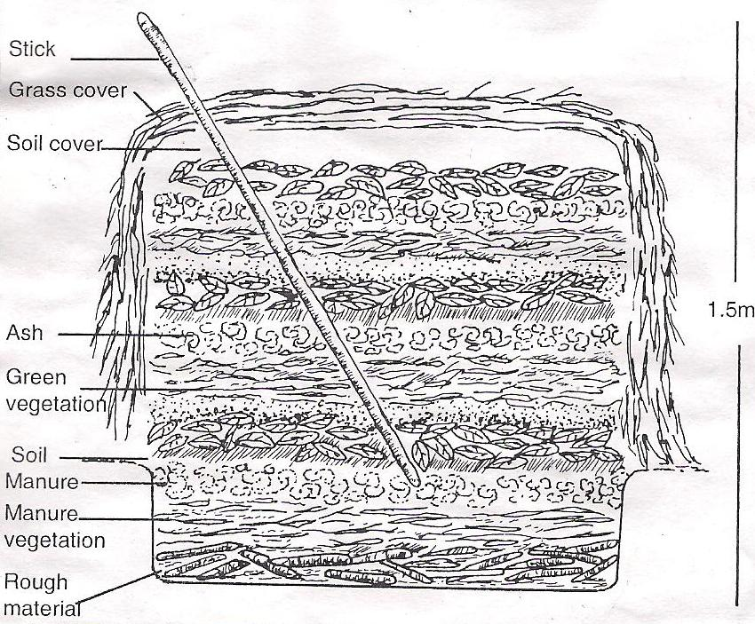

- Name the type of organic manure that s being prepared above ( 1mk)
……………………………………………………………………………………………………………………………………………………………………………………………………………………………………………………………………………………………………
(b)Give one reason in each case for adding the following layers during preparation of the organic manure named in (a) above ( 1mk)
- A thin layer of wood ash ( 1 mk) …………………………………………………………………………………………………………………
- A layer of top soil ( 1 mk)
………………………………………………………………………………...…………….
- Give two main factors that should be considered when selecting the suitable site for the preparation of organic manure ( 2 mks)
……………………………………………………………………………………………………………………………………………………………………………………………………
17.
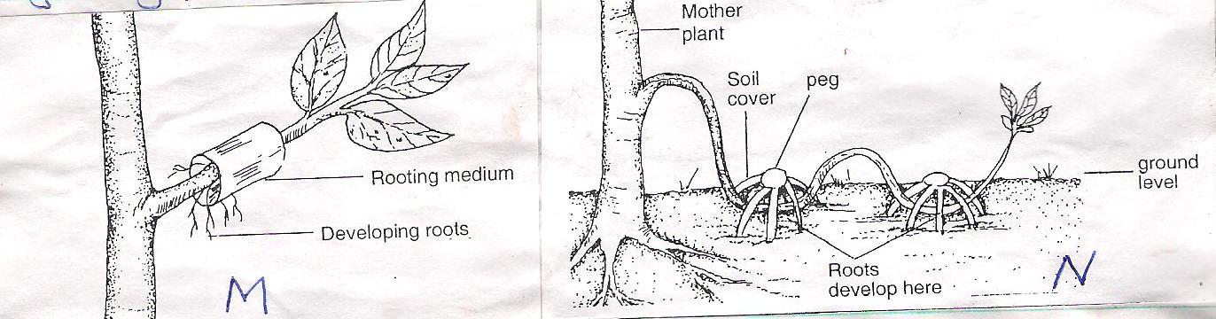

The illustrations below shows the method of layering
- Identify the method of layering illustrated in ( 1 mk)
- M…………………………………………………………………………….
- N…………………………………………………………………………………
- Give two practices or methods that can be used to enhance factor root development in M (2 mks)
………………………………………………………………………………………………………………………………………………………………………………………………………………………………………………………………………………
- Describe procedure followed in order to obtain ready planting material using the method N ( 3 mks)
………………………………………………………………………………………………………………………………………………………………………………………………………………………………………………………………………………
18. Below are the diagrams showing certain types of weeds
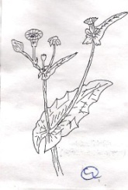
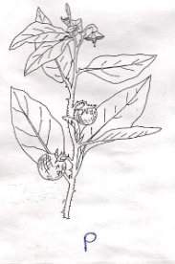

- Identify the weeds labeled P and Q above ( 2 mks)
P…………………………………………………………………………………….
Q…………………………………………………………………………………..
- Give one main disadvantage of the weed labeled P ( 1 mk)
………………………………………………………………………………………………………………………………………………………………………………..
- State two methods that may be used to control weed P in a crop of maize ( 2 mks)
………………………………………………………………………………………………………………………………………………………………………………………………………………………………………………………………………………
19. The graph below is an illustration of a certain economic law in farming business.
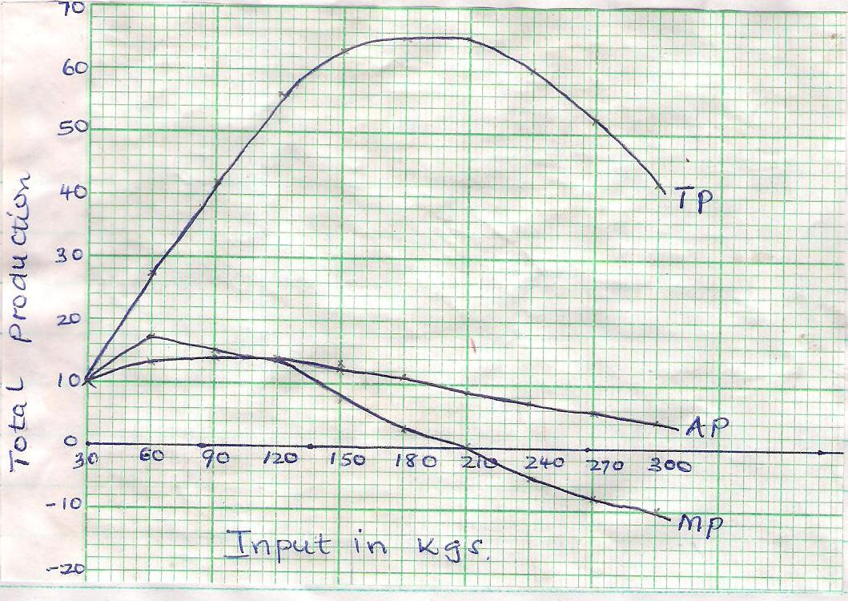
Study it carefully and answer the questions that follow

- Identify the law demonstrated by the graph ( 2 mk)
………………………………………………………………………………………
- State the law depicted by the graph shown above ( 2 mk)
……………………………………………………………………………………………………………………………………………………………………………………………………………………………………………………………………………….
- On the graph, draw a perpendicular lines through
- Where average product and marginal products curves intersect
- Where marginal product equals to zero or where the marginal product intersects the horizontal axis
This divides the graph into three zones. Give two reasons why the farmer should concentrate production in zone two. ( 2 mks)
…………………………………………………………………………………………………………………………………………………………………………………………………………………………………………………………………………………………………….

SECTION C (40 MARKS)
Answer any two questions from this section in the spaces provided after question
20(a) Describe the procedure of harvesting sugarcane ( 5 mks)
(b) Describe seven management practices carried out during establishment of vegetable seedlings ( 7 mks)
(c) Explain four effects of biotic factors that affect agricultural production ( 4 mks)

(d)Outline four agricultural practices that cause water pollution ( 4 mks)

21(a) State and explain how various environmental factors affect selectively and effectiveness of herbicides ( 5 mks)
(b) Describe eight harmful effects of crop pests ( 8 mks)
(c) The following is a farm record kept by Baraka farm as at 31st Dec 2010 study it carefully and answer the questions that follow
KSH
Cash in hand 21000
Cash at bank 65000
Buildings 52000
Disc ploughs 16500
Depts. Received 16000
Working tool 12000
Bank overdraft 24000
Land 81000
Loan 51000
Cattle 40000
Depts. Payable 19500
- Prepare a balance sheet from the above information for Baraka farm ( 6 mks)
- State the benefits of a balance sheet in agricultural production ( 1 mk)

22(a) Describe the productions of beans under the following headlines
- Bean varieties ( 2 mks)
- Selection and preparation of planting materials ( 3 mks)
(b) Describe five management practices that should be out on already established pasture crops ( 5 mks)
(c) Outline various factors that determine crop spacing during planting (6mks)

………………………………………………………………………………………………………………………………………………………………………………………………………………………………………………………………………………………………………………………………………………………………………………………………………………………………………………………………………………………………………………………………………………………………………………………………………………………………………………………………………………………………………………………………………………………………………………………………………………………………………………………………………………………………………………………………………………………………………………………………………………………………………………………………………………………………………………………………………………………………………………………………………………………………………………………………………………………………………………………………………………………………………………………………………………………………………………………………………………………………………………………………………………………………………………………………………………………….……………………………………………………………………………………………………………………………………………………………………………………………………………………………………………………………………………………………………………………………………………………………………………………………………………………………………………………………………………………………………………………………………………………………………………………………………………………………………………………………………………………………………………………………………………………………………………………………………………………………………………………………………………………………………………………………………………………………………………………………………………………………………………………………………………………………………………………………………………………………………………………………………………………………………………………………………………………………………………………………………………………………………………………………………………………………………………………………………………………………………………………………………………………………………………………………………………………………………………….………………………………………………………………………………………………………………………………………………………………………………………………………………………………………………………………………………………………………………………………………………………………………………………………………………………………………………………………………………………………………………………………………………………………………………………………………………………………………………………………………………………………………………………………………………………………………………………………………………………………………………………………………………………………………………………………………………………………………………………………………………………………………………………………………………………………………………………………………………………………………………………………………………………………………………………………………………………………………………………………………………………………………………………………………………………………………………………………………………………………………………………………………………………………………………………………………………………………………….………………………………………………………………………………………………………………………………………………………………………………………………………………………………………………………………………………………………………………………………………………………………………………………………………………………………………………………………………………………………………………………………………………………………………………………………………………………………………………………………………………………………………………………………………………………………………………………………………………………………………………………………………………………………………………………………………………………………………………………………………………………………………………………………………………………………………………………………………………………………………………………………………………………………………………………………………………………………………………………………………………………………………………………………………………………………………………………………………………………………………………………………………………………………………………………………………………………………………….………………………………………………………………………………………………………………………………………………………………………………………………………………………………………………………………………………………………………………………………………………………………………………………………………………………………………………………………………………………………………………………………………………………………………………………………………………………………………………………………………………………………………………………………………………………………………………………………………………………………………………………………………………………………………………………………………………………………………………………………………………………………………………………………………………………………………………………………………………………………………………………………………………………………………………………………………………………………………………………………………………………………………………………………………………………………………………………………………………………………………………………………………………………………………………………………………………………………………….………………………………………………………………………………………………………………………………………………………………………………………………………………………………………………………………………………………………………………………………………………………………………………………………………………………………………………………………………………………………………………………………………………………………………………………………………………………………………………………………………………………………………………………………………………………………………………………………………………………………………………………………………………………………………………………………………………………………………………………………………………………………………………………………………………………………………………………………………………………………………………………………………………………………………………………………………………………………………………………………………………………………………………………………………………………………………………………………………………………………………………………………………………………………………………………………………………………………………….………………………………………………………………………………………………………………………………………………………………………………………………………………………………………………………………………………………………………………………………………………………………………………………………………………………………………………………………………………………………………………………………………………………………………………………………………………………………………………………………………………………………………………………………………………………………………………………………………………………………………………………………………………………………………………………………………………………………………………………………………………………………………………………………………………………………………………………………………………………………………………………………………………………………………………………………………………………………………………………………………………………………………………………………………………………………………………………………………………………………………………………………………………………………………………………………………………………………………….………………………………………………………………………………………………………………………………………………………………………………………………………………………………………………………………………………………………………………………………………………………………………………………………………………………………………………………………………………………………………………………………………………………………………………………………………………………………………………………………………………………………………………………………………………………………………………………………………………………………………………………………………………………………………………………………………………………………………………………………………………………………………………………………………………………………………………………………………………………………………………………………………………………………………………………………………………………………………………………………………………………………………………………………………………………………………………………………………………………………………………………………………………………………………………………………………………………………………….………………………………………………………………………………………………………………………………………………………………………………………………………………………………………………………………………………………………………………………………………………………………………………………………………………………………………………………………………………………………………………………………………………………………………………………………………………………………………………………………………………………………………………………………………………………………………………………………………………………………………………………………………………………………………………………………………………………………………………………………………………………………………………………………………………………………………………………………………………………………………………………………………………………………………………………………………………………………………………………………………………………………………………………………………………………………………………………………………………………………………………………………………………………………………………………………………………………………………….……………………………………………………………………………………………………………………………………………………………………………………………………………………………………………………………………………………………………………………………………………………………………………………………………………………………………………………………………………………………………………………………………………………………………………………………………………………………………………………………………………………………………………………………………………………………………………………………………………………………………………………………………………………………………………………………………………………………………………………………………………………………………

