NAME………………………………………………………………………………………..………. INDEX No……………………../………
ADM………….….…..…………..
Student’s signature………………………………
Date………………………………
443/2
AGRICULTURE PAPER 2
Paper 2
(THEORY)
JULY/AUGUST 2014
2 Hours
SUBUKIA DISTRICT JOINT EXAMINATION
KENYA EXAMINATION OF SECONDARY EDUCATION (K.C.S.E)
INSTRUCTIONS TO CANDIDATES
- Write your NAME, INDEX NUMBER and ADM NUMBER in the spaces provided above.
- Sign and write the date of examination in the spaces provided above.
- This paper consists of three sections: A, B and C.
- Answer ALL questions in sections A and B.
- Answer any two questions in Section C.
- Answers to all questions must be in the spaces provided.
- This paper consists of eleven (11) printed pages.
- Candidates should check the question paper to ascertain that all the pages are printed as indicated and that no questions are missing

For examiner’s use only
Section | Question | Maximum score | Candidates Score
A | 1 - 18 | 30
B | 19 – 22 | 20
C | 23 | 20
 | 24 | 20
 | 25 | 20
Total Score |  | 90

SECTION A (30MARKS)
Answer all questions from this section in the spaces provided
1. State the common faults in the operation of Knapsack spray (2mks)
………………………………………………………………………………………………………………………………………………………………………………………………………………………………………………………………………………………………………………………………
2. List three methods of stocking a beehive with honey bee (1 ½ mks)
…………………………………………………………………………………………………………………………………………………………………………………………………………………………………………………………………………………………………………………………………………………………………………………………………………………………………………………………………………………….
3. Give four features of a good laying nest (2mks)
………………………………………………………………………………………………………………………………………………………………………………………………………………………………………………………………………………………………………………………………………………………………………………………………………………………………………………………………………………………………………………………………………………………………………………………………………………………………………………………………………
4. State four reasons for feeding Colostrums to calves immediately after calving (2mks)
……………………………………………………………………………………………………………………………………………………………………………………………………………………………………………………………………………………………………………………………………………………………………………………………………………………………………………………………………………………………………………………………………………………………………………………………………………………………………………………………………..
5. Name the role of the following parts of a mould board plough (1½ mks)
a) Share .……………………………………………………………………………………………………………………………………………………….
b) Mouldboard
……………………………………………………………………………………………………………………………………
c) Land side
…………………………………………………………………………………………………………………………………......
6 .Give three ideal conformation features of beef cattle (1½ mks)
………………………………………………………………………………………………………………………………………………………………………………………………………………………………………………………………………………………………………………………………………………………………………………………………………………………………………………………………………………………………………
7. Apart from high batter fat content, give two other good qualities of Jersey breed over Friesian breed. (1mk)
……………………………………………………………………………………………………..
8. State four factors that influence rate of respiration in farm animals (2mks)
……………………………………………………………………………………………………………………………………………………………………………………………………………………………………………………………………………………………………………………………………………………………………………………………………………………………………………………………………………………………………………………………………………………………………………………………………………………………………………………………………..
9. List four factors considered when formulating a livestock ration. (2mks)
…………………………………………………………………………………………………………………………………………………………………………………………………………………………………………………………………………………………………………………………………………………………………………………………………………………………………………………………………………………………………………………………………………………………………………………………………………………………………………………………………….. 10. Give four microbial activities that take place in the Rumen of a cow. (2 marks)
……………………………………………………………………………………………………………………………………………………………………………………………………………………………………………………………………………………………………………………………………………………………………………………………………………………………………………………………………………………………………………………………………………………………………………………………………………………………………………………………………….... 11.Give two functions of drones in a bee colony (1mk) …………………………………………………………………………………………………………………………………………………………………………………………………………………………………………………………………………………………………………………………………....
12. Give three problems associated with lambing. (1 ½ mks) …………………………………………………………………………………………………………………………………………………………………………………………………………………………………………………………………………………………………………………………………………………………………………………………………………………………………………………………………………………………………....
13. Differentiate between strategic and tactical treatment as used in control of endo parasites. (2mks) …………………………………………………………………………………………………………………………………………………………………………………………………………………………………………………………………………………………………………………………………………………………………………………………………………………………………………………………………………………………………....
14. Outline four management practices a farmer should undertake to ensure maximum number of fish is harvested from a fish pond. (2 marks)
………………………………………………………………………………………………………………………………………………………………………………………………………………………………………………………………………………………………………..
15. State any four characteristics of the landrace breed of pigs (2mks)
………………………………………………………………………………………………………………………………………………………………………………………………………………………………………………………………………………………………………………………………………………………………………………………………………………………………………………………………………………………………………………………………………………………………………………………………………………………………………………………………….
16. Give one hormones that influence milk let down (½ mk)
……………………………………………………………………………………………………………………………………………………………..
17. List four factors that may lead to culling in dairy cattle (2mks)
………………………………………………………………………………………………………………………………………………………………………………………………………………………………………………………………………………………………………………………………………………………………………………………………………………………………………………………………………………………………………………………………………………………………………………………………………………………………………………………………………….18. List four causes of overheating in an engine (2mks) ………………………………………………………………………………………………………………………………………………………………………………………………………………………………………………………………………………………………………………………………………………………………………………………………………………………………………………………………………………………………………………………………………………………………………………………………………………………………………………………………………….
Section B (20 Marks)
Answer all the questions from this section.
- The diagrams below represent tools used in the farm.
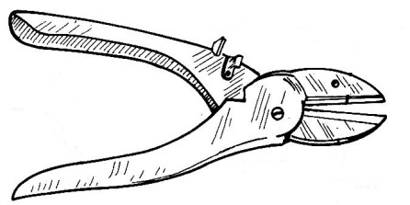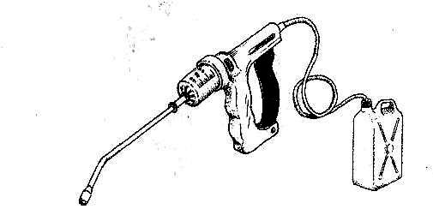
Diagram 1 Diagram 2
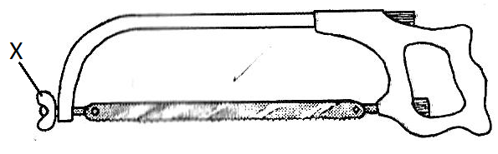
Diagram 3
- Identify the tool represented by diagrams 1, 2 and 3. (1½ mks)
Diagram 1
……………………………………………………………………………………………………………………………………………………..
Diagram 2
……………………………………………………………………………………………………………………………………………………..
Diagram 3
……………………………………………………………………………………………………………………………………………………..
- State the uses of the tools represented by diagrams 1 and 2. (2 mks)
Diagram 1
……………………………………………………………………………………………………………………………………………………..
Diagram 2
……………………………………………………………………………………………………………………………………………………..
- Identify the part labeled X in the tool represented by diagram 3. (1 mk)
……………………………………………………………………………………………………………………………………………………..
20.The picture below represents a pig breed.
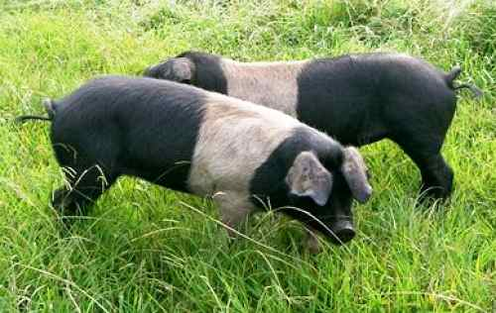
- Identify the pig breed. (½ mk)
……………………………………………………………………………………………………………………………………………………..
- Give a reason for your answer in (a) above. (1 mk)
……………………………………………………………………………………………………………………………………………………..
- Name two pig breeds kept for bacon production. (2 mks)
……………………………………………………………………………………………………………………………………………………..
……………………………………………………………………………………………………………………………………………………..
- Differentiate between a lig and gilt in pig production. (2 mks)
Lig
……………………………………………………………………………………………………………………………………………………..
Gilt
……………………………………………………………………………………………………………………………………………………..
21.The diagrams below represent tractor drawn implements.
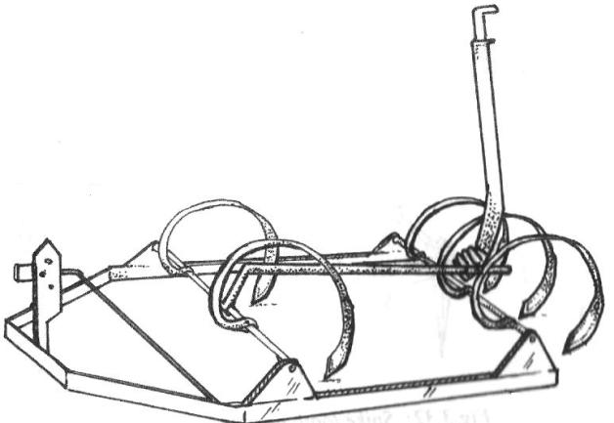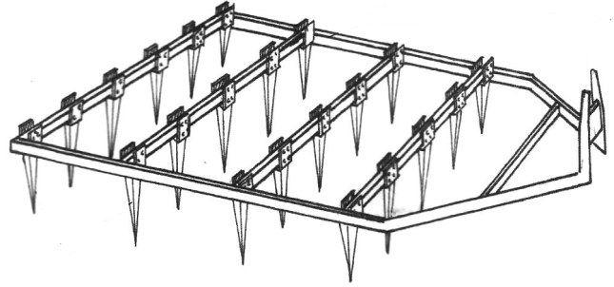
Diagram 4 Diagram 5
- Identify the implement represented by diagrams 4 and 5. (1 mk)
Diagram 4
……………………………………………………………………………………………………………………………………………………..
Diagram 5
……………………………………………………………………………………………………………………………………………………..
- State three functions of the implement represented by diagram 4. (2 mks)
……………………………………………………………………………………………………………………………………………………..
……………………………………………………………………………………………………………………………………………………..
……………………………………………………………………………………………………………………………………………………..
- State two maintenance practices that should be carried out on the implement represented by diagram 5. (2 mks)
……………………………………………………………………………………………………………………………………………………..
……………………………………………………………………………………………………………………………………………………..
22.The diagram below represents part of a fence.
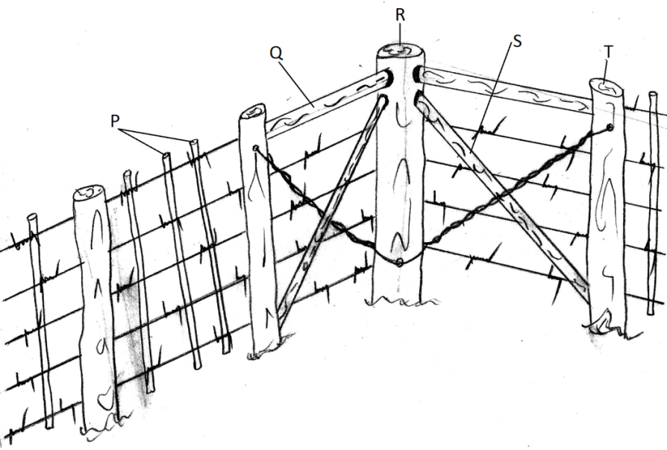S
Diagram 6
- Name the parts labeled P, R, S and T. (2 mks)
P
……………………………………………………………………………………………………………………………………………………..
R
……………………………………………………………………………………………………………………………………………………..
S
……………………………………………………………………………………………………………………………………………………..
T
……………………………………………………………………………………………………………………………………………………..
- State two advantages of using plain wire fence over barbed wire fence. (2 mks)
………………………………………………………………………………………………………………………………………………………………………………………………………………………………………………………………………………………………………..
- State the use of the following tools during fencing:
- Ramming rod. (½ mk)
………………………………………………………………………………………………………………………………………………
- Claw bar. (½ mk)
………………………………………………………………………………………………………………………………………………
Section C (40 Marks)
Answer any two questions from this section.
- (a) Discuss mastitis under the following subheadings
- Animals affected. (1 mk)
- Predisposing factors. (5 mks)
- Symptoms. (3 mks)
- Control. (3 mks)
(b) Discuss the factors to consider when selecting piglets to act as the breeding stock. (8 mks)
- (a) Discuss the structural differences between a petrol engine and a diesel engine. (5 mks)
(b) Highlight the disadvantages of animal drawn implements over tractor drawn implements.
(6 mks)
(c) Discuss the routine management practices carried out on calves. (5 mks)
(d) Discuss the functions of the worker bee. (4 mks)
- (a) Discuss the symptoms of liver fluke infestation in sheep. (7mks)
(b) Discuss the causes of stress in poultry. (7mks)
(c) Discuss the factors that determine water requirements in livestock animals. (6 mks)
………………………………………………………………………………………………………………………………………………………………………………………………………………………………………………………………………………………………………………………………………………………………………………………………………………………………………………………………………………………………………………………………………………………………………………………………………………………………………………………………………………………………………………………………………………………………………………………………………………………………………………………………………………………………………………………………………………………………………………………………………………………………………………………………………………………………………………………………………………………………………………………………………………………………………………………………………………………………………………………………………………………………………………………………………………………………………………………………………………………………………………………………………………………………………………………………………………………………………………………………………………………………………………………………………………………………………………………………………………………………………………………………………………………………………………………………………………………………………………………………………………………………………………………………………………………………………………………………………………………………………………………………………………………………………………………………………………………………………………………………………………………………………………………………………………………………………………………………………………………………………………………………………………………………………………………………………………………………………………………………………………………………………………………………………………………………………………………………………………………………………………………………………………………………………………………………………………………………………………………………………………………………………………………………………………………………………………………………………………………………………………………………………………………………………………………………………………………………………………………………………………………………………………………………………………………………………………………………………………………………………………………………………………………………………………………………………………………………………………………………………………………………………………………………………………………………………………………………………………………………………………………………………………………………………………………………………………………………………………………………………………………………………………………………………………………………………………………………………………………………………………………………………………………………………………………………………………………………………………………………………………………………………………………………………………………………………………………………………………………………………………………………………………………………………………………………………………………………………………………………………………………………………………………………………………………………………………………………………………………………………………………………………………………………………………………………………………………………………………………………………………………………………………………………………………………………………………………………………………………………………………………………………………………………………………………………………………………………………………………………………………………………………………………………………………………………………………………………………………………………………………………………………………………………………………………………………………………………………………………………………………………………………………………………………………………………………………………………………………………………………………………………………………………………………………………………………………………………………………………………………………………………………………………………………………………………………………………………………………………………………………………………………………………………………………………………………………………………………………………………………………………………………………………………………………………………………………………………………………………………………………………………………………………………………………………………………………………………………………………………………………………………………………………………………………………………………………………………………………………………………………………………………………………………………………………………………………………………………………………………………………………………………………………………………………………………………………………………………………………………………………………………………………………………………………………………………………………………………………………………………………………………………………………………………………………………………………………………………………………………………………………………………………………………………………………………………………………………………………………………………………………………………………………………………………………………………………………………………………………………………………………………………………………………………………………………………………………………………………………………………………………………………………………………………………………………………………………………………………………………………………………………………………………………………………………………………………………………………………………………………………………………………………………………………………………………………………………………………………………………………………………………………………………………………………………………………………………………………………………………………………………………………………………………………………………………………………………………………………………………………………………………………………………………………………………………………………………………………………………………………………………………………………………………………………………………………………………………………………………………………………………………………………………………………………………………………………………………………………………………………………………………………………………………………………………………………………………………………………………………………………………………………………………………………………………………………………………………………………………………………………………………………………………………………………………………………………………………………………………………………………………………………………………………………………………………………………………………………………………………………………………………………………………………………………………………………………………………………………………………………………………………………………………………………………………………………………………………………………………………………………………………………………………………………………………………………………………………………………………………………………………………………………………………………………………………………………………………………………………………………………………………………………………………………………………………………………………………………………………………………………………………………………………………………………………………………………………………………………………………………………………………………………………………………………………………………………………………………………………………………………………………………………………………………………………………………………………………………………………………………………………………………………………………………………………………………………………………………………………………………………………………………………………………………………………………………………………………………………………………………………………………………………………………………………………………………………………………………………………………………………………………………………………………………………………………………………………………………………………………………………………………………………………………………………………………………………………………………………………………………………………………………………………………………………………………………………………………………………………………………………………………………………………………………………………………………………………………………………………………………………………………………………………………………………………………………………………………………………………………………………………………………………………………………………………………………………………………………………………………………………………………………………………………………………………………………………………………………………………………………………………………………………………………………………………………………………………………………………………………………………………………………………………………………………………………………………………………………………………………………………………………………………………………………………………………………………………………………………………………………………………………………………………………………………………………………………………………………………………………………………………………………………………………………………………………………………………………………………………………………………………………………………………………………………………………………………………………………………………………………………………………………………………………………………………………………………………………………………………………………………………………………………………………………………………………………………………………………………………………………………………………………………………………………………………………………………………………………………………………………………………………………………………………………………………………………………………………………………………………………………………………………………………………………………………………………………………………………………………………………………………………………………………………………………………………………………………………………………………………………………………………………………………………………………………………………………………………………………………………………………………………………………………………………………………………………………………………………………………………………………………………………………………………………………………………………………………………………………………………………………………………………………………………………………………………………………………………………………………………………………………………………………………………………………………………………………………………………………………………………………………………………………………………………………………………………………………………………………………………………………………………………………………………………………………………………………………………………………………………………………………………………………………………………………………………………………………………………………………………………………………………………………………………………………………………………………………………………………………………………………………………………………………………………………………………………………………………………………………………………………………………………………………………………………………………………………………………………………………………………………………………………………………………………………………………………………………………………………………………………………………………………………………………………………………………………………………………………………………………………………………………………………………………………………………………………………………………………………………………………………………………………………………………………………………………………………………………………………………………………………………………………………………………………………………………………………………………………………………………………………………………………………………………………………………………………………………………………………………………………………………………………………………………………………………………………………………………………………………………………………………………………………………………………………………………………………………………………………………………………………………………………………………………………………………………………………………………………………………………………………………………………………………………………………………………………………………………………………………………………………………………………………………………………………………………………………………………………………………………………………………………………………………………………………………………………………………………………

