Name……………………………………………………………. Index No……………………………..
School…………………………………………………………… Candidate’s sign…………………….
Date………………………………….
231/1
BIOLOGY
PAPER 1
THEORY
July/August 2014
2 HOURS
SUBUKIA SUB-COUNTY JOINT EVALUATION EXAMINATION– 2014
Kenya Certificate of Secondary Education (K.C.S.E)
INSTRUCTIONS TO CANDIDATES
1. Write your name and index number in the spaces provided above
2. Sign and write the date of examination in the spaces provided above.
3. Answer ALL the Questions in this paper in the spaces provided.
FOR EXAMINER’S USE ONLY
QUESTIONS | MAXIMUM SCORE | CANDIDATE’S SCORE
1 – 24 | 80
TOTAL SCORE | 80

This paper consists of 9 printed pages. Candidates should check carefully to ascertain that all the pages are printed as indicated and no questions are missing.

1 .a)Distinguish between growth and development in living organism. (2mks)
………………………………………………………………………………………………………………………………………………………………………………………………………………………………………………………………………………………………………………………………………………………………………………………………………………………………………………………………………………………………………
2.(a)State the reason why scientific names are given in Latin. (1mk)
……………………………………………………………………………………………………………………………………………………
(b) The length of a beetle is 2cm, when the beetle is magnified using a hand lens the length of the drawing is 6 cm workout the magnification. (2mks)
……………………………………………………………………………………………………………………………………………………………………………………………………………………………………………………………………………………………………………………………………………………………………………………………………………………………………………………………………………………………………..
3. (a) Highlights two similarities between mitosis and meiosis. (2mk)
…………………………………………………………………………………………………………………………………………………………………………………………………………………………………………………………………………………………………………………………………..
(b) Study the diagram below and answer the questions that follow
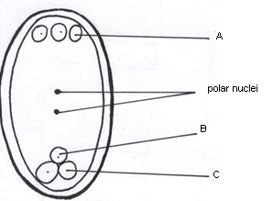

Name the parts labeled A, B and C (3mks)
A………………………………………………….
B…………………………………………………..
C……………………………………………………

(c) What does the part B form after fertilization (1mk)
……………………………………………………………………………………………………………………………………………………
4(a) Highlight the importance of the respiratory surface being:
Thin………………………………………………………………………………………………………………………….. (1mk)

Moist………………………………………………………………………………………………………………………… (1mk)

- State three adaptations of gills to their function. (3mks)
……………………………………………………………………………………………………………………………………………………
…………………………………………………………………………………………………………………………………………………….
…………………………………………………………………………………………………………………………………………………….

- State how a guard cell is adapted to its function. (1mk)
………………………………………………………………………………………………………………………………………………………
………………………………………………………………………………………………………………………………………………………

5.(a) Distinguish between hypertonic and hypotonic solutions. (2mks)
…………………………………………………………………………………………………………………………………………………..
………………………………………………………………………………………………………………………………………………….
…………………………………………………………………………………………………………………………………………………..
(b) How is the rate of diffusion affected by:
(i) Temperature………………………………………………………………………………………………………………………………. (1mk)
(ii) Concentration………………………………………………………………………………………………………………………….. (1mk)
(iii) Surface area to volume ratio…………………………………………………………………………………………………….. (1mk)

6. Distinguish between analogous and homologous structures. (2mks) ……………………………………………………………………………………………………………………………………………………….
………………………………………………………………………………………………………………………………………………………
……………………………………………………………………………………………………………………………………………………..
……………………………………………………………………………………………………………………………………………………..
7.The scheme below shows two inter-related process A and B that occur in the same cell.
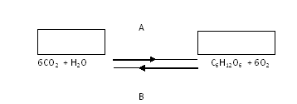
a) Identify process A and B (2mks)
A …………………………………………………………………………………
B …………………………………………………………………………………
b) From the diagram, state two differences between process A and B. (2mks)
…………………………………………………………………………………………………………………………………………………………………
………………………………………………………………………………………………………………………………………………………………..
………………………………………………………………………………………………………………………………………………………………..
8. Name the part of the brain responsible for:- (3mks)
- Maintaining balance of the body.
…………………………………………………………………………………………………………………………………………
- Thermoregulation and osmoregulation.
…………………………………………………………………………………………………………………………………………
- Sensation of pain, touch and sight.
…………………………………………………………………………………………………………………………………………

9. A group of form two students set up an experiment as shown below.
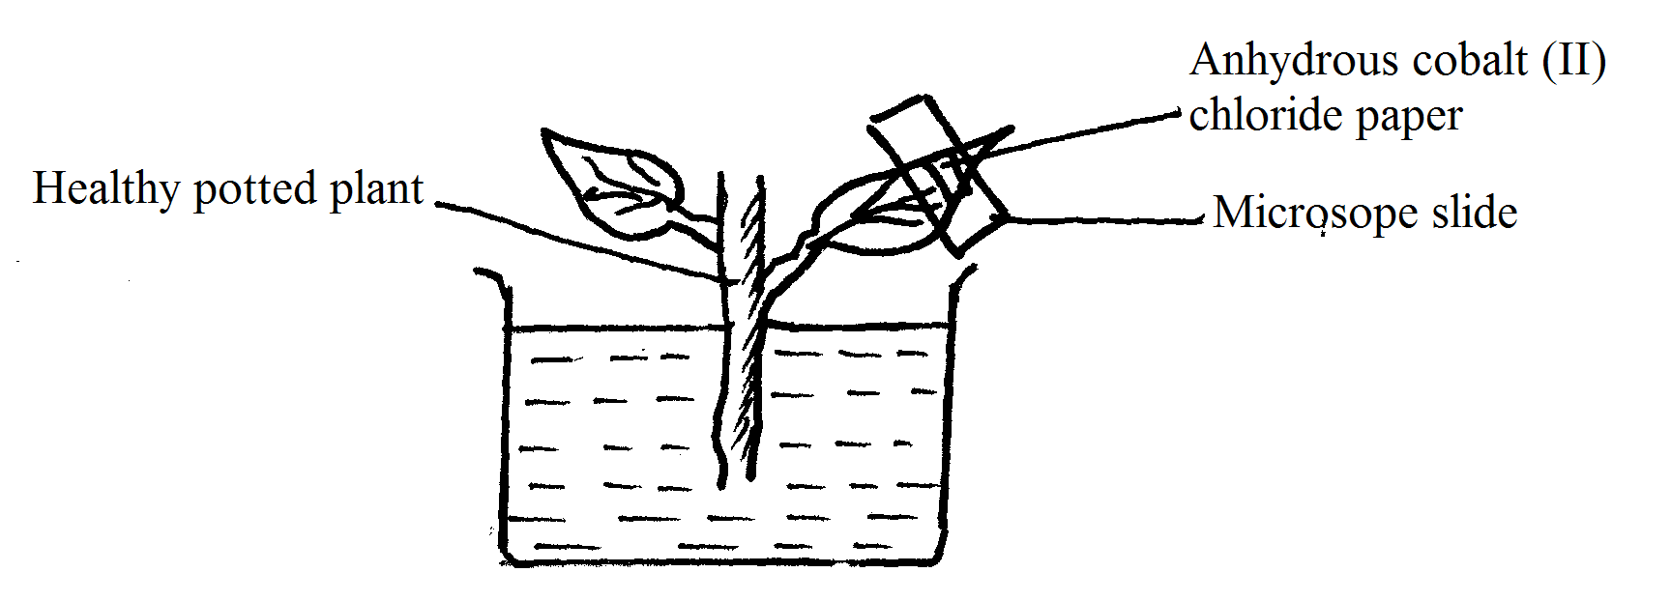
a) i) Which are the expected observable results. (1mk)
…………………………………………………………………………………………………………………………………….
ii) Explain your answer in a (i) above. (1mk)
……………………………………………………………………………………………………………………………………..
b) Suggest a control for this experimental set up. (1mk)
……………………………………………………………………………………………………………………………………
10.) The diagram below shows a vertical section through a mammalian heart
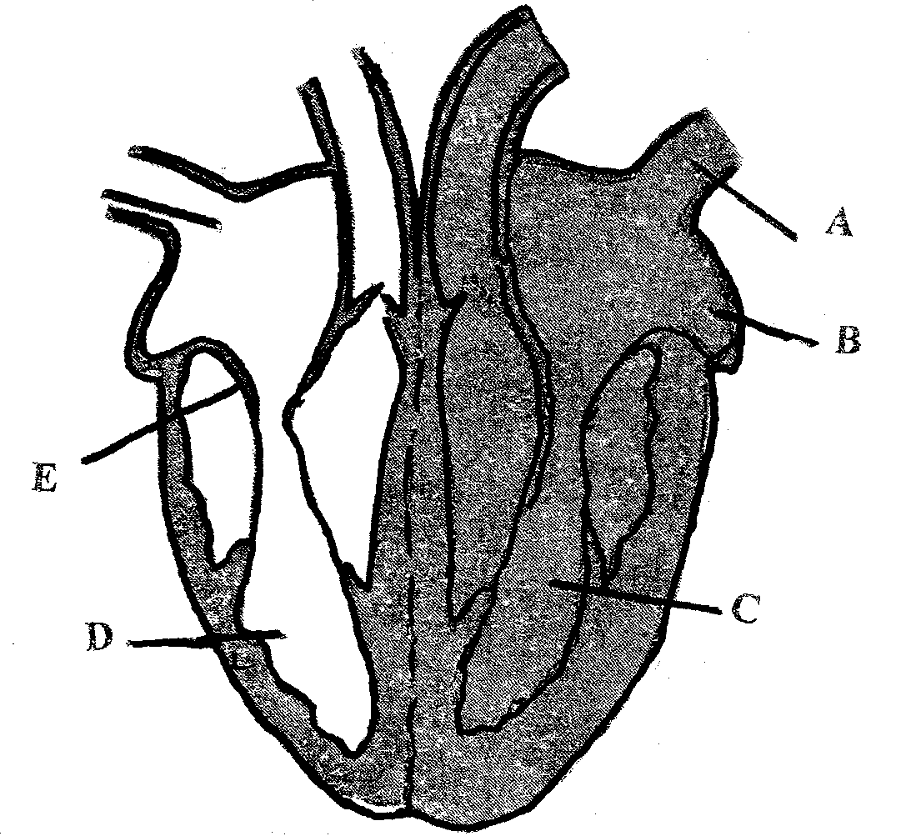

i) Name the parts labeled A and B (2mks)
A ………………………………………………………………………………………….
B …………………………………………………………………………………………..
ii) Give a reason why the wall of chamber C is thicker than chamber D. (2mks)
……………………………………………………………………………………………………………………………………………………….
…………………………………………………………………………………………………………………………………………………………

11a) The diagram below shows part of alimentary canal of a mammal.

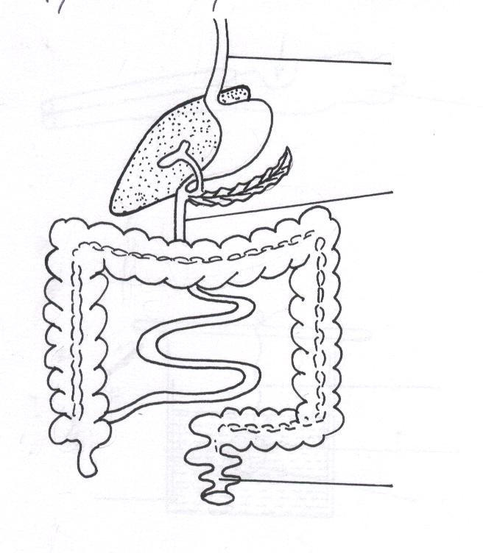
B
A
C
(i)Name the parts labeled.
A……………………………………………. (1 mk)
C……………………………………………. (1 mk)
(ii) State the function of the part labeled B. (1 mk)
………………………………………………………………………………………………………………………………………………………………
b) Why is xylem tissue referred to as a mechanical tissue in plants (1mk)
………………………………………………………………………………………………………………………………………………………………

12. A patient was given a drug which caused afferent arteriole entering the glomerulus to dilate while efferent arteriole constricted. Explain the effect the drug had to the amount of urine produced. (3 mks)
………………………………………………………………………………………………………………………………………………………………………
………………………………………………………………………………………………………………………………………………………………………
………………………………………………………………………………………………………………………………………………………………………
13 a) What is homeostasis? (1mk)
………………………………………………………………………………………………………………………………………………….
(b) Name three processes in the human body in which homeostasis is involved. (3mks)
i)…………………………………………………………
ii)………………………………………………………..
iii)………………………………………………………….
14.a) Name two divisions in the kingdom plantae that show alternation of generation . (2mks)
i)......................................................................................................
ii)………………………………………………………………………………………………………
(b)Name the phylum whose member possesses a notochord. (1mk)
.......................................................................................................
15a) State three reasons why biomass decreases as you move from a lower to a higher tropic level. (3mks) i)…………………………………………………………………………………………………………………………………………………..
ii)…………………………………………………………………………………………………………………………………………………..
iii)……….…………………………………………………………………………………………………………………………………………
b) List two external features that distinguish members of class mammalian from other classes. (2mks)
i) ……………………………………………………………………………………………………………………………………………….
ii)…………………………………………………………………………………………………………………………………………………

16 .State the adaptation of olecranon process to its function. (2mks)
……………………………………………………………………………………………………………………………………………………………………
……………………………………………………………………………………………………………………………………………………………………

17. Which type of joint is found at the articulation of?
(i) Pelvic girdle and femur (1mk)
…………………………………………………………………………………………………………………………………………………….
18. Name the organelle that:-
a) Manufacture and transport lipids and steroids in a cell. (1mk)
………………………………………………………………………………………………………………………………………………………
b) Contain enzymes that are capable of destroying old damaged cells. (1mk)
………………………………………………………………………………………………………………………………………………………
c) Control all the processes in a cell. (1mk)
………………………………………………………………………………………………………………………………………………………….
d) Form cilia and flagella in cells that have them. (1mk)
..............................................................................................................................................................
19. State two differences between bryophytes and pteridophytes (2mks)
…………………………………………………………………………………………………………………………………………………………………………………………………………………………………………………………………………………………………………………………………………………………
20. List three applications of genetics. (3mks)
i)…………………………………………………………………………………………………………………………………………………………………………
ii)…………………………………………………………………………………………………………………………………………………………………………
iii)………………………………………………………………………………………………………………………………………………………………………

21. State three causes of variation in living things. (3mks)
i)……………………………………………………………………………………………………………………………………………………………………
ii)……………………………………………………………………………………………………………………………………………………………………
iii)……………………………………………………………………………………………………………………………………………………………………
22. State the significance of sunken stomata in plants. (2mks)
………………………………………………………………………………………………………………………………………………………………………
……………………………………………………………………………………………………………………………………………………………………….
……………………………………………………………………………………………………………………………………………………………………..
23. Highlight three importance of transpiration in plants. (3mks)
i)…………………………………………………………………………………………………………………………………………………………………………
ii)…………………………………………………………………………………………………………………………………………………………………………
iii)…………………………………………………………………………………………………………………………………………………………………………
24. State three differences between male and female gametes . (3mks)
i)…………………………………………………………………………………………………………………………………………………………………………
ii)…………………………………………………………………………………………………………………………………………………………………………
iii)………………………………………………………………………………………………………………………………………………….....................

