NAME…………………………………………………………………………. ………….. INDEX NO:………………….
CANDIDATE’S SIGNATURE:………………………………… DATE………………………...
233/1
CHEMISTRY
THEORY
Paper 1
JULY/AUG. 2014
Time: 2 HRS
SUBUKIA SUB-COUNTY JOINT ASSESSEMENT 2O14
Kenya Certificate of Secondary Education (K.C.S.E)

INSTRUCTIONS TO CANDIDATES

- Write your Name, School and Index No. in the spaces provided.
- Sign and write the date of examination in the spaces provided.
- Answer ALL the questions in the spaces provided.
- Mathematical tables and electronic calculators may be used.
- All working must be clearly shown where necessary.

EXAMINERS USE ONLY
QUESTION | MAXIMUM SCORE | CANDIDATES SCORE
1-29 | 80
Total | 80

This paper consists of 11 printed pages. Candidates should check the question paper to ensure that all pages are printed as indicated and no questions are missing

- The diagram below shows the physical state of matter

S
R V
SOLID
GAS
LIQUID
U W
T

- Name the processes represented by letters
- R
- V
- T
- S (2mks)
- Name two substances which undergo process T.
- ___________________________________
- ___________________________________ (1mk)

- A certain liquid is suspected to be water. Describe three methods that could be used to show that the liquid is water
- ……………………………………………………………………………. (1mk)

- …………………………………………………………………………… (1mk)

- ……………………………………………………………………………. (1mk)

- Complete the following table to show the colour of the following indicators in acidic and basic solution (3mks)

indicator | Colour in
 | Acidic solution | Basic solution
Phenolphthalein
Methyl orange
Litmus solution

4.Sodium chloride was contaminated with copper (II) Oxide. How could pure crystals of sodium chloride be obtained. (3mks)

5. (i)Name Chemical substances used in preparation of Carbon (ii) Oxide (1MK)
i) (a)

(b)

(II) Write the equation for the reaction (1mk)

- What precaution should be taken when carrying out the experiment
Precaution ($\frac{1}{2} mk)$

Reason ( $\frac{1}{2} mk)$

6.Using dot(.) and cross (x) to represent electrons, draw diagrams to show bonding in
- CO (1mk)

- CO₂ (1mk)

- NH₄⁺ (1mks)

7. (i) What is an electrolyte ? (1mk)

(ii) Explain how the following substances conduct electricity
- Molten calcium chloride (1mk)

- Graphite (1mk)

- Study the standard potential given below and answer the questions that follow. (letters do not represent actual symbols of elements)
M ²⁺_{(aq)} + 2e⁻ M_{(s)} -0.76v
N²⁺_{(aq)} +2 e⁻ N_{(s)} -2.37v
P⁺_{(aq)} + e⁻ P _{(s)} +0.80v
Q ²⁺⁽aq) + 2e⁻ Q_{(s)} -0.14v
- E^{ѳ} for Fe ²⁺ is -0.44v. Select the element that would best protect Iron from rusting (1mk)

- Calculate the EѲ value for the cell
M(s)/M²⁺(aq)//P⁺(aq) / P(s) (2mks)

9. The first step in the industrial manufacturing of nitric acid is the catalytic oxidation of ammonia gas
- What is the name of the catalyst used (1mk)

- Write chemical equation of the catalytic oxidation of ammonia gas (1mk)

- Nitric acid is used in making ammonium nitrate.
State two uses of ammonium nitrate.

- ……………………………………

(ii)…………………………………… (1mk)

- (a) In an experiment, 375cm³ of gas P has a pressure of 800mmHg. What will be its volume if pressure is reduced to 720 mmHg. (2mk)

- State the gas law related to question 10(a) above. (1mk)

11. In an experiment to determine the percentage of purity of a sample of sodium carbonate produced in the Solvay process, 2.15g of sample reacted completely with 40.0 cm³ of 0.5M sulphuric (IV) acid.
- Determine the percentage of moles of sodium carbonate that reacted (2mks)

- Determine the percentage of sodium carbonate in the sample
(Na = 23.0; C=12.0; O = 16.0)

12. The table below shows the relative atomic masses and the percentages abundance of the isotopes K₁ and K₂ of the element K

isotope | Relative atomic mass | % abundance
K 1 | 62.93 | 69.09
K2 | 64.93 | 30.91

- What is an isotope (1MK)

- Calculate the relative atomic mass of element K. (1mk)

13(a) Distinguish between a strong acid and a concentrated acid.
- Strong acid

- Concentrated acid (1mk)

- To dissolve hydrogen chloride gas in water, the following set-up is used:
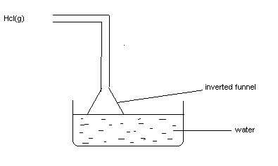

(i)Explain why an inverted funnel is used. (1mk)

ii) Litmus paper was dipped in the resulting solution (in b above) (1mk)
a) What is the observation?

b) Using the equations explain the observation (2mks)

- Sulphur exists in two crystalline forms.
- What is the meaning of crystalline (1/2 mk)

- Name the one form of sulphur (1/2 mk)

- State two uses of sulphur

- ………………………………………………… (1/2mk)

- …………………………………………………. (1/2mk)

- Y gms of Potassium hydroxide were dissolved in distilled water to make 100 cm³ of solution. 50cm³ of the solution required 50cm³ of 2M Nitric acid for complete neutralization.
Calculate:
- Moles of nitric acid (1/2 mk)

- Moles of potassium hydroxide in 50cm³ (1/2 mk)

- Moles of potassium hydroxide in 100cm³ (1/2 mk)

- Mass of x (1/2 mk)

- During athletics competition urine samples of five runners were taken and tested for banned substances steroids by paper chromatography. Methanol was used as the solvent. The chromatogram was as shown below
X
B
X
2
X
1
X
3
X
5
X
4
X
A
A
KEY
SPOT A—STEROID A
SPOT B— STEROID B
SPOT 1— Athlete 1
SPOT 2— Athlete 2
SPOT 3— Athlete 3
SPOT 4— Athlete 4
SPOT 5— Athlete 5

- Which of the two steroids is most likely to be more soluble in methanol (1mk)

- Identify the athletes that tested positive for banned substances (2mks)

- Sulphur is extracted by FRASCH PROCESS.
What is the function of:
i)Super heated water at 170⁰c (1mk)

ii) Explain how it is possible to obtain water at temperature of 170⁰c. (2mks)

i) 100 gm of radioactive ${}_{91}^{233}{Pa }$was reduced to 12.5 g after 81 days.
- Determine the half life of Pa (1mk)

- ²³³ Pa decays by beta particles emissions. What is the mass number and atomic
⁹¹
number of the element formed?
- Mass number (1mk)

- Atomic number (1mk)

- State what would be observed if concentrated sulphuric (VI)acid is added to;
- Dry sugar crystals (1mk)

- Hydrated copper(II) sulphate crystals (1mk)

- What type of reaction has taken place? (1mk)

- a) What is a fuel? (1mk)

b) State two factors to consider while choosing a fuel (1mk)
i)

ii)

- The gases X and Y have relative densities of 1.98 and 2.90 respectively. They diffuse under the same conditions.
a) How do their rate of diffusion compare? (1mk)

b) Determine the relative molecular mass of X given the relative molecular mass of Y = 64 (2mks)

22.(i) Draw the structure of methanoic acid (1mk)

(ii) What is the total number of electrons used for bonding in a molecule of methanoic acid (1mk)

iii)Explain how you arrive at the answer in (ii) above (1mk)

- In preparation of chlorine , the following set – up was used.
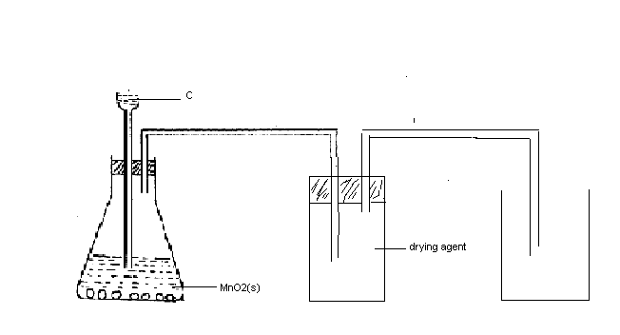

- Name;
- Substance C (1mk)

- A suitable drying agent (1mk)

- What property makes the gas collected using the above method (1mk)

- The reaction of propane with chlorine gas gave a compound of formula C₃H₇Cl .
- What condition is necessary for the above reaction to take place? (1mk)

- Draw and name the structural formula of the compound (1mk)

25. (i) Write the equation for the reaction of magnesium metal and dilute hydrochloric acid (1/2mk)

- Write the equation for reduction process in the above equation (1/2mk)

ii) Which substance is the oxidizing agent (1mk)

- The formula given below represents a portion of a polymer.
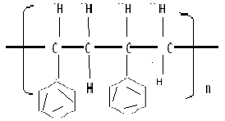
- What is a polymer (1mk)

- Give the name of the polymer (1mk)

- Give one disadvantage of this polymer. (1mk)

- A group of students investigated a sample of water from a spring. The result of the test was as follows

Portion | Test | Observations | Inferences
1st | Add 1 cm³ of  Soap solution to the sample | No lather
2nd | .boil the sample  .cool it  .add 1cm³ of soap solution | No Lather
3rd | . to a sample add 3cm³ Na ₂CO₃(aq)  . add 1 cm³of soap solution to the filtrate | Lathering  occurs

Complete the inferences (3mks)

- Metals F and G were connected to form a cell as shown in the diagram below
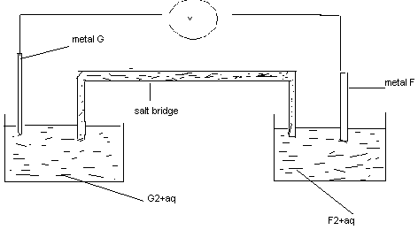
- Write the equation for the reactions that occur at electrodes;

F……………………………………

G ………………………………….

- What is the function of salt bridge (1mk)

- Study the nuclear reaction given below.
${}_{6}^{12}c$ ${}_{6}^{14}C {}_{ 7}^{ 14}N$
I II

i)Write the equation for the nuclear reaction in step II (1mk)

ii)Give one use of ${}_{6}^{14}C$
(1mk)

