
SCHOOL OF ENGINEERING
DEPARTMENT OF ELECTRICAL/ELECTRONICS
DIPLOMA IN ELECTRICAL AND ELECTRONICS ENGINEERING
MODULE I

END OF SERIES EXAMINATIONS
SEPTEMBER/ OCTOBER 2017
ANALOGUE ELECTRONICS
KNEC 2601/106

TIME: 2HOURS

INSTRUCTIONS TO CANDIDATES:
- Attempt ALL questions.
- Any examination IRREGULARITY will lead to DISQUALIFICATION.
- Indicate your FULL ADMISSION NUMBER in each Answer Sheet used.
- Cell phones are NOT allowed in the examination room
- Ensure you have both SCHOOL ID and EXAM CARDS in the examination room
- Scientific calculators and mathematical tables may be used where appropriate.
- Do not write your name anywhere on the answer booklet

QUESTIONS ONE (20 MARKS).
- Define the following terms :-
- Semi conductors
- Conductors
- Non- Conductors
- Doping
- Insulators (10marks)

- Distinguish between intrinsic and extrinsic semi – conductors
(4marks)
- With the aid of a symbols differentiate between PNP and NPN transistors. (6marks)
QUESTION TWO (20MARKS)
- What is a P- N junction (2marks)
- With the aid of a labeled circuit diagrams, explain forward and reverse bias of a P- N junction diode (10marks)
- Define the following terms:
- Proton
- Neutrons. (4marks)
- Distinguish between excited and ionized atoms. (4marks)

QUESTION THREE (20MARKS)
- Given that R_{S} = 3kΩ, V_{in} ranges from 40-70V, R_{L}= 2kΩ and zener voltage, V_{z} = 10V,
- Calculate the currents through R_{S} ,through the load and zener diode current I_{z}
- How will these values be affected if source voltage increases to 70V? (6marks)
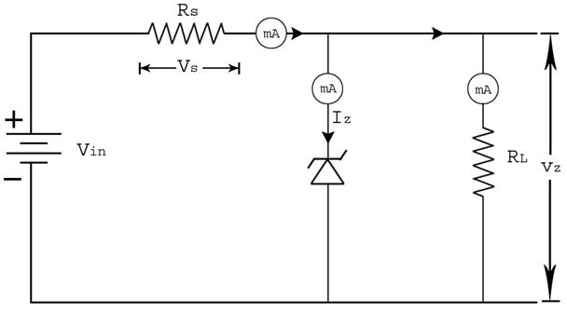

- Define the following terms as applied in the electronic industry :-
- Doping
- Insulator
- Diode
- P-N junction (4marks)
- With aid of relevant curves, explain the operation of a Thyristor device (10marks)

QUESTION FOUR (20MARKS)
- Give the difference between series and parallel connection of resistors. (4marks)
- Two resistors of 25 Ω and 35 Ω are connected in different circuits. Find their respective series and parallel resistances. (4marks)
- In question 4 (b) , if a voltage of 12 volts is connected at the source , find the current flowing through the series resistors. (5marks)
- What is the work of a capacitor? (3marks)
- State four advantages of FETS(Field Effect Transistors) (4marks)
QUESTION FIVE (20 MARKS)
- Mention the work of an Amplifier in electronic circuits. (2marks)
- With an aid of labeled diagrams, explain a two stage Amplifier circuit. (7marks).
- Using block diagrams differentiate between current series feedback and current shunt feedback connections (8marks)
- Outline THREE advantages of Negative feedback as applied in Feedback amplifiers. (3marks)

