 SCHOOL OF ENGINEERING
DEPARTMENT OF ELECTRICAL/ELECTRONICS
CERTIFICATE IN ELECTRICAL AND ELECTRONICS ENGINEERING
MODULE I

END OF SERIES EXAMINATIONS
September/october 2017
ELECTRICAL PRINCIPLES
KNEC 1601/102

TIME: 2HOURS

INSTRUCTIONS TO CANDIDATES:
- Answer ALL questions.
- Any examination IRREGULARITY will lead to DISQUALIFICATION.
- Indicate your FULL ADMISSION NUMBER in each Answer Sheet used.
- Cell phones are NOT allowed in the examination room
- Ensure you have both SCHOOL ID and EXAM CARDS in the examination room
- Scientific calculators and mathematical tables may be used where appropriate.
- Do not write your name anywhere on the answer booklet

QUESTION ONE (20 MARKS)
- Define the following laws as used in d.c circuits.
- Kirchhoff’s voltage law;
- Ohm’s law. (4 marks)
- Determine the resistance of 1400m of copper having a diameter of 14mm if the resistivity of copper is 1.7x10⁻⁸ Ωm (4marks)
- Figure 1 shows an electrical circuit network.

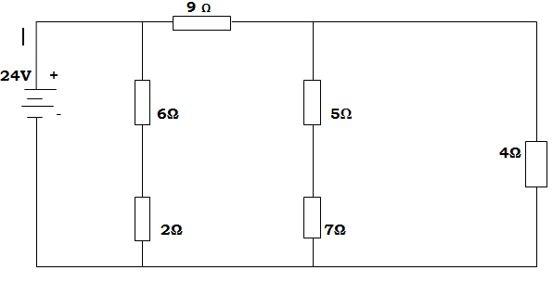

Determine the:
- Total resistance
- Voltage drop across 5 Ω resistor
- Power dissipated by 9 Ω resistor
- Energy consumed by 6 Ω resistor after 12min in joules
- Energy consumed by the whole circuit after 1hr 30mins in watt hours. (12marks)

t Figure 1

QUESTION TWO (20MARKS)
- Distinguish between;
- electrolysis and electroplating
- Primary and secondary cells. (6marks)
- With an aid of well labeled diagrams, explain the process of charging a battery using a solar panel, without using a regulator circuit. (8marks)
- Draw a labeled diagram of a lechlanche dry cell. (4marks)
- Explain the effect of temperature change in electrical conductors. (2marks)
QUESTION THREE (20MARKS)
- A capacitor consisting of two metal plates each area 50cm² and spaced 0.2mm apart in air is connected across 150V. calculate the:
- Energy stored by the capacitor;
- Electric flux density;
- Potential gradient. (8marks)
- With aid of diagrams explain the principle operation of a moving – coil Galvanometer ( 12 marks)
QUESTION FOUR (20 MARKS)
- Define the following terms as used in electrostatics :-
- Electric flux density;
- Relative permittivity. (4marks)
- A capacitance of 3μf, 6μf and 18μf are connected in series across a 340Vsupply. Determine the;
- Charge on each capacitor,
- Potential difference across 18μf capacitor. (4marks)
- A multiplier of internal resistor 5Ω is used for a full deflection of 15 mA. if the main current supplies a current of 1.5 A, calculate the shunt resistor required to make it operational (6marks)
- With the aid of a labeled diagram, derive an expression for equivalent capacitance of four capacitors connected in series. (6marks)
QUESTION FIVE (20MARKS)
- Define the following trerms as used in magnetism:
- Magneto motive force;
- Reluctance. (4marks)
- A resistor of 20Ω, inductor of 0.3 H and a capacitor of 100 µF are connected across a 220v, 50 Hz mains. Determine the following:
- Impedance
- Voltage across R,L & C
- Power factor ( p.f) ( 10mark
- Describe an electric bell. (6 marks)

