 SCHOOL OF ENGINEERING
DEPARTMENT OF ELECTRICAL/ELECTRONICS
DIPLOMA IN ELECTRICAL AND ELECTRONICS ENGINEERING
MODULE I

END OF SERIES EXAMINATIONS
September/October 2017
TECHNICAL DRAWING
KNEC 2601/104

TIME: 3HOURS

INSTRUCTIONS TO CANDIDATES:
- Attempt ALL questions.
- Any examination IRREGULARITY will lead to DISQUALIFICATION.
- Indicate your FULL ADMISSION NUMBER in each Answer Sheet used.
- Cell phones are NOT allowed in the examination room
- Ensure you have both SCHOOL ID and EXAM CARDS in the examination room
- Scientific calculators and mathematical tables may be used where appropriate.
- Do not write your name anywhere on the answer booklet

QUESTION ONE
Figure below shows a pictorial drawing of a block unit. Draw full size in third angle projection the following views:
- Plan
- Sectional front elevation X-X
- End elevation
Insert any six major dimensions (20marks)
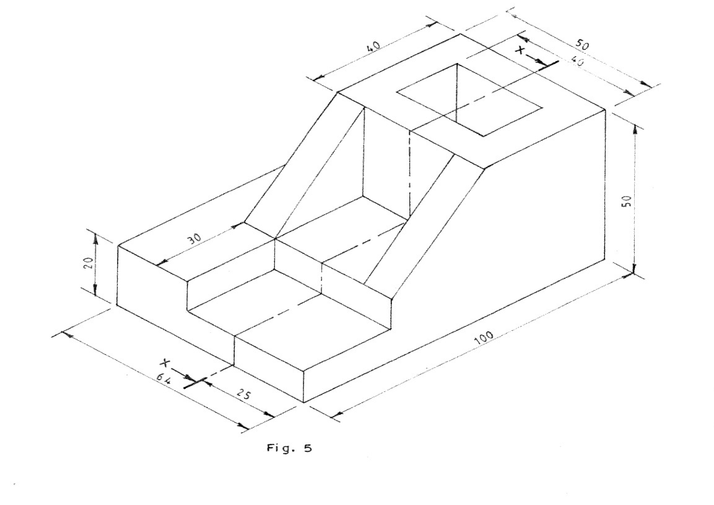

QUESTION TWO
- Sketch the following accessories and hand tools:
- Tee-box;
- Flat screw driver;
- Switched socket out let;
- Straight batten lamp holder;
- Ball pein hammer. (10marks)
- Draw an ellipse using concentric circles method given major and minor axis as 140mm and 100mm respectively (10marks)

QUESTION THREE
- Construct a regular heptagon give the length of one side as 25 mm. (6marks)
- Sketch the conventional symbols for the following:
- First angle projection;
- Third angle projection. (4marks)
- Construct a triangle whose sides have ratios 1:5 .2:4 if its perimeter is 120 mm and 100 mm respectively (10 marks)

QUESTION FOUR
- Construct an inscribed circle in a triangle ABC given AB = 90 mm, BC=80mm, CA=70mm. (6marks)
- Construct the following angles; (6marks)
- 22 ½ ⁰
- 75⁰

- Draw the preferred symbols for the following:
- Voltmeter;
- Motor;
- Photo diode;
- NPN transistor;
- D.C. voltage source;
- Light emitting diode;
- Generator;
- Microphone. (8marks)

