NAME……………………………INDEX No:………………………ADM. No: ……………
CANDIDATE’S SIGNATURE……………………….. DATE……………………
CLASS: …………………….

NJORO BOYS HIGH SCHOOL
FORM FOUR MARATHON EXAM

443/2
AGRICULTURE 2014
PAPER 2
TIME:2HRS

INSTRUCTIONS TO CANDIDATES
This paper consists of three sections A,B and C.
Answer all the questions in section A and B in the spaces provided and ANY TWO questions from section C.

SECTION | QUESTIONS | MAX SCORE | CADIDATES SCORE
A | 1 - 18 | 30
B | 19-21 | 20
C |  | 40
TOTAL SCORES |  | 90

SECTION A
Answer all the questions in this section in spaces provided.
- Give a reason why Irish potatoes should not be fed to rabbits. (1 mks )
…………………………………………………………………………………………………………………………………………………………………………………………………………………………………………………………………………………………….
- Mention four advantages of natural mating in cattle management. (2mks)
……………………………………………………………………………………………………………………………………………………………………………………………………………………………………………………………………………………………………………………………………………………………………………………………..
- Give three reasons why camels are able to survive in their dry habitat. (1 ½mks )
……………………………………………………………………………………………………………………………………………………………………………………………………………………………………………………………………………………………………………………………………………………………………………………………..

- List four factors associated to the animals that determine the amount of feeds that an animal consumes. (2mks)
……………………………………………………………………………………………………………………………………………………………………………………………………………………………………………………………………………………………………………………………………………………………………………………………..

- Which tool/equipment would be required for each of the following operations. (2mks)

- Cutting wool from sheep………………………………………………………..
- Castrating piglets………………………………………………………………..
- Determine the verticleness of a tall wall……………………………………………
- Make threads on metallic pipes……………………………………………….

- Mention one main reasons for carrying out the following management practices in livestock production.(1 mks)
- Tagging in ewes ……………………………………………………………
- Raddling …………………………………………………………………….
- Docking in rams…………………………………………………………….
- Give two reasons why walls of dairy shed should be white washed instead of painting with oil-based paints. (1mk)

……………………………………………………………………………………………………………………………………………………………………………………………………………………………………………………………………………………………………………………………………………………………………………………………..
a)What is the duration of oestrus cycle in a cow. ( ½mks)
……………………………………………………………………………………………..
b)if a dairy cow is noticed to be showing first signs of heat at 6:00am,what time should it be inseminated. (1 mk)

- Name the intermediate host of the following parasites in cattle :- (1mk)
- Liver fluke ………………………………………………………………..
- Tapeworm ………………………………………………………………….
- Give three factors that should be considered when designing a piggery. (1 ½ mks)
……………………………………………………………………………………………………………………………………………………………………………………………………………………………………………………………………………………………………………………………………………………………………………………………..

- Name two cattle diseases that can be controlled by administering one vaccine.( 1 mk)
……………………………………………………………………………………………………………………………………………………………………………………………………………………………………………………………………………………………………………………………………………………………………………………………..

- Mention four symptoms that would show that a cow is suffering from rinderpest and not foot and mouth disease. (2mks)
……………………………………………………………………………………………………………………………………………………………………………………………………………………………………………………………………………………………………………………………………………………………………………………………..

- State four maintainance practices that are carried out on a cutter-bar mower. (2mks)

……………………………………………………………………………………………………………………………………………………………………………………………………………………………………………………………………………………………………………………………………………………………………………………………..

- Mention two main functions of each of the following parts of the tractor engine:-
- Differential (1mk)
……………………………………………………………………………………………………………………………………………………………………………………………………………………………………………………………………………

- Gear box (1mk)
………………………………………………………………………………………………………………………………………………………………………………………………………………………………………………………………………

Mention four reasons why a farmer may cull a breeding boar.( 2mks) ……………………………………………………………………………………………………………………………………………………………………………………………………………………………………………………………………………………………………………………………………………………………………………………………..

Mention four reasons for measuring timber before use. (2mks) ……………………………………………………………………………………………………………………………………………………………………………………………………………………………………………………………………………………………………………………………………………………………………………………………..

Mention three reasons why ewes may disown their lambs soon after lambing. (1 ½ mks) ……………………………………………………………………………………………………………………………………………………………………………………………………………………………………………………………………………………………………………………………………………………………………………………………..

a)Mention four advantages of using artificial incubation in poultry management. (2mks) ……………………………………………………………………………………………………………………………………………………………………………………………………………………………………………………………………………………………………………………………………………………………………………………………..

b)Give the importance of the following parts of the incubator :- (2mks)
- Water in the trough……………………………………………………………….
- Thermometer……………………………………………………………………..
- Thermostat……………………………………………………………………….
- Ventilation………………………………………………………………………..
SECTION B (20MKS)
Answer ALL the questions in this section in spaces provided.
- The diagram below illustrates a life cycle of a given tick on cattle.
Study it and answer the questions that follow.
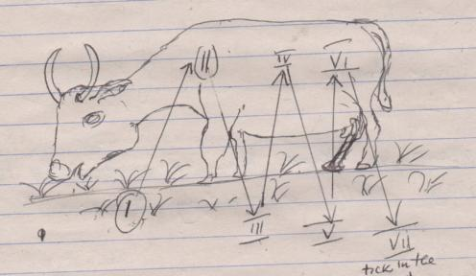
Describe the life cycle of the tick in the above illustrated diagram.Use the stages I –VII (3 ½ mks) ……………………………………………………………………………………………………………………………………………………………………………………………………………………………………………………………………………………………………………………………………………………………………………………………..

- Identify the type of tick in the illustration.( ½ mk
…………………………………………………………………………………………..
- Give two examples of ticks in cattle management which undergo the life cycle illustrated above. (1mk)
……………………………………………………………………………………………………………………………………………………………………………………
- Mention one disease transmitted by the above illustrated tick. (1mk)
…………………………………………………………………………………………
- Apart from transmitting diseases,mention two other economic importance of the ticks to cattle. (2mks)
…………………………………………………………………………………………
- vv Identify the type

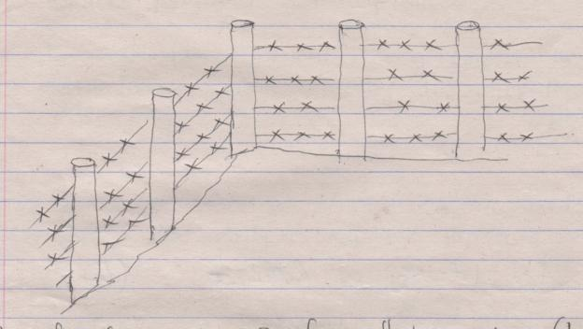
- Identify the type of fence illustrated above. (1mk)
………………………………………………………………………….
- On the illustration,draw and label
- Dropper (1mk)
- Wire brace (1mk)
- Name the correct tool for tightening the type of fence illustrated above. (1mk)
.........................................................................................................................................
- Give one disadvantage of using the above type of fence in livestock management. (1mk)……………………………………………………………………………
- The diagram below represents a farm implement.
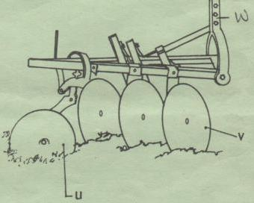
- Identify the implement. (1mk)
..................................................................................................................................
- Identify the parts labeled U,V,W (3mks)
U ……………………………………………….
V………………………………………………..
W……………………………………………….
- Give the function of the parts identified above.(3mks)
U……………………………………………………………………………………
V……………………………………………………………………………………
W……………………………………………………………………………………
SECTION C (40MKS)
Answer any TWO questions from this section in spaces provided.
- Describe the management of layers in a deep litter system starting from the point of lay.
(20mks) ………………………………………………………………………………………………………………………………………………………………………………………………………………………………………………………………………………………………………………………………………………………………………………………………………………………………………………………………………………………………………………………………………………………………………………………………………………………………………………………………………………………………
………………………………………………………………………………………..
……………………………………………………………………………………………………………………………………………………………………………………………………………………………………………………………………………………………………………………………………………………………………………………………………………………………………………………………………………………………………………………………………………………………………………………………..
……………………………………………………………………………………………………………………………………………………………………………………………..
………………………………………………………………………………………………………………………………………………………………………………………………………………………………………………………………………………………………………………………………………………………………………………………………………………………………………………………………………………………………………………………………………………………………………………………………..
…………………………………………………………………………………………………………………………………………………………………………………………..

a)Outline the advantages of farm mechanization. (5mks) ………………………………………………………………………………………………………………………………………………………………………………………………………………………………………………………………………………………………………………………………………………………………………………………………………………………………………………………………………..
………………………………………………………………………………………………………………………………………………………………………………………………………………………………………………………………………………………………
b) Outline the daily management practices carried out on a tractor. (7mks)
………………………………………………………………………………………………………………………………………………………………………………………………………………………………………………………………………………………………………………………………………………………………………………………………………………………………………………………………………………………………………………………………………………………………………………………………
………………………………………………………………………………………………………………………………………………………………………………..
……………………………………………………………………………………………………………………………………………………………………………………………………………………………………………………………………………………………………………………………………………………………………………………………..

c)Describe the procedure followed when castrating a piglet. (8mks)
………………………………………………………………………………………………………………………………………………………………………………………………………………………………………………………………………………………………………………………………………………………………………………………………………………………………………………………………………………………………………………………………………………………………………………………………………………………………………………………………………………………………
……………………………………………………………………………………..
……………………………………………………………………………………………………………………………………………………………………………………………………………………………………………………………………………………………………………………………………………………………………………………………..

- a)Describe the factors that are considered while selecting a heifer for breeding. (10mks)
……………………………………………………………………………………………………………………………………………………………………………………………………………………………………………………………………………………………………………………………………………………………………………………………..
………………………………………………………………………………………………………………………………………………………………………………………………………………………………………………………………………………………………………………………………………………………………………………………………………………………………………………………………………………………………………………………………………………………………………………………………
……………………………………………………………………………………………………………………………………………………………………………………..
……………………………………………………………………………………………………………………………………………………………………………………………………………………………………………………………………………………………………………………………………………………………………………………………..

a) Name the tools that are used to erect a barbed wire fence and describe their uses. (10mks)
……………………………………………………………………………………………………………………………………………………………………………………………………………………………………………………………………………………………………………………………………………………………………………………………..
……………………………………………………………………………………………………………………………………………………………………………………………………………………………………………………………………………………………………………………………………………………………………………………………..
……………………………………………………………………………………………………………………………………………………………………………………………………………………………………………………………………………………………………………………………………………………………………………………………..
……………………………………………………………………………………………………………………………………………………………………………………………………………………………………………………………………………………………………………………………………………………………………………………………..
……………………………………………………………………………………………………………………………………………………………………………………………………………………………………………………………………………………………………………………………………………………………………………………………..

