Name:…………………………………………..… Index Number:……….…....……….
Class…………………… Candidate’s Signature:……………..
ADM. No: ……………

NJORO BOYS HIGH SCHOOL
MARATHON EXAMINATION - 2014
AGRICULTURE PAPER 1
TIME 2HOURS

INSTRUCTIONS
- Attempt all questions in section A&B
- Attempt only two questions in section C
- Write your answers in the spaces provided
- Write your answers in English language only

Section A | 30
Section B | 20
Section C | 40
Total | 90

SECTION A (30mks)
Answer all the questions in this section in the spaces provided.
- Name two types of drainage systems used on farms.(1mk)
…………………………………………………………………………………………………………………………………………………………………………………………………………………………………………………………………………………………………………………………………………….
…………………………………………………………………………………………………………….
- List two biotic factors that influence agriculture negatively.(1mk)
………………………………………………………………………………………………………………………………………………………………………………………………………………………………………………………………………………………………………………………………………………

- State three factors which influence the extent of soil erosion.(1½mks)
………………………………………………………………………………………………………………………………………………………………………………………………………………………………………………………………………………………………………………………………………………………………………………………………………………………………………………………………..
4.Give three importance of tissue culture.(1 ½mks) ………………………………………………………………………………………………………………………………………………………………………………………………………………………………………………………………………………………………………………………………………………………………………………

5List four reasons for conserving forage in a farm.(2mks)
……………………………………………………………………………………………………………………………………………………………………………………………………………………………………………………………………………………………………………………………………………………………………………………………………………………………………………………………………………………………………………………………………………………………………………..

6.Differentiate between the following terms as used in crop production.(1mk)a)staking
………………………………………………………………………………………………………………………………………………………………………………………………………………………………………………………………………………………………………………………………………………
b)propping……………………………………………………………………………………………………………………………………………………………………………………………………………………………………………………………………………………………………………………………
7.List three care and maintenance practices that are carried out in agroforestry trees.(1½mks)
……………………………………………………………………………………………………………………………………………………………………………………………………………………………………………………………………………………………………………………………………………………………………………………………………………………………………………………………………………………………………………………………………………………………………………..
8.State four characteristics of crops that a farmer can use to prepare green manure.(2mks) ……………………………………………………………………………………………………………………………………………………………………………………………………………………………………………………………………………………………………………………………………………………………………………………………………………………………………………………………………………………………………………………………………………………………………………..
9.Give three reasons for preparing a seedbed.(1½mks)
………………………………………………………………………………………………………………………………………………………………………………………………………………………………………………………………………………………………………………………………………………
10.Define the term capital as used in agricultural production.(1mk)
………………………………………………………………………………………………………………………………………………………………………………………………………………………………………………………………………………………………………………………………………………
11.State four problems associated with credits as a support service to the farmer.(2mks)
……………………………………………………………………………………………………………………………………………………………………………………………………………………………………………………………………………………………………………………………………………………………………………………………………………………………………………………………………………………………………………………………………………………………………………..
12.Give three reasons for pruning agroforestry tree.(1½mks)
…………………………………………………………………………………………………………………………………………………………………………………………………………………………………………………………………………………………………………………………………………………………………………………………………………………………………………………………………………………………………………………………………………………………………………….
13.State four methods of breaking seed dormancy in some crops before planting.(2mks)
…………………………………………………………………………………………………………………………………………………………………………………………………………………………………………………………………………………………………………………………………………………………………………………………………………………………………………………………………………………………………………………………………………………………………………….
14.List four reasons why maize should be harvested at milk stage for silage making.(2mks) …………………………………………………………………………………………………………………………………………………………………………………………………………………………………………………………………………………………………………………………………………………………………………………………………………………………………………………………………………………………………………………………………………………………………………………………………………
15.Mention three causes of land fragmentation in Kenya.(1½mks)
…………………………………………………………………………………………………………………………………………………………………………………………………………………………………………………………………………………………………………………………………………………………………………………………………………………………………………………………………………………………………………………………………………………………………………….
16.List four factors which determine the time of planting a crop.(2mks)
…………………………………………………………………………………………………………………………………………………………………………………………………………………………………………………………………………………………………………………………………………………………………………………………………………………………………………………………………………………………………………………………………………………………………………….
17.What is a fertilizer grade?(1mk)
………………………………………………………………………………………………………………………………………………………………………………………………………………………………………………………………………………………………………………………………………………
17.State four harmful effects of diseases to crops.(2mks)
……………………………………………………………………………………………………………………………………………………………………………………………………………………………………………………………………………………………………………………………………………………………………………………………………………………………………………………………………………………………………………………………………………………………………………..
18.Outline four reasons for discouraging use of fire during seedbed preparation.(2mks)
……………………………………………………………………………………………………………………………………………………………………………………………………………………………………………………………………………………………………………………………………………………………………………………………………………………………………………………………………………………………………………………………………………………………………………………………………………………………………

SECTION B(20marks)
Answer all the questions in this section in the spaces provided.
19.Describe three influences of soil pH on mineral availability, plant growth and production.(3mks) ……………………………………………………………………………………………………………………………………………………………………………………………………………………………………………………………………………………………………………………………………………………………………………………………………………………………………………………………………………………………………………………………………………………………………………………………………………………………………………………………………………………………………………………………………………………………………………………………………………..
20.The illustration below indicates types of soil erosion that take place on cultivated land. Study it carefully and answer questions that follow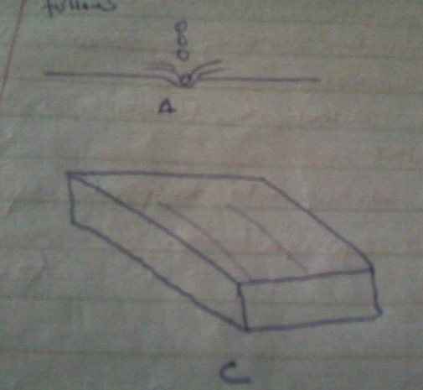.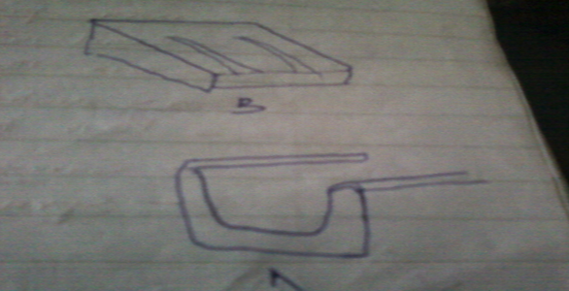
a)Identify the type of erosion represented by each of the illustrations.(2mks)
………………………………………………………………………………………………………………………………………………………………………………………………………………………………………………………………………………………………………………………………………………………………………………………………………………………………………………………………………………………………………….
b)List one factor that may accelerate the rate of the type of erosion represented by A.(1mk) ……………………………………………………………………………………………………………………………………………………………………………………………………………………………………………………

c)State one practice that may reduce the impact of the type of erosion represented by A.(1mk)
……………………………………………………………………………………………………………………………………………………………………………………………………………………………………………………………………………………………………………………………………………………………………………..
21. a)Describe the procedure which should be followed in spraying a crop of tomatoes using fungicide powder, water and knapsack sprayer.(3mks)
…………………………………………………………………………………………………………………………………………………………………………………………………………………………………………………………………………………………………………………………………………………………………………………………………………………………………………………………………………………………………………………………………………………………………………………………………………………………………………………………………………………………………………………………………………………………………………………………………………………………………………………………………………………………………………………………………………………………………………………………………………………….

b) Name one fungal disease of tomatoes that can be controlled using the above procedure.(1mk) …………………………………………………………………………………………………………………………………………………………………………………………………………………………………………………………………………………………………………………………………………………………………………….
c) Give four safety measures that should be taken while spraying the crop using the fungicide.(2mk) ……………………………………………………………………………………………………………………………………………………………………………………………………………………………………………………………………………………………………………………………………………………………………………………………………………………………………………………………………………………………………………………………………………………………………………………………………………………………………………………………………………………………………………………………………………………………….
22. The diagram below shows some vegetative materials used to propagate some crops. Study them carefully and answer the questions that follow.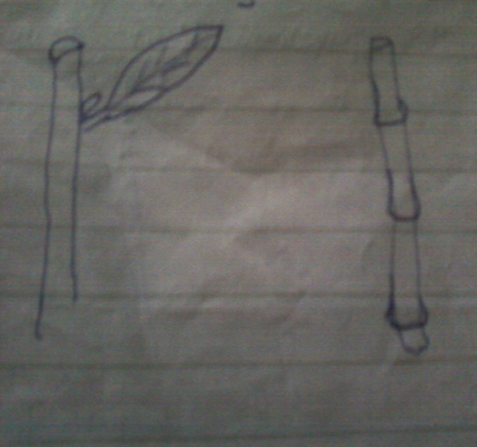

a) Explain three factors that affect rooting of such materials.(3mks)
……………………………………………………………………………………………………………………………………………………………………………………………………………………………………………………………………………………………………………………………………………………………………………………………………………………………………………………………………………………………………………………………………………………………………………………………

23. a)Describe three importance of a farm record as used by a farmer.(3mks)
……………………………………………………………………………………………………………………………………………………………………………………………………………………………………………………………………………………………………………………………………………………………………………………………………………………………………………………………………………………………………………………………………………………………………………………………
b) List down two conditions under which the opportunity cost does not exist. (1mk)
………………………………………………………………………………………………………………………………………………………………………………………………………………………………………………………………………………………………………………………………………………………
SECTION C (40mks)
Answer any two questions from this section.
24.a)Describe the field production of sorghum under the following sub-headings.
- Seedbed preparation (3mks)
- Planting (3mks)
- Field management(4mks)
b)State and explain five factors to consider when choosing seed rates .(10mks)

25.a)A farmer intends to replace maize with wheat in his one hectare farm the following season .Use the following information to prepare a partial budget(7marks)
Wheat | SHS | Maize | SHS
Expected revenue for wheat | 60,000 | Expected revenue for maize | 40,000
Variable costs |  | Variable costs
Ploughing | 8,000 | Fertilizer | 5,000
fertirizer | 6,000 | Weed control | 6,000
Weed control | 3,000 | harvesting | 4,000
harvesting | 8,000 | Ploughing | 10,000
b)Explain whether its advisable to undertake 2marks
c)Explain six factors that influence the demand for a commodity(6mks)
d)State five details that are included in marketing records.(5mks)
27.a)Explain six ways in which soil losses its fertility.(6mks)
b)Outline six characteristics of nitrogenous fertilizers.(6mks)
c)Explain the importance of organic matter in the soil.(8mks)
......................................................................................................................................................................................................................................................................................................................................................................................................................................................................................................................................................................................................................................................................................................................................................................................................................................................................................................................................................................................................................................................................................................................................................................................................................................................................................................................................................................................................................................................................................................................................................................................................................................................................................................................................................................................................................................................................................................................................................................................................................................................................................................................................................................................................................................................................................................................................................................................................................................................................................................................................................................................................................................................................................................................................................................................................................................................................................................................................................................................................................................................................................................................................................................................................................................................................................................................................................................................................................................................................................................................................... ........................................................................................................................................................................................................................................................................................................................................................................................................................................................................................................................................................................................................................................................................................................................................................................................................................................................................................................................................................................................................................................................................................................................................................................................................................................................................................................................................................................................................................................................................................................................................................................................................................................................................................................................................................................................................................................................................................................................................................................................................................................................................................................................................................................................................................................................................................................................................................................................................................................................................................................................................................................................................................................................................................................................................................................................................................................................................................................................................................................................................................................................................................................................................................................................................................................................................................................................................................................................................................................................................................................................................................................................................................................................................................................... ............................................................................................................................................................................................................................................................................................................................................................................................................................................................................................................................................................................................................................................................................................................................................................................................................................................................................................................................................................................................................................................................................................................................................................................................................................................................................................................................................................................................................................................................................................................................................................................................................................................................................................................................................................................................................................................................................................................................................................................................................................................................................................................................................................................................................................................................................................................................................................................................................................................................................................................................................................................................................................................................................................................................................................................................................................................................................................................................................................................................................................................................................................................................................................................................................................................................................................................................................................................................................................................................................................................................................................................................................................................................................................................ ........................................................................................................................................................................................................................................................................................................................................................................................................................................................................................................................................................................................................................................................................................................................................................................................................................................................................................................................................................................................................................................................................................................................................................................................................................................................................................................................................................................................................................................................................................................................................................................................................................................................................................................................................................................................................................................................................................................................................................................................................................................................................................................................................................................................................................................................................................................................................................................................................................................................................................................................................................................................................................................................................................................................................................................................................................................................................................................................................................................................................................................................................................................................................................................................................................................................................................................................................................................................................................................................................................................................................................................................................................................................................................................... ............................................................................................................................................................................................................................................................................................................................................................................................................................................................................................................................................................................................................................................................................................................................................................................................................................................................................................................................................................................................................................................................................................................................................................................................................................................................................................................................................................................................................................................................................................................................................................................................................................................................................................................................................................................................................................................................................................................................................................................................................................................................................................................................................................................................................................................................................................................................................................................................................................................................................................................................................................................................................................................................................................................................................................................................................................................................................................................................................................................................................................................................................................................................................................................................................................................................................................................................................................................................................................................................................................................................................................................................................................................................................................................................................................................................................................................................................................................................................................................................................................................... ........................................................................................................................................................................................................................................................................................................................................................................................................................................................................................................................................................................................................................................................................................................................................................................................................................................................................................................................................................................................................................................................................................................................................................................................................................................................................................................................................................................................................................................................................................................................................................................................................................................................................................................................................................................................................................................................................................................................................................................................................................................................................................................................................................................................................................................................................................................................................................................................................................................................................................................................................................................................................................................................................................................................................................................................................................................................................................................................................................................................................................................................................................................................................................................................................................................................................................................................................................................................................................................................................................................................................................................................................................................................................................................... ............................................................................................................................................................................................................................................................................................................................................................................................................................................................................................................................................................................................................................................................................................................................................................................................................................................................................................................................................................................................................................................................................................................................................................................................................................................................................................................................................................................................................................................................................................................................................................................................................................................................................................................................................................................................................................................................................................................................................................................................................................................................................................................................................................................................................................................................................................................................................................................................................................................................................................................................................................................................................................................................................................................................................................................................................................................................................................................................................................................................................................................................................................................................................................................................................................................................................................................................................................................................................................................................................................................................................................................................................................................................................................................................................................................................................................................................................. ............................................................................................................................................................................................................................................................................................................................................................................................................................................................................................................................................................................................................................................................................................................................................................................................................................................................................................................................................................................................................................................................................................................................................................................................................................................................................................................................................................................................................................................................................................................................................................................................................................................................................................................................................................................................................................................................................................................................................................................................................................................................................................................................................................................................................................................................................................................................................................................................................................................................................................................................................................................................................................................................................................................................................................................................................................................................................................................................................................................................................................................................................................................................................................................................................................................................................................................................................................................................................................................................................................................................................................................................................................................................................................................ ............................................................................................................................................................................................................................................................................................................................................................................................................................................................................................................................................................................................................................................................................................................................................................................................................................................................................................................................................................................................................................................................................................................................................................................................................................................................................................................................................................................................................................................................................................................................................................................................................................................................................................................................................................................................................................................................................................................................................................................................................................................................................................................................................................................................................................................................................................................................................................................................................................................................................................................................................................................................................................................................................................................................................................................................................................................................................................................................................................................................................................................................................................................................................................................................................................................................................................................................................................................................................................................................................................................................................................................................................................................................................................................................................................................................................................................................................. ............................................................................................................................................................................................................................................................................................................................................................................................................................................................................................................................................................................................................................................................................................................................................................................................................................................................................................................................................................................................................................................................................................................................................................................................................................................................................................................................................................................................................................................................................................................................................................................................................................................................................................................................................................................................................................................................................................................................................................................................................................................................................................................................................................................................................................................................................................................................................................................................................................................................................................................................................................................................................................................................................................................................................................................................................................................................................................................................................................................................................................................................................................................................................................................................................................................................................................................................................................................................................................................................................................................................................................................................................................................................................................................ ...........................................................................................................................................................................................................................................................................................................................................................................................................................................................................................................................................................................................................................................................................................................................................................................................................................................................................................................................................................................................................................................................................................................................................................................................................................................................................................................................................................................................................................................................................................................................................................................................................................................................................................................................................................................................................................................................................................................................................................................................................................................................................................................................................................................................................................................................................................................................................................................................................................................................................................................................................................................................................................................................................................................................................................................................................................................................................................................................................................................................................................................................................................................................................................................................................................................................................................................................................................................................................................................................................................................................................................................................................................................................................................................

