Name……………………………………………………………………………… Index No:……………………………………..
Adm. No………………………………….. Class………………. Candidate ‘s Signature:…………………
231/1 Date……………………………………………
NJORO BOYS HIGH SCHOOL
MARATHON EXAMINATION - 2014
BIOLOGY Paper 1
(THEORY)
May/June.2014
2 hours

Instructions to Candidates
- Write your name and index number in the spaces provided above .
- Sign and write the date of examination in the spaces provided above .
- Answer all the questions .
- Answers must be written in the spaces provided in the question paper .
- Additional pages should not be inserted .
- Candidate should check the question paper to ascertain that all pages are printed as indicated and that no question is missing .
- Candidates should answer questions in English

For Examiner’s Use Only

Question | Maximum  Score | Candidate’s  Score
1-27 | 80

1.State the function of each of the following apparatus in the study of living organisms.
(a) Pooter (1mk)
………………………………………………………………………………………………………………………………………………….
(b) Pitfall trap (1mk)
………………………………………………………………………………………………………………………………………………...
2. Explain how temperature control the rate of enzyme controlled reaction. (3mks)
……………………………………………………………………………………………………………………………………………………………………………………………………………………………………………………………………………………………………………………………………………………………………………………………………………………………………………………………………………………………………………………………………………………………………………………………………………………
3. ( a)Distinguish between epigeal and hypogeal germination. (1,mk)
…………………………………………………………………………………………………………………………………….
……………………………………………………………………………………………………………………………………
…………………………………………………………………………………………………………………………………
b) Why is oxygen necessary in the germination of seeds? (2mks)
………………………………………………………………………………………………………………………………………………………………………………………………………………………………………………………………………………..
4 . Account for the following phases of a sigmoid curve of a growth of an organism
(a) Lag phase ( 1 mk)
………………………………………………………………………………………………………………………………….
(b) Plateau phase ………………………………………………………………………………………………………………………………………… …………………………………………………………………………………………………………………………………………
5. Explain why sexual reproduction is important in organisms. (3mks)
……………………………………………………………………………………………………………………………………………………………………………………………………………………………………………………………………………………………………………………………………………………………………………………………………………………….

6.(a) State two functions of bile juice in the digestion of food. (2mks)
(i)
(ii)
b) How does substrate concentration affect the rate of enzyme action? (1mk)
………………………………………………………………………………………………………………………………………………………………………………………………………………………………………………………………………………
7.Explain what happens when there is oxygen debt in human muscles. ( 2 mks)
………………………………………………………………………………………………………………………………………………………………………………………………………………………………………………………………………………

8. State two importance of deamination in mammals. (2mks)
(i)
(ii)
9. (a) Name the antigens that determine human blood groups . ( 2 mks)
(i)
(ii)
(b) State the adaptation that enables the red blood cells to move in blood capillaries . (1mk)
…………………………………………………………………………………………………………………………

10.(a) State three functional differences between arteries and veins in mammals. (3 mks)
(i)
(ii)
(iii)
(b) Name a disease that causes thickening and hardening of arteries (1 mk)
……………………………………………………………………………………………
11.State the changes that occur in arterioles in the human skin during thermoregulation. (2mks)
…………………………………………………………………………………………………………………………………………………………………………………………………………………………………………………………………………………………………………
12. (a) What is homeostasis? ( 1 mk)
………………………………………………………………………………………………………………………………………………………………………………………………………………………………………………………………………………
(b) Name three processes in the human body in which homeostasis is Involved. (3 mks)
(i)
(ii)
(iii)
13.State three external differences between chilopoda and diplopoda. (3 mks)

14. (a)Distinguish between population and community (1 mk)
……………………………………………………………………………………………………………………………………………………………………………………………………………………………………………………………………………………………………………………………………………………………………………………………………………………..
(b) Name a method that could be used to estimate the population size of the following organisms
(i) Fish in a pond (1 mk)
………………………………………………………………………………………………………………………….
(ii) Black jack in a garden (1mk)
………………………………………………………………………………………………………………………….

(c).Give a reason why two species in ecosystems cannot occupy the same niche. (1 mk)
………………………………………………………………………………………………………………………………………………………………………………………………………………………………………………………………………………
15.(a) Name two tissues in plants which are thickened with lignin. (2mks)
………………………………………………………………………………………………………………………………………
………………………………………………………………………………………………………………………………………
16(.a) What name is given to response to contact with surface exhibited by tendrils and climbing stems in plants? (1 mk)
……………………………………………………………………………………………………………………………………….
b) State three biological importance of tropisms plants. (3 mks)
(i)
(ii)
(iii)
17.(a)Apart from the lungs ,name other gaseous exchange surfaces in a frog. (2mks)
(i)
(ii)
(b) Write the equation that summarizes the process of anaerobic respiration. (1mk) …………………………………………………………………………………………………………………………………………
18.(a)State 2 role of mucus in the stomach (2mks)
…………………………………………………………………………………………………………………………………………………………………………………………………………………………………………………………………………………………………………………………………...........................................................................................................................................................................
(b) Explain how age determines a person’s energy requirement. (2mks)
……………………………………………………………………………………………………………………………………………………………………………………………………………………………………………………………………………………………………………………………………………………………………………………………………………………………………………………………..
19.State one adaptation of xylem vessels to their function. (2mks)
………………………………………………………………………………………………………………………………………………………………………………………………………………………………………………………………………………………………………….
20.(a) State 2 differences between complete and incomplete metamorphosis (2mks)
……………………………………………………………………………………………………………………………………………………………………………………………………………………………………………………………………………………………………………………………………………………………………………………………………………………………………………………………….
(b)State the importance of moulting to an insects (1mks)
…………………………………………………………………………………………………………………………………………………………………………………………………………………………………………………………………………………………………………

21.(a)Distinguish between respiratory quotient and oxygen debt. (1mk)
………………………………………………………………………………………………………………………………………………………………………………………………………………………………………………………………………………………………………………………………………………………………………………………………………………………………………………………………
(b)Name the site where anaerobic respiration occurs in the cell. (1 mk)
……………………………………………………………………………………………………………………………………………………
22.Explain the role of continental drift in evolution . (3mks)
…………………………………………………………………………………………………………………………………………………………………………………………………………………………………………………………………………………………………………………………………………………………………………………………………………………………………………………………………………………………………………………………………………………………………………………………………………………….
23. State 2 functions of pelvic girdle in mammals (2mks)
………………………………………………………………………………………………………………………………………………………………………………………………………………………………………………………………………………………………………………………………………………………………………………………………………………………………………………………………24.(a).Describe the condition known as varicose veins . (2mks)
…...………………………………………………………………………………………………………………………………………………………………………………………………………………………………………………………………………………………………………………………………………………………………………………………………………………………………………………………….
(b).What is the role of blood platelets in blood clotting . (2mks)
………………………………………………………………………………………………………………………………………………………………………………………………………………………………………………………………………………………………………………………………………………………………………………………………………………………………………………………………
25.The diagram below represents the structure of a flower .
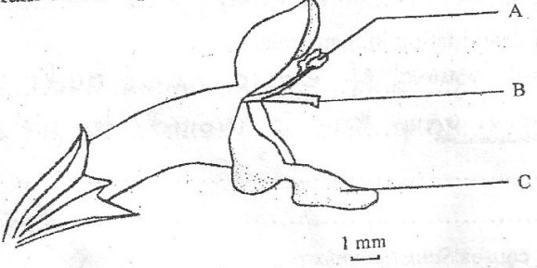
(a) Name the part marked A (1mk)
(b)State the function of the part marked C (1mk)
……………………………………………………………………………………………………………………………………………………
(c).The flower represented is insect pollinated .How is the part marked B adapted to pollination in wind pollinated flower. (1mk)
…………………………………………………………………………………………………………………………………………………………………………………………………………………………………………………………………………………………………………
26.State 2 functions of malpighian layer of the skin (2mk)
(i)
(ii)
27.What is apical dominance (3mks)
……………………………………………………………………………………………………………………………………………………………………………………………………………………………………………………………………………………………………………………………………………………………………………………………………………………………………………………………………………………………………………………………………………………………………………………………………………………
28.The diagram below represents a certain plant .
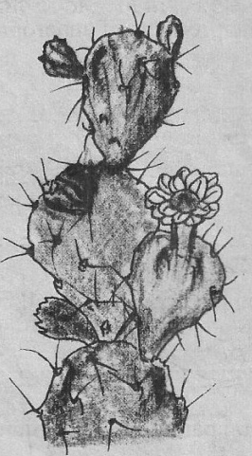
- What is the likely habitat for the plants . (1mk)
…………………………………………………………………………………………………………………………………………
- Give the reasons for your answer in (a) above. (2mks)
………………………………………………………………………………………………………………………………………………………………………………………………………………………………………………………………………………………………………………………………………………………………………………………………………………………………

