Name:………………………………………….….Index Number:…………………………………… Adm.no…………………………Class………………….
Candidates’ Signature:………………………..…….
Date:……………………………………..………….
NJORO BOYS HIGH SCHOOL
FORM FOUR MARATHON EXAM – TERM 2 – 2014
BIOLOGY PAPER 2
231/2
Biology Paper 2
(THEORY)
2 Hours
Instructions to candidates
- Write your details in the spaces provided above
- This paper consist of TWO sections : A and B
- Answer ALL the questions in section A in the spaces provided
- In section B answer Question 6 (Compulsory) and either question 7 or 8 in the spaces provided after question 8
For Examiner’s use only
Section | Question | Maximum Score | Candidates Score
A | 1 | 8
A | 2 | 8
A | 3 | 8
A | 4 | 8
A | 5 | 8
B | 6 | 20
B | 7 | 20
B | 8 | 20
B | Total | 80

This paper consists of 9 printed pages. Candidates should check the questions paper to ascertain that all the pages are printed as indicated and that no questions are missing

SECTION A (40 MARKS)
Answer ALL the questions in this section in the spaces provided
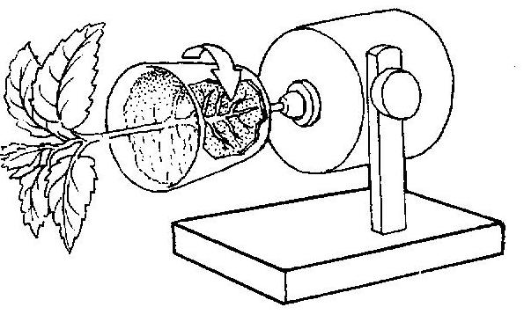
a)Identify the device used in the set up (1mrks)
………………………………………………………………………………………………….
b) Suggests the observation on the shoot and the roots after 48 hours , if the device was not rotating.
Shoot ………………………………………………………………………………..(1mrk)
Root ………………………………………………………………………………..(1mrk)
c) name the type of response exhibited by the root from the observation in (b) above (1mrks)
d) Explain expected observation after 48 hours, if the device was rotating slowly . (3mrks)
………………………………………………………………………………………………….
………………………………………………………………………………………………….
………………………………………………………………………………………………….
………………………………………………………………………………………………….
………………………………………………………………………………………………….
e)Define the term tropism (1mrk)
………………………………………………………………………………………………….
………………………………………………………………………………………………….
………………………………………………………………………………………………….
2a) State the two principal functions of the kidney (2mrks)
………………………………………………………………………………………………….
………………………………………………………………………………………………….
b) the figure below shows a highly magnified cross section of a proximal convoluted tubule of a mammalian kidney . study it and answer the questions that follow .
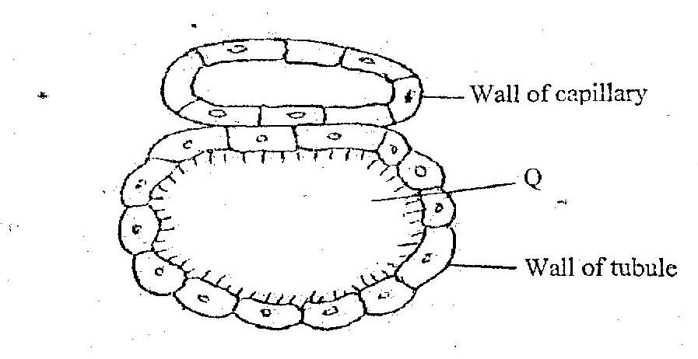
- Form the diagram , identify three structural features that adapt the tubule to its functions (3mrks)
- …………………………………………………………………………………………
………………………………………………………………………………………
………………………………………………………………………………………
………………………………………………………………………………………
………………………………………………………………………………………
………………………………………………………………………………………
- Name the physiological process involved in the re-absorption of water and glucose from the tubule into the blood stream (2mrks)
Water …………………………………………………………………………………
Glucose ………………………………………………………………………………
c) Which fluid substance flows in the part labeled Q? (1mrk)

………………………………………………………………………………………

3. Equal volumes of blood were put into three different salt concentrations for 2 hours. After 2 hours the numbers of red blood cells in each set up were determined. The result were as follows
 |  | Number of red blood cells found
Set up | % of salt concentration | At start | At the end
A | 0.95 | 120 | 120
B | 0.50 | 109 | 83
C | 0.25 | 131 | 0
- Which physiological process is being investigated? (1mrk)
………………………………………………………………………………………………….

- Account for the results in set up A and C
- A (2mrks)
………………………………………………………………………………………………….
………………………………………………………………………………………………….
………………………………………………………………………………………………….
(ii) C (3mrks)
………………………………………………………………………………………………….
………………………………………………………………………………………………….
………………………………………………………………………………………………….
- Explain the observation made if the experiment was repeated using 1.4% salt concentration with regard to number and shape of the red blood cells (2mrks)
………………………………………………………………………………………………….
………………………………………………………………………………………………….
………………………………………………………………………………………………….

4. In a family of eight children, one son was colour blind, where both parent had normal colour vision.
a) Using a genetic cross, show the genotypes of parents and F₁ generation. Use letter b to represent the recessive gene for colour blindness

b) From the genetic cross, what is the probability of daughter being ?
(i) Colour blind …………………………………………………………………………(1mrk)
(ii) A carrier ……………………………………………………………………………(1mrk)
- Give two reasons why Drosophila melanogaster is suitable for use in genetic studies …………………………………………..…………………………………………………
…………………………………………………………………………………………….
…………………………………………..…………………………………………………
…………………………………………………………………………………………….

5. The flow chart below , illustrates blood circulation in certain organs in humans
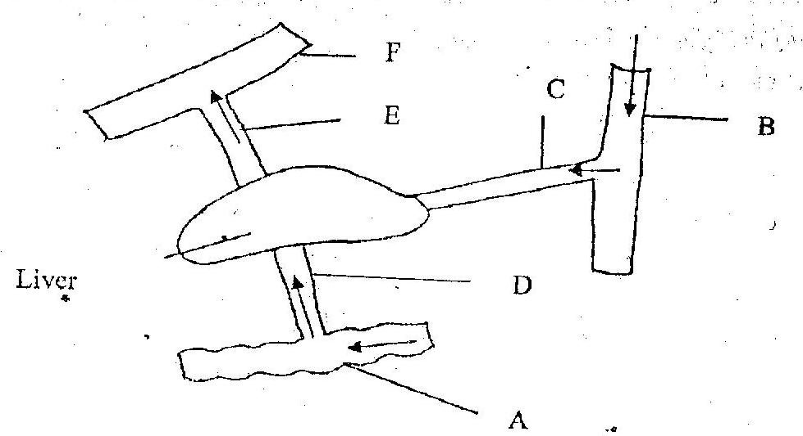
- Name the organ labeled A. (1mrk)
………………………………………………………………………………………………

- Name the blood vessels labeled Band F (2mrks)
B……………………………………………………………………………………………
F……………………………………………………………………………………………
- State how the composition of blood in vessels E differs from that in vessels D.(3mrks)
………………………………………………………………………………………………
………………………………………………………………………………………………
………………………………………………………………………………………………
………………………………………………………………………………………………
………………………………………………………………………………………………
- Name two hormones whose target organ is the liver when there is variation in simple carbohydrates concentration in blood (2mrks)
………………………………………………………………………………………………
………………………………………………………………………………………………
………………………………………………………………………………………………

SECTION B (40 MARKS)
Answer question 6(compulsory) and either 7 and 8 in the space provided after question 8.
6. The following table represents the development in dry mass of germinating seedlings within 18 weeks
Time in weeks | 0 | 1 | 2 | 4 | 6 | 10 | 13 | 15 | 16 | 18
Dry mass in grammes | 1.0 | 2.0 | 3.2 | 10 | 18 | 32 | 44 | 45 | 44 | 38

- Using suitable scale, plot a graph of dry mass against time in the grid provided after questions eight below. (6mrks)
- With reference to the graph, explain the changes in dry mass between; (2mrks)
- Weeks 0 to 2
………………………………………………………………………………………………
………………………………………………………………………………………………
………………………………………………………………………………………………
- Weeks 5 to 13 (2mrks)
………………………………………………………………………………………………
………………………………………………………………………………………………
………………………………………………………………………………………………
- Weeks 16 to 18 (2mrsk)
………………………………………………………………………………………………
………………………………………………………………………………………………
………………………………………………………………………………………………
- (i) What is the significance of time Zero? (1mrk)
………………………………………………………………………………………………
………………………………………………………………………………………………
………………………………………………………………………………………………

- What difference would be expected from the above results if the experiments started with the seeds? Give a reason for your answer (2mrks)
…………………………………………………………………………………………
…………………………………………………………………………………………
…………………………………………………………………………………………

d)(i) describe the procedure carried out in the experiment to obtain dry mass in the respective weeks (4mrks)
…………………………………………………………………………………………
…………………………………………………………………………………………
…………………………………………………………………………………………
…………………………………………………………………………………………
…………………………………………………………………………………………
…………………………………………………………………………………………
(ii) State one advantage of using dry mass instead of fresh weight in estimating growth of an organism (1mrk)
…………………………………………………………………………………………
…………………………………………………………………………………………
…………………………………………………………………………………………
…………………………………………………………………………………………
…………………………………………………………………………………………
…………………………………………………………………………………………
7. Describe how hormones influence growth and development in plants (20mrsk)
8. Explain how biotic factors regulate the population of animals in an ecosystem (20mrks)

