NAME……………………………………….. CLASS………………ADM. NO…………...
INDEX.NO………………………..
231/3
BIOLOGY
PAPER 3
(PRACTICAL)
TIME: 1HR .45MINS
NJORO BOYS HIGH SCHOOL
MARATHON EXAMINATION - 2014
Answer all questions in the spaces provided
- You’re provided with a solution labeled L, starch solution and sodium chloride solution in two different concentrations of 0.1% and 1.4%. Place 3ml of starch solution in test tubes labeled 1, 2 and 3. Add 3 drops of 0.1% sodium chloride to the test tube labeled 3. Add 3mls of solution L to each test tube labeled 2 and 3.
- Place a drop of contents from each test tube 1, 2 and 3 on a white tile. To each drop add iodine solution. Record your results in the table below ( 1 ½mk)
Test tube Observation at start of experiment
1

2

3

- Place the test tubes in water bath maintained at 37⁰c. Allow to stand for 30 minutes place a drop of the contents from each test tube on a white tile. To each drop, add iodine solution. Record your observation in the table below. (1½mk)

Test tube Observation at start of experiment
1

2

3

- Add equal amounts of Benedict’s solution in test tubes labeled 2 and 3. Boil and record observations in the table below. (1¹/₂mk)
Test tube Observation at start of experiment
1

2

3

- Why the test tube labeled 1 was included in the experiment. (1mk)
…………………………………………………………………………………………………………………………………………………………………………
…………………………………………………………………………………….
e).Account for the results in the test tube 1,2 and 3 at the end of the experiment. (3mks)
………………………………………………………………………………………………………………………………………………………………………….
…………………………………………………………………………………………………………………………………………………………………………..
………………………………………………………………………………………………………………………………………………………………………….
f).Suggest the identity of solution L. (1mk)
…………………………………………………………………………………………………………………………………………………………………………
g).Why were the test tubes placed in water bath maintained at 37⁰c. (1mk)
………………………………………………………………………………………………………………………………………………………………………….

- Photographs J and K1 represent specimens which were obtained from different habitats. K2 represents the features of the stem of K1.
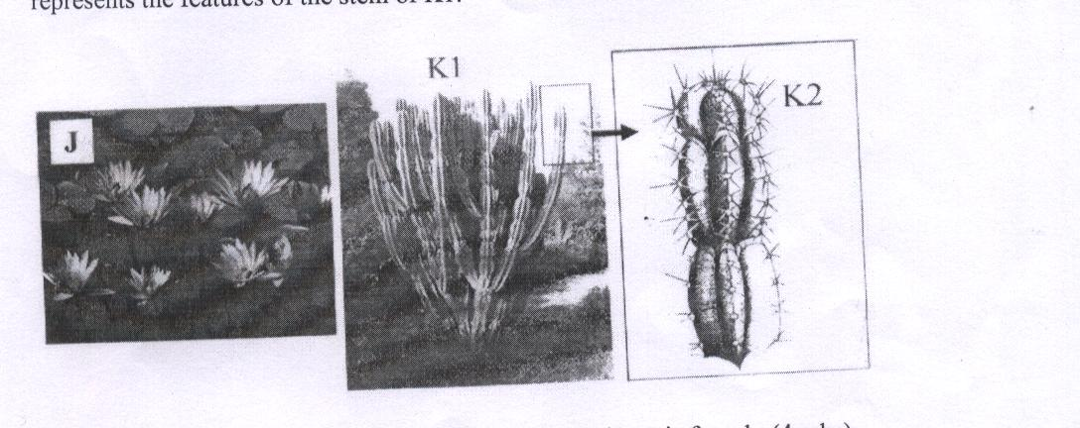
- With reasons, identify the habitat where each specimen is found. (4mks)
Habitat for J
…………………………………………………………………………………………
Reason
…………………………………………………………………………………………
…………………………………………………………………………………………
Habitat for K1
…………………………………………………………………………………………

Reason
…………………………………………………………………………………………
b). The observable features which adapt specimen K1 to its habitat. (2mks)
…………………………………………………………………………………………
…………………………………………………………………………………………
…………………………………………………………………………………………
c). State the significance of the numerous leaves in specimen J. (3mks)
…………………………………………………………………………………………………………………………………………………………………………………
…………………………………………………………………………………………
…………………………………………………………………………………………
d). Suggest expected differences between root systems of specimen J and K1 (2mks)
…………………………………………………………………………………………
…………………………………………………………………………………………
………………………………………………………………………………………………………………………………………………………………………………………..
e).Give the term used to describe plants found in the same habitat with specimen K1.(1mk)
…………………………………………………………………………………………
………………………………………………….
- Figures 1, 2, 3 and 4 provided and labeled Q3, are of the same organism but at different stages of their life cycle. Study the figures carefully.
- i) Using observable features only state the phylum of the organism in figure4
(1mk)
………………………………………………………………………………………………………………………………………………………….
ii) Give a reason for your answer in a) i) above. (2mks)
…………………………………………………………………………………………………………………………………………………………
iii) Give two differences between the organism in figure 3 and the organism in figure 4 (2mks)

Figure 3 | Figure4

- Figure 1, 2, and 3 shows the same organism at different stages of incomplete metamorphosis.
- What is the name given to the stage represented by figure 1 (1mk)
……………………………………………………………………………………………………………………………………………….
- Give the name of the hormone responsible for transforming organism in figure 1 into organism in figure 3 (1mk)
……………………………………………………………………………………………………………………………………………….
- What is the importance of metamorphosis to the organism above?(2mks)
………………………………………………………………………………………………………………………………………………...

- Label any three parts On figure 3 (3mks)
………………………………………………………………………………………………………………………………………………………………
……………………………………………………………………………..

- What is the economic importance of the organism in figure 4? (2mks)
…………………………………………………………………………………………………………………………………………….

DIAGRAMS FOR Q 3
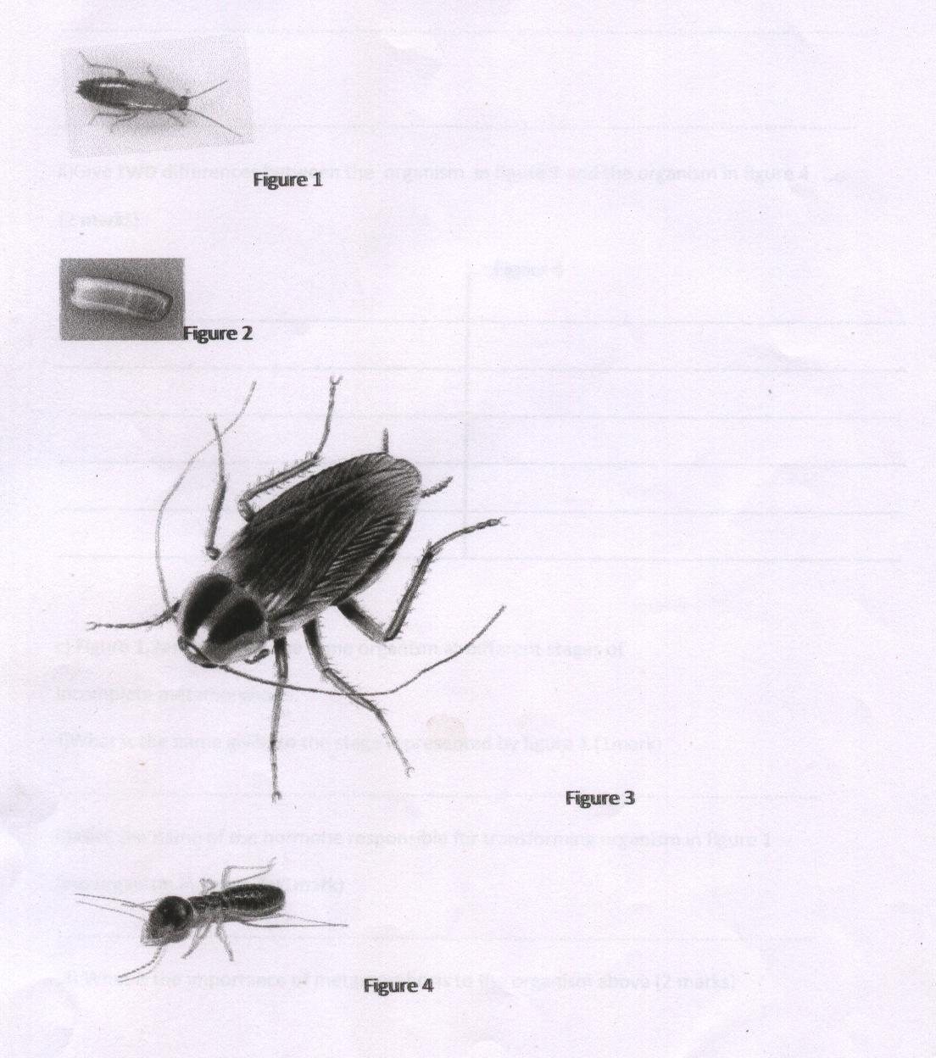
CONFIDENTIAL INSTRUCTION
Each candidate will require the following:
- 0.1% starch solution
- Diastase/amylase/ptyalin labeled solution L
- Benedicts solution
- Iodine solution
- 1.4% sodium chloride solution
- Water bath maintained at 37⁰c
- White tile
- 3 labels
- Droppers
- Stop watch

MARKING SCHEME: BIOLOGY PAPER 3 2014
Question1 a.
Test tube | Observation at start of experiment
1 | Blue –black √ ½
2 | Blue -Black √½
3 | Blue - Black√½
b.
Test tube | Observation at the end of experiment
1 | Blue black √½
2 | Colour of Iodine retained /brown½
3 | Colour of Iodine retained /brown colours½
c.
Test tube | Observation
2 | Colour changed to green yellow √½
3 | Colour changed to orange √ ½

d. To act as control experiment for test tubes 2 and 3 √ 1
e. In test tube 1 -starch was not converted into reducing sugar due to lack of sodium chloride and enzyme amylase. (1 mk)
In test tube 2 –starch was converted into reducing sugar glucose and maltose.(1 mk)

In test tube 3. There was more reducing sugar in test tube 3 due to high concentration of sodium chloride.(1 mk)
f. Enzyme diastase/amylase/ptyalin.(1 mk)
g. Water bath provided optimum temperature for enzyme activity √ 1
2. (a) J - fresh water habitat;
Reason - many leaves/large leaves;
K- Desert/arid/semi arid;
Reason - leaves reduced to spines/thick cuticle in stem;
(b) - leaves reduced to spines/thorns to reduce rates of transpiration;
Thick cuticle to reduce rate of transpiration; Thick stem/succulent stem; to store water (any 2 correct) (NB: award full marks only structure is tied to adaptation.)
(c) provides large surface area for transpiration; gaseous exchange; photosynthesis;
(d)

J- root system | K- root system
Poorly developed/lacks vascular tissue | Well developed, have vascular tissue
Lack roots hairs; | Presence of many root hairs;
Shallow and fibrous; | Deep and tap root ;
Do not form superficial roots; | Develops superficial roots;
(e) Xerophytes;
(any two correct contrasting differences) 2 mks)

3(a). (i). Arthropoda; RJ arthropods (1 mk).

(ii). -Jointed legs appendages;
-Presence of exoskeleton;
-Bilateral symmetry; (2mks)

(iii).
Wings present | Wings absent;
Dorso –ventrally flattened | Not flattened dorse – vertically;
(2 mks)
c. (i). Nymph;
(ii). Ecdysone /moulting hormone;
(iii). Nymph feed in different food / occupy a different ecological niche from the adult; reducing competition between the two; (2 maks).
(iv). -Destroys timber /fencing poles;
-Destroys crops
-improves soil fertility;
-used as food; (2 mks)

