Name:…………………………………………..…… Index Number:……….…....……….
Class…………………… Candidate’s Signature:……………..
ADM. No:…………………

NJORO BOYS HIGH SCHOOL
MARATHON EXAMINATION - 2014
COMPUTER STUDIES PAPER 1
451/1
COMPUTER STUDIES
Paper 1
May 2014
2 ½ Hours
INSTRUCTIONS TO CANDIDATES
- Write your Name and Index Number in the spaces provided.
- This paper consists of TWO sections: A and B
- Answer ALL questions in section A
- Answer question 16 and any other THREE from section B
- All answers should be written in the spaces provided in the question paper

For Examiners use only.

Section | Question | Candidates Score
A | 1 – 15
B | 16
B | 17
B | 18
B | 19
B | 20
Total Score

This paper consists of 11 Printed pages.
Candidates should check the question paper to ensure that all the
Papers are printed as indicated and no questions are missing
Section A (40 marks)
1. Name two types of data ( 2 mks)

2. Write the following in acronyms in full as use as used in computer programming generations. ( 3mks)

- FORTRAN

(ii) COBOL

iii) BASIC

3. Name and explain two types of system unit. ( 4 mks)

4. Give three differences between data and information. ( 3 mks)

5. a) Is a UPS a peripheral device? ( 1 mk)

b) Give a reason your answer above. (1 mk)

6. (a) What is virtual reality? (1mk)

(b) State four components of sensory devices used in virtual reality. (2mks)

7. Name 2 main types of DTP software (2 mks)

8. Differentiate between data validation and verification. ( 2 mks)

9. Explain the meaning of the following terms ( 2 mks)
i) Artificial intelligence

ii) Parallel architecture

10. Match the following statements with repeater, router or a bridge. ( 2 mks)
Statement | Device
  - Operates at data link layer
  - Determines the best path for data to follow
  - Regenerates signals
  - Forwards everything which it doesn’t recognize

11.Distinguish between count and countif functions as used in spreadsheets. (2 mks)

12. a) Using BCD method, Convert 369₁₀ into binary. ( 2 mks)

b) Subtract 1111101₂ From 100100101₂ and convert your answer into decimal notation. (3mks)

13. Differentiate the following.
i) Broadband and Baseband ( 2 mks)

ii) System analyst and Programmer ( 2 mks)

14. What is an embedded computer? ( 1 mk)

15. a) What is a human computer interface ( 1 mk)

b) Give two features of a user friendly human computer interface (HCI). (2 mks)

SECTION B (60MKS)
Answer question 16 and any other three questions from this section in the spaces provided.
16. (a) Study the flowchart below and answer the questions that follows.

Start
Enter: N, M
x = M: Y = N N, M
P = y - x: Q = x - y
P > Q?
P = y
Q = x
P = x
Q = y
PRINT: P, Q, χ, y
Stop
No
Yes

(i)State the name of the control structure shown in the flowchart. (1 mk)

(ii)Assuming the user keys in 8 and 14 when prompted to enter the values for m and N respectively, determine the printed values of P, Q, χ and y. (4 mks)

(iii) Write the pseudocode that would be used in place of the flowchart. (5 mks)

(b) What is the difference between looping and selection. (2 mks)

(c) Name the stage of program development cycle when: (3 mks)
(i) A user guide would be written.

- A programmer dry-runs the code.

- System charts would be drawn.

17.(a)Define the term network topology and explain the two types of topology. (5mks)

(c) Name the parts labeled A, B, C and D in the diagram below. (4 mks)

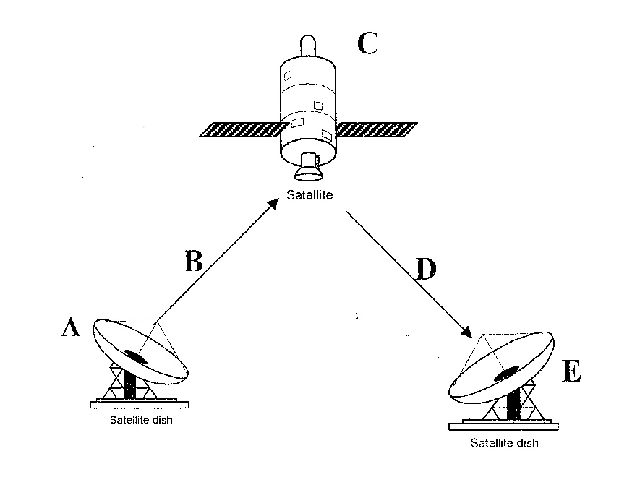

A

B

C

D
(d)Explain the meaning of the following terms as used in signal transmission. (4mks)

- Attenuation

(ii) Noise

(e)State two advantages of using fiber optic cables. (2mks)

- The information below is maintained by the sales lady at the school canteen. Study it and answer the questions that follow.
 | A | B | C | D | E | F
1 | Item | units (kg) | value (ksh) | 10% incr | Ranking
2 | oranges | 12 | 2000
3 | mangoes | 12 | 1000
4 | tomatoes | 12 | 1400
5 | cabbages | 15 | 2500
6
7 |  | 10%

- Provide an absolute formula that would be used to; ( 4 mks)
- Calculate the value(Ksh) if increased by 10%.

- To rank the items based on value( ksh)

(b) Provide a single formula that would be used to
- Count the number of items whose units are equal; to 15 (2mks)

- Sum the values of items whole units are equal to 12 (2mks)

- Differentiate the following terms as used in spreadsheets. ( 4 mks)
- What if analysis and automatic recalculation

- Relative cell refrencing and Absolute cell referencing.

(ii) Explain the three basic components of spreadsheets (3mks)

19. a) Explain two reasons for use of binary in digital technology. (2mks)

b) Perform the following binary arithmetic
i) 10100001 – 01011111 ( 2 mks)

ii) 100001010 + 11101101 ( 2 mks)

c) Using two,s complement subtract 26 from 48 and give your answer in decimal notation.( 3 mks)

d. Give two reasons why data and information in a computer system needs to be converted
to other number systems other than binary. (2mks)

e) Convert the following to their binary equivalent ( 4 mks)
i) -53

- 36.0625

20. (a) Define Internet. (1 mk)

(b) Describe the transmission of data over a telephone line (4 mks)

( c) Outline the ‘line of sight’ principle in wireless transmission. (2mks)

(d) Explain the following terms. (2 mks)
(i) Multiplexing

- Bandwidth

(iii) Explain three examples of radio waves signals (6mks)

