Name:…………………………………………..……Index Number:……….…....……….
Class…………………… Candidate’s Signature:……………..
Date:………………………………. ADM. No.: .......................................

NJORO BOYS HIGH SCHOOL
MARATHON EXAMINATION - 2014
GEOGRAPHY PAPER 2
312/2
GEOGRAPHY PAPER 2
TIME: 2 ¾ HOURS

Instructions to Candidates.

- Write your name and index number in the spaces provided.
- Sign and write the date of examination in the spaces provided above.
- Answer ALL questions in SECTION A.
- In SECTION B answer question 6 and any other 2 questions.
- All the answers must be written in the answer booklet provided.

SECTION A (Answer all Questions in this section)
- (a) Mention two social factors influencing agriculture in Kenya (2 marks)

(b) Explain three ways in which commercial beef-cattle farming contributes to the economy
of Kenya (3 marks)

- (a) Distinguish between land reclamation and land rehabilitation (2 marks)
(b) Name three methods that are used to reclaim the Lambwe Valley (3 marks)

- (a) What is ecotourism (1 mark)
(b) Outline four similarities between tourism in Kenya and Switzerland (4 marks)

- (a) Give two causes of the energy crisis (2 marks)
(b) Describe three consequences of the energy crisis in Kenya (3 marks

- (a) Explain three roles of transport and communication in the economic development of Africa (3 marks)
(b) Which two measures were undertaken to overcome the challenge of navigability on the St Lawrence Seaway. (2 marks)

SECTION B (Answer Question 6 and any other two questions in this section)
- Study the table below and use it to answer the question 6(a) below

Kenyas Exports to the European Union Countries in 2006
Item | Value in ’000 tonnes
Coffee | 234,000
Tea | 367,890
Pyrethrum | 123,000
Horticultural Produce | 400,000
Minerals | 140,000

(a) (i) Using a radius of 5 centimetres draw a pie chart to represent the information in the table
above. (7 marks)
(ii) Give two advantages of using pie charts to represent statistical information (2 marks)

(b) (i) Describe the processing of oil palm from the harvesting time to exportation (5 marks)
(ii) Give three uses of oil palm in Nigeria (3 marks)

(c) (i) What is transhumance? (2 marks)
(ii) Explain three measures taken by the Kenya Government to improve dairy farming
(6 marks)

- (a) (i) Give four characteristics of demersal fish (4 marks)
(ii) Name two traditional fishing methods (2 marks)
(iii)Describe three ways in which the meeting of cold and warm ocean currents encourages fishing. (3 marks)

(b) (i)Explain four reasons why marine fishing is of little significance in East Africa (8 marks)
(ii)Describe three challenges facing Kenyan fishermen in Lake Victoria (3 marks)

(c) (i) Other than being a source of food outline two other uses of fish (2 marks)
(ii) Mention three major challenges facing fishing in Japan (3 marks)

8. (a) (i)What factors have led to the decline of barter trade (5 marks)
(ii) Give three objectives of COMESA (3 marks)
(iii) How does Kenya benefit from being a member of COMESA (5 marks)
(b) The diagram below shows HEP projects in Africa.
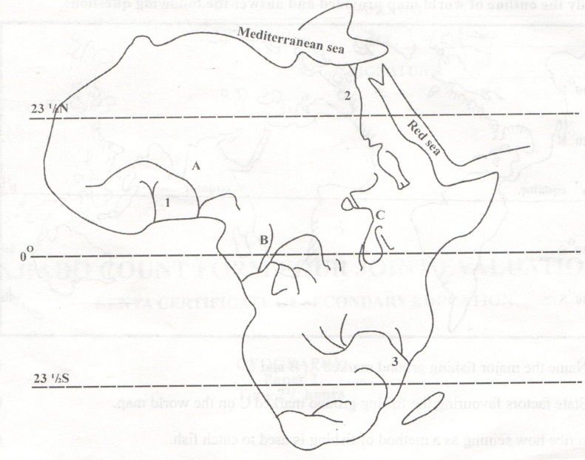
(i) Name the HEP projects marked 1,2 and 3 (3 marks)
(ii) Name the rivers marked A,B and C (3 marks)
(c) Explain three negative consequences of rationing electricity power in Kenya (6 marks)

9. Use the figure of the population pyramid below to answer question 6(a) (i) and (ii) below
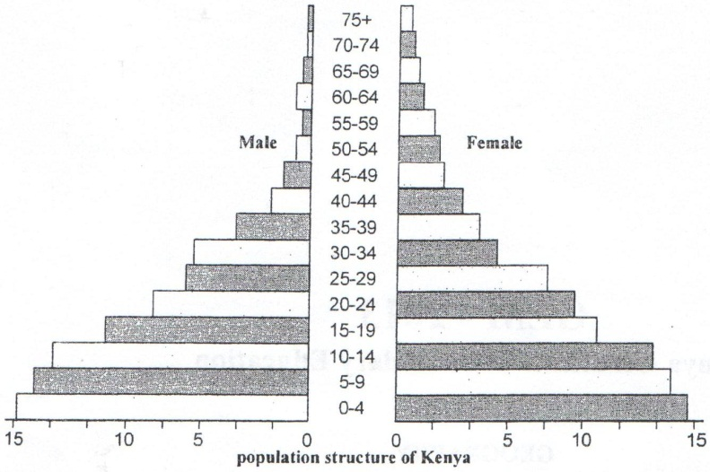
(a) (i) Describe the characteristics of the population represented by the pyramid illustrated above.
(5 marks)
(ii) Explain four economic challenges associated with the above population characteristics.
(8 marks)
(b) (i) Distingish between fertility and mortality (2 marks)
(ii) Give three reasons why governments conduct human population censuses (3 marks)
(iii) Outline four cultural factors behind the rapidly growing population growth in Kenya
(4 marks)
(c) Mention three effects of rural urban migration on rural areas ( 3 marks)

10. (a) (i) What is an environmental hazard (2 marks)
(ii) Outline three reasons for the need of environmental management and conservation
(6 marks)
(b) (i) Distinguish between drought and desertification (2 marks)
(ii) Mention three effects of windstorms (3 marks)
(iii) Explain four measures taken by the Kenya government to control pollution (8 marks)
(c) Give four roles of the National Environmental Management Authority (4 marks)

