Name:……….............................................Index Number ……………………Date ......................
Candidate’s Signature:……........................

443/1
AGRICULTURE
PAPER 1
MOCK JULY- 2014
TIME 2 HOURS

STAREHE GIRLS’ CENTRE MOCK EXAMINATIONS- 2014
Kenya Certificate of Secondary Education

443/1
AGRICUITURE
PAPER 1
JULY - 2014

INSTRUCTIONS TO CANDIDATES
- Answer All the Question in section A and B and TWO questions in section C.
- ALL Answers must be clearly shown and diagrams must be visible in any.

For Examiner’s Use Only.
Section | Questions | Maximum Marks | Candidate’s Score
A | 1-20 | 30
B | 21 -24 | 20
C | 25 | 20
C | 26 | 20
C | 27 | 20
C | GRAND TOTAL

This paper consists of 14 printed pages. Students should check the question paper to ensure that all pages are
Printed as indicated and that no questions are missing.

SECTION A - (30 Marks)
Answer all the questions on the spaces provided on this section.

- Differentiate between apiculture and aquaculture (1 mark )
………………………………………………………………………………………………………………………………………………………………………………………………………………………………………………………………………………………………………………………………………………………………………………………………………………………………………………………………………………………………………………………………………

- Give two examples of variable and fixed inputs
- Variable inputs (1 mark )
………………………………………………………………………………………………………………………………………………………………………………………………………………………………………………………………………………………………………………

- Fixed inputs (1 mark
……………………………………………………………………………………………………… ……………………………………………………………………………………………………… ………………………………………………………………………………………………………
- Name two positive effects of wind on farming (1 mark )

………………………………………………………………………………………………………………………………………………………………………………………………………………………………………………………………………………………………………………………………………………………………………………………………………………………………………………………………………………………………………………………………………

- Give four activities involved in land clearing during land preparation (2 marks)

……………………………………………………………………………………………………………………………………………………………………………………………………………………………………………………………………………………………………………………………………………………………………………………………………………………………………………………………………………………………………………………………………………………………………………………………………………………………………………

- Differentiate between opening valuation and closing valuation in farm accounts (1 mark)
………………………………………………………………………………………………………………………………………………………………………………………………………………………………………………………………………………………………………………………………………………………………………………………………………………………………………………………………………………………………………………………………………
- State two excellent adaptations of weed to their environment (1 marks)
………………………………………………………………………………………………………………………………………………………………………………………………………………………………………………………………………………………………………………………………………………………………………………………………………………………………………………………………………………………………………………………………………

- State three characteristics of tree for agro forestry (1½ marks)
………………………………………………………………………………………………………………………………………………………………………………………………………………………………………………………………………………………………………………………………………………………………………………………………………………………………………………………………………………………………………………………………………
- State any two factors which determine the amount of fertilizer to be applied in the farm (1 mark)
………………………………………………………………………………………………………………………………………………………………………………………………………………………………………………………………………………………………………………………………………………………………………………………………………………………………………………………………………………………………………………………………………
- What is seed dormancy? (1 mark)
………………………………………………………………………………………………………………………………………………………………………………………………………………………………………………………………………………………………………………………………………………………………………………………………………………………………………………………………………………………………………………………………………
- State three disadvantage of over head irrigation. (1½ marks)
………………………………………………………………………………………………………………………………………………………………………………………………………………………………………………………………………………………………………………………………………………………………………………………………………………………………………………………………………………………………………………………………………

- A farmer was advised to apply 200kg of CAN per hectare while top dressing the maize crop, CAN contains 21% Nitrogen calculate the amount of Nitrogen applied per ha (show your working) (2 marks)

- Give two features of perennial weeds that make them difficult to control. (1 mark)
………………………………………………………………………………………………………………………………………………………………………………………………………………………………………………………………………………………………………………………………………………………………………………………………………………………………………………………………………………………………………………………………………

- Give three importance of time by planting (1½ marks)
………………………………………………………………………………………………………………………………………………………………………………………………………………………………………………………………………………………………………………………………………………………………………………………………………………………………………………………………………………………………………………………………………
- Give three reasons as to why ear thing up is done in crop production (1½marks)

………………………………………………………………………………………………………………………………………………………………………………………………………………………………………………………………………………………………………………………………………………………………………………………………………………………………………………………………………………………………………………………………………

- State four advantages of establishing seeds in a nursery instead of planting directly into the field (2 marks)

………………………………………………………………………………………………………………………………………………………………………………………………………………………………………………………………………………………………………………………………………………………………………………………………………………………………………………………………………………………………………………………………………
………………………………………………………………………………………………………………………………………………………………………………………………………………………………………………………………………………………………………………………

- Explain the term ‘roguing’ as used in crop production (1 mark)
………………………………………………………………………………………………………………………………………………………………………………………………………………………………………………………………………………………………………………………………………………………………………………………………………………………………………………………………………………………………………………………………………

- State four advantages of practicing mixes farming in Kenya (2 marks)
………………………………………………………………………………………………………………………………………………………………………………………………………………………………………………………………………………………………………………………………………………………………………………………………………………………………………………………………………………………………………………………………………
………………………………………………………………………………………………………………………………………………………………………………………………………………………………………………………………………………………………………………………

- Give two ways in which good communication has contributed positively towards Agricultural growth. (1 mark)
………………………………………………………………………………………………………………………………………………………………………………………………………………………………………………………………………………………………………………………………………………………………………………………………………………………………………………………………………………………………………………………………………

- Give two importance of ridging as a tertiary operation in crop production. (1marks)

………………………………………………………………………………………………………………………………………………………………………………………………………………………………………………………………………………………………………………………………………………………………………………………………………………………………………………………………………………………………………………………………………
a. What is irrigation? ( ½marks)

………………………………………………………………………………………………………………………………………………………………………………………………………………………………………………………………………………………………………………………
b. State three conditions under which irrigation is recommended to be used. (1¹/₂ mark)
………………………………………………………………………………………………………………………………………………………………………………………………………………………………………………………………………………………………………………………………………………………………………………………………………………………………………………………………………………………………………………………………………
- State four ways in which soil fertility can be maintained. (2 marks

………………………………………………………………………………………………………………………………………………………………………………………………………………………………………………………………………………………………………………………………………………………………………………………………………………………………………………………………………………………………………………………………………

SECTION B - (20MARKS)
Answer all the questions in the spaces provided.

- The following table illustrates the relationship between the input (NPK) fertilizer and total maize production (90kg) bag.
NPK fertilizer Total maize Marginal
In put (kg) production products in
In 90 kg bags 90kg bags
0 5 __
30 12 __
60 28 __
90 47 __
120 59 __
150 65 __
180 68 __
210 70 __
240 70 __
270 68 __

a. Calculate the marginal production (5 marks)

b. On a graph paper, plot put of the maize against the NPK fertilizer (4 marks)

c. What is the name given to the relationship between the units of input that a farmer employs in the production and the corresponding units of out put? (1 mark)

………………………………………………………………………………………………………………………………………………………………………………………………………………………………………………………………………………………………………………………………………………………………………………………………………………………………………………………………………………………………………………………………………

- The diagram below shows one method of propagation. Study them carefully and answer the questions that follow.

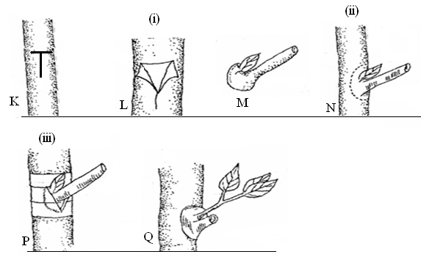

a. Identify the method of crop propagation illustrated above. (1 mark)
………………………………………………………………………………………………………………………………………………………………………………………………………………………………………………………………………………………………………………………………………………………………………………………………………………………………………………………………………………………………………………………………………

b. Describe the activities illustrate by (i) and (ii) (2 marks)

………………………………………………………………………………………………………………………………………………………………………………………………………………………………………………………………………………………………………………………………………………………………………………………………………………………………………………………………………………………………………………………………………

c. State one reason for carrying out the procedure (iii) (1 mark)
………………………………………………………………………………………………………………………………………………………………………………………………………………………………………………………………………………………………………………………………………………………………………………………………………………………………
d. Name one crop that can be propagated by above method. (1 mark)
………………………………………………………………………………………………………………………………………………………………………………………………………………………………………………………………………………………………………………………………………………………………………………………………………………………………………………………………………………………………………………………………………

- Study the illustration of a soil and water conservation structure shown below and answer the questions follow
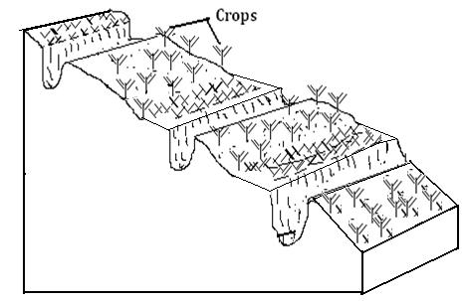

a. Identify the methods of soil and water conservation illustrated above (1 mark)

………………………………………………………………………………………………………………………………………………………………………………………………………………………………………………………………………………………………………………………………………………………………………………………………………………………………………………………………………………………………………………………………………

b. State three practices undertaken to ensure the above structure remains stable. (1½ marks)

………………………………………………………………………………………………………………………………………………………………………………………………………………………………………………………………………………………………………………………………………………………………………………………………………………………………………………………………………………………………………………………………………

- The diagram below shows a common weed. Study it carefully and answer the questions that follow.
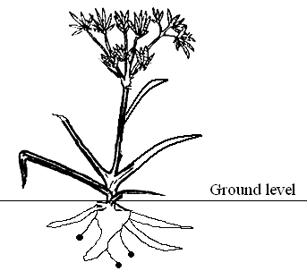

a. Name the weed (1 mark)
………………………………………………………………………………………………………………………………………………………………………………………………………………

b. Why is it difficult to control the above weed? (½ marks)
………………………………………………………………………………………………………………………………………………………………………………………………………………………………………………………………………………………………………………………………………………………………………………………………………………………………………………………………………………………………………………………………………

c. State two economic importance of the weed. (1 mark)

………………………………………………………………………………………………………………………………………………………………………………………………………………………………………………………………………………………………………………………………………………………………………………………………………………………………………………………………………………………………………………………………………

SECTION C - (40 MARKS)
Answer only two questions in this section in the spaces provided.

- Describe the production of onions under the following sub headings
a. Ecological requirements (4marks)
b. Planting (5 marks)
c. Field practices (4 marks)
d. Harvesting and marketing (7 marks)

26 a. Explain uses of farm records (14marks
b. Explain the various ways by which a farmer can adjust to risks and uncertainties (6 marks)

27. a. Explain five causes of land fragmentation in Kenya since independence (5 marks)
b. Describe the advantages of land consolidation and registration. (8 marks)
c. Explain the objectives of land reform under taken in Kenya. (7 marks)

…………………………………………………………………………………………………………………………………………………………………………………………………………………………………………………………………………………………………………………………………………………………………………………………………………………………………………………………………………………………………………………………………………………………………………………………………………………………………………………………………………………………………………………………………………………………………………………………………………………………………………………………………………………………………………………………………………………………………………………………………………………………………………………………………………………………………………………………………………………………………………………………………………………………………………………………………………………………………………………………………………………………………………………………………………………………………………………………………………………………………………………………………………………………………………………………………………………………………………………………………………………………………………………………………………………………………………………………………………………………………………………………………………………………………………………………………………………………………………………………………………………………………………………………………………………………………………………………………………………………………………………………………………………………………………………………………………………………………………………………………………………………………………………………………………………………………………………………………………………………………………………………………………………………………………………………………………………………………………………………………………………………………………………………………………………………………………………………………………………………………………………………………………………………………………………………………………………………………………………………………………………………………………………………………………………………………………
………………………………………………………………………………………………………………………………………………………………………………………………………………………………………………………………………………………………………………………………
………………………………………………………………………………………………………………………………………………………………………………………………………………………………………………………………………………………………………………………………
…………………………………………………………………………………………………………………………………………………………………………………………………………………………………………………………………………………………………………………………………………………………………………………………………………………………………………………………………………………………………………………………………………………………………………………………………………………………………………………………………………………………………………………………………………………………………………………………………………………………………………………………………………………………………………………………………………………………………………………………………………………………………………………………………………………………………………………………………………………………………………………………………………………………………………………………………………………………………………………………………………………………………………………………………………………………………………………………………………………………………………………………………………………………………………………………………………………………………………………………………………………………………………………………………………………………………………………………………………………………………………………………………………………………………………………………………………………………………………………………………………………………………………………………………………………………………………………………………………………………………………………………………………………………………………………………………………………………………………………………………………………………………………………………………………………………………………………………………………………………………………………………………………………………………………………………………………………………………………………………………………………………………………………………………………………………………………………………………………………………………………………………………………………………………………………………………………………………………………………………………………………………………………………………………………………………………………
………………………………………………………………………………………………………………………………………………………………………………………………………………………………………………………………………………………………………………………………
………………………………………………………………………………………………………………………………………………………………………………………………………………………………………………………………………………………………………………………………
……………………………………………………………………………………………………………………………………………………………………………………………………………………………………………………………………………………………………………………………………………………………………………………………………………………………………………………………………………………………………………………………………………………………………………………………………………………………………………………………………………………………………………………………………………………………………………………………………………………………………………………………………………………………………………………………………………………………………………………………………………………………………………………………………………………………………………………………………………………………………………………………………………………………………………………………………………………………………………………………………………………………………………………………………………………………………………………………………………………………………………………………………………………………………………………………………………………………………………………………………………………………………………………………………

