STAREHE GIRLS’ CENTRE

NAME……………………………………………………INDEX NO…………………ADM……….…CLASS…
CANDIDATE’S SIGNATURE………………………… DATE……………………………………………………

Kenya Certificate of Secondary Education
AGRICULTURE
Paper 2
July/ August 2014
Time: 2 hours

INSTRUCTIONS TO CANDIDATES
- Write your name and index number in the spaces provided above.
- Sign and write the date of examination in the spaces provided above.
- This paper consists of THREE sections A, B and C.
- Answer ALL the questions in Sections A and B in the spaces provided.
- Answer any two questions from section C.
- Answers to all questions must be in the spaces provided.
- This paper consists of 14 printed pages.
- Candidates should check the question paper to ascertain that all the pages are printed as
indicated and that no questions are missing.

For examiner’s use only
Section | Question | Maximum score | Candidates Score
A | 1 - 21 | 30
B | 22 - 25 | 20
C | 26 - 28 | 20  20
Total Score |  | 90

SECTION A (30 MARKS)
Answer ALL the questions in this section

1. Differentiate between selection and culling in animals. Selection
_______________________________________________________________________________________________________________________________________________________________________________
Culling
____________________________________________________________________________________________________________________________________________________________ ___________________
2. State three methods of stocking a beehive. ( 1 ½ marks)
_______________________________________________________________________________________________________________________________________________________________________________________________________________________________________________________________________
3. What term is used to describe a case where during parturition the hind legs comes out first. (½ mark)
_______________________________________________________________________________________

4. Give three methods of selection. ( 1 ½ marks)
_______________________________________________________________________________________________________________________________________________________________________________________________________________________________________________________________________
_______________________________________________________________________________________________________________________________________________________________________________________________________________________________________________________________________
5. Give the two breeding system used in livestock improvement. ( 1 mark )
_______________________________________________________________________________________________________________________________________________________________________________
______________________________________________________________________________________________________________________________________________________________________________
6. State four advantages of embryo transplant. (2 marks )
_______________________________________________________________________________________________________________________________________________________________________________________________________________________________________________________________________________________________________________________________________________________________________________________________________________________________________________________
_______________________________________________________________________________________
7. Give the four groups of vaccines. (2 marks )
________________________________________________________________________________________________________________________________________________________________________________________________________________________________________________________________________________________________________________________________________________________________
______________________________________________________________________________________________________________________________________________________________________________
8. Give the two types of lambing management. ( 1 mark )
_______________________________________________________________________________________________________________________________________________________________________________________________________________________________________________________________________________________________________________________________________________________________
9. Give four of the six parts of Kenya top bar hive. (2 marks )
_______________________________________________________________________________________________________________________________________________________________________________________________________________________________________________________________________________________________________________________________________________________________
______________________________________________________________________________________________________________________________________________________________________________
10. Give two diseases mostly affecting bees. ( 1 mark )
_______________________________________________________________________________________________________________________________________________________________________________
______________________________________________________________________________________________________________________________________________________________________________
11. Soil is a factor to assist in fish farming. (Clay is the best). State the four procedural activity to test
whether the soil is suitable to make a fish pond. ( 2 marks )
_______________________________________________________________________________________________________________________________________________________________________________________________________________________________________________________________________________________________________________________________________________________________
12. Give the two types of treatment administered to animals. ( 1 mark )
______________________________________________________________________________________
_______________________________________________________________________________________
________________________________________________________________________________________
_______________________________________________________________________________________

13.State three signs of anthrax infection disease observed in the carcass of cattle. ( 1 ½ marks )
_____________________________________________________________________________________
____________________________________________________________________________________
____________________________________________________________________________________
____________________________________________________________________________________
______________________________________________________________________________________________________________________________________________________________________________
14.Give four preventive measures of milk fever (Parturient parensis ) ( 2 marks )
________________________________________________________________________________________
________________________________________________________________________________________
________________________________________________________________________________________
________________________________________________________________________________________
________________________________________________________________________________________
______________________________________________________________________________________________________________________________________________________________________________
15. Give two examples of viral diseases in animals. ( 1 mark )
____________________________________________________________________________________
____________________________________________________________________________________
____________________________________________________________________________________
____________________________________________________________________________________
16. Give four characteristics of acaricide that must be met for it to be effective. ( 2 marks )
___________________________________________________________________________________
___________________________________________________________________________________
___________________________________________________________________________________
___________________________________________________________________________________
___________________________________________________________________________________
17. Give four conditions necessary for artificial incubation. (2 marks )
__________________________________________________________________________________
__________________________________________________________________________________
__________________________________________________________________________________
__________________________________________________________________________________
__________________________________________________________________________________
__________________________________________________________________________________

18.Give four characteristics of colostrums that made it ideal for a calf. ( 2 marks )
__________________________________________________________________________________
__________________________________________________________________________________
__________________________________________________________________________________
__________________________________________________________________________________
__________________________________________________________________________________
__________________________________________________________________________________

19. List three advantages of Biogas. ( 1 ½ marks )
__________________________________________________________________________________
__________________________________________________________________________________
__________________________________________________________________________________
__________________________________________________________________________________
__________________________________________________________________________________

20. What is the work of hydraulic system in a tractor? (½ mark )
__________________________________________________________________________________
__________________________________________________________________________________
__________________________________________________________________________________
__________________________________________________________________________________
__________________________________________________________________________________
__________________________________________________________________________________
21. Name one dual purpose breed of the following animals. ( 1 mark)
(a) Sheep ____________________________________________________________________
(b) Cow _________________________________________________________ ___________

SECTION B - (20 mks)
22. Study the diagram of a cow below and answer the subsequent questions.

- Identify the livestock equipment marked E above. (1mark)
______________________________________________________________

ii) State TWO uses of the equipment in 18(i) above (2 marks)
__________________________________________________________________________________
__________________________________________________________________________________
__________________________________________________________________________________
__________________________________________________________________________________

iii) Name the TWO types of identification marks applied on the animal above. (2 marks)
__________________________________________________________________________________
__________________________________________________________________________________
__________________________________________________________________________________
__________________________________________________________________________________

iv) Show with an arrow and mark with letter P where pye-grease should be applied on the animal. (1 mark)

23. The diagram below shows a tractor drawn implement. Study it carefully and answer the questions that follow.
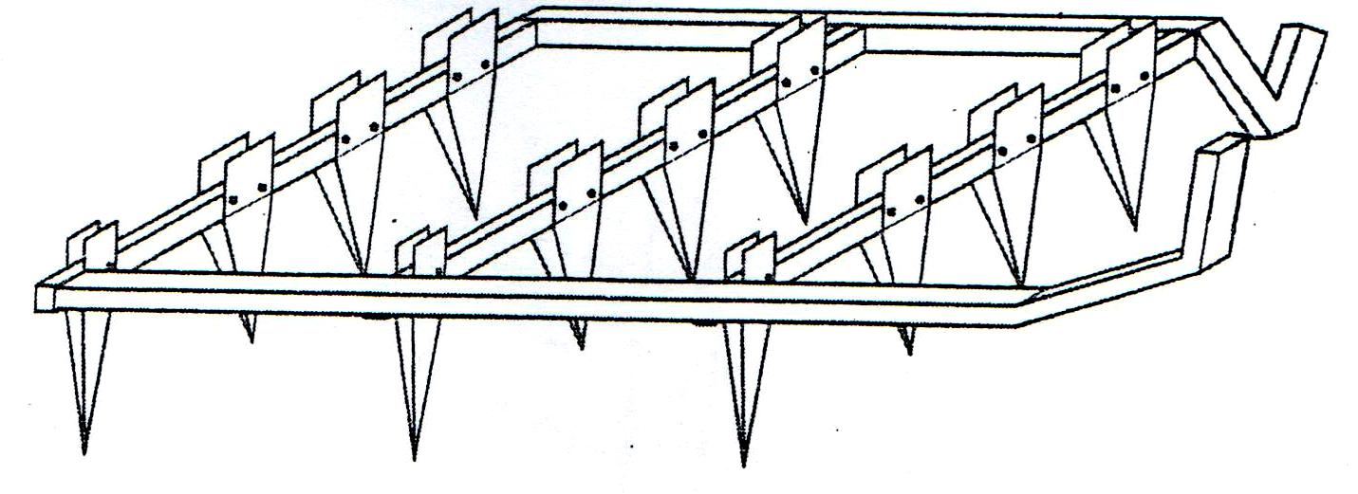

a)(i) Identify the implement. (1mark)

___________________________________________________________________________
(ii) Give two uses of the implement (2 mks)
________________________________________________________________________________________
________________________________________________________________________________________
________________________________________________________________________________________
________________________________________________________________________________________
________________________________________________________________________________________
________________________________________________________________________________________

(iii) List two maintenance practices carried out on the implement. (1 mk)
________________________________________________________________________________________
________________________________________________________________________________________
________________________________________________________________________________________
________________________________________________________________________________________

- The diagram below represents farm tools. Study them carefully and answer the questions follow
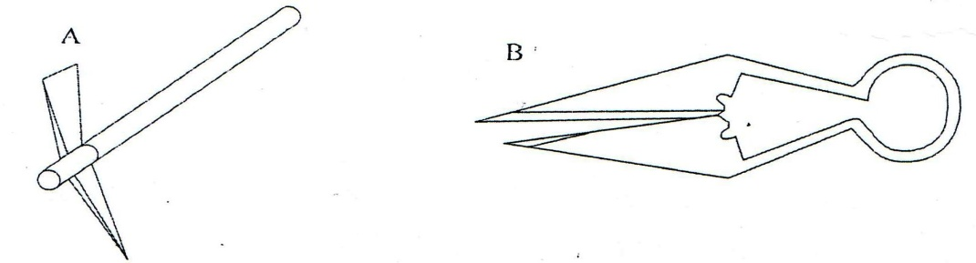

(i) Identify tool A and B ( 1mk)
A_______________________________________________________________
B_______________________________________________________________
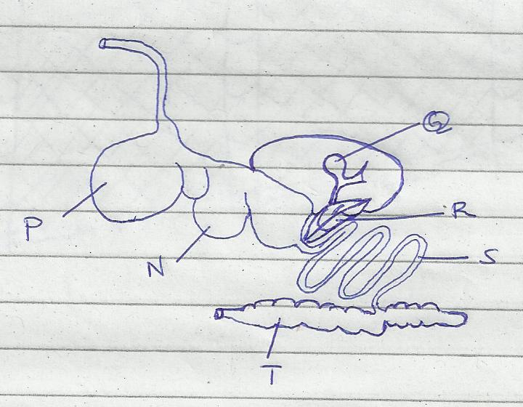
24.The diagram below shows the digestive system of cattle. Study it and answer the questions that follow.

a) Name the parts labeled N, P, Q and R (2mks)
N_________________________________________
P__________________________________________
Q__________________________________________
R__________________________________________

b) State one function for each of the parts labeled S and T. (1mks)
S___________________________________________________________________________
___________________________________________________________________________

T__________________________________________________________________________
___________________________________________________________________________

c) Give one enzyme produced by each of the parts labeled R and S. (1mks)
R________________________________________________________________________ S________________________________________________________________________

25.a) Name the type of wire fence illustrated in the diagram G below. (½ mark)

________________________________________________________________________

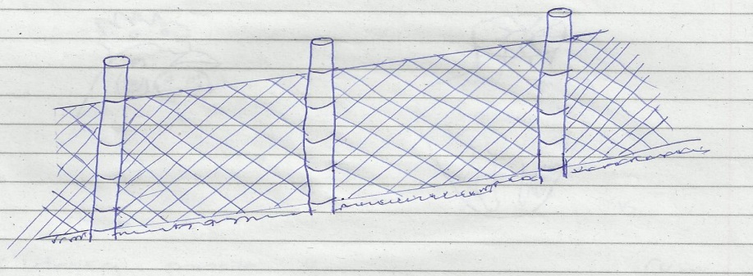
b) Name the type of live fence in the diagram H below. (½ mark)
___________________________________________________________________________

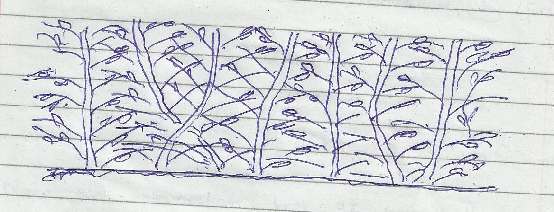

c) Name the correct material and tool for fastening the wire onto the wooden part when constructing the type of fence illustrated in diagram G. (1 mark)
________________________________________________________________________________________
________________________________________________________________________________________
________________________________________________________________________________________
________________________________________________________________________________________

- State two advantages that fence G may have over fence H. (2 marks)

________________________________________________________________________________________
________________________________________________________________________________________
________________________________________________________________________________________
________________________________________________________________________________________
________________________________________________________________________________________
________________________________________________________________________________________

- Give one use of each of the tools above.
- ___________________________________ ( ½ mk)
- ______________________________________ ( ½ mk)

SECTION C - (40 marks)
Answer ANY two questions in this section in the spaces provided:

23. (a) Describe brucellosis disease in cattle under the following subheadings.
(i) Causal organism ( 1mk)
(ii) Symptoms of attack (4 mks)
(iii) Control measures (5 mks)
(b) Explain the factors considered when selecting breeding stock. ( 10mks)

24. (a) Give the differences between petrol and diesel engine. (10 mks)
(b) Outline five advantages of farm mechanization. (5 mks)
(c) Explain factors considered in selection of construction materials. ( 5mks)

25. Describe management of a gilt from weaning to farrowing. (20 mks)

__________________________________________________________________________________________________________________________________________________________________________________________________________________________________________________________________________________________________________________________________________________________________________________________________________________________________________________________________________________________________________________________________________________________________________________________________________________________________________________________________________________________________________________________________________________________________________________________________________________________________________________________________________________________________________________________________________________________________________________________________________________________________________________________________________________________________________________________________________________________________________________________________________________________________________________________________________________________________________________________________________________________________________________________________________________________________________________________________________________________________________________________________________________________________________________________________________________________________________________________________________________________________________________________________________________________________________________________________________________________________________________________________________________________________________________________________________________________________________________________________________________________________________________________________________________________________________________________________________________________________________________________________________________________________________________________________________________________________________________________________________________________________________________________________________________________________________________________________________________________________________________________________________________________________________________________________________________________________________________________________________________________________________________________________________________________________________________________________________________________________________________________________________________________________________________________________________________________________________________________________________________________________________________________________________________________________________________________________________________________________________________________________________________________________________________________________________________________________________________________________________________________________________________________________________________________________________________________________________________________________________________________________________________________________________________________________________________________________________________________________________________________________________________________________________________________________________________________________________________________________________________________________________________________________________________________________________________________________________________________________________________________________________________________________________________________________________________________________________________________________________________________________________________________________________________________________________________________________________________________________________________________________________________________________________________________________________________________________________________________________________________________________________________________________________________________________________________________________________________________________________________________________________________________________________________________________________________________________________________________________________________________________________________________________________________________________________________________________________
_______________________________________________________________________________________________________________________________________________________________________________________________________________________________________________________________________________________________________________________________________________________________________________________________________________________________________________________________________________________________________________________________________________________________________________________________________________________________________________________________________________________________________________________________________________________________________________________________________________________________________________________________________________________________________________________________________________________________________________________________________________________________________________________________________________________________________________________________________________________________________________________________________________________________________________________________________________________________________________________________________________________________________________________________________________________________________________________________________________________________________________________________________________________________________________________________________________________________________________________________________________________________________________________________________________________________________________________________________________________________________________________________________________________________________________________________________________________________________________________________________________________________________________________________________________________________________________________________________________________________________________________________________________________________________________________________________________________________________________________________________________________________________________________________________________________________________________________________________________________________________________________________________________________________________________________________________________________________________________________________________________________________________________________________________________________________________________________________________________________________________________________________________________________________________________________________________________________________________________________________________________________________________________________________________________________________________________________________________________________________________________________________________________________________________________________________________________________
_____________________________________________________________________________________________________________________________________________________________________________________________________________________________________________________________________________________________________________________________________________________________________________________________________________________________________________________________________________________________________________________________________________________________________________________________________________________________________________________________________________________________________________________________________________________________________________________________________________________________________________________________________________________________________________________________________________________________________________________________________________________________________________________________________________________________________________________________________________________________________________________________________________________________________________________________________________________________________________________________________________________________________________________________________________________________________________________________________________________________________________________________________________________________________________________________________________________________________________________________________________________________________________________________________________________________________________________________________________________________________________________________________________________________________________________________________________________________________________________________________________________________________________________________________________________________________________________________________________________________________________________________________________________________________________________________________________________________________________________________________________________________________________________________________________________________________________________________________________________________________________________________________________________________________________________________________________________________________________________________________________________________________________________________________________________________________________________________________________________________________________________________________________________________________________________________________________________________________________________________________________________________________________________________________________________________________________________________________________________________________________________________________________________________________________________________________________________________________________________________________________________________________________________________________________________________________________________________________________________________________________________________________________________________________________________________________________________________________________________________________________________________________________________________________________________________________________________________________________________________________________________________________________________________________________________________________________________________________________________________________________________________________________________________________________________________________________________________________________________________________________________________________________________________________________________________________________________________________________________________________________________________________________________________________________________________________________________________________

