Name………………………………………………………. Index No…………………/…….
School……………………………………………………… Date ………………………….…
Candidate’s Signature………………………

233/2
CHEMISTRY
Paper 2
JULY / AUGUST - 2014
Time: 2 Hours

Starehe girls centre and school
Kenya Certificate of Secondary Education (K.C.S.E)

233/2
CHEMISTRY
Paper 2
JULY / AUGUST - 2014
Time: 2 Hours

INSTRUCTIONS TO CANDIDATES

- Write your name and index number in the spaces provided above.
- Sign and write the date of the examination in space provided.
- Answer ALL the questions in the spaces provided.
- All working must be clearly shown where necessary
- Mathematical tables and electronic calculators may be used for calculations

FOR EXAMINER’S USE ONLY
QUESTION | MAXIMUM SCORE | CANDIDATE’S SCORE
1 | 12
2 | 11
3 | 13
4 | 13
5 | 11
6 | 9
7 | 9
TOTAL | 80

This paper consists of 12 printed pages.
Candidates should check the question paper to ascertain that all pages are printed as indicated and that no question is missing

1. (a) What is a saturated solution? (1 mk)
……………………………………………………………………………………………………….
……………………………………………………………………………………………………….
(b) The diagram below represents an arrangement for a large scale manufacture of ethanol for
domestic consumption.
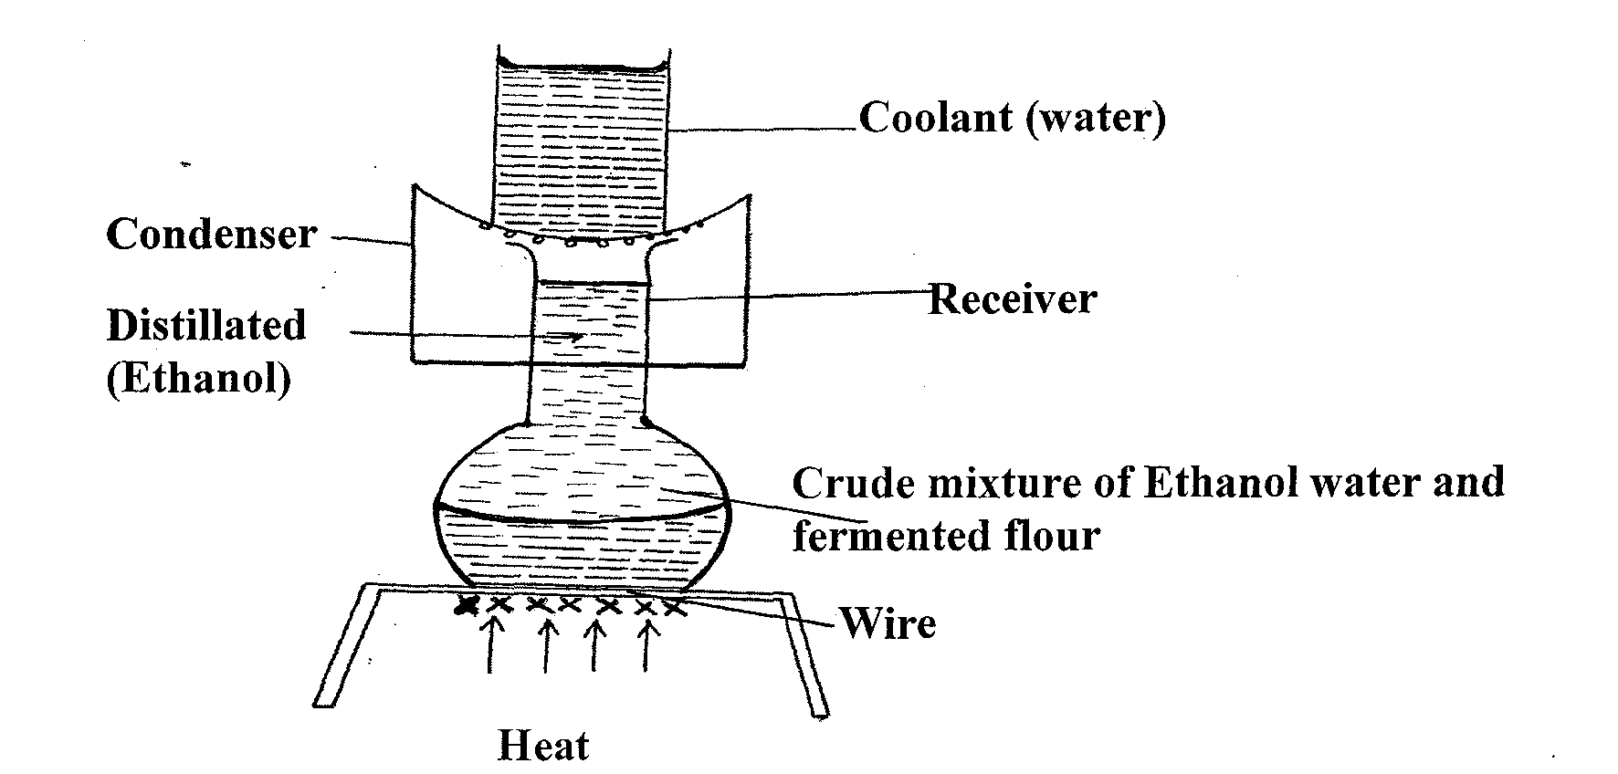
(i) Name the process by which ethanol is obtained from the crude oil. (l mk)
……………………………………………………………………………………………………….
……………………………………………………………………………………………………….
(ii) Suggest two reasons why water is a coolant in this process. (2mks)
……………………………………………………………………………………………………….
……………………………………………………………………………………………………….……………………………………………………………………………………………………….
……………………………………………………………………………………………………….
(iii) Why is it possible to separate ethanol from the mixture by this process. (1 mk)
……………………………………………………………………………………………………….
……………………………………………………………………………………………………….
(c) (i) Describe how the mixture of Ammonium chloride, sodium chloride and lead II
chloride can be separated if all the components of the mixture are to be recovered.
(3mks)
……………………………………………………………………………………………………….
……………………………………………………………………………………………………….……………………………………………………………………………………………………….
……………………………………………………………………………………………………….……………………………………………………………………………………………………….
……………………………………………………………………………………………………….

(ii) The following process shows how Nitrogen and Oxygen can be obtained from air.
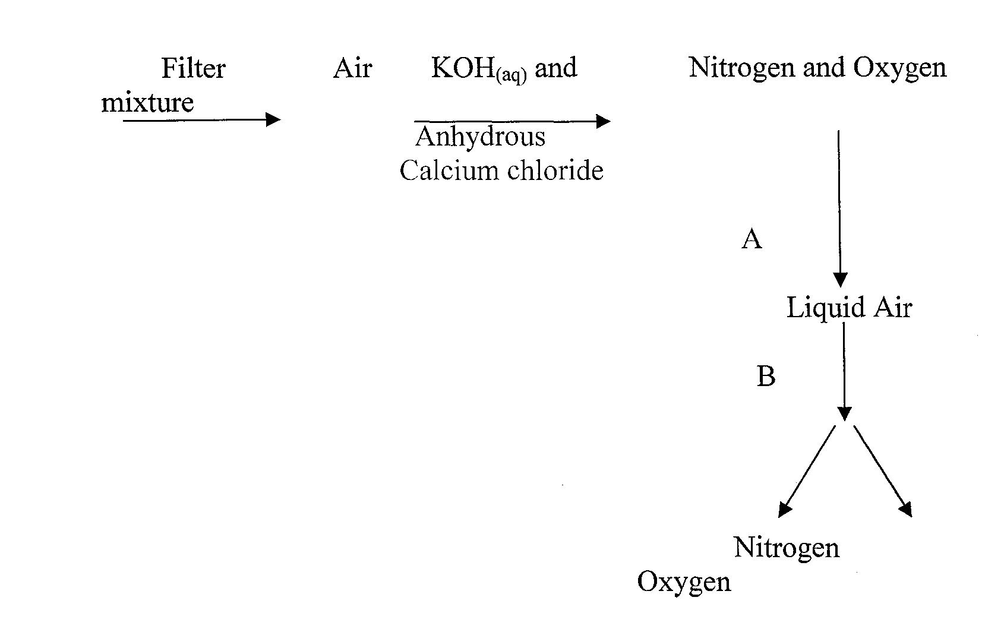

I. Name the processes
A________________________________________
(1 mk)
B________________________________________
(l mk)
II. What is the purpose of
Potassium hydroxide solution KOH _{(aq)} in the process. (1 mk)
……………………………………………………………………………………………………….
……………………………………………………………………………………………………….
Anhydrous Calcium Chloride solid. (1 mk)
……………………………………………………………………………………………………….
……………………………………………………………………………………………………….

2. (a) Give the names of the following compounds.
(i) CH₃CH₂CH₂OH (1 mk)
……………………………………………………………………………………………………….
……………………………………………………………………………………………………….
(ii) CH₃CH₂COOH (1 mk)
……………………………………………………………………………………………………….
……………………………………………………………………………………………………….

(b) Study the information in the table below and answer the questions that follow.
No. of carbon atoms per molecule | Relative molecular mass of hydrogen
2 | 28
3 | 42
4 | 56

(i) Write the general formula of the hydrocarbons in the table. (1 mk)
……………………………………………………………………………………………………….
……………………………………………………………………………………………………….
(ii) Predict the relative molecular mass of the hydrocarbon with 5 carbon atoms. (l mk)
……………………………………………………………………………………………………….
……………………………………………………………………………………………………….
(iii) Determine the molecular formula of the hydrocarbon in (ii) and draw its structural
formula. (2 mks)
……………………………………………………………………………………………………….
……………………………………………………………………………………………………….
……………………………………………………………………………………………………….
……………………………………………………………………………………………………….
(c) Study the scheme given below and answer questions that follow.
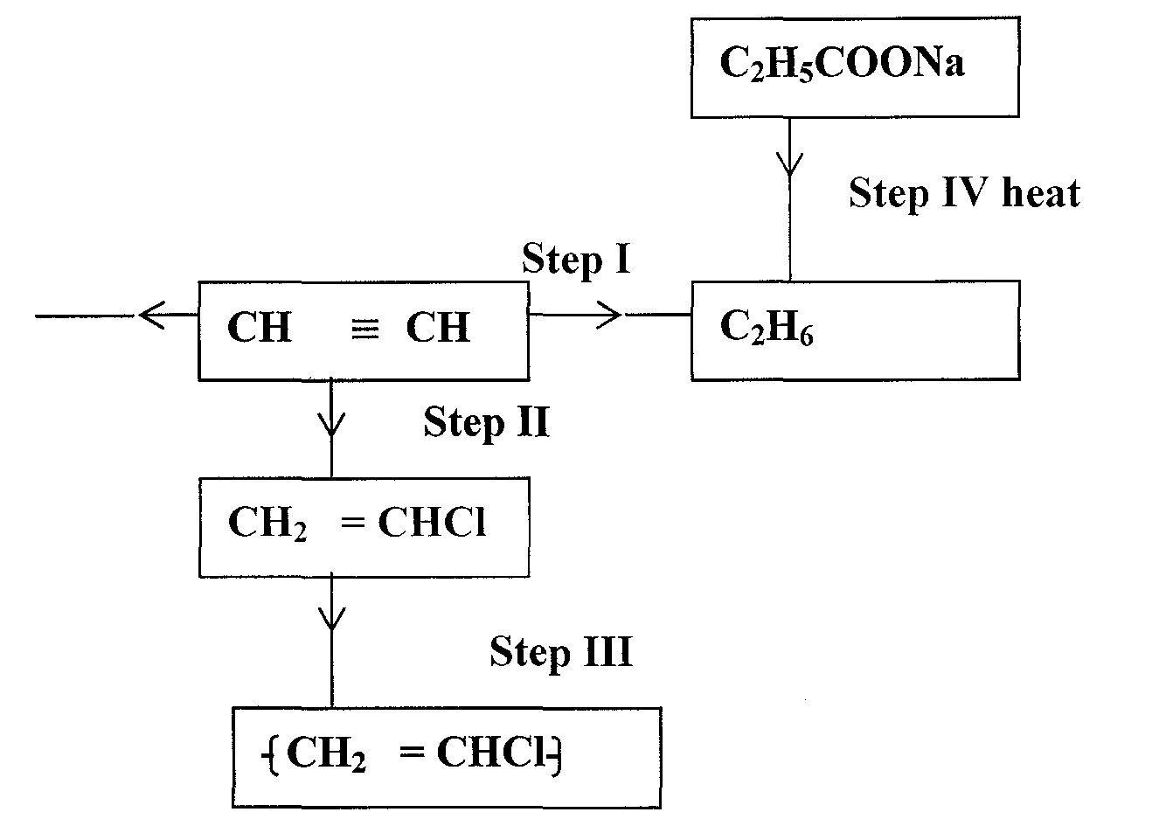
(i) Name the reagent used in
Step I (l mk)
……………………………………………………………………………………………………….
……………………………………………………………………………………………………….
Step II (1 mk)
……………………………………………………………………………………………………….
……………………………………………………………………………………………………….
Step III (1 mk)
……………………………………………………………………………………………………….
……………………………………………………………………………………………………….
(ii) Write an equation for complete combustion of CH ≡ CH (1 mk)
……………………………………………………………………………………………………….
……………………………………………………………………………………………………….
(iii) Explain one disadvantage of the continued use of items in step III. (1 mk)
……………………………………………………………………………………………………….
……………………………………………………………………………………………………….
3. (a) The diagram below represents the extraction of sulphur by the frasch process.
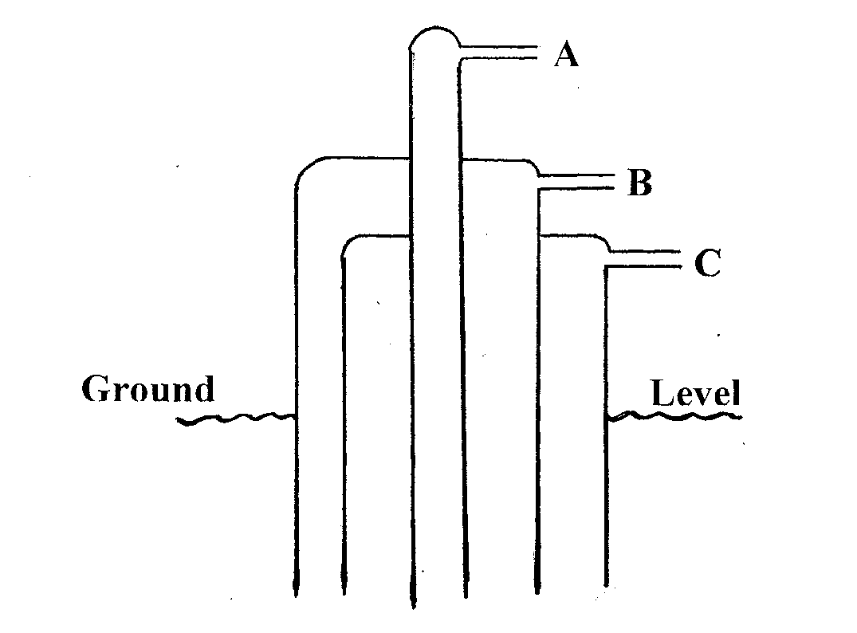
(i) Identify and state the use of the substances that pass through tubes A and C.
(2mks)
A………………………………………………………………………..
C………………………………………………………………………..
(ii) Rhombic and monoclinic are Allotropes of sulphur. They are inter convertible as
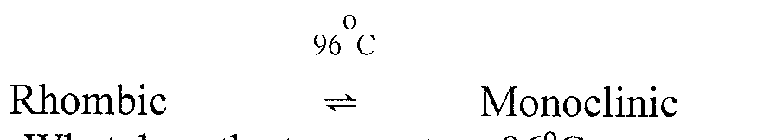
shown below.

I. What does the temperature 96°C represent. (1 mk)
……………………………………………………………………………………………………….
……………………………………………………………………………………………………….
II. State the differences in crystalline appearances between rhombic and monoclinic crystals. (l mk)
……………………………………………………………………………………………………….
……………………………………………………………………………………………………….

(b) The following scheme represents the steps followed in the contact process, study it and answer the questions which follow.
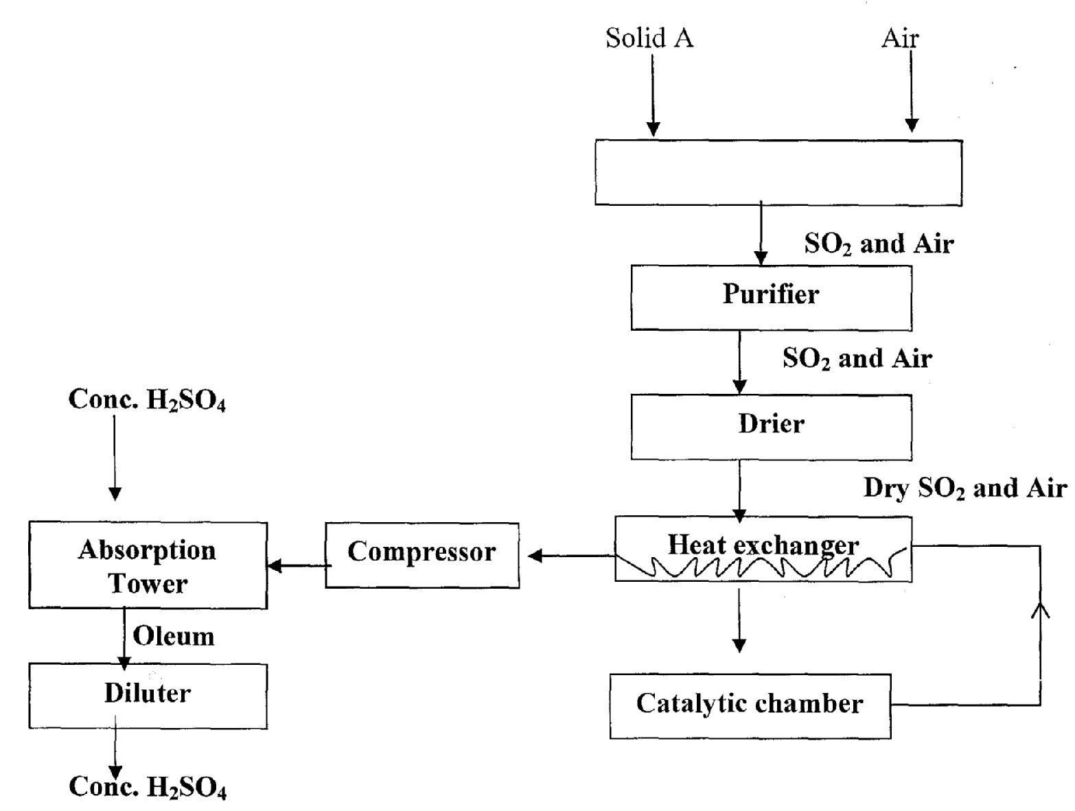

(i) Name three possible identities of solid A. (l mk)
……………………………………………………………………………………………………….
……………………………………………………………………………………………………….
……………………………………………………………………………………………………….
……………………………………………………………………………………………………….
(ii) Name two impurities removed by the purifier. (1 mk)
……………………………………………………………………………………………………….
……………………………………………………………………………………………………….
(iii) Why is it necessary to remove impurities? (l mk)
……………………………………………………………………………………………………….
……………………………………………………………………………………………………….
(c) The following chemical equation shows a reaction taking place in the catalytic chamber/converter.
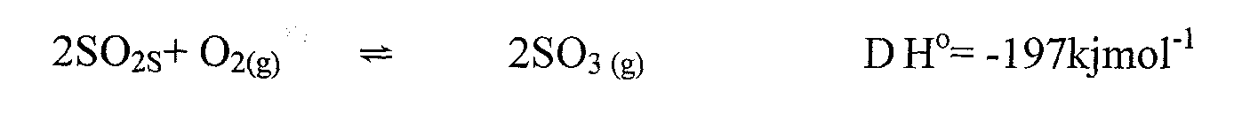
(i) How would the following factors affect the production of sulphur (IV) oxide.
I Increase in temperature. (l mk)
……………………………………………………………………………………………………….
……………………………………………………………………………………………………….

II Decrease in pressure (1 mk)
……………………………………………………………………………………………………….
……………………………………………………………………………………………………….
(ii) Name the catalyst which is commonly used in this process and why? (l mk)
……………………………………………………………………………………………………….
……………………………………………………………………………………………………….
(iii) State and explain one environmental effect of sulphur (IV) oxide in the
atmosphere. (2mks)
……………………………………………………………………………………………………….
……………………………………………………………………………………………………….
……………………………………………………………………………………………………….
……………………………………………………………………………………………………….
4. The grid below represents part of the periodic table. Study it and answer the questions that follow.
The letters do not represent the actual symbols of the elements.
A |  |  |  |  |  |  |  | K
B | D |  |  |  | G |  | I
 |  |  | F |  | H |  |  | L
C | E |  |  |  |  |  | J

(a) (i) Which letter represents an element that is least reactive. (1 mk)
……………………………………………………………………………………………………….
(ii) Why are elements D and E referred to as alkali earth metals. (1 mk)
……………………………………………………………………………………………………….
……………………………………………………………………………………………………….
(b) How does the atomic radius of F and H compare? (2mks)
……………………………………………………………………………………………………….
……………………………………………………………………………………………………….
……………………………………………………………………………………………………….
……………………………………………………………………………………………………….
(c) Select two letters representing a pair of elements that would react most explosively.
(2mks)
……………………………………………………………………………………………………….
……………………………………………………………………………………………………….
……………………………………………………………………………………………………….
……………………………………………………………………………………………………….

(d) Write an equation showing how D forms its ions. (1 mk)
……………………………………………………………………………………………………….
……………………………………………………………………………………………………….
(e) Write the formulae of
(i) Bromide of D (½ mk)
……………………………………………………………………………………………………….
(ii) Sulphate of C ( ½ mk)
……………………………………………………………………………………………………….
(f) What type of bonding exists between
(i) E and I (½ mk)
……………………………………………………………………………………………………….
(ii) G and J (½ mk)
……………………………………………………………………………………………………….
(g) Explain why the melting point of J is higher than that of I. (1 mk)
……………………………………………………………………………………………………….
……………………………………………………………………………………………………….
(h) The 1st, 2nd and 3rd ionization energies in KJ/mol of element B and C are given below.
Element | 1st I.E | 2nd I.E | 3rd I.E
B | 520 | 7,300 | 9,500
C | 420 | 3,100 | 4,800

(i) What is the 1st ionization energy? (1 mk)
……………………………………………………………………………………………………….
……………………………………………………………………………………………………….
(ii) Apart from the decrease in energy levels, explain the difference between 1st and
2nd Ionization energies. (1 mk)
……………………………………………………………………………………………………….
……………………………………………………………………………………………………….
(iii) Calculate the amount of energy in KJ/mol for the process.
C_{g} C_{g}³⁺ +3e⁻ (1 mk)

5. The flow chart below illustrates the major steps in extraction of aluminium from bauxite.
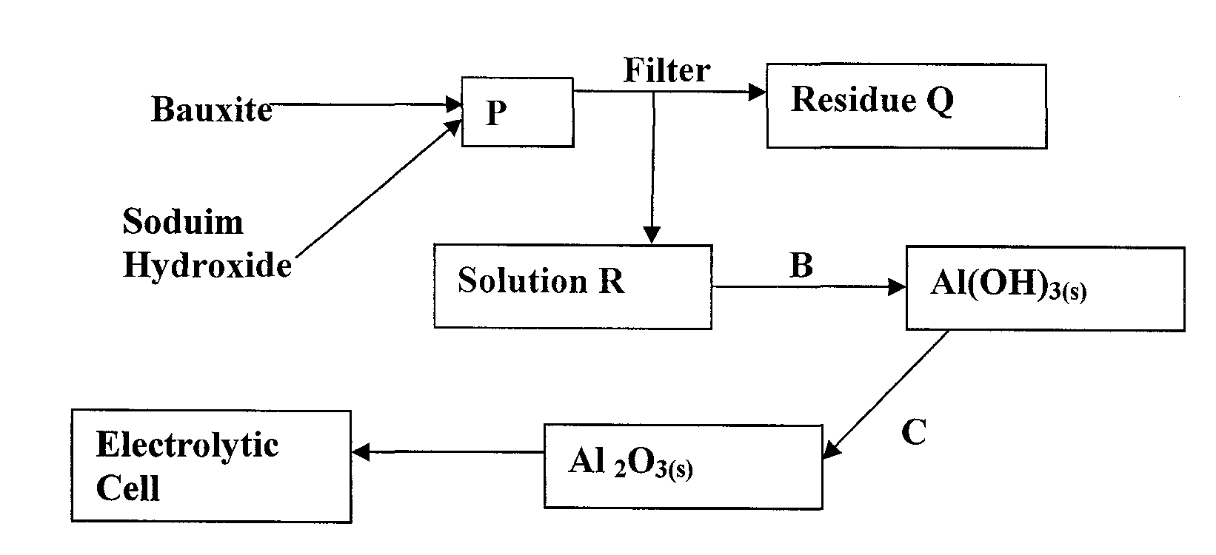
(a) (i) Give the chemical formula of bauxite. (l mk)

(ii) Write the equation for the reaction in chamber P. (l mk)
……………………………………………………………………………………………………….
……………………………………………………………………………………………………….
(iii) Write the formula of the main impurity in chamber Q. (l mk)
……………………………………………………………………………………………………….
……………………………………………………………………………………………………….
(iv) Name and explain the process that takes place at B. (2 mks)
……………………………………………………………………………………………………….
……………………………………………………………………………………………………….
……………………………………………………………………………………………………….
……………………………………………………………………………………………………….
(b) State the role of cryolite (Na₂A1F₆) in the extraction of alluminium (2 mks)
……………………………………………………………………………………………………….
……………………………………………………………………………………………………….
……………………………………………………………………………………………………….
……………………………………………………………………………………………………….
(c) Write an equation for the reaction taking place at:
i) Anode (1 mk)
……………………………………………………………………………………………………….
……………………………………………………………………………………………………….
ii) Cathode (1 mk)
……………………………………………………………………………………………………….
……………………………………………………………………………………………………….

(d) Give two properties which make alluminium and its alloys suitable for making aircraft
bodies. (2mks)
……………………………………………………………………………………………………….
……………………………………………………………………………………………………….
……………………………………………………………………………………………………….
……………………………………………………………………………………………………….
6. Use the standard electrode potentials given below to answer the questions that follow:
EV
Ag⁺_{(aq)} + e⁻ Ag_{(s)} + 0.80
Cu²⁺_{(aq)} + 2e⁻ Cu_{(s)} + 0.34
Pb²⁺_{(aq)} + 2e⁻ Pb_{(s)} - 0.13
Zn²⁺_{(aq)} + 2e⁻ Zn_{(s)} - 0.76
(a) Select two half-cells which when combined give the lowest workable cell. (lowest e.m.f) (l mk)
……………………………………………………………………………………………………….
……………………………………………………………………………………………………….
(b) Calculate the e.m.f of the cell formed by combining the two half-cells in (a) above. (1 mk)

(c) (i) Select the strongest oxidizing agent. ( ½ mk)
……………………………………………………………………………………………………….
(ii) Strongest reducing agent. (½ mk)
……………………………………………………………………………………………………….
(d) A cell was set up using lead and zinc electrodes as shown below.
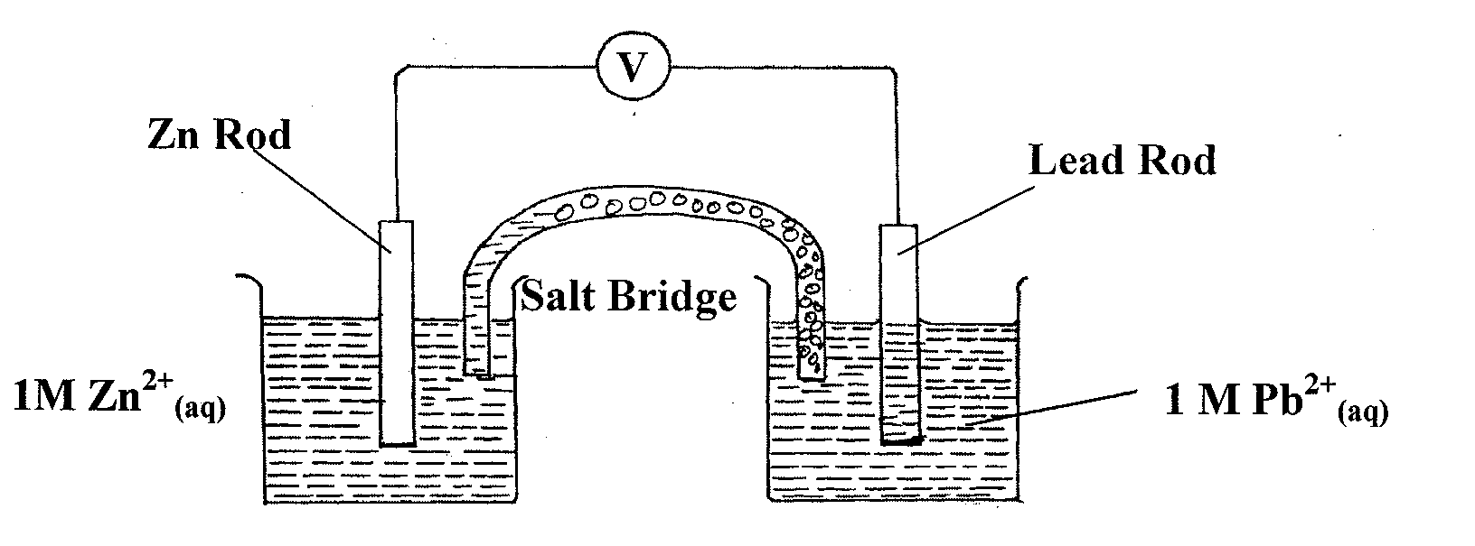
(i) Write the half equation for the half-cell in which oxidation occurs. (1 mk)
……………………………………………………………………………………………………….
……………………………………………………………………………………………………….

(ii) Write the overall cell equation. (1 mk)
……………………………………………………………………………………………………….
……………………………………………………………………………………………………….
(iii) What is the role of the salt bridge. (2 mks)
……………………………………………………………………………………………………….
……………………………………………………………………………………………………….
……………………………………………………………………………………………………….
……………………………………………………………………………………………………….
(e) An iron cup was electroplated using chromium. The chromium electrode and the iron cup
was thoroughly cleaned and weighed before being dipped into the elcolyte.
(i) Why was it necessary to clean the metals before dipping them into the electrolyte?
(1 mk)
……………………………………………………………………………………………………….
……………………………………………………………………………………………………….
(ii) A current of 0.75 A was passed through the solution for one hour and four minutes. The mass of
chromium deposited on the cup was 0.52g (l Faraday =96500C) Cr=52
I. Calculate the quantity of electricity. (1 mk)

II. How many mole of chromium were deposited. (1 mk)

III. Calculate the quantity of electricity to deposit one mole of chromium.
(1 mk)

IV. Calculate the number of Faradays required to deposit one mole of chromium and hence deduce the charge of ion. (2 mks)

7. (a) The curve below represents the change of concentration with time in a chemical reaction.
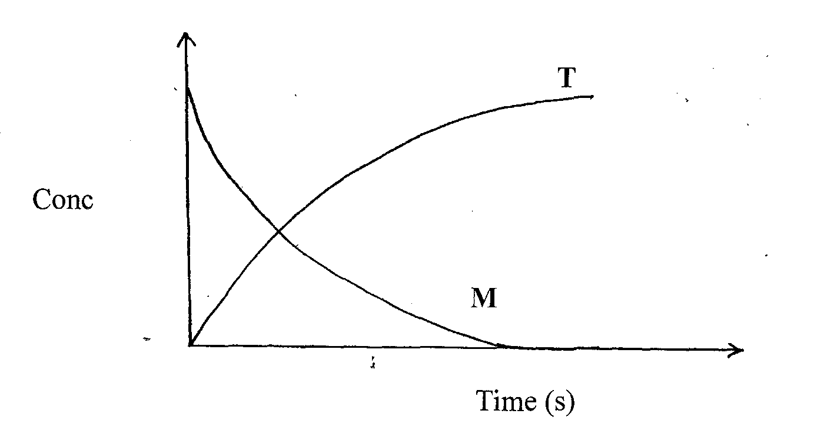
(i) Which curve represents change in concentration for:
Reactants………………………………………………………………… ( ½ mk)
Products…………………………………………………………………. ( ½ mk)
(ii) On the same axes sketch the curves of T and M for the catalysed reaction. (l mk)

(b) (i) Y grammes of a radioactive isotope take 120 days to decay to 3.5 grammes. The
half-life period of the isotope is 20 days. Find the initial mass of the isotope.
(2 mks)

(ii) Below is a radioactive decay series starting from
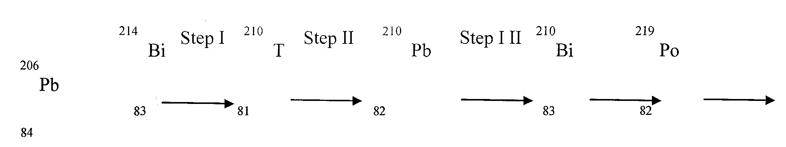

I Identify the particles emitted in Steps I and II.
Step I ………………………………………………………………………………………………
Step II
………………………………………………………………………………………………
END

