312/1
GEOGRAPHY
PAPER 1
JULY 2014
TIME: 2 ¾ Hours

KCSE MOCK
STAREHE GIRLS’
FORM 4 2014

INSTRUCTIONS TO CANDIDATES
- Answer all the questions in section A
- In Section B answer question 6 and any other two questions.
- Answer section A and each question attempted in Section B on a separate answer sheet.
- This paper consists of 5 printed pages
- Students should check the question paper to ensure that all pages are printed as indicated and that no questions are missing.

SECTION A
Answer ALL the questions in this section.

Q1. a) Study the diagram below and answer the questions that follow

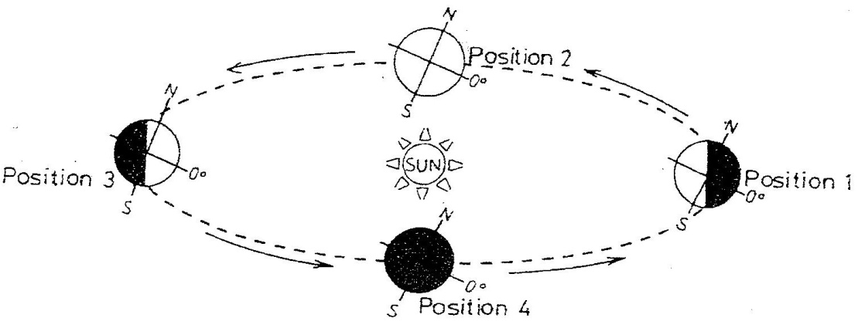

(i ) If the earth takes 366 days to make a complete revolution during a leap year, how long will
it take to move from position 1 to position 4? ( 2 mks)
(ii) Give three effects of the movement represented by the diagram ( 3mks)

Q2. a) Give two examples of mechanically formed sedimentary rocks. (2mks)
b) State two changes that occur in sedimentary rocks when they are subjected to intense
heat and pressure. (2 mks)

Q3. a) What is soil conservation? (2mks)
b) State three factors that contribute to soil leaching (3mks)

Q4. a) Differentiate between folding and faulting (2mks)
b) Give three reasons why it is necessary to study plate tectonics theory. (3mks)

Q5. a) State three conditions that influence river capture (3mks)
b) Differentiate between river rejuvenation and river capture (2mks)

SECTION B
Answer question 6 and any other TWO questions from this section.

6. Study the Map of Homa Bay 1:50000(129/2) provided and answer the following questions.
(a) ( i)What is the six figure grid reference of the Borehole at Olambwe Valley National
Reserve. (1mk)
( ii) Measure the distance of the all weather road loose surface from the junction at Lieta market
to Lake Victoria. (2mks)
(iii) What is the bearing of the Air photo principal point No. 20 from Gamba Dam (1mk)

b) (i) Calculate the area bound by the national reserve .(Give your answer in square kilometers) (2mks)
ii) Describe the relief of the area covered by the map. (5mrks)
c) (i) Using a scale of 1cm represent 50 feet, draw a cross section from grid reference 490410 to
grid reference 560410. (4mks)

ii) On the cross section mark and name the following:
- a hill (1mk)
- a river (1mk)
- All weather road loose surface (1mk)
iii) State the intervisibility of the cross section (1mk)

d) Citing evidence from the map, explain three factors that influence distribution of settlement in
the area covered by the map. (6mks)

Q7. (a) The table below shows rainfall and temperature figures of station in Africa
Month | J | F | M | A | M | J | J | A | S | O | N | D
Temp in ⁰C | 24 | 24 | 23 | 22 | 19 | 17 | 17 | 18 | 19 | 20 | 22 | 23
Rainfall in mm | 109 | 122 | 130 | 76 | 52 | 34 | 28 | 38 | 70 | 108 | 121 | 120

(ii) Describe the rainfall pattern of the station (4mks)
(iii) Calculate the average monthly temperature for the station (Show your calculations ) (2mks)
(b) Describe how a six’s thermometer works (5mks)

c ) i)Explain how lake Victoria influences the climate of the surrounding areas ( 6 mks)
ii) Describe the climatic characteristics of Mediterranean climate. (4mks)

(d ) i) What is climate change? (1mks)
ii) State three effects of climate change. (3mks)

Q8.a) i) What is a wave? (2mks)
ii) Explain three factors which influence transportation of materials by waves along the
coast (6mks)
b) i ) With the aid of labeled diagrams, describe the processes through which the following
features are formed.
- Wave cut platform. (6mks)
- Cuspate foreland (4mks)

(ii) Differentiate between a barrier reef and an atoll (4mks)
c) State three significances of emerged coasts to Kenya. (3mks)

Q9. a) i) Apart from a valley glacier, name two types of ice masses found on Mountains in East
Africa. (2marks)
ii) Describe how ice is formed on a high mountain. (3 marks)

b) Explain how the movement of a valley glacier is influenced by the following factors:
i) Temperature (2mks)
ii) Width of a glacier channel. (2mks)

c) Describe the distinctive characteristics of the following features resulting from glacial
erosion:
i) A corrie (3mks)
iii) a fiord (fjord) (3mks)
d) The diagram below shows a glaciated upland area
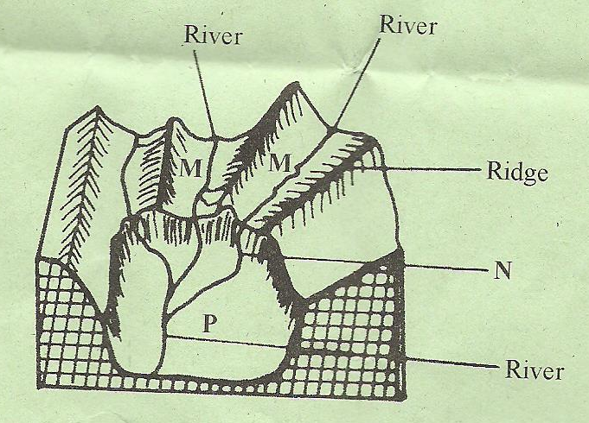
i) Name the features marked M, N, and P.
ii) Describe the process through which a crag and tail is formed
(4mks)

(e) Students from a school near Mt. Kenya were planning to carry out a field study of the glaciated features on the top of the mountain.
(i) Give four reasons why it would be difficult for the students to undertake the
field study on the glaciated features on the mountain. (4mks)
(ii) Describe how the students would use a photograph of Mt. Kenya to identify
the glaciated features of the mountain. (2mks)

Q10. a) i) What is a lake? (1mk)
ii) Explain three ways by which human activities threaten the existence of lakes in
Kenya (6mks)
b) i) Name two types of lakes formed as a result of deposition. (2mks)
ii) Describe how lake Tanganyika was formed. 4 mks)

c). i) What is an artesian well? (2mks)
ii) State four conditions necessary for the formation of an artesian well. (4mks)
iii) Describe the formation of a limestone pillar (6mks)

