312/2
GEOGRAPHY
PAPER 2
JULY 2014
TIME: 2 ¾ Hours

KCSE MOCK
STAREHE GIRLS’
FORM 4 2014

INSTRUCTIONS TO CANDIDATES
- Answer all the questions in section A
- In Section B answer question 6 and any other two questions.
- Answer section A and each question attempted in Section B on a separate answer sheet.
- This paper consists of 6 printed pages
- Students should check the question paper to ensure that all pages are printed as indicated and that no questions are missing.

SECTION A
Answer ALL the questions in this section.

Q1.(a) Name one area where each of the following minerals are mined in Tanzania:

(i) Gold
(ii) Diamond (2 marks)

(b) Give three processes which influence the occurrence of minerals. (3 marks)

Q2. a) Name one area in Brazil where coffee is grown on large scale . (1 marks)
b) State three physical conditions that favour coffee growing in Brazil. (3 marks)

Q3. Compare the population in Kenya and Sweden under the following sub-headings:

- Distribution (2 marks)
- Growth (2 marks)
- Age. (1marks)

Q4. a) What is a hinterland? (1mark)
b) Identify four differences between Mombasa and Rotterdam ports (4marks)

Q5. Use the map of Kenya below to answer question (a).
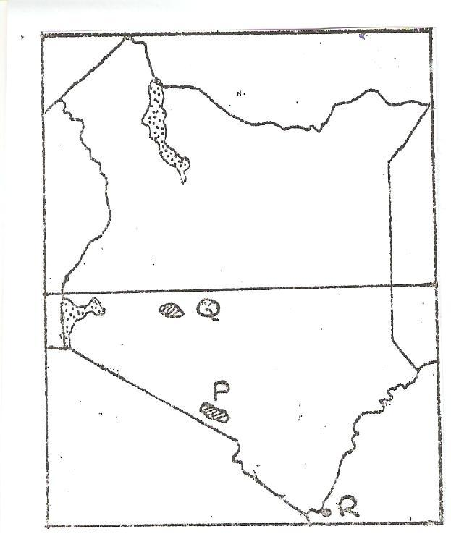
R
Q
P

(a) Name:
(i) the national park marked P. (1 mark)
(ii) the game sanctuary marked Q. (1 mark)
(iii) the marine park marked R. (1 mark)
(b). State three reasons why tourism is more developed in Switzerland than in Kenya. (3 marks)

SECTION B
Answer question 6 and any other two questions from this section.

6. (a) State four characteristics of horticulture farming. (4 marks)

(b) Study the photograph below and answer the following questions.
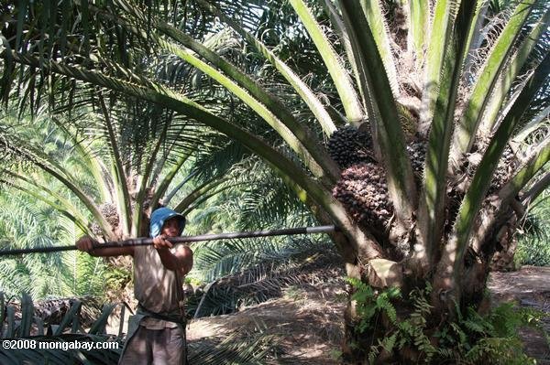

(i) Giving reasons identify the type of photograph shown above. (3 marks)

(ii) Draw a rectangle measuring 15cm by 10cm to represent the area covered by the photograph. (1 mark)

(iii) On the rectangle, sketch and label four main features. (4 marks)

(c) Describe the stages involved in oil Palm production from harvesting to marketing. (7marks)

(d) Explain three problems facing oil palm farming in Nigeria. (6 marks)

Q7. a) i) Differentiate between transport and communication ( 2 mks)
(ii) State three recent development that have taken place in Kenya to improve
Communication of information. (3mks)

b.(i)Identify two major trans-continental highways of Africa (2mks)
ii) State three problems faced by air transport in Kenya. (3mks)
iii) One of the problems facing road transport is the high frequency of accidents.
Give three conditions of roads in Kenya that may lead to accidents. (3mks)

c.) Explain the three ways through which Kenya is likely to benefit from renewed
East African Co-operation. (6mks)

d) Your Geography class carried out a field study on a nearby market in a county in Kenya
(i) During the field study the class collected data on quantities of items of trade in the
market, State three methods that the class may have used to present the data . (3mks)
(ii ) Give three problems facing traders that they are likely to have found out during the
study. (3mks)

Q8 The map below shows some major fishing grounds in the world. Use it to answer question (a)
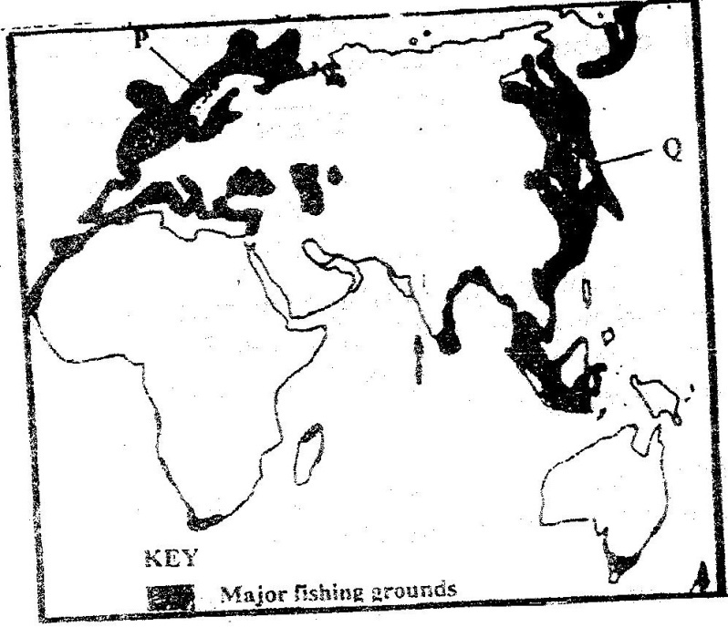

(a) (i) Name the countries marked P and Q. (2mks)
(ii) Explain four conditions that favour fishing in the shaded coastal waters (8mks)
(b) The diagrams below represent some fishing methods

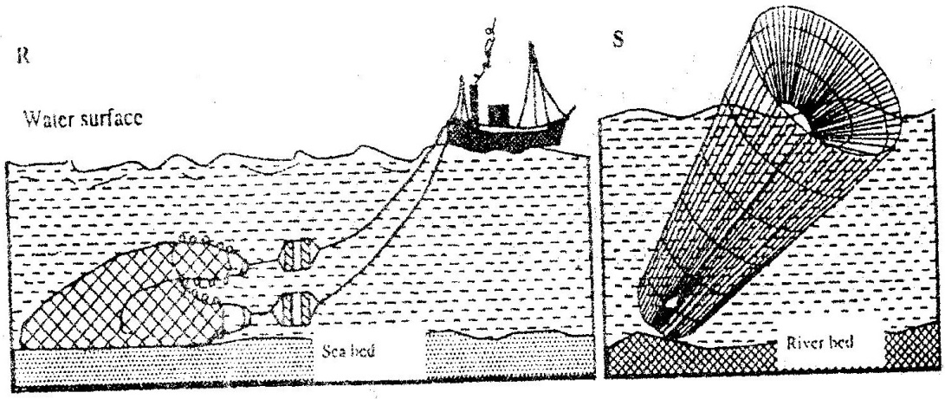

(i) Name the methods R and S . (2mks)
(ii) Describe how each of the two methods is used in fishing
- R (4mks)
- S (3mks)
(c) Explain three measures used to conserve fisheries in Kenya (6mks)

Q9. a) The table below shows four principal crops produced in Kenya in the years 2008 ,2009
and 2010. Use it to answer question(i) (ii) and (iii).

CROP | AMOUNT IN | METRIC TONS
 | 2008 | 2009 2010
Wheat | 70,000 | 130,000 142,100
Maize | 200,000 | 370,000 400,500
Coffee | 98,000 | 55,000 43,000
Tea | 240,000 | 295,000 300,000

(i) Using a scale of 1 cm to represent 50,000 metric tons, draw a Comparative bar graph based on the data above. (6mks)
(ii) State two advantages of using comparative bar graphs (2mks)

iii) Calculate the percentage increase in maize production between the years 2009 and
2010. (2mks)

b) State three physical conditions required for the growing of maize in Kenya. (3mks)
c) i) Name two exotic breeds of cattle reared in commercial ranches in Kenya. (2mks)

(ii) Give four ways in which the government of Kenya assist nomadic pastoralist to
improve the quality of their livestock. (4mks)

(iii) Explain three factors that favour beef farming in Argentina. (6mks)

Q10 (a) (i) Differentiate between Environmental Management and Environmental
Conservation. (2 mks)

(ii) State four effects of wind as an environmental hazard in Kenya (4mks)
(b) (i) Explain four conditions that made perkerra a suitable location for irrigation scheme (8mks)
(ii) Give four economic benefits of irrigation farming in Kenya. (4mks)

(c) Describe the steps which are followed in reclaiming land in the Netherlands (7 mks)

