NAME………………………………………………………….ADM NO……………..STREAM……….

232/3
PHYSICS
PAPER 3
(PRACTICAL)
MARCH 2014
TIME: 2 ½ HOURS

SUNSHINE SECONDARY SCHOOL
Kenya Certificate of Secondary Education (K.C.S.E)

PRE-MOCK1 1

INSTRUCTIONS TO CANDIDATES:-
- Write your name, index number and school in the spaces provided above.
- Sign and write the date of examination in the space provided above
- Answer all the questions in the spaces provided in the question paper
- You are supposed to spend the first 15 minutes of 2½ hours allowed for this paper reading the whole paper carefully before commencing your work.
- Marks are given for a clear record of the observations actually made, their suitability, accuracy and the use made of them
- Record your observations as soon as you make them.
- Silent electronic calculators and KNEC Mathematical tables, may be used except where stated otherwise.

For Examiners’ Use Only:

CANDIDATE’S SCORE
MAXIMUM SCORE | 40

- You are provided with the following apparatus
- Resistance wire fitted on a scale labeled AB
- Switch
- Voltmeter
- Ammeter
- Two dry cells
- Six connecting wires

Proceed as follows:-
(i) Set up the apparatus as shown below
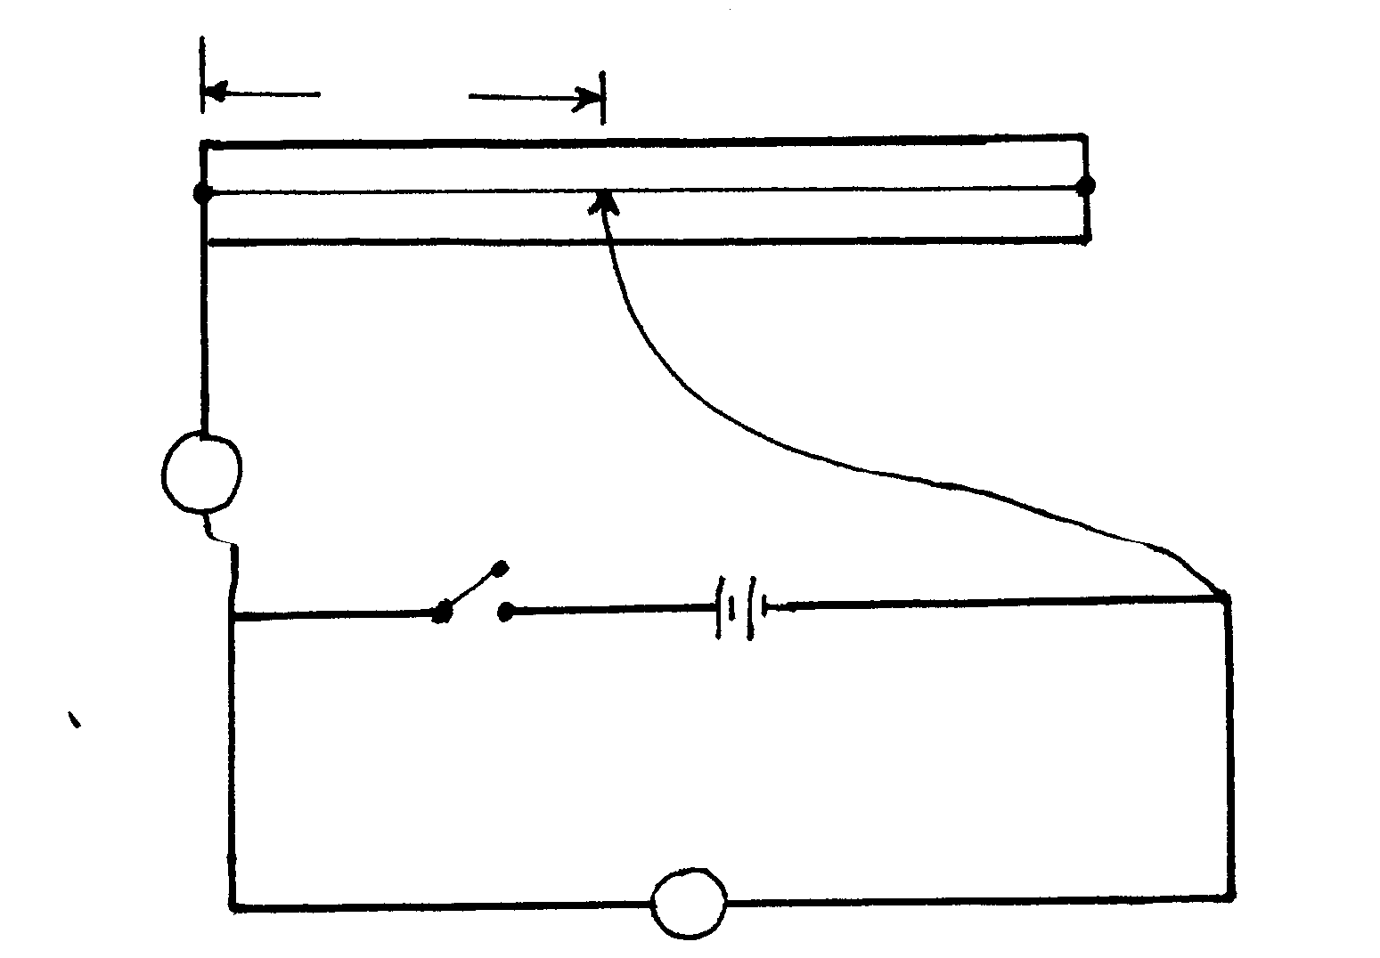
B
L
A
v
A

(ii)Remove the jockey from resistance wire AB and close the switch. Record the voltmeter reading X=___________________volts (1mk)
(iii) Attach the jockey to the resistance wire such that L=10cm
(iv) Record the voltmeter and ammeter reading in the table below
(v) Repeat the procedure in iii and iv for L=20cm, 30cm, 40cm, 50cm,60cm,70c, and 80cm

(vi) Complete the table below
Length L(cm) | 10 | 20 | 30 | 40 | 50 | 60 | 70 | 80
Current I (A)
p.d V (v)
X-V(V)
V
X-V
V=R(Ω)
I
(10mks)

(viii) (a) Plot the graph of v against R (5mks)
x-v

(b) Determine the slope S of the graph (2mks)

(c) The graph is given by the equation
V = mR +d
x-v 5
Determine the value of m and d (2mks)

- You are provided by the following:

- Burette
- Retort stand
- Two clamps
- Two bosses
- Stop watch
- Funnel
- Water in 200 ml beaker
- 100 ml beaker

Proceed as follows:

1. Set up the apparatus as shown in the diagram below with the burette clamped onto the stand. Clamp the metre rule vertically and place it as close as possible to the burette. Adjust the height of the burette such that the lowest point of the rubber tube is about 10cm above the bench

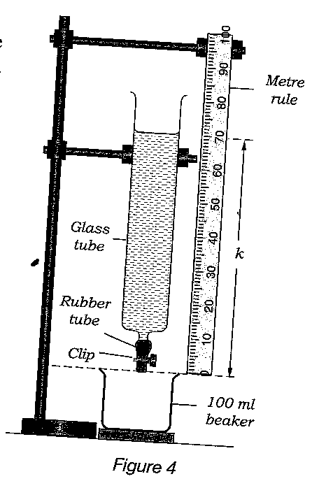

2. Close the screw clip. Use the funnel to fill the burette with water to a height above the 70cm mark of the metre rule. Open the clip. By trial and error method, adjust the rate of flow of water until the time taken for the water to flow from 7ocm mark to 65 cm mark is between 25-30 seconds. Once this rate of flow of water is achieved, do not alter the rate of flow for the rest of the experiment.

3. Fill the tube with water to a level above the 70cm mark. When the water level comes to the 70cm mark (t = 0) start the stop watch. Note,t, the time taken for the time,h,of the water surface in the burette, above the lowest point of the rubber tube to decrease by 5cm.Do not stop the stop watch. Continue to record the time for the height, h, of the water surface to decrease by 5cm marks till you have about 9 or 10 readings. Enter your results in the table below. Stop the stop watch and close the clip (11 mks)

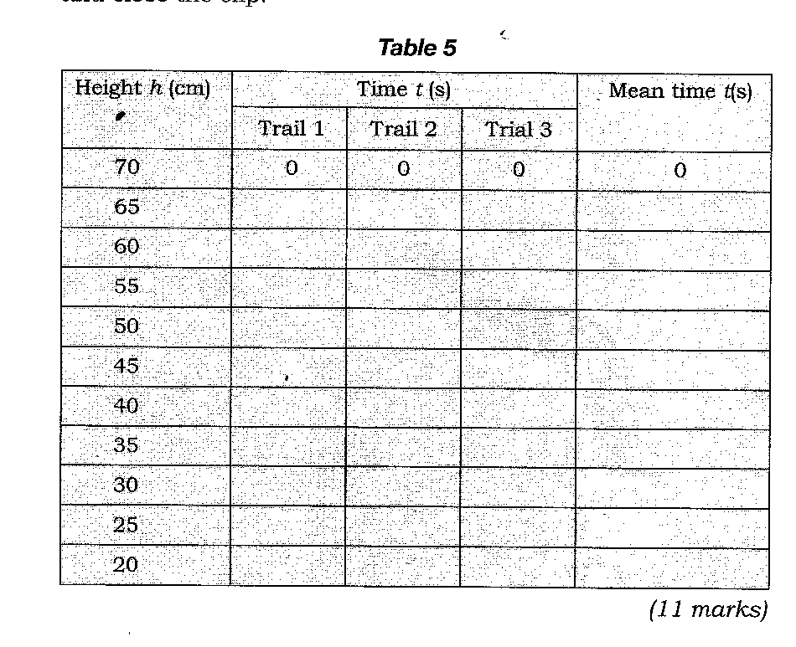

4. Repeat part (3) of the experiment to get a second and third set of readings for h and t. Enter your result s in the table above. Complete for the mean time taken, t.
5. on the grid provided plot a graph of height h, (y-axis) against time t (5mks)

6. Use the graph to determine the time taken for the height h to change from

- 64cm to 32cm (ii) 54cm to 27 cm (2mks)

7. Is this experiment similar to the radioactive decay of radioactive substance? Justify your answer (2mks)

