SUNSHINE SECONDARY SCHOOL
FORM 4
PREMOCK-MARCH 2014
PHYSICS
PAPER 2
TIME: 2HRS

NAME…………………………………………….………ADMIN NO……… CLASS………

INSTRUCTIONS

- This paper consists of two sections A and B
- Answer all the questions in both sections in the spaces provided
- All working must be clearly shown
- Electronic Calculators may be used

For Examiners Use Only

Section | Questions | Maximum Score | Candidates Score
A | 1-11 | 25
B | 12-17 | 55
TOTAL |  | 80

SECTION A (25 MARKS)

- Name one source and use of infrared radiation (2mks)
………………………………………………………………………………………………………………………………………………………………………………………………………………………………………………………………………………………………………………………………………………………………………………………………
- The figure below shows curves obtained with a magnetic material
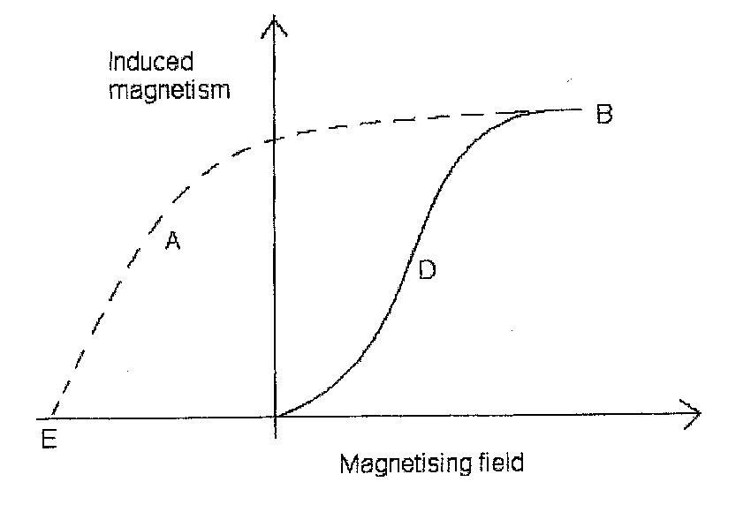
State what curves A and B represent (2mks)
………………………………………………………………………………………………………………………………………………………………………………………………………………………………………………………………………………………………………………………………………………………………………………………………
- State the importance of ear thing in domestic wiring (1mk)
………………………………………………………………………………………………………………………………………………………………………………………………………………………………………………………………………………………………

- The figure below shows the three nuclear radiation labeled A, B, and C under the influence of an electric field.

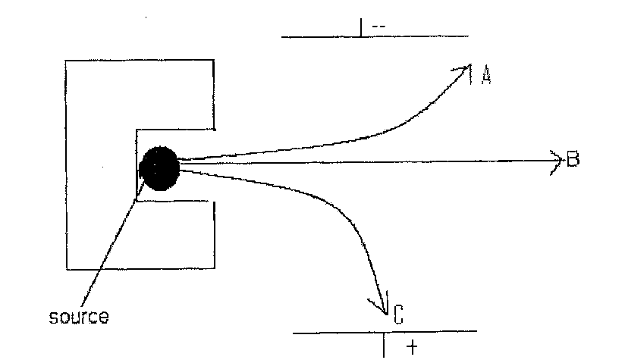

Identify the radiation A, B and C (3mks)
A……………………………………………………………………………………………
B……………………………………………………………………………………………
C……………………………………………………………………………………………
- In an experiment with a convex lens, image distances were measured when an object was placed at various distances away from the lens. The figure below shows a graph of 1/v against 1/u for the experiment where u is the object and v is the image distance.

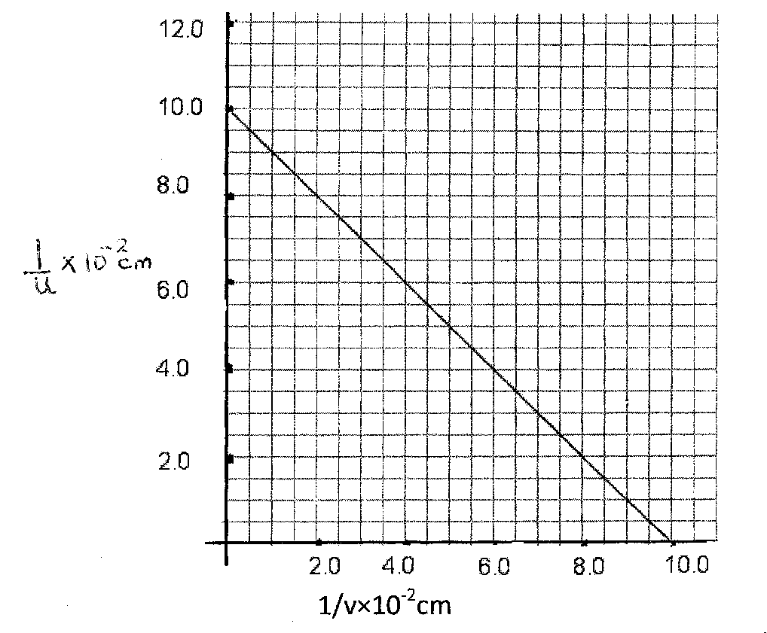
Use the graph to find the focal length f of the lens (3mks)
………………………………………………………………………………………………………………………………………………………………………………………………………………………………………………………………………………………………………………………………………………………………………………………………………………………………………………………………………………………………
- A student synchronizes his watch with a church bell 2km away. The following morning, there is a wind. He notes that the church bell sounded 0.15s later. Assuming his watch is correct and bell was sounded at the usual time. Determine the direction of the wind and its speed. (Assuming the speed of sound in still air is 340ms ⁻¹) (3mks)
………………………………………………………………………………………………………………………………………………………………………………………………………………………………………………………………………………………………………………………………………………………………………………………………………………………………………………………………………………………………………………………………………………………………………………………………
- The figure below shows a GM tube

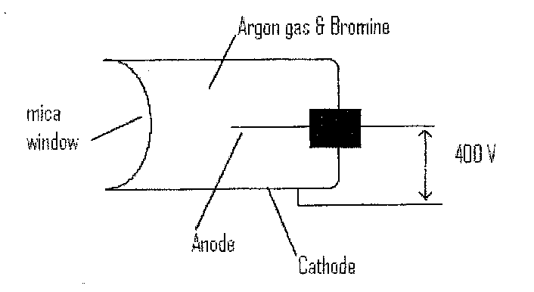
- Give a reason why the mica window is made thin (1mk)
………………………………………………………………………………………………………………………………………………………………………………………………………………………………………………………………………………

- The tube has got a small amount of bromine. State the purpose of the bromine in the tube (1mk)
………………………………………………………………………………………………………………………………………………………………………………………………………………………………………………………………………………
Study the ray diagram below and use it to answer question 8 & 9

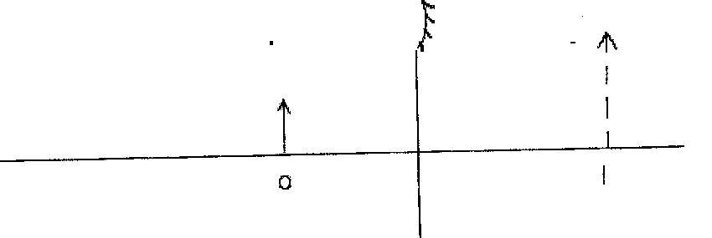

- Complete the diagram by drawing the correct rays on it (1mk)

- Use your drawing to determine the focal length f of the mirror (2mks)
………………………………………………………………………………………………………………………………………………………………………………………………………………………………………………………………………………………………
- A 5V ac signal with a frequency of 50Hz is applied across the y-plates. The y-gain and time base setting is 2.5V/cm and 10Ms/cm respectively. Use the information above to sketch a wave form as seen on CRO screen (3mks)

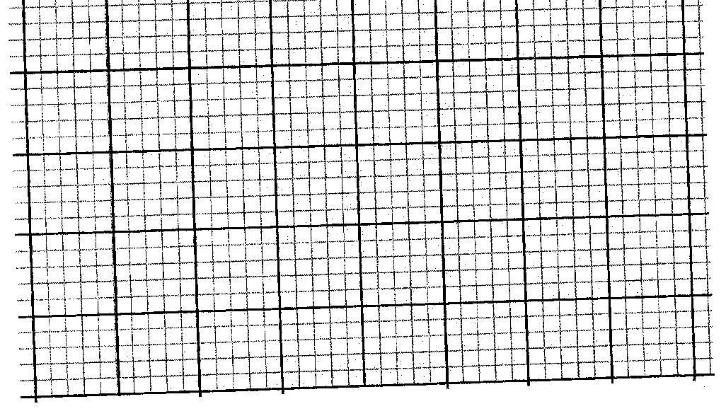
- State Faraday’s law of electromagnetic induction (1mk)
………………………………………………………………………………………………………………………………………………………………………………………………………………………………………………………………………………………………
- State three points to observe in maintaining a lead-acid battery (3mks)
………………………………………………………………………………………………………………………………………………………………………………………………………………………………………………………………………………………………
………………………………………………………………………………………………
SECTION B(55 MARKS)

- a) State three factors affecting the capacitance or a parallel plate capacitor (3mks)
………………………………………………………………………………………………………………………………………………………………………………………………………………………………………………………………………………………………………………………………………………………………………………………………………………………………………………………………………………………………
b) You are provided with the following apparatus
-uncharged capacitor
-Voltmeter
-Milliammeter
-12v battery
-A load resistor
-Two way switch
i) Using the above apparatus draw a circuit diagram that can be used to study the
charging and discharging the capacitor. (3mks)

ii) Use the diagram in b(i) to describe how a fully charged capacitor is discharged (2mks)

…………………………………………………………………………………………………………………………………………………………………………………………………………………………………………………………………………………………………………………………………………………………………………………………………………………………………………………………………………………

iii) On the axis provided sketch a voltage –time graph of discharging of capacitor (1mk)

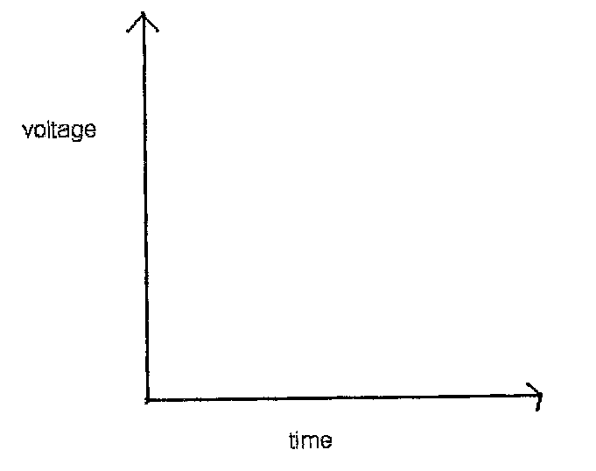
c) The zinc plate shown below connected to the electroscope and is exposed to ultraviolet
radiation.

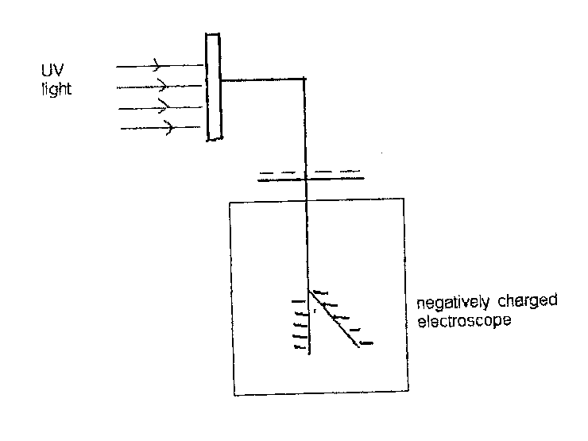

Explain what happens to the charged electroscope (2mks)
………………………………………………………………………………………………………………………………………………………………………………………………………………………………………………………………………………………………………………………………………………………………………………………………
- a) With the aid of a well labeled diagram, explain how lunar eclipse occurs. (4mk)

………………………………………………………………………………………………………………………………………………………………………………………………………………………………………………………………………………………………………………………………………………………………………………………………………………………………………………………………………………………………………………………………………………………………………………………………
b) Explain why large convex mirrors are placed at certain points in supermarket (2mks)
………………………………………………………………………………………………………………………………………………………………………………………………………………………………………………………………………………………………………………………………………………………………………………………………………….
c) An object 2.5 m tall is at a point 8m from a pinhole camera. If the distance of the screen is 8.16m from the object, calculate the size of the image (3mks)

………………………………………………………………………………………………………………………………………………………………………………………………………………………………………………………………………………………………………………………………………………………………………………………………………………………………………………………………………………………………………………………………………………………………………………………………
d) i) Draw a diagram to show how prisms are used in a periscope (2mks)

ii) Calculate the critical angle of a ray of light passing from glass to water, if their
refractive indices are ²/₃ and ⁴/₃ respectively. (3mks)

- a) State the Ohms’ law (1mk)
………………………………………………………………………………………………………………………………………………………………………………………………………………………………………………………………………………………………………
b) Three resistors x,y and z where x = 200 Ω, y = 100 Ω and z is unknown resistance are
connected in parallel. This arrangement is then placed in a circuit and current passing
through, and potential difference across its measured the table below shows the result.

p.d(v) | 2.0 | 4.0 | 6.0 | 8.0 | 10.0 | 12.0
Current(l) (A) | 0.10 | 0.20 | 0.30 | 0.40 | 0.50 | 0.60

- Plot a graph of p.d against current (4mks)

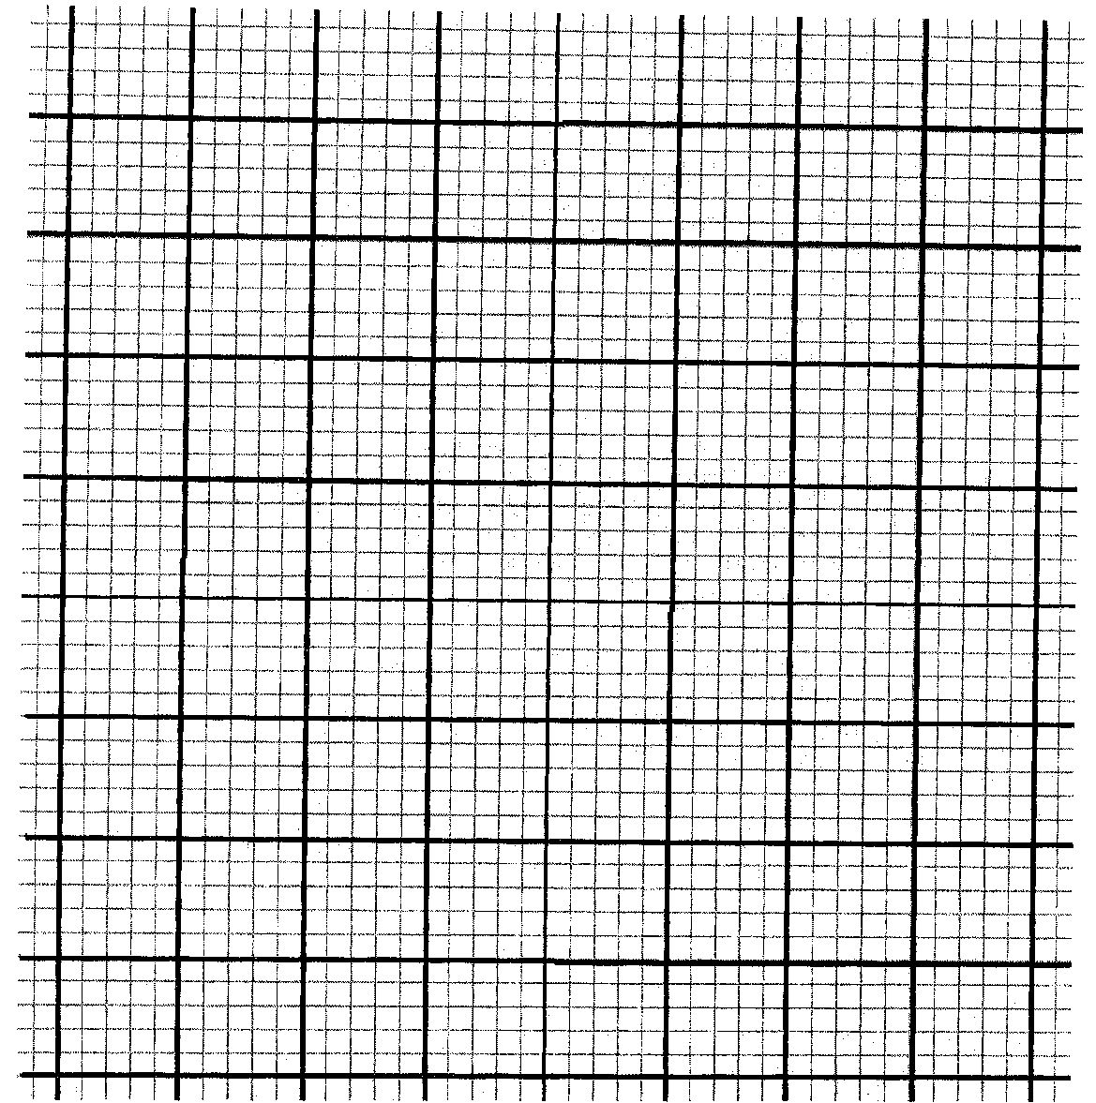

- Use your graph to calculate the value of unknown resistance. (4mks)

c) Four resistors are connected in a circuit as shown in the diagram below

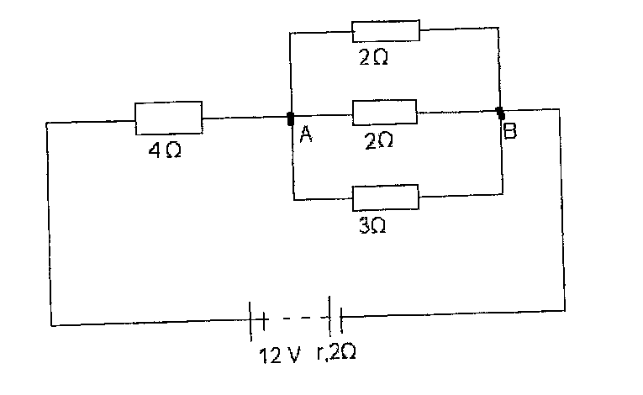
Calculate the p.d across AB. (3mks)

………………………………………………………………………………………………………………………………………………………………………………………………………………………………………………………………………………………………………………………………………………………………………………………………………………………………………………………………………………………………………………………………………………………………………………………………
- a) Distinguish between diffraction and refraction of waves (1mk)
………………………………………………………………………………………………………………………………………………………………………………………………………………………………………………………………………………………………………………………………………………………………………………………………
b) Explain clearly how the following affect light intensity in the young’s double slit
experiment
i) Separation of the slits (2mks)
………………………………………………………………………………………………………………………………………………………………………………………………………………………………………………………………………………………………
ii) Width of the slits (2mks)
………………………………………………………………………………………………………………………………………………………………………………………………………………………………………………………………………………………………
iii) Frequency of incident light (2mks)
………………………………………………………………………………………………………………………………………………………………………………………………………………………………………………………………………………………………
c) The figure below shows circular wave fronts approaching a convex barrier. Complete
the figure to show what happens to the wave fronts after reflection on the barrier. (2mks)
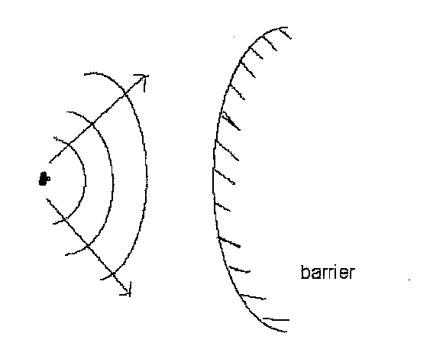
- The figure below shows current-voltage characteristics of a junction diode.

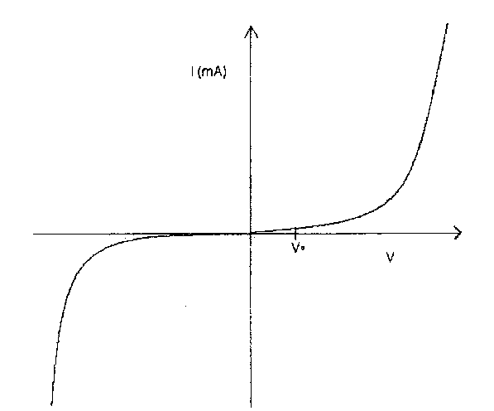
a) In the forward bios, the diode does not conduct until a certain minimal voltage is
reached. Explain the effect (2mks)

………………………………………………………………………………………………………………………………………………………………………………………………………………………………………………………………………………………………………………………………………………………………………………………………
b) Where the voltage is increased in reverse bias, the diode conducts when a certain
voltage is reached. What is the name given to this voltage (1mk)

………………………………………………………………………………………………………………………………………………………………………………………………
c) i) List two properties of x-rays (2mks)
………………………………………………………………………………………………
………………………………………………………………………………………………
ii) The figure shows a simplified illustration of an x-ray tube

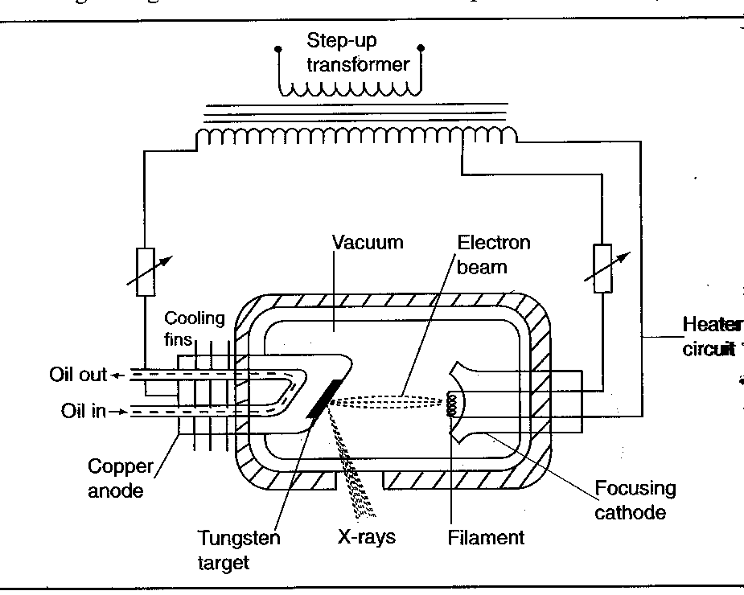

Explain the following features in an x-ray tube
Low pressure………………………………………………………………………….
………………………………………………………………………………(1 mk)
Lead shield……………………………………………………………………………
………………………………………………………………………………(1 mk)
iii) Explain the adjustment that can be made to obtain hard x-rays (2mks)
…………………………………………………………………………………………
………………………………………………………………………………………….
………………………………………………………………………………………….
………………………………………………………………………………………….

