SUNSHINE SECONDARY SCHOOL
FORM 4
MATHS PAPER 2
PREMOCK EXAMS- MARCH 2014
TIME: 2 ½ HOURS

NAME…………………………………………….ADMIN NO………CLASS……

INSTRUCTIONS TO CANDIDATES

- Write your Name, Adm. No and Class in the spaces provided on the top of this page.
- This paper contains two sections: Section A and B.
- All answers and workings must be written on the question paper in the spaces provided below each question.
- Negligence and slovenly work will be penalized.
- Electronic calculators and mathematical tables may be used.

For Examiners Use Only.

Section I

1 | 2 | 3 | 4 | 5 | 6 | 7 | 8 | 9 | 10 | 11 | 12 | 13 | 14 | 15 | 16 | Total

Section II

17 | 18 | 19 | 20 | 21 | 22 | 23 | 24 | Total

SECTION 1 (50 MARKS)

- a) Expand (1 + 2x)⁶ upto the term with $x^{4}$ (1mk)

b) Hence use your expansion to evaluate (0.2)⁶ (2mks)

2. The quantity y varies partly as x and partly as the square of x. When x = 2, y = 14 and when
X = 5 y = 65. Express y in terms of X. Hence find y when X = -2 (4mks)

3. Solve for P in the equation:
Log₃ (2p + 8) – log₃ P = 1 + log₃ 2 (3mks)

4. Solve the trigonometric equation (3mks)
2 Sin²$θ$ – Sin$- \frac{1}{2}$ = 0 for 0$°$ $≤ θ ≤360°$

5. The fifth term of an arithmetic progression is 11 and the twenty fifth term is 51. Calculate the
first term and the common difference of the progression (3mks)

6. Solve the inequality, illustrate your solution on a number line and state the integral values of x
4 – 3x $<$ X + 12 $≤$ - $\frac{3X+29}{2}$ (3mks)

7. The diagram below represents a semi-circular block of metal with a semi-circular groove
removed. The block is1.2m long and the radii of the block and the groove are 14cm and 7 cm
respectively

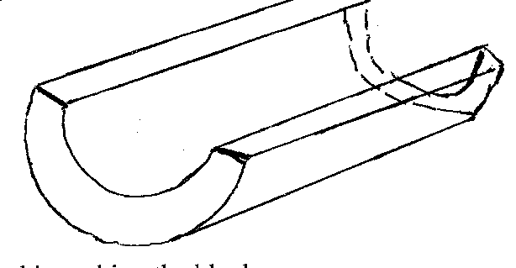
Calculate the volume of metal used in making the block (3mks)

8. In an agricultural research centre, the length of sample of 50 maize cobs were measured and
recorded as shown.

Length (cm) | 8-10 | 11-13 | 14-16 | 17-19 | 2-0-22 | 23-25
No. of cobs | 4 | 7 | 11 | 15 | 8 | 5

Calculate the median (3mks)

9. Winnie bought maize and millet flour from a vendor. She then mixed them in the ration 4:3.
She bought the maize flour at Kshs 41 per kg and the millet flour as Ksh 61 per kg. If she was
to sell and make a profit of 20%. What should be the selling price of 1kgof the mixture? Give
your answer to the nearest 10 cent (3mks)

10. Kamau wishes to purchase not less then 10 items comprising books and pens only. A book
cost shs 20 and a pen shs 10 Kamau has shs 220 to spend. For all the inequalities form the
given conditions (3mks)

11. An employee of a certain company earns a monthly basic salary of Kshs 29400. He is
entitled to a monthly house allowance of Kshs 40,000 and medical allowance of Kshs 3,588
per month. He is entitled to a personal relief of Ksh 1162 per month. Using the tax table
below .Calculate his net tax per month. (4mks)

Taxable Income (P.A) in Ke | Rate in shs /KE
1-5808 | 2
5809 – 11280
11281 -16752 | 4
16753 -22224 | 5
22225 and above | 6

12. Simplify:-
(6$x^{2}$ + 7xy + 2$y^{2}$) (4$x^{2}$ - $y^{2}$) ⁻¹ (2mks)

13. John an American tourist arrived in Kenya with 100US$ and converted the whole amount
into Kenyan shillings. He spent, shs 39,000 and changed the balance to sterling pound before
leaving for United Kingdom. A Kenyan bank buys and sells foreign currencies as shown

Buying (in kshs) Selling (in ksh)
1 US Dollar 86.2184 86,3907
1 Sterling pound 136.8041 137,1394

Calculate the amount he received to the nearest sterling pound (4mks)

14. a) Construct triangle PQR such that PQ = 7cm, QR = 5cm and $<PQR=30°$

b) Construct the focus L₁ of points equidistant from P and Q to meet the locus L2 of points
equidistant from Q and R at M. Measure PM.

15. A point P (-2, 5) is mapped onto P¹(1,9) by a translation T1. If P¹ is mapped onto P¹ by a
translation T² given by $\left(\begin{aligned}-4 \\ -1\end{aligned}\right)$. Find the c-ordinates of P^{II} and the translation vector T¹ (3mks)

16. Find the centre and radius of a circle whose equation is (3mks)
${3x}^{2 }+{3y}^{2}$ - 18x + 12y + 39 = 12

SECTION 2 (50 MARKS)

17. a) The current price of a vehicle is shs 500,000. If the vehicle depreciates at a rate of 15%
p.a . Find the number of years it will take for its value to fall to shs 180,000. (4mks)

b) The cash price of a cooker is shs 9,000. A customer bought the cooker by paying 15 monthly installments of shs 950 each. Calculate:

a) the carrying charge (3mks)

b) the rate of interest (3mks)

18. a) Given that the matrix A =$\left(\begin{aligned}6 5 \\ 4 7\end{aligned}\right)$ , find the inverse of A⁻¹. (3mks)

b) James sells shirts and vests in his shop. On Monday he sold 4 shirts and 40 vets for a
total Kshs. 24,000. On Tuesday he sold 24 shirts and 42 vests for a total of Kshs 18,600

i) Form a matrix equation to represent the information (3mks)

ii) Using A – in (a) above find the price each shirt and each vest (4mks)

19. Kamau, Njoroge and Kariuki are practicing archery. The probability for Kamau hitting the
target is$\frac{2}{5}$ , that of Njoroge hitting the target is $\frac{1}{4}$ and that of Kariuki hitting the target is $\frac{3}{7}$.
Find the probability that in one attempt;

- Only one hits the target (2mks)

b) All three hit the target (2mks)

c) None of them hits the target (2mks)

d) Two hit the target (2mks)

e) At least one hits the target (2mks)

20. Two aeroplanes S and T leave airport A at the same time, S flies on a bearing of 060$°$ at
750km/h while T flies on a bearing of 210$°$ at 900km/h.
a) Using a suitable scale, draw a diagarams to show the positions of aeroplanes after
two hours (4mks)

b) Use your diagram to determine
i) The actual distance between the two aeroplanes (2mks)

ii) The bearing of T from S (2mks)

iii) The bearing of S from T (2mks)

21. The bearing of towns P and Q on a horizontal ground from a tower are 050$°$ and 142$°$
respectively. The angle of elevation of the top of the lower from town P is 34$°$. Given that
P is 200m from the top of the tower and Q is 120m from the base of the tower

Determine
a) The height of the tower (3mks)

b) The angle of elevation of the top of the lower from Q (3mks)

c) The distance between the two towns P and Q (4mks)

22. A plane leaves an airport x(41.5$°$N, 36.4$°W) at$9.00a.m and flies due north to airport Y on
latitude 53.2$°$N.
- Calculate the distance covered by the plane in Km (3mks)

b) After stopping for 30 mins to refuel at Y, the plane then flies due East to airport 2,
2500km from Y. Find:

- The position of Z

- The time the plane lands at Z if its speed is 500km/h. (Take the value of $π as \frac{22}{7}$ and radius of the earth as 6370Km) (7mks)

23. A triangle has vertices at a(1,2) b(-2,4) and C)3,5)
a) Plot the triangle on the grid provided (1mk)

b) Triangle ABC is mapped onto triangle A¹B¹C¹ by a transformation given by M= $\left(\begin{aligned}-1 1 \\ 0 1\end{aligned}\right)$

State the co-ordinates of triangle A¹B¹C¹ on the same grid plot triangle A¹B¹C¹ (3mks)

c) Triangle A¹¹B¹¹C¹¹ is the image of triangle A¹B¹C¹ under a reflection on the line y = 0.
Plot the triangle A¹¹B¹¹C¹¹ and state its co-ordinates (2mks)

d) Triangle A¹¹B¹¹C¹¹ is further rotated through -90$°$about (0,0) to obtain triangle
A¹¹¹B¹¹¹C¹¹¹. Write down the co-ordinated of triangle A¹¹¹B¹¹¹C¹¹¹. Plot the triangle on
the grid as a &b above
(2mks)

24. The figure below shows a cuboid ABCDEFGH with a square base. The points L,M, and N
are the midpoints of EH, AD and BC respectively. AC = 7.5 cm and CF = 10cm. Calculate
to 1 decimal place

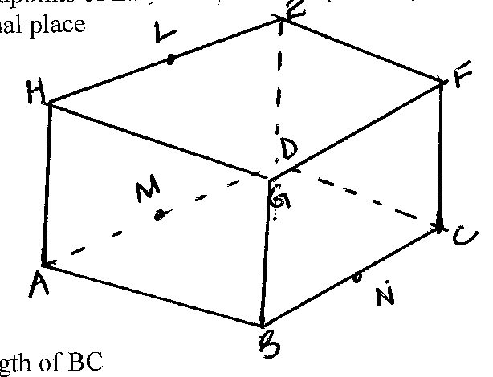
a) The length of BC (3mks)

b) The length of LN (2mks)

c) The size of angle between the plane EHBC and ABCD (3mks)

d) The angle between the lines CH and the base (2mks)

