SUNSHINE SECONDARY SCHOOL

FORM 4
MATHEMATICS
PAPER 1
PRE-MOCK – MARCH 2014
TIME: 2 ½ HOURS

NAME…………………………………………………….ADMIN NO….….…..CLASS..……..

INSTRUCTIONS TO CANDIDATES
- Write your Name, Adm. No and Class in the spaces provided on the top of this page.
- This paper contains two sections: Section I and II.
- All answers and workings must be written on the question paper in the spaces provided below each question.
- Answer all question in section I and only 5 questions in section II.
- Negligence and slovenly work will be penalized.
- Electronic calculators and mathematical tables may be used.

For Examiners Use Only.

Section I

1 | 2 | 3 | 4 | 5 | 6 | 7 | 8 | 9 | 10 | 11 | 12 | 13 | 14 | 15 | 16 | Total

Section II

17 | 18 | 19 | 20 | 21 | 22 | 23 | 24 | Total
SECTION 1
- Use logarithms to evaluate (4mks)

$$\frac{{16.92}^{2} x \sqrt{0.6318}}{327.5}$$

- Solve the equation (3mks)
${6 }^{2x+1}$ = $2^{ 3X + 1}$

- Evaluate using tables of reciprocals, squares and cubes. (4mks)

$\frac{\sqrt[3]{0.0008} }{0.375}$ - $\frac{10}{{37.5}^{2}}$

- A student requires x = ⁵/₉ and y = ⁵/₃ in decimal form. He truncates the values to 3 significant figures. Determine the percentage error in the quotient ^{y}/_{x} using the truncated values. (4mks)

- In the figure below O is the centre of circle ABCD. <ADC = 70°. AD = AC.

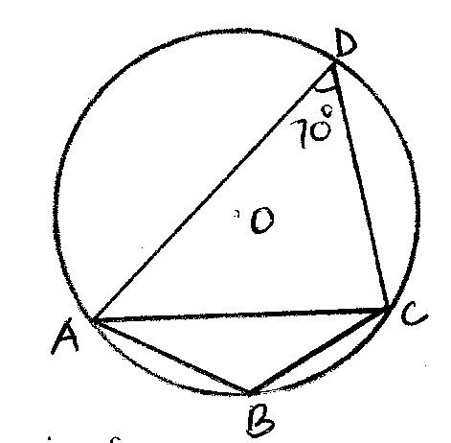
Find the size of
- <ABC (1mk)

- <DAO (2mks)

- If tan θ = $\frac{24}{25}$ , find without using tables or calculator, the value of
$\frac{ Tan θ – Cos θ }{Cos θ + Sin θ}$ (2mks)

- Point $P^{1}\left(5,6\right)$ is the image of point P $\left(-1, -4\right)$ under a rotation of 180° about point Q$\left(x,y\right)$. Find the co-ordinates $\left(x,y\right)$ (2mks)

- Find the area of Δ ABC with sides 8cm, 9cm, and 10cm (3mks)

- Simplify $\frac{{15x}^{2} + xy - {6y}^{2} - \left(3x+2y\right) \left(2x-y\right)}{2y-3x}$ (3 mks)

- A scale on a map is 1:2000. A circular piece of land for growing maize has a radius of 7cm on the map. Calculate the actual area in hectares of this piece of land. (Take $П= \frac{22}{7}$) (3mks)

- The internal and external radii of spherical shell are 6 cm and 9 cm respectively. Calculate the volume of the material of the shell. (4 mks)

- The masses of two similar bars of soap are 343 g and 1331 g. If the surface area of the smaller bar is 196 cm². Calculate the surface area of the larger bar (3mks)

- A perpendicular line is draw from point P(3,4) so that it meets line 3 y = 2x + 12 at point Q. Find the exact co-ordinates of point Q (3mks)

- Two tractors A and B travel between two towns 120km apart. Tractor A has an average speed of 10km/h more than tractor B and takes 1 hour less than tractor B. Find the respective speeds of the two tractors. (3mks)

- Find the surface area of the figure given below, which is completely closed. (3mks)
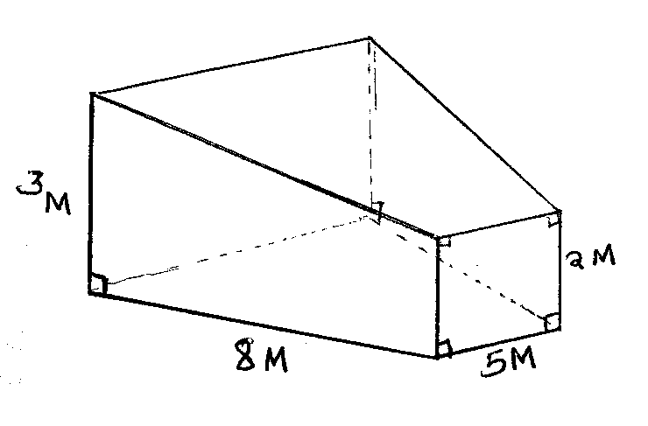

- Vector r has a magnitude of 14 and is parallel to vector s. Given that s = 6i – 2j + 3k, express vector r in terms of i, j and k (3mks)

SECTION 11 (50MKS)
- (i) A particle moves in a straight line in such a way that its distance, S meters after t seconds
is given by the equation

S = $\frac{t^{3}}{3}$ - ${3t}^{2}$ + 5t, find the times when:
a) the particle is stationery (3mks)

b) Its velocity is 5 m/s (2mks)

c) Its acceleration is 10 m/s² (2mks)

- Find the equations of the tangent and normal to the curve y = ${2x}^{2}$ + 1 at the point where x = 2 (3mks)

- A triangle whose vertices are A(1,4) B(2,1) and C(5,2) is given the following transformations.
- A reflection along the line y = x to $A^{1}B^{1}C^{1}$
- $A^{1}B^{1}C^{1}$ is given a rotation of a positive quarter turn about the origin $A^{11}B^{11}C^{11}$
- $A^{11}B^{11}C^{11}$ is given an enlargement of linear scale factor -2 about (1,2) to $A^{111}B^{111}C^{111}$

- Using the grid provided, plot the triangle ABC and its image $A^{1}B^{1}C^{1}$ (3mks)

- Locate the image $A^{11}B^{11}C^{11}$ from the grid hence state its co-ordinates. (3mks)

- Find the co-ordinates of $A^{111}B^{111}C^{111}$ hence plot it on the grid (4mks)

- Three machines A, B, and C are set to work together. A working alone takes 6hrs to complete the work, B takes 8hrs while C takes 12 hrs.

- Find the time taken by A, B &C to complete the work while working together(3mks)

- All the three machines started working at the same time, 40 mins later machine A broke down B and C continued for another 1 hr before B ran out of fuel and therefore stopped working for 20 mins while C continued. If B resumed working after 20mins
Find
- The function of work left after machine A broke down. (2mks)

- The fraction of work done by C working alone for 20 mins. (2mks)

- The total time taken for the work to be completed. (3mks)

- In a Δ OAB, M and N are points on OA and OB respectively, Such that OM:MA = 2:3 and ON:NB = 2:1. AN and BM intersect at X. Given that OA = a and OB = b
a) Express in terms of a and b (2mks)
i) BM

ii) AN

b) Taking BX = tBM an AX = LAN where t and h are scalars, find two Expressions of OX (4mks)

- Find the values of t and h (4mks)

- Two variables quantities p and Q are connected by the equation p = KQ^{n} where K and n are constants. The following table gives the values of p and Q.

P | 2.29 | 3.16 | 3.98 | 4.57 | 5.01 | 6.31 | 8.71
Q | 2.0 | 3.16 | 3.98 | 5.25 | 6.31 | 8.32 | 12.59

- Find a linear equation connecting P and Q.

- Using a graph, draw a straight line and use it to estimate the values of K and n. (8 mks)

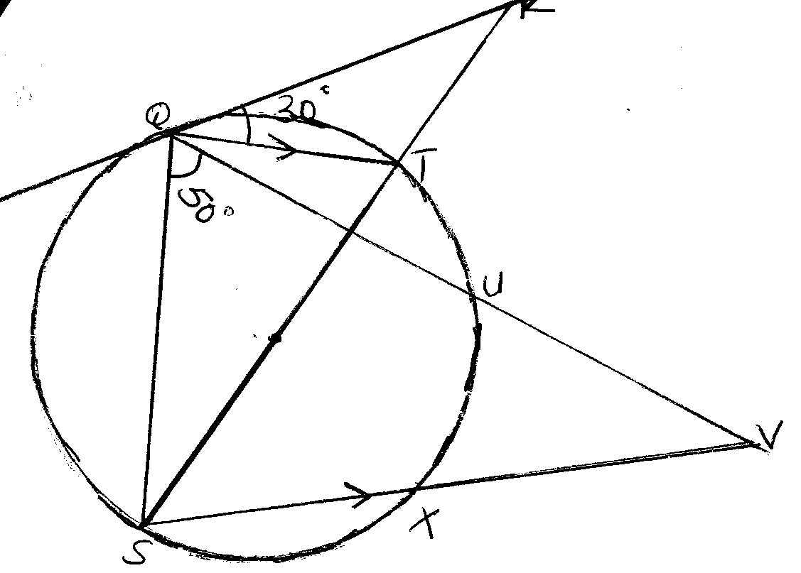
In the figure above PQR is a tangent to the circle at Q. ST is a diameter and STR and QUV are straight line QT is parallel to SV. Angle TQR = 30⁰ and angle SQV = 50⁰. Find the following angle, giving reasons for each answer.
- QST (2 mks)

- QRT (2 mks)

- QVS (2 mks)

- USV (2mks)

- QTS (2 mks)

- Two points A and B lie on the circumference of the circle, of the circle of centre O and radius 8 cm, where <AOB = 80⁰. Calculate:

- The length of the minor arc AB. (2 mks)

- The length of the chord AB. (2 mks)

- The area of the sector AOB (2 mks)

- The area of triangle AOB. (2 mks)

- The area of the minor segment of circle cut off by AB. (2 mks)

- The table below shows the distributions of marks scored in a test by form 4 students in a certain school.

Marks | 30-34 | 35-39 | 40-44 | 45-49 | 50-54 | 55-59 | 60-64 | 65-69 | 70-74 | 75-79
No of students | 1 | 5 | 10 | 10 | 19 | 20 | 20 | 8 | 4 | 3

- Using 62 as a working mean, calculate the actual mean mark. (4 mks)

- Calculate the variance of the data above. (4 mks)

- Calculate the standard deviation. (2 mks)

