NAME: ……………………………………….. …INDEX NO: …………

DATE..........................SIGNATURE.....................................
121/1
MATHEMATICS ALT A
Paper 1
Form 4 mock EXAMINATION 2014
2½ Hours
STAREHE GIRLS` CENTRE

Instructions to candidates
- Write your name and class in the spaces provided above.
- The paper contains two sections: Section I and Section II.
- Answer ALL the questions in Section I and any five questions in Section II.
- All working and answers must be written on the question paper in the spaces provided below each question.
- Marks may be awarded for correct working even if the answer is wrong.
- Negligent and slovenly work will be penalized.
- Non-programmable silent electronic calculators and mathematical tables are allowed for use.

FOR EXAMINER’S USE ONLY

1 | 2 | 3 | 4 | 5 | 6 | 7 | 8 | 9 | 10 | 11 | 12 | 13 | 14 | 15 | 16 | Total

17 | 18 | 19 | 20 | 21 | 22 | 23 | 24 | Total
 |  |  |  |  |  |  |  |  | Grand Total %

This booklet contains 15 printed pages. Please confirm that all the pages exist and are properly printed before starting the exam

SECTION I
- Without using a calculator evaluate (3marks)
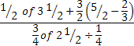

- Find the possible values of X in the equation $9^{X^{2}}$ = 27^{(2X + 12)} (3marks)

- Use square roots, reciprocal and square tables to evaluate to 4 significant figures the expression; ( 4 marks)
$${\left(0.06458\right)}^{\frac{1}{2}}+ {\left(\frac{2}{0.4327}\right)}^{2}$$

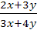
- Given that = 5, find the ratio of y:x (3marks)

- Two similar solids have surface areas of 48cm2 and 108cm2 respectively. Find the volume of the smaller solid if the bigger one has a volume of 162cm3. (3 marks)

- A Kenyan tourist left Germany for Kenya through Switzerland. While in Switzerland he bought a watch worth 52 Deutsche marks. Find the value of the watch in:-
(a) Swiss Francs
(b) Kenya shillings (3 marks)
Use the exchange rates below
1 Swiss Franc = 1.28 Deutsche marks
- Swiss Franc = 45.21 Kenya shillings

- The lines 4ax = 3y +12 and 7bx – 2 = 3y are parallel .Find the ratio a:b (3mks)

- In a Mathematical experiment it was derived that Tan 144⁰ = 1 - √3, determine the value
Of Tan 54⁰ from this results leaving your answer in the form $\frac{a + c }{ b }$ where a, b and c are integers.
( 3 marks )

- Simplify (3mks)

- (a) Find the inverse of the matrix $\left(\begin{matrix}4 & 3 \\ 3 & 5\end{matrix}\right)$ (1 mark)

(b) Hence solve the simultaneous equation using the matrix method (2 marks)
4x +3y = 6
3x + 5y = 5

- Use the inequality below to find the integral values of x that satisfy the inequality and show the solution on the number line. (4marks) 3x + 1 ≤ 4x + 5 ≤x + 13

- The points A, B and C lie on a straight line. The position vectors of A and C are 2i + 3j + 9k and 5i – 3j + 4k respectively; B divides AC internally in the ration 2:1. Find the
- Position vector of B. (2 marks)

- Distance of B from the origin. (1 mark)

- Simplify without using tables (2 marks)
$\frac{Log 125 – log 25}{Log 25+log5}$

- The L.C.M of three numbers is 7920 and their G.C.D is 12. Two of the numbers are 48 and 264. Using factor notation find the third number if one of its factors is 9. (3mark)

- The figure below (not drawn to scale) shows the cross-section of a metal bar of length 3 metres. They are equal semi-circles.
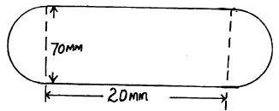

Determine the mass of the metal bas in kilograms if the density of the metal is 8.87g/cm3. (3marks)

- A regular polygon has an internal angle of 1500 and a side length 10cm.
a) Find the number of sides of the polygon. (2marks)

b) Find the perimeter of the polygon. (2marks)

SECTION II
- A frequency distribution of marks obtained by 120 candidates is to be represented in a histogram. The table below shows the grouped marks, frequencies for all the groups and also the area and height of the rectangle for the group 30-60 marks. SCALE: x Axis: 1cm to represent to represent 10 units y – axis: 1cm to represent 1 unit
Marks | 0 – 10 | 10 -30 | 30 -60 | 60 -70 | 70 -100
Frequency | 12 | 40 | 36 | 8 | 24
Area of rectangle |  |  | 180
Height of rectangle |  |  | 6
- Complete the table (4mks)
- On the grid provided below, draw a histogram (2mks)

- i) State the group in which the median mark lies(1mk)

ii) A vertical line drawn through the median mark divides the total area of the histogram into two equal parts. Using this information or otherwise estimate the median (3mks)

- (a) Complete the table below for the function y = 3x² – 2x – 1 for -3 ≤ x ≤ 4. ( 2 marks )

X | -3 | -2 | -1 | 0 | 1 | 2 | 3 | 4
3x² |  |  | 3 |  |  |  | 27
-2x | 6 |  |  |  |  |  |  | -8
-1
Y |  | 15 |  |  |  | 7

(b) Draw the graph of y = 3x² – 2x – 1. (3 marks)

(c ) Draw the line y =3x + 1 on the same axis hence find the values of x for which
y = 3x + 1 and y = 3x² – 2x – 1 are equal. (3 marks)

- a) Find the equation of a straight line passing through the points (3,2) and (-3,6) giving
Your answer in the form, where a and b are constants. (4marks)

b) State the coordinates of point A and B, at which the line in (a) above crosses the x-axis and y-axis respectively. (2marks)

c) Using the information in (a) and (b) above, find the area of triangle AOB, where O is the origin. (2marks)

d) Find the acute angle the line in (a) above makes with the x-axis. (2marks)

- a) Using a ruler and a pair of compasses only construct a line PQ, 8cm long. On the line construct triangle PQR such thatQPR = 75⁰ and line PR = 7cm. measure line QR (4marks)

b) Construct a circum circle of triangle PQR and measure its radius. (3marks)

c) Calculate the difference in area between the circle and triangle PQR. (3marks)

- The figure below shows a circle centre O in which QOT is a diameter. Angle QTP = 460, angle TQR = 750 and SRT = 380, PTU and RSU are straight lines.
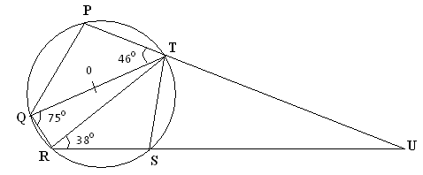

Determine the following, giving reason in each case.
a) Angle RST (2marks)

b) Angle SUT (2marks)

c) Angle PST (2marks)

d) Obtuse angle ROT (2marks)

e) Angle SQT (2marks)

- The boundaries PQ, QR, RS and SP of a ranch are straight lines such that: Q is 16 km on a bearing of 040⁰ from P; R is directly south of Q and east of P and S is 12 km on a bearing of 120⁰ from R.
- Using a scale km to represent 2 km, show the above information in a scale drawing. (3marks)

(b) From the scale drawing determines:
i) The distance in kilometres, of P from S. (2 marks)

ii) The bearing of P from S. (2 marks)

c) Calculate the area of the ranch PQRS in square kilometres. (3 marks)

- PQRS is a regular tetrahedron of side 4cm.
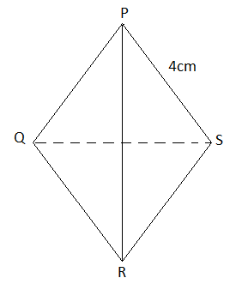
- Calculate the angle between planes PSR and QRS ( 4 marks)

- Calculate the volume of the Tetrahedron ( 6 marks)

- A matatu and Nissan left town A for town B 240km away at 8.00a.m travelling at 90km/hr and 120km/hr respectively. After 20 minutes the Nissan had a puncture which took 30 minutes to mend.
a) How far from town A did the Nissan catch up with the matatu? (6 marks)

b) At what time did the Nissan catch up with the matatu? (1 mark)

c) At what time did the matatu reach town B? (3 marks)

