Name ……………………………………………………… Index No. ………………/….…

Candidate’s Signature …………..………………

Date ………………..

Starehe Boys’ Centre, School and Institute
Kenya Certificate of Secondary Education
MOCK EXAMINATIONS, 2014

443/1
Agriculture
Paper 1
2 hours

Write your name and index number in the spaces provided above.
Sign and write the date of examination in the spaces provided above.
This paper consists of three sections: A, B and C.
Answer ALL the questions in sections A and B, in the spaces provided.
Answer ANY TWO questions in section C in the spaces provided after question 27

For Examiner’s Use Only

Section | Question | Maximum Score | Candidate’s  Score
A | 1 - 17 | 30
B | 18 - 24 | 20
C |  | 20
 |  | 20
Total Score |  | 90

This paper consists of 12 printed pages.
Candidates should check the question paper to ascertain that
all the pages are printed as indicated and no questions are missing.

© 2014, Starehe Boys Centre and School
SECTION A (30 marks)
Answer all questions in this section in the spaces provided

- Mention one form in which nitrogen is taken in by plants (½ mark)

………………………………………………………………………………………………………………………...

- (a) What is meant by a perennial crop? (1 mark)

………………………………………………………………………………………………………………………...

………………………………………………………………………………………………………………………...

(b) Name one perennial fruit crop (½ mark)

………………………………………………………………………………………………………………………...

- State two practices carried out on stored hay to lower the risk of fire (2 marks)

………………………………………………………………………………………………………………………...

………………………………………………………………………………………………………………………...

- (a) Give the term used to describe the process of harvesting each of the following crops
(1½ marks)
Sugarcane …………………………………………………………………………………….

Tea …………………………………………………………………………………………….

Coffee …………………………………………………………………………………………

(b) Why should harvested cotton lint not be packed in gunny bags? (1 mark)

………………………………………………………………………………………………………………………...

………………………………………………………………………………………………………………………...

- (a) Define land tenure (1 mark)

………………………………………………………………………………………………………………………...

(b) Give one advantage of communal land tenure (½ mark)

………………………………………………………………………………………………………………………...

………………………………………………………………………………………………………………………...
- State two possible causes of wilting in tomato plants when the water supply is otherwise adequate
(1 mark)
………………………………………………………………………………………………………………………...

………………………………………………………………………………………………………………………...

- (a) Define ley farming (1 mark)

………………………………………………………………………………………………………………………...

………………………………………………………………………………………………………………………...

(b) State one reason for carrying out ley farming (½ mark)

………………………………………………………………………………………………………………………...

- State one shortfall of crop rotation (1 mark)

………………………………………………………………………………………………………………………...

- List three field practices carried out in a crop to obtain optimum plant population (1½ marks)

………………………………………………………………………………………………………………………...

………………………………………………………………………………………………………………………...

………………………………………………………………………………………………………………………...

- Give two possible meanings of root stock (2 marks)

………………………………………………………………………………………………………………………...

………………………………………………………………………………………………………………………...

- Define gross domestic product (½ mark)

………………………………………………………………………………………………………………………...

………………………………………………………………………………………………………………………...

- State two positive effects of soil organisms (1 mark)

………………………………………………………………………………………………………………………...

………………………………………………………………………………………………………………………...

- (a) What is the source of power for a tractor-drawn rotary cultivator? (½ mark)

………………………………………………………………………………………………………………………...

(b) State two ways in which the rotary cultivator kills the weeds in a growing crop (2 marks)

………………………………………………………………………………………………………………………...

………………………………………………………………………………………………………………………...

- (a) Give two reasons for adding water onto a compost heap, during the preparation of manure
(1 mark)
………………………………………………………………………………………………………………………...

………………………………………………………………………………………………………………………...

(b) What three other practices are carried out to improve the quality of the manure obtained?
(1½ marks)
………………………………………………………………………………………………………………………...

………………………………………………………………………………………………………………………...

………………………………………………………………………………………………………………………...

- List four factors that speed up soil erosion (2 marks)

………………………………………………………………………………………………………………………...

………………………………………………………………………………………………………………………...

………………………………………………………………………………………………………………………...

………………………………………………………………………………………………………………………...

- Write down four maintenance requirements of a metallic watering can (2 marks)

………………………………………………………………………………………………………………………...

………………………………………………………………………………………………………………………...

………………………………………………………………………………………………………………………...

………………………………………………………………………………………………………………………...

………………………………………………………………………………………………………………………...

………………………………………………………………………………………………………………………...
- Give three possible meanings of production (3 marks)

………………………………………………………………………………………………………………………...

………………………………………………………………………………………………………………………...

………………………………………………………………………………………………………………………...

………………………………………………………………………………………………………………………...

………………………………………………………………………………………………………………………...

………………………………………………………………………………………………………………………...

SECTION B (20 marks)
Answer all questions in this section in the spaces provided

- In the table below, indicate with a tick (√) whether the cost given is variable or fixed (3 marks)

Cost | Fixed | Variable
Rent
Maize seed and fertilizer
Wages
Fuel and electricity bill
Salaries

- Study the illustration of a cabbage leaf damaged by the cabbage sawfly (Athalia spp.) and answer the questions that follow

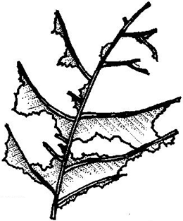
- At what stage of development of the pest does the cabbage sawfly cause the damage illustrated in the diagram above? (1 mark)

………………………………………………………………………………………………………………………...

- Name three other cultivated plants that are attacked by the cabbage sawfly (1½ marks)

………………………………………………………………………………………………………………………...

………………………………………………………………………………………………………………………...

………………………………………………………………………………………………………………………...

- Shown below is a diagrammatic section through a hillside, illustrating terracing

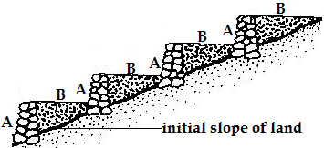

KEY
A “Bank” of stone and earth
B Soil built up behind “bank”

- Identify the type of terrace shown in the diagram above (1 mark)

………………………………………………………………………………………………………………………...

- How does the terrace in (a) above conserve soil and water? (1 mark)

………………………………………………………………………………………………………………………...

………………………………………………………………………………………………………………………...

- Students at Kaputiei school set up the apparatus shown in the diagrams below (on page 7)

The set ups were allowed to stand for a period of seven days

- What was the aim of the experiment? (1 mark)

………………………………………………………………………………………………………………………...

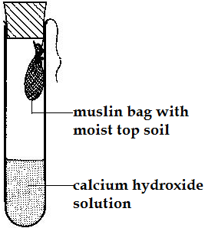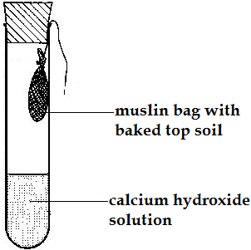
A B

- State the results that were obtained, at the end of the experiment, in set up A (1 mark)

………………………………………………………………………………………………………………………...

………………………………………………………………………………………………………………………...

- How was the “baking” in set up B carried out? (1 mark)

………………………………………………………………………………………………………………………...

………………………………………………………………………………………………………………………...

- Give reason why bags made of muslin, rather than polythene, were used in the experiment
(2 marks)
………………………………………………………………………………………………………………………...

………………………………………………………………………………………………………………………...

- Carefully study the diagram of a water weed shown below and answer the questions that follow

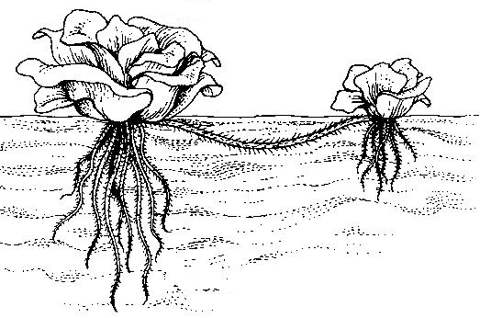
- Identify the weed in the diagram above (1 mark)

………………………………………………………………………………………………………………………...

- The weed in (a) above has been referred to as an indicator organism. Explain (1 mark)

………………………………………………………………………………………………………………………...

………………………………………………………………………………………………………………………...

- Give two “commercial” uses of the weed identified in (a) above (1 mark)

………………………………………………………………………………………………………………………...

………………………………………………………………………………………………………………………...

- Illustrated below is a method of applying water to a tomato crop. Study the illustration carefully and answer the questions that follow

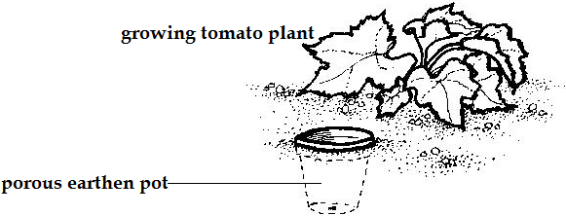

State three reasons why a farmer would carry out the practice illustrated, in preference to conventional irrigation of the crop (1½ marks)

………………………………………………………………………………………………………………………...

………………………………………………………………………………………………………………………...

………………………………………………………………………………………………………………………...

- Shown below (on page 9) is the diagram of a pest and a bean plant infested by the same pest. Study the diagrams carefully and answer the questions that follow

- Name the pest in the diagrams (1 mark)

………………………………………………………………………………………………………………………...

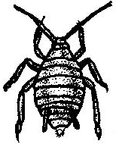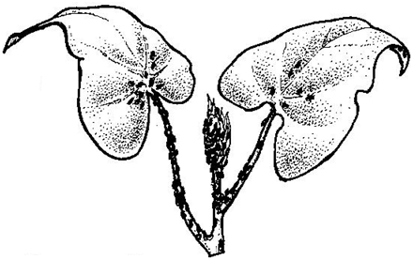

- State four effects of the pest named in (a) above (2 marks)

………………………………………………………………………………………………………………………...

………………………………………………………………………………………………………………………...

………………………………………………………………………………………………………………………...

………………………………………………………………………………………………………………………...

SECTION C (40 marks)
Answer ANY TWO questions in this section in the spaces provided after question 27

- (a) Mr. Korir- a farmer in Narok county has 16 hectares of land, 0.6ha being under permanent
pasture. The farmer intends to grow beans on 6 hectares of land. In the previous seasons, he
hired casual workers at the rate of 80 man-days per hectare. The cost was ksh30.00 per man–day.
This season, he intends to hire a tractor to open the land at a cost of ksh.600.00 per hectare. In the
farmer’s estimation, using a tractor will increase bean production from 800kg/ ha to 1 200kg/ha.
Harvesting will cost kshs6.00 per kg of bean seeds and the price of beans is forecasted at
ksh60.00/kg. Draw up a partial budget to show whether the change would be worthwhile
(5 marks)
- Sigma supplies agency supplied the following goods to Ukulima farm, at 7.5% discount
20 bags of Layers mash @ sh2 200.00
5 bags of dairy meal @ sh2 150.00
10 bags of maize seed @ sh1 350.00
2 bags of DAP fertilizer @ sh2 100.00
Prepare an invoice detailing this transaction (15 marks)

- (a) What is meant by a concession? (2 marks)
- Give examples of concessions, in Kenya (4 marks)
- Outline the benefits and demerits associated with concessions (14 marks)

- (a) Define drip irrigation (3 marks)
- Outline the factors that would make a farmer choose drip irrigation in preference to other methods of irrigation (17 marks)
………………………………………………………………………………………………………………………...

………………………………………………………………………………………………………………………...

………………………………………………………………………………………………………………………...

………………………………………………………………………………………………………………………...

………………………………………………………………………………………………………………………...

………………………………………………………………………………………………………………………...

………………………………………………………………………………………………………………………...

………………………………………………………………………………………………………………………...

………………………………………………………………………………………………………………………...

………………………………………………………………………………………………………………………...

………………………………………………………………………………………………………………………...

………………………………………………………………………………………………………………………...

………………………………………………………………………………………………………………………...

………………………………………………………………………………………………………………………...

………………………………………………………………………………………………………………………...

………………………………………………………………………………………………………………………...

………………………………………………………………………………………………………………………...

………………………………………………………………………………………………………………………...

………………………………………………………………………………………………………………………...

………………………………………………………………………………………………………………………...

………………………………………………………………………………………………………………………...

………………………………………………………………………………………………………………………...

………………………………………………………………………………………………………………………...

………………………………………………………………………………………………………………………...

………………………………………………………………………………………………………………………...

………………………………………………………………………………………………………………………...

………………………………………………………………………………………………………………………...

………………………………………………………………………………………………………………………...

………………………………………………………………………………………………………………………...

………………………………………………………………………………………………………………………...

………………………………………………………………………………………………………………………...

………………………………………………………………………………………………………………………...

………………………………………………………………………………………………………………………...

………………………………………………………………………………………………………………………...

………………………………………………………………………………………………………………………...

………………………………………………………………………………………………………………………...

………………………………………………………………………………………………………………………...

………………………………………………………………………………………………………………………...

………………………………………………………………………………………………………………………...

………………………………………………………………………………………………………………………...

………………………………………………………………………………………………………………………...

………………………………………………………………………………………………………………………...

………………………………………………………………………………………………………………………...

………………………………………………………………………………………………………………………...

………………………………………………………………………………………………………………………...

………………………………………………………………………………………………………………………...

………………………………………………………………………………………………………………………...

………………………………………………………………………………………………………………………...

………………………………………………………………………………………………………………………...

………………………………………………………………………………………………………………………...

………………………………………………………………………………………………………………………...

………………………………………………………………………………………………………………………...

………………………………………………………………………………………………………………………...

………………………………………………………………………………………………………………………...

………………………………………………………………………………………………………………………...

………………………………………………………………………………………………………………………...

………………………………………………………………………………………………………………………...

………………………………………………………………………………………………………………………...

………………………………………………………………………………………………………………………...

………………………………………………………………………………………………………………………...

………………………………………………………………………………………………………………………...

………………………………………………………………………………………………………………………...

………………………………………………………………………………………………………………………...

………………………………………………………………………………………………………………………...

………………………………………………………………………………………………………………………...

………………………………………………………………………………………………………………………...

………………………………………………………………………………………………………………………...

………………………………………………………………………………………………………………………...

………………………………………………………………………………………………………………………...
This is the last printed page of this paper

