Name …….……………………………………………..…… Class …………..

231/3 Candidate’s Signature ………………….…...………..
BIOLOGY
Paper 3
(Practical) Date …………………..
June/ July, 2014
1¾ hours

Starehe Boys’ Centre, School and Institute
Kenya Certificate of Secondary Education
MOCK EXAMINATIONS, 2014

Instructions to candidates
Write your name and class in the spaces provided above.
Sign and write the date of examination in the spaces provided above.
Answer ALL questions in the spaces provided.
Additional pages MUST NOT be inserted.
Candidates will be penalized for incorrect spelling especially of technical terms and for use of slovenly language
You are required to spend the first 15 minutes of the 1¾ hours allowed for this paper reading the whole paper carefully before commencing your work.

For Examiner’s Use Only

Question | Maximum  Score | Candidate’s  Score
1 | 12
2 | 14
3 | 14
Total score | 40

This paper consists of 5 printed pages.
Candidates should check the question paper to ascertain that ALL the pages are
printed as indicated and no questions are missing
- You are provided with specimens labelled R1 and R2. Carefully study the specimens

- State the common name of specimen R1 (1 mark)

………………………………………………………………………………………………………………………...

- (i) Name the taxonomic class to which specimen R1 belongs (1 mark)

………………………………………………………………………………………………………………………...

- Give two reasons for your answer in (b)(i) above (2 mark)

………………………………………………………………………………………………………………………...

………………………………………………………………………………………………………………………...

- Name two other organisms in the taxonomic class named in (b)(i) above (1 mark)

………………………………………………………………………………………………………………………...

………………………………………………………………………………………………………………………...

- (i) Name the taxonomic class to which specimen R2 belongs (1 mark)

………………………………………………………………………………………………………………………...

(ii) Give two reasons for your answer in (c)(i) above (2 marks)

………………………………………………………………………………………………………………………...

………………………………………………………………………………………………………………………...

- (i) Write down two observable differences between specimens R1 and R2 (2 marks)

………………………………………………………………………………………………………………………...

………………………………………………………………………………………………………………………...

………………………………………………………………………………………………………………………...

(ii) Give two other differences between specimens R1 and R2 (2 marks)

………………………………………………………………………………………………………………………...

………………………………………………………………………………………………………………………...

………………………………………………………………………………………………………………………...
- (a) Illustrated below is the photograph of the leaf of Bougainvillea glabra- the “paper flower plant”,
on a graphical background

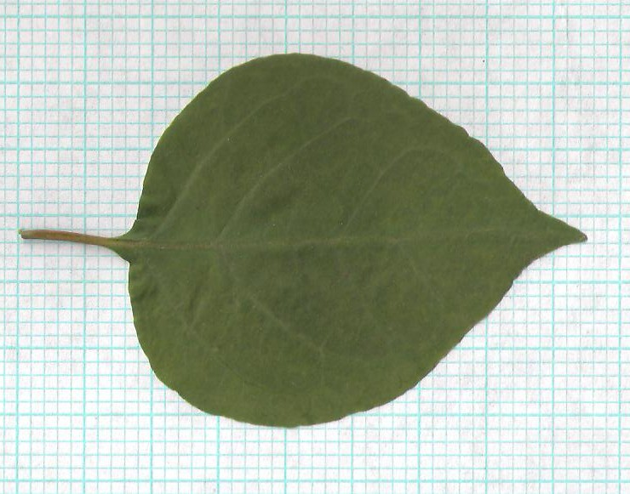

Note: The thick grid lines are 1cm apart

- Determine the surface area of the leaf above (2 marks)

………………………………………………………………………………………………………………………...

………………………………………………………………………………………………………………………...

………………………………………………………………………………………………………………………...

- Briefly describe how you arrived at your answer in (a)(i) above (2 marks)

………………………………………………………………………………………………………………………...

………………………………………………………………………………………………………………………...

………………………………………………………………………………………………………………………...

………………………………………………………………………………………………………………………...

- Give three benefits, to the plant, in having leaves with a large surface area (3 marks)

………………………………………………………………………………………………………………………...

………………………………………………………………………………………………………………………...

………………………………………………………………………………………………………………………...

………………………………………………………………………………………………………………………...
(b) You are provided with specimens labelled P, S1 and Q. Carefully study the specimens

- List three features common to the leaves of specimens P, S1 and Q (3 marks)

………………………………………………………………………………………………………………………...

………………………………………………………………………………………………………………………...

………………………………………………………………………………………………………………………...

………………………………………………………………………………………………………………………...

- Write down one other similarity between the leaves of specimens P and Q (1 mark)

………………………………………………………………………………………………………………………...

- State one difference between the leaves of specimens S1 and Q (1 mark)

………………………………………………………………………………………………………………………...

………………………………………………………………………………………………………………………...

- Give two differences between the leaves of specimens P and Q (2 marks)

………………………………………………………………………………………………………………………...

………………………………………………………………………………………………………………………...

………………………………………………………………………………………………………………………...

- (a) You are provided with a solution labelled D. Using the reagents and materials provided, carry
out tests to identify the food substances contained in solution D. In each case, indicate the
procedure used and record your observation(s) and conclusion, in the table below
(10 marks)
Test | Procedure | Observation | Conclusion
(b) Shown below are the results of a chemical test carried out on crushed specimen R2

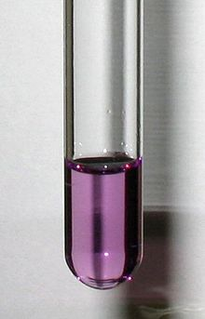

- Name the reagent that was used in the test whose results are shown above (1 mark)

………………………………………………………………………………………………………………………...

- What inference could be made from the results of the experiment whose results are shown above? (1 mark)

………………………………………………………………………………………………………………………...

- State two nutritional benefits, to man, of the material in (b)(ii) above (2 marks)

………………………………………………………………………………………………………………………...

………………………………………………………………………………………………………………………...

………………………………………………………………………………………………………………………...

This is the last printed page of this paper

