Name: ..................................................................................................Class........................

Candidate’s signature……………….Date……………….

Index number…………………………………………….
233/2
CHEMISTRY.
Theory
Paper 2
Time: 2 Hours

STAREHE BOYS’ CENTRE & SCHOOL
Kenya Certificate of Secondary Education.
MOCK EXAMINATION, JUNE/JULY2014.

INSTRUCTIONS
- Answer ALL questions in the spaces provided.
- Mathematical tables and electronic calculators may be used.
- All working MUST be clearly shown where necessary.

For examiners’ use only.
Questions | Max-score | Candidates score
1 | 14
2 | 13
3 | 12
4 | 13
5 | 10
6 | 10
7 | 8
Total score = 80

NB: This paper consists of 10 printed pages.
Students should check the question paper to ensure that All pages are printed as indicated and that no questions are missing.

Turn over
- Below is diagram showing how hydrogen can be prepared in the laboratory and the study of its reaction with lead (II) oxide.
C
Lead (II) oxide

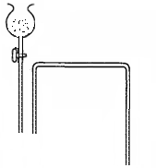
solution
A

Liquid
D

Zinc
granules

Cold water

Liquid B

(a) Name the reducing agents in the two reactions that take place in the set up above. (1 mark)

(b) Identify apparatus C. (1 mark)

(c) Identify one mistake in set up. (1 mark)

(d) Name liquid B and state its purpose in this experiment. (2 marks)

(e) Write equations for the reactions that take place in the conical flask and in the
Apparatus labeled C. (2 marks)
- Conical flask

- Apparatus C

(f) State and explain the observations made in the apparatus labeled C. (3 marks)

(g). Give two tests that can be carried out to determine the purity of liquid D.
(2marks)

(h) State uses of hydrogen gas;
(i) In the food industry. (1mark)

- In manufacture of a raw material used in making a chemical used in agriculture. (1mark)

- Solubility of potassium nitrate and copper (II) sulphate were determined at different temperatures. The following data was obtained.
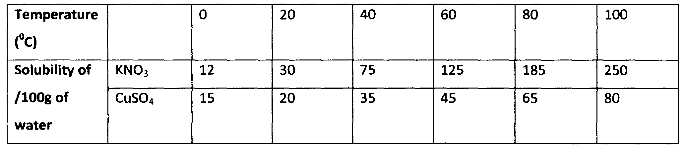
- On the graph paper provided;
- Plot solubility curves for both salts, where solubility (vertical axis) is plotted against temperature. (3marks)
(ii) Determine from the graph the solubility of each salt at 70°C.
I. KNO₃ (1mark)
II. CuSO₄ (1mark)
iii) At what temperature was the solubility of both salts equal? (l mark)

- 262.5g of saturated solution of potassium nitrate at 100°C was cooled to 20°C. What mass of the crystals will be deposited? (4 marks)

- Write the chemical formula of the compounds that causes temporary water hardness.
(1mark)

(c) Give balanced equations for the reactions that take place when temporary hard water is
heated. (2marks)

- Use the standard electrode potentials for elements ABC D and F to answer the questions that follow.
A²⁺_{(aq)} + 2e⁻ A_{(s)} E^{θ} ^{volts} - 2.90
B²⁺_{(aq)} + 2e B_{(s)} -2.38
C⁺(_{aq)} + e⁻ ½C_{2(g)} 0.00
D²⁺_{(aq)} + 2e⁻ D_{(s)} +0.34
½ ^{F}_{2(aq)} + e⁻ F⁻_{(aq)} +2.87
- Which element is likely to be hydrogen? Explain. (2marks)

- Identify the species that is the weakest reducing agent. Explain. (2marks)

c) In the space provided, draw a labeled diagram of the electrochemical cell that would be obtained when half cells of elements B and D are combined. (3marks)

- Calculate the E^{θ} value for the cell constructed in (c) above. (1mark)

d) During the electrolysis of aqueous lead (II) nitrate using lead electrodes, a current of 4 amperes was passed through the cell for 18 minutes and 15 seconds.
- Write an ionic equation for the reaction that took place at the anode. (1mark)

- Determine the change in mass of the anode which occurred as a result of the electrolysis. (1F =96500C, Pb=207) (3marks)

4 (a) Below is a simplified diagram of the Downs cell used for the manufacture of sodium.
study it and answer the questions that follow:
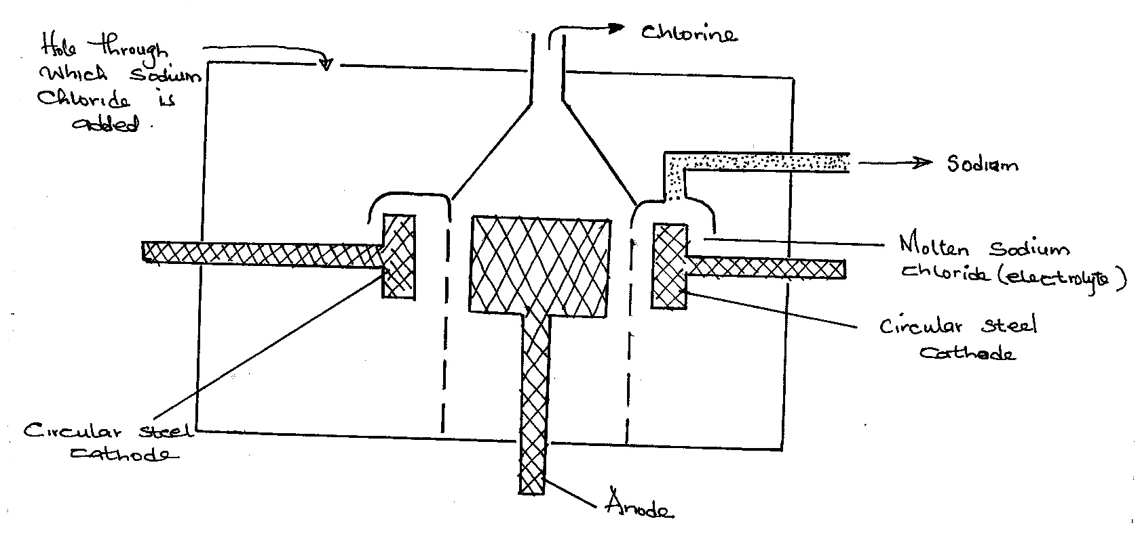

(i) Explain why the anode is not made of steel. (2 marks)

- What precaution is taken to prevent chlorine and sodium from recombining? (1 mark)

- Write an ionic equation for the reaction that took place at the :( 2marks)
- Anode.

- cathode

(b) (i) In the Downs process calcium chloride salt is added to sodium
Chloride. Explain why? (2 marks)

(ii) In Down’s process liquid calcium metal may also be formed alongside . liquid sodium metal. Explain how the two can be separated. (1 mark)

(c) Explain why aqueous sodium chloride is not suitable as an electrolyte for the manufacture of sodium in the Downs process. (2 marks)

- Sodium reacts with water to form sodium hydroxide and hydrogen gas.
(i) Write the equation for the reaction. (1 mark)

(ii) Explain two observations stated below, made on placing a piece of sodium metal. (2marks)
- Sodium melts into a silvery ball.

- Solution turns methyl orange yellow.
5a) The grid below represents part of the periodic table. Study it and answer the questions
that follow. (The letters do not represent the actual symbols of the elements)
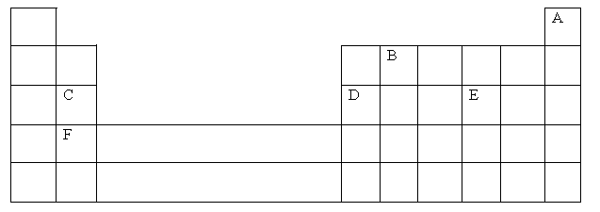
- What name is given to the group of elements to which C and F belong?(1 mark)

- Which letter represents the element that is least reactive? (1 mark)

- What type of bond is formed when D and E react? Explain. (2 marks)

- Draw the cross(x)-dot (o) of the compound formed in 5a (iii) above. (2marks)

- Write the formula of the compound formed when D and oxygen gas react and give the nature of this oxide. (2 mark)

- Write the chemical formula of the ion of E and explain why the ionic radius is larger than its atomic radius. (2marks)

6 a) Study the table below and answer the questions that follow.
Compound | Melting points(K) | Boiling point(K)
C₂H₄O₂  C₃H₆  C₃H₈O  C₅H₁₂  C₆H₁₄ | 289.6  88  146  143  177.7 | 391  225.3  370.2  309.2  341.7
( i) Which of the compounds is a gas at 0⁰C? Explain. (1marks)

(ii) The compound C₃H₈O is an alkanol. How does its solubility in water differ from the
Solubility of C₅H₁₂? Explain. (2marks)

(iii) Name two possible functional groups that could be present in an organic compound with molecular formula C₂H₄O₂. (2marks)

c) Complete combustion of 0.2g of an organic compound containing carbon, hydrogen and oxygen produced 0.44g of Carbon (IV) oxide and 0.24g of water only. Calculate the mass of :
(i) Carbon in 0.44g of carbon (IV) oxide. (C=12, O=16) (1mark)

(ii) Hydrogen in 0.24g of water. (H=1, O=16) (1mark)

- The empirical formula of the organic compound. (3 marks)

7 (a) Methanol is manufactured from carbon (IV) oxide and hydrogen gas according to
the equation:

CO₂(g) + 3H₂(g) CH₃OH(g) + H₂O(g)
The reaction is carried out in the presence of a chromium catalyst at 700K and 30kPa. Under these conditions, equilibrium is reached when 2% of the carbon (IV) oxide is converted to methanol

(i) How does the rate of the forward reaction compare with that of the reverse reaction when 2% of the carbon (IV) oxide is converted to methanol? (1 mark)

(ii) Explain how each of the following would affect the position of the equilibrium:
I Reduction in pressure. (2marks)

II Using a more efficient catalyst (2marks)

(iii) If the reaction is carried out at 500K and 30kPa, the percentage of carbon (IV) oxide converted to methanol is higher than 2%

I what is the sign of ∆H for the forward reaction? Give a reason. (2marks)

II Explain why in practice the reaction is carried out at 700K but NOT at 500K
(1mark)

