312/1
GEOGRAPHY
Paper 1
June 2014
Time: 2¾ Hours

STAREHE BOYS’ CENTRE & SCHOOL
Form 4 Mock Examination 2014
GEOGRAPHY PAPER 1
2¾ Hours

INSTRUCTIONS

- Answer all the questions in section A.
- In section B, answer question 6 and any other two questions.
- Answer section A and each question attempted in section B on a separate answer sheet.
- Failure to follow instructions will be penalized.

SECTION A
Answer all questions in this section

1(a) i) What is natural satellite. (1 mark)
ii) Differentiate between a meteor and a meteorite. (2 marks)
(b) State two effects of the revolution of the earth. (2 marks)

2(a) State two factors which determine the choice of tools to be carried during a field study.
(2 marks)
(b) i) What is a working schedule? (1 mark)
ii) Give two significances of a working schedule in a field study. (2 marks)

3(a) What is a steam jet? (1 mark)
(b) Describe how a hot spring was formed. (3 marks)

4 (a) State how a river erodes by hydraulic action. (2 marks)
(b) i) What is an antecedent gorge? (1 mark)
ii) State two ways in which waterfalls may be formed. (2 marks)

5. Carefully study the diagram below and use it to answer question (a)
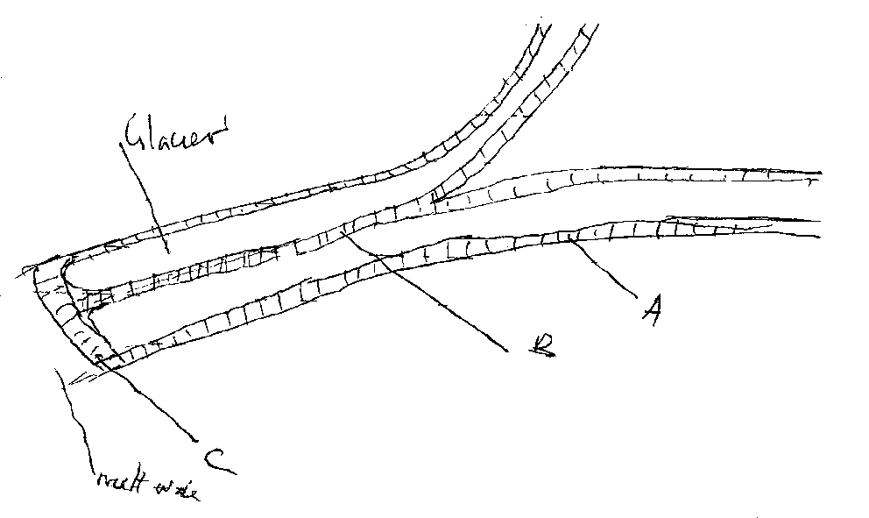

SECTION B
MAP WORK

6. Using the map of Kitale provided answer the following questions.
a) i) Name two administrative units in the area covered by the map.
ii) What is the vertical interval in the area covered by the map? (1 mark)
iii) Name two methods that have been used to represent relief in the area
covered by the map? (2 marks)
b) i) Measure the distance of the all weather road B10/2 from grid reference
230206 upto the junction he grid square 2328. Give your answer in kilometers.
ii) Calculate the area of Kitale Municipality.
- What is the magnetic variation as at the time when the map was made. (1 mark)
iv) Give the bearing and direction of the air photo principal point in the grid square 2232
from the one in the grid square 2928. (3 marks).

c) Draw a cross-section along northing 20 from grid reference 2320 to grid reference 3120 and show;
i) A papyrus swamp
ii) River Koitobos
iii) A road

Use the vertical scale km represents 20m. (6 marks).

d) Explain three factors that have influenced settlement in the area covered by the map. (6 marks)

e) Identify the parts marked A,B and C. (3 marks)
f) State two conditions that lead to glacial deposition. (2 marks)

7a) Differentiate between plutonic rocks and volcanic rocks.
b) i) Give two examples in each of the following
- Hyperbyssal igneous rocks (2 marks)
- Chemical formed sedimentary rocks (2 marks)
- Volcanic rocks (2 marks)
ii) Explain three conditions necessary for the growth of coral polyps (3 marks)
c) i) Define faulting (2 marks)
ii) Differentiate between normal fault and reverse fault. (2 marks)
d) The diagram below shows a faulted landscape. Use it to answer question d (i)
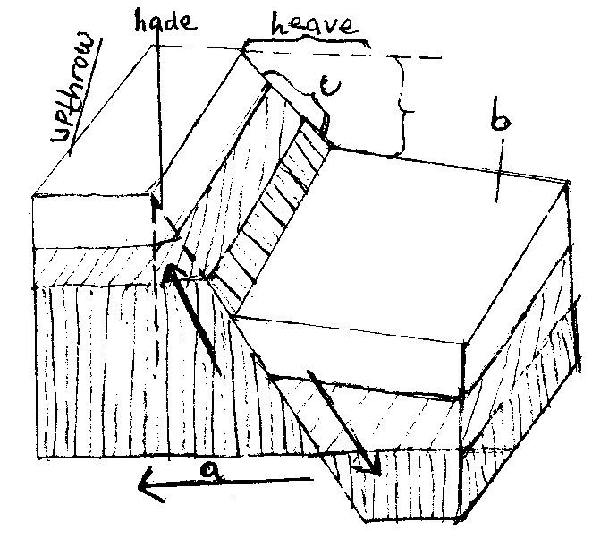

Name the features marked a,b and c. Differentiate between heave and hade (2 marks)
With aid of a diagram explain the formation of rift valley by compression force. (6 marks)

8(a) i) List two agents of weathering. ( 2 marks)
ii) State the effects of the following factors on weathering
- Nature of rocks
- Plants and animals
iii) Explain how weathering occurs by following processes
- block disintegration
- Pressure release or unloading
- Oxidation (6 marks)
b) Students from Kilifi High school conducted a field study of weathering in Kambe region.
i) State the type of weathering they could have identified (1 mark)
ii) Explain how weathering occurs by that process
iii) What two characteristics of the landscape could they have identified during their study? (2 marks)
c. Using the diagram below answer the questions that follow.
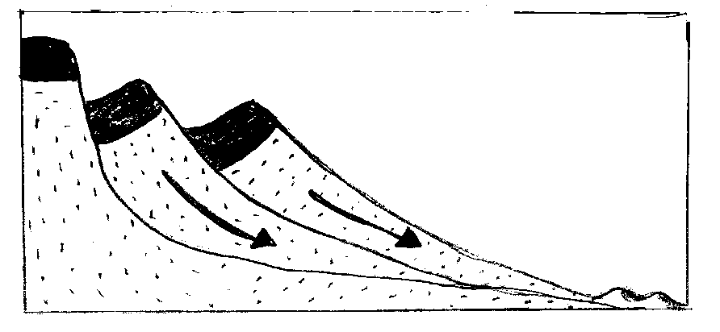

- Identify the process of mass – wanting represented by the diagram (1 mark)
- How does the process in 8 c (i) above take place? (2 marks)
d) State two positive effects of mass – wasting to human activities. (2 marks)

9(a) i) State three factors that influence the occurrence of underground water. (2 marks)
ii) Explain three ways through which springs are formed. (6 marks)
b) i) Draw a well labeled diagram an artesian well and basin. (3 marks)
ii) State four factors favouring the formation of an artesian well. (4 marks)
c) i) Explain three factors influencing the formation of karst scenery. (6 marks)
ii) With the aid of a diagram, explain the formation of grikes and clints. (3 marks)
d) State the significance of limestone rocks to agriculture (1 mark)

10(a) i) What is soil? (1 mark)
ii) State two characteristics of desert soils. (2 marks)
b) Explain how the factors below affect soil formation.
i) Climate (2 marks)
ii) Parent rock (2 marks)
iii) Topography (2 marks)
c) i) Differentiate soil profile from soil catena (2 marks)
ii) Draw a well labeled diagram showing a mature soil profile (4 marks)
d) Explain how the following beaching processes take place.
i) Ferralisation (3 marks)
ii) Podizolisation (3 marks)
e) Supposing you were to carry out a field study of soils around the school.
i) State two soil characteristics that you would study. (2 marks)
ii) Name two methods that you would use to present the data. (2 marks)

