NAME-------------------------------------------ADM NO. ---------------------
FORM III END OF TERM 2 EXAM
MATHEMATICS 121
TIME: 1³/₄HOUR
Instruction to candidate: Attempt all the questions in this paper.

1. Use logarithm tables to evaluate 2347 x 0.4666 (4 mks)
3√0.0924

2. A shirt whose marked price in shs.800 is sold to a customer after allowing him a discount of 13%. If the trader makes a profit of 20%, find how much the trader paid for the shirt. (3mks)

3. The table below shows the number goals scored by a football team in 20 matches
Goals scored | 0 | 1 | 2 | 3 | 4 | 5
Number of matches | 5 | 6 | 4 | 3 | 1 | 1
Find:
a) The mode (1mk)

b) The mean number of goals (2mks)

4. A straight line passes through points A(-3,8) and B(3, -4).Find the equation of the straight line through(3,4) and parallel to AB. Give the answer in the form
y – mx +c,m and c are constants. (3mks)

5. Solve the equation ^{log}₁₀ (6x – 2) – 1 = ^{log} ₁₀ (x -3) (3mks)

6. A train moving at an average speed of 72km/h takes 15 seconds to completely cross a bridge that is 80 metres long.
a) Express 72km/h in metres per second (1mk)

b) Find the length of the train in metres (2mks)

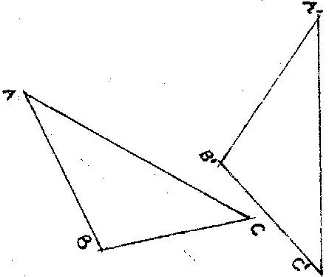
7. In the figure below, triangle A’B’C’ is the image of triangle ABC under a rotation, centre O. (2mks)

By construction, find the label the centre O of the rotation. Hence, determine the angle of the rotation.

8. Given that a = 1 and b =13, express 2 3 - 6 39 in terms of a and b and
3
Simplify the answer. (3mks)

9. Machine A can do a piece of work in 6 hours while machine B can do the same work in 9 hours. Machine A was set to do the piece of work but after 3¹/₂ hours, it broke down and machine B did the rest of the work. Find how long machine B took to do the rest of the work (3mks)

10. Three business partners Atieno, wambui and Mueni contributed sh 50,000, Sh.40,000 as sh 25,000 respectively to start a business.After some time, they realized a profit, which they decided to share in the ration of their contributions.If Mueni’s share was sh 10,000, by how much was Atieno’s share more than wambui’s? (3mks)

11. A colony of insects was found to have 250 insects at the beginning. Thereafter the number of insects doubled every 2 days. Find how many insects there were after 16 days. (3mks)

12. Given that P = 2 3 and Q = 2 -3 , find the matrix product PQ
1 2 1 2

Hence, solve simultaneous equations below: (4mks)
2x – 3 y = 5
-x + 2y = -3

13. Three quantities t, x and y are such that t varies directly as x and inversely as the square root of y. Find the percentage in t if x decreases by 4% when y increases by 44% ( 4 mks)

14. The probability of three darts players Akinyi, Kamau, and Juma hitting the bulls eye are 0.2, 0.3 and 1.5 respectively.
(a) Draw a probability tree diagram to show the possible outcomes (3mks)

(b) Find the probability that:
(i) All hit the bulls eye (2mks)

(ii) Only one of them hit the bulls eye (2mks)

(iii) at most one missed the bull’s eye (3mks)

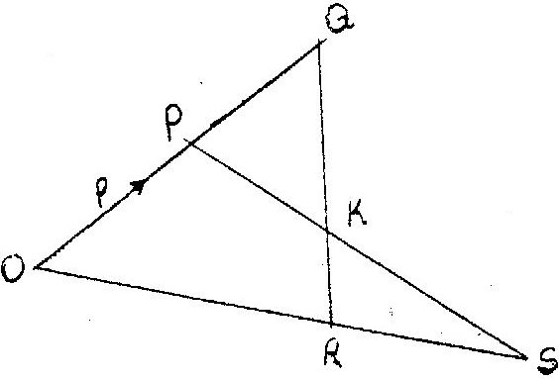
15. In the figure below, vector OP = P and OR =r. Vector OS = 2r and OQ = ³/₂p.

a) Express in terms of p and r
(i) QR (2mks)

(ii) PS (2mks)

b) The lines QR and PS intersect at K such that QK = m QR and PK = n PS, where m and n are scalars. Find two distinct expressions for OK in terms of p,r,m and n. Hence find the values of m and n. (5mks)

c) State the ratio PK:KS (1mks)

16. The table below shows monthly income tax rates for the year 2003.

Monthly taxable income in Ksh. | Tax rates(Percentage)
1-9860  9861 – 18800  18801 – 37040  37041 and above | 10%  15%  20%  25%  30%

In the year 2003.Ole Sanguya’s monthly earnings were as follows:-
Basic salary Ksh 20600
House allowance ksh 12000
Medical allowance Ksh 2880
Transport allowance Ksh 340.
Ole Sanguya was entitled to a monthly tax relief of Ksh 1056.
Calculate:
a) His monthly taxable income (3mks)

b) The monthly tax paid by Ole Sanguya. (7mks)

Good Luck

