Jina ……………………………………………….......Nambari yako …………….…..……......
Sahihi ………………..……………............................Tarehe: ………………………............

102/2 SUKEMO JET
KISWAHILI
KARATASI 2
LUGHA
JULAI/AGOSTI 2016
MUDA: SAA 2½

MAAGIZO
Andika jina lako na namba yako katika nafasi uliyoachiwa hapo juu.
Jibu maswali yote.
Andika majibu yako katika nafasi zilizoachiwa katika kijitabu hiki cha maswali.
Karatasi ina kurasa 11.

KWA MATUMIZI YA MTAHINI PEKEE
SWALI | UPEO | ALAMA
1 | 15
2 | 15
3 | 40
4 | 10
Jumla | 80

1. UFAHAMU (Alama15)
Soma habari ifuatayo kisha ujibu maswali yanayofuata.
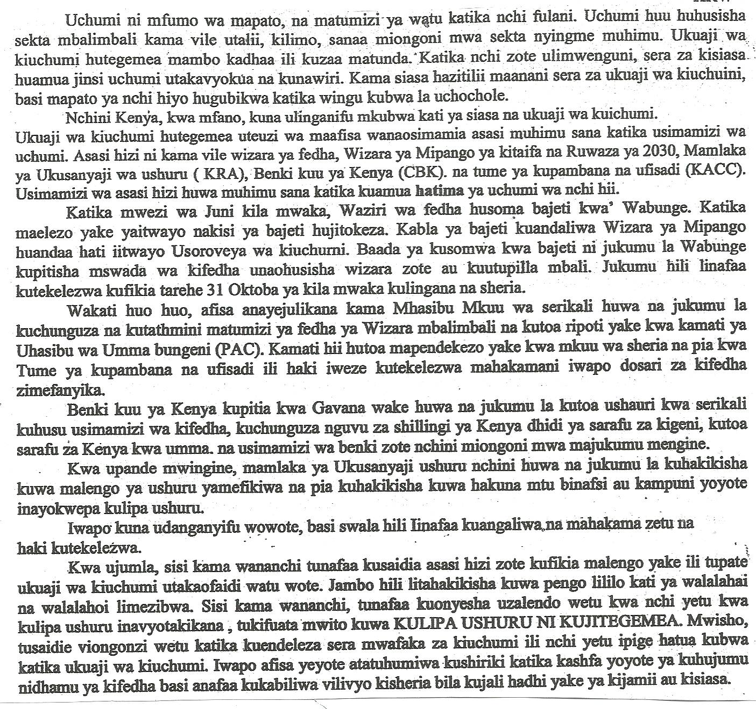

Maswali
- Ipe habari hii kichwa mwafaka. (alama 1)
…………………………………………………………………………………………………
- Ukuaji wa kiuchumi nchini Kenya hutegemea nini? (alama 2)
………………………………………………………………………………………………….
………………………………………………………………………………………………….
………………………………………………………………………………………………….
- Benki kuu ya Kenya ina majukumu yepi? (alama 4)
………………………………………………………………………………………………….
………………………………………………………………………………………………….
………………………………………………………………………………………………….
………………………………………………………………………………………………….
………………………………………………………………………………………………….
………………………………………………………………………………………………….
………………………………………………………………………………………………….
- Mhasibu mkuu ana dhima ipi serikarini? (alama 2)
………………………………………………………………………………………………….
………………………………………………………………………………………………….
………………………………………………………………………………………………….
………………………………………………………………………………………………….
- Pendekeza hatua tatu za kufufua uchumi kulingana na taarifa (alama 3)
………………………………………………………………………………………………….
………………………………………………………………………………………………….
………………………………………………………………………………………………….
………………………………………………………………………………………………….
………………………………………………………………………………………………….
………………………………………………………………………………………………….
- Ni vipi Wakenya wanaweza kuonyesha uzalendo? (alama 1)
………………………………………………………………………………………………….
………………………………………………………………………………………………….
- Eleza maneno yafuatayo kama yalivyotumika katika ufahamu. (al 2)
(i) hatima ………………………………………………………………………………………
(ii) wahalahai…………………………………………………………………………………..
(Alama15)
Soma habari yafuatao kisha ujibu maswali yanayofuata.
Maswali
(a)Iipe habari hii kichwa mwafaka.(alama 1)

…………………………………………………………………………………………………
(b)Ukuaji wa kiuchumi nchini Kenya hutegemea nini?(alama 2)
………………………………………………………………………………………………….
………………………………………………………………………………………………….
………………………………………………………………………………………………….
(c)Benki kuu ya Kenya ina majukumu yepi?(alama 4)
………………………………………………………………………………………………….
………………………………………………………………………………………………….
………………………………………………………………………………………………….
………………………………………………………………………………………………….
………………………………………………………………………………………………….
………………………………………………………………………………………………….
………………………………………………………………………………………………….
(d)Mhasibu mkuu ana dhima ipi serikarini?(alama 2)
………………………………………………………………………………………………….
………………………………………………………………………………………………….
………………………………………………………………………………………………….
………………………………………………………………………………………………….
(e)Pendekeza hatua tatu za kufufua uchumi kulingana na taarifa(alama 2)
………………………………………………………………………………………………….
………………………………………………………………………………………………….
………………………………………………………………………………………………….
………………………………………………………………………………………………….
………………………………………………………………………………………………….
………………………………………………………………………………………………….
(f)Ni vipi wakenya wanaweza kuonyesha uzalendo?(alama 1)
………………………………………………………………………………………………
………………………………………………………………………………………………….
(g)Eleza maneno yafuatayo kama yalivyotumika katika ufahamu
(i)hatima ………………………………………………………………………………………
(ii)wahalahai…………………………………………………………………………
UFAHAMU (Alama15)
Soma habari yafuatao kisha ujibu maswali yanayofuata.
Maswali
(a)Iipe habari hii kichwa mwafaka.(al
…………………………………………………………………………………………………
(b)Ukuaji wa kiuchumi nchini Kenya hutegemea nini?(alama 2)
………………………………………………………………………………………………….
………………………………………………………………………………………………….
………………………………………………………………………………………………….
(c)Benki kuu ya Kenya ina majukumu yepi?(alama 4)
………………………………………………………………………………………………….
………………………………………………………………………………………………….
………………………………………………………………………………………………….
………………………………………………………………………………………………….
………………………………………………………………………………………………….
………………………………………………………………………………………………….
………………………………………………………………………………………………….
(d)Mhasibu mkuu ana dhima ipi serikarini?(alama 2)
………………………………………………………………………………………………….
………………………………………………………………………………………………….
………………………………………………………………………………………………….
………………………………………………………………………………………………….
(e)Pendekeza hatua tatu za kufufua uchumi kulingana na taarifa(alama 2)
………………………………………………………………………………………………….
………………………………………………………………………………………………….
………………………………………………………………………………………………….
………………………………………………………………………………………………….
………………………………………………………………………………………………….
………………………………………………………………………………………………….
(f)Ni vipi wakenya wanaweza kuonyesha uzalendo?(alama 1)
………………………………………………………………………………………………….

………………………………………………………………………………………………….
(g)Eleza maneno yafuatayo kama yalivyotumika katika ufahamu
(i)hatima ………………………………………………………………………………………
(ii)wahalahai………………………………………………………………………
UFAHAMU (Alama15)
Soma habari yafuatao kisha ujibu maswali yanayofuata.
Maswali
(a)Iipe habari hii kichwa mwafaka.(ala
…………………………………………………………………………………………………
(b)Ukuaji wa kiuchumi nchini Kenya hutegemea nini?(alama 2)
………………………………………………………………………………………………….
………………………………………………………………………………………………….
………………………………………………………………………………………………….
(c)Benki kuu ya Kenya ina majukumu yepi?(alama 4)
………………………………………………………………………………………………….
………………………………………………………………………………………………….
………………………………………………………………………………………………….
………………………………………………………………………………………………….
………………………………………………………………………………………………….
………………………………………………………………………………………………….
………………………………………………………………………………………………….
(d)Mhasibu mkuu ana dhima ipi serikarini?(alama 2)
………………………………………………………………………………………………….
………………………………………………………………………………………………….
………………………………………………………………………………………………….
………………………………………………………………………………………………….
(e)Pendekeza hatua tatu za kufufua uchumi kulingana na taarifa(alama 2)
………………………………………………………………………………………………….
………………………………………………………………………………………………….
………………………………………………………………………………………………….
………………………………………………………………………………………………….
………………………………………………………………………………………………….
………………………………………………………………………………………………….
(f)Ni vipi wakenya wanaweza kuonyesha uzalendo?(alama 1)
………………………………………………………………………………
………………………………………………………………………………………………….
(g)Eleza maneno yafuatayo kama yalivyotumika katika ufahamu
(i)hatima ………………………………………………………………………………………
(ii)wahalahai…………………………………………………………………………
UFAHAMU (Alama15)
Soma habari yafuatao kisha ujibu maswali yanayofuata.
Maswali
(a)Iipe habari hii kichwa mwafaka.(alam
…………………………………………………………………………………………………
(b)Ukuaji wa kiuchumi nchini Kenya hutegemea nini?(alama 2)
………………………………………………………………………………………………….
………………………………………………………………………………………………….
………………………………………………………………………………………………….
(c)Benki kuu ya Kenya ina majukumu yepi?(alama 4)
………………………………………………………………………………………………….
………………………………………………………………………………………………….
………………………………………………………………………………………………….
………………………………………………………………………………………………….
………………………………………………………………………………………………….
………………………………………………………………………………………………….
………………………………………………………………………………………………….
(d)Mhasibu mkuu ana dhima ipi serikarini?(alama 2)
………………………………………………………………………………………………….
………………………………………………………………………………………………….
………………………………………………………………………………………………….
………………………………………………………………………………………………….
(e)Pendekeza hatua tatu za kufufua uchumi kulingana na taarifa(alama 2)
………………………………………………………………………………………………….
………………………………………………………………………………………………….
………………………………………………………………………………………………….
………………………………………………………………………………………………….
………………………………………………………………………………………………….
………………………………………………………………………………………………….
(f)Ni vipi wakenya wanaweza kuonyesha uzalendo?(alama 1)
………………………………………………………………………………………………….

………………………………………………………………………………………………….
(g)Eleza maneno yafuatayo kama yalivyotumika katika ufahamu
(i)hatima ………………………………………………………………………………………
(ii)wahalahai…………………………………………………………………………
2. MUHTASARI
Soma makala yafuatayo kisha ujibu maswali
Mwana wa Adamu ni kiumbe cha ajabu! Ni kiumbe kilichopewa uwezo wa kuhodhi na kumiliki kila kitu; kiumbe kilichopewa akili na maarifa fuvu tele ili kuratibu shughuli na mambo; kiumbe kilichopewa uwezo wa kuwasiliana na kutumia sauti nasibu ili kuwa na urari na muwala; kiumbe kilichopewa uwezo wa kufaidi viumbe wengine kwa njia mbalimbali na jumla jamala; hichi ndicho kiumbe kilichopewa idhini maalumu ya kuzaana na kujaza dunia. Huyu ndiye mwana wa mama Hawa ambaye sasa amegeuka ndovu kumla mwanawe.
Kwa sababu ya bongo alizonazo, binadamu ana uwezo wa kutumia teknolojia kwa manufaa yake na ithibati zipo tele. Binadamu ametumia nyambizi kuzuru chini ya bahari; amefika mwezini; amevumbua mangala; amevumbua uyoka; amevumbua tarakilishi na sasa shughuli zake ni za kutandaridhi. Mwenyewe yuasema kuwa dunia yake imekuwa kitongoji katika muumano huu.
Chambacho wavyele, akili nyingi huondoa maarifa.Binadamu amekuwa dubwana linalojenga kushoto na kubomoa kulia na tuna sababu ya kulisoza dubwana hili kidole. Rabana ndiye msanii asiye mfanowe kwani aliisawiri dunia kwa kila lililo jema kwa siku sita mtawalia na kumpa binadamu mazingira murua. Rabuka akaona yote yalikuwa mema na mazuri; akamwambia binadamu, “Haya, twende kazi!”
Viwanda vya binadamu vinatiririsha maji-taka ovyo hadi mitoni, maziwani na baharini na matokeo yamekuwa ni vifo vya viumbe vya majini kama samaki ambavyo ni urithi aliopewa na Muumba. Hakuna kiumbe kinachoweza kustahimili maisha bila maji safi. Maji yote sasa yametiwa sumu na binadamu kwa sababu ya ‘maendeleo’ yake. Joshi kutoka katika viwanda vivyo hivyo nalo limehasiri ukanda wa ozoni ambao sasa umeruhusu jua kutuhasiri kwa joto kali mno. Siku hizi inasemekana kuwa kuna mvua ya asidi inayonyesha katika baadhi ya sehemu za dunia na kuleta madhara makubwa. Labda hata mabahari yamekasirika kwa sababu hivi majuzi katika kile kilichoitwa ‘tsunami’ bahari lilihamia nchi kavu na kusomba maelfu ya binadamu na kuwameza wazima wazima. Vimbunga navyo vimetokea kwa wingi. Wataalamu wanasema kuwa viwango vya miyeyuko vitazidi kwa sababu ya joto na kiwango cha maji kitazidi pia. Binadamu atatorokea wapi?
Idadi ya binadamu imezidi hadi kiasi asichoweza kukishughulikia kwa sababu anaijaza kiholela kwa sababu anadai kuwa aliruhusiwa kuijaza. Hii ni imani potovu. Anasahau kuwa alipewa ubongowa kuwaza na kuwazua kabla ya kufanya chochote. Dhiki, maradhi na ufukara zimehamia kwa binadamu na kumtia kiwewe.
Binadamu amefyeka misitu kwa kutaka makao, mashamba, mbao, makaa, ujenzi wa nyumba na barabara na mahitaji mengine mengi. Wanyama wamefurushwa na wengi kuangamia kwa sababu ya ukosefu wa chakula na wengine kushindwa kuhimili mabadiliko katika mazingira. Chemichemi za maji zimekauka nalo jangwa limeanza kutuzuru kwa kasi inayotisha. Kazi ya binadamu imekuwa ya kusukia kamba motoni. Itambidi aanze kujenga kwa matofali ya barafu!
Maswali
- Bila kupoteza maana iliyokusudiwa na mwandishi wa taarifa, fupisha aya ya kwanza. (Maneno 40-50) (alama 5)

Matayarisho
………………………………………………………………………………………………
………………………………………………………………………………………………
………………………………………………………………………………………………
………………………………………………………………………………………………
………………………………………………………………………………………………
………………………………………………………………………………………………
………………………………………………………………………………………………
Jibu
………………………………………………………………………………………………
………………………………………………………………………………………………
………………………………………………………………………………………………
………………………………………………………………………………………………
………………………………………………………………………………………………
………………………………………………………………………………………………
………………………………………………………………………………………………
………………………………………………………………………………………………
Kwa kuzingatia aya nne za mwisho, eleza mambo muhimu yanayoshughulikiwa na mwandishi. (Maneno 95 – 105) (alama8)
Matayarisho:
………………………………………………………………………………………………
………………………………………………………………………………………………
………………………………………………………………………………………………
………………………………………………………………………………………………
………………………………………………………………………………………………
………………………………………………………………………………………………
………………………………………………………………………………………………
………………………………………………………………………………………………
Jibu:
………………………………………………………………………………………………
………………………………………………………………………………………………
………………………………………………………………………………………………
………………………………………………………………………………………………
………………………………………………………………………………………………
………………………………………………………………………………………………
………………………………………………………………………………………………
………………………………………………………………………………………………
………………………………………………………………………………………………
………………………………………………………………………………………………
………………………………………………………………………………………………
………………………………………………………………………………………………
………………………………………………………………………………………………
3. MATUMIZI YA LUGHA (ALAMA 40)
1.a. Eleza maana ya ngeli. (al 1)
………………………………………………………………………………………………
………………………………………………………………………………………………
………………………………………………………………………………………………
b. Nomino hizi zinapatikana katika ngeli zipi? (al 1)
i. saa ………………………………………………………………………………………………
ii. dunia ………………………………………………………………………………………
2. Tambua sauti yenye sifa; mbele, juu na tandazwa. .............................................................(al 1)
3. Ainisha vitenzi katika sentensi ifuatayo. Watoto wale waliokuwa hapo sio wa Maria. (al 2)
………………………………………………………………………………………………
………………………………………………………………………………………………
4. Ainisha viambishi katika neno; yatabomolewa (al 2)
i. kimuundo

ii. kimajukumu

5. Andika kwa ukubwa wingi. (al 2)
Kiti kilichokuwa kimekaliwa na mwanamke yule kilivunjika
………………………………………………………………………………………………
………………………………………………………………………………………………
6. Tunga sentensi tatu kudhihirisha matumizi matatu tofauti ya kiambishi ngali. (al 3)
i.……………………………………………………………………………………………
ii……………………………………………………………………………………………
iii……………………………………………………………………………………………
7. Tunga sentensi mbili ukitumia kabla ya kama ; (al 2)
i. Kihusishi cha wakati ………………………………………………………………………………………………
………………………………………………………………………………………………
ii. Kiunganishi cha wakati
………………………………………………………………………………………………
………………………………………………………………………………………………
8. Ainisha virai vyote katika sentensi ifuatayo; Nyuta zao zote ziliibwa jana usiku. (al 2)
………………………………………………………………………………………………
………………………………………………………………………………………………
9. Ainisha vishazi katika sentensi ifuatayo; Kondoo ambao walichinjwa jana walikuwa wagonjwa. (al 2)
………………………………………………………………………………………………
………………………………………………………………………………………………
………………………………………………………………………………………………
10. Ainisha yambwa katika sentensi hii; Yusuf alitumiwa hundi ya karo na shangazi yake kwa posta. ( 3)
………………………………………………………………………………………………
………………………………………………………………………………………………
………………………………………………………………………………………………
………………………………………………………………………………………………
11. Changanua sentensi ifuatayo kwa njia ya mstari. (al 4)
Dhahabu ni madini yanayothaminiwa na wengi.

12. Eleza maana mbili zinazojitokeza katika sentensi hii; Anawadhamini watoto maskini. (al2)
i……………………………………………………………………………………………
………………………………………………………………………………………………
ii……………………………………………………………………………………………
………………………………………………………………………………………………
13. a. Tunga sentensi mbili kuonyesha matumizi tofauti ya neno jinsi (al 2)
i.……………………………………………………………………………………………
ii……………………………………………………………………………………………
b. Tunga sentensi katika hali ya wingi ukitumia kiambishi NDI pamoja na nomino katika ngeli ya U-ZI. (al 2)
………………………………………………………………………………………………
………………………………………………………………………………………………
14. Kamilisha sentensi hii kwa nahau ifaayo. (al 1)
Nipatie angaa maji baridi ili niweze ………………………………………………
15. Tunga sentensi mbili ukitumia kitenzi lia katika kauli ya kutendea kuleta dhana tofauti.(al 2)
i.……………………………………………………………………………………………
ii……………………………………………………………………………………………
16. Andika katika usemi wa taarifa. (al 2)
“Ala! Ninataka kujua ni nani amekula chakula changu.” Asha akasema.
…………………………………………………………………………………………………
…………………………………………………………………………………………………
17. Tumia alama ya nyonza/achwa katika sentensi. (al 1)
…………………………………………………………………………………………………
18. Andika kinyume cha sentensi ifuatayo. Maria alitabasamu alipofuzu mtihani. (al 1)
…………………………………………………………………………………………………

19. Tunga sentensi moja kudhihirisha maana ya vitate hivi; afya na avya.
…………………………………………………………………………………………………
…………………………………………………………………………………………………
20. Ondoa amba katika sentensi ifuatayo. Mti ambao hukatwa hukauka. (al 1)
…………………………………………………………………………………………………

4. ISIMUJAMII (AL 10)
1. a. Eleza athari nne hasi kwa mwanafunzi za matumizi ya Sheng’. (al 4)
i……………………………………………………………………………………………
………………………………………………………………………………………………
……………………………………………………………………………………………

ii……………………………………………………………………………………………
………………………………………………………………………………………………
………………………………………………………………………………………………

iii……………………………………………………………………………………………
………………………………………………………………………………………………
………………………………………………………………………………………………

iv……………………………………………………………………………………………
………………………………………………………………………………………………
………………………………………………………………………………………………
………………………………………………………………………………………………

b. Taja na ueleze mambo sita yaliyochangia kuenea kwa lugha ya Kiswahili nchini Kenya kabla ya uhuru. (al 6)
i.……………………………………………………………………………………………
………………………………………………………………………………………………
………………………………………………………………………………………………
………………………………………………………………………………………………
ii……………………………………………………………………………………………
………………………………………………………………………………………………
………………………………………………………………………………………………
………………………………………………………………………………………………
iii……………………………………………………………………………………………
………………………………………………………………………………………………
………………………………………………………………………………………………
………………………………………………………………………………………………
iv……………………………………………………………………………………………
………………………………………………………………………………………………
………………………………………………………………………………………………
………………………………………………………………………………………………
v……………………………………………………………………………………………
………………………………………………………………………………………………
………………………………………………………………………………………………
vi……………………………………………………………………………………………
………………………………………………………………………………………………
………………………………………………………………………………………………

