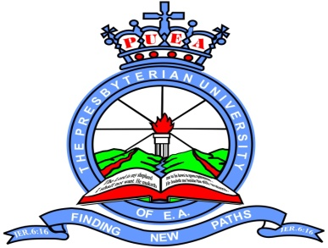

The Presbyterian University of East Africa

School: HEALTH SCIENCES
Program: DIPLOMA
Semester: JAN – APR 2013
Course Code: MCO 321
Course Title: OPTHALMOLOGY
Date: 23/04/2013
Campus: Kikuyu

Instructions
- Answer all questions as directed in each section of the paper
- Read the question and indicate whether true or false at the beginning of the each statement
- Do not guess. If you do not know the answer, leave blank. 1 mark will be deducted for each wrong answer
- If you make corrections, do so clearly, failure to do so will lead to loss of marks
- Enter your registration number at the top right hand corner of every sheet of paper used (NO NAMES)
- There is negative 1 marking for every wrong response in MCQs
SECTION –A. Circle either T or F for each true or false answer. Each wrong answer is negative one mark.Attemt all the questions.
- The oculomotor nerve supplies the
- Superior oblique
- Orbicularis oculi
- Dilator pupilae
- Inferior rectus
- None of the above muscles
2 .Which of the following structures does not form part of the eyelid ?
- Tarsal plate
- Meibomian glands
- Orbital septum
- Ciliary muscles
- Eye rashes
3 .The orbicularis oculi is supplied by the
- Temporal branch of the facial nerve
- Supra orbital nerve
- Oculomotor nerve
- Infra orbital nerve
- Zygo matico-facial nerve
4 .The floor of the orbit is formed by the
- Maxillaz,ygomatic and sphenoid
- Maxilla,sphenoid and palatine
- Maxilla,palatine and zygomatic
- Maxilla and zygomatic only
- Maxilla and sphenoid only
5 .The muscles served by trochlear nerve are
- Inferior oblique
- Superior oblique
- Superior rectus
- Inferior rectus
- Lateral rectus

6. The muscles served by abducent nerve are
- Inferior oblique
- Superior oblique
- Superior rectus
- Inferior rectus
- Lateral rectus
7. Tears pass through all the following structures except
- Conjuctival sac
- Lacrimal sac
- Frontonasal duct
- Inferior meatus of nose
- Cavernous

SECTION B; Attempt all the questions.
8 .What do you find on doing fundoscopy of a patient with the following chronic conditions;
- Hypertension
- Diabetes mellitus
- Increased intracranial pressure
- Glaucoma
- Cataract
SECTION C; Answer both questions.
1. Describe the various causes of blindness in Kenya and their various modes of management and prevention [15 MARKS].
2. Describe the causes, clinical features, modes of management and prevention of trachoma in kenya [15 marks].

