Name:....................................................................................Index No.: ........................................
Candidate’s Signature: .................
Date: ................................................

231/2
BIOLOGY
Paper 2
JUNE 2014
Time: 2 hours

BUSIA COUNTY JOINT EVALUATION EXAMINATION
Kenya Certificate of Secondary Education
Paper 2
BIOLOGY
Instructions to Candidates

- Write your name and index number in the spaces provided above.
- Sign and write the date of the examination paper.
- Answer ALL the questions in the spaces provided in the question paper.
- ALL working MUST be clearly shown where necessary.
- Mathematical tables and silent electronic calculators may be used.

CANDIDATE’S SCORE

SECTION A (40 MARKS)

- The diagram below shows a life cycle of a cockroach
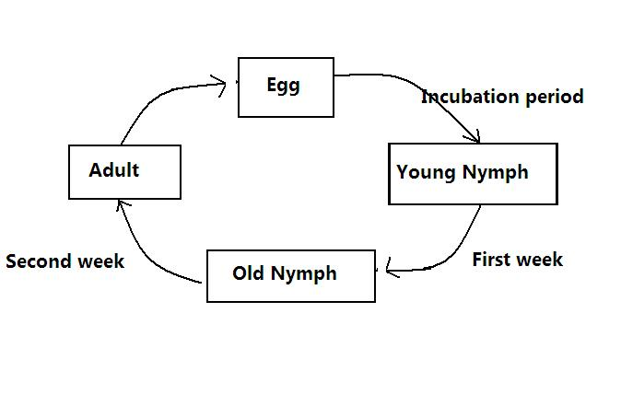
  - Name the hormone that would be at high concentration during the first and second week and their functions.
- First week (2mks)
Hormone ………………………………………………………………………………………………
Function
………………………………………………………………………………………………
(ii) Second week (2mks)
Hormone ………………………………………………………………………………………………
Function
………………………………………………………………………………………………
  - Name the structure that produces hormone named in a (ii) above (1mk)
………………………………………………………………………………………………
c) Name the process represented by the life cycle above (1mk)
………………………………………………………………………………………………
d) State two importance for the process named in (c) above (2mks)
………………………………………………………………………………………………………………………………………………………………………………………………………………………………………………………………………………………………

- The diagram below represents part of a geasous system in a grasshopper.
P Q
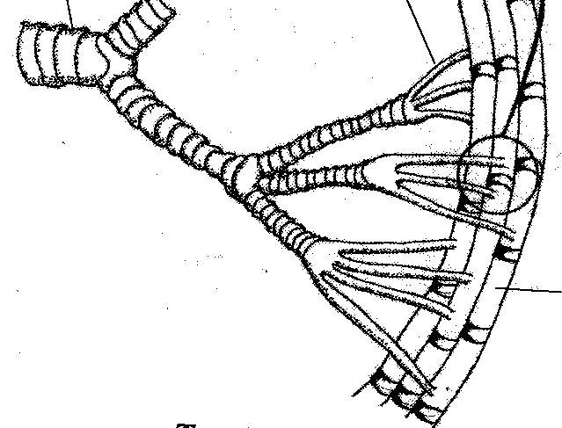

a) Name the structures labeled P and Q
P……………………………………………………………………………………..(1mk)
Q …………………………………………………………………………………….(1mk)
b) State the function of the structure labeled P (1mk)
………………………………………………………………………………………………………………………………………………………………………………………………
c) Describe the path taken by carbon (IV) oxide from the tissues of the insect the atmosphere (3mks)
………………………………………………………………………………………………………………………………………………………………………………………………………………………………………………………………………………………………………………………………………………………………………………………………
d) How is the structure labeled Q adapted to its functions (2mks)
……………………………………………………………………………………………………………………………………………………………………………………………………………………………………………………………………………………………………………………………………………………………………………………………..

- The set up below illustrates an experiment to demonstrate a certain biological process, before the addition of the yeast suspension the glucose solution was first boiled and then cooled at 40ºC.
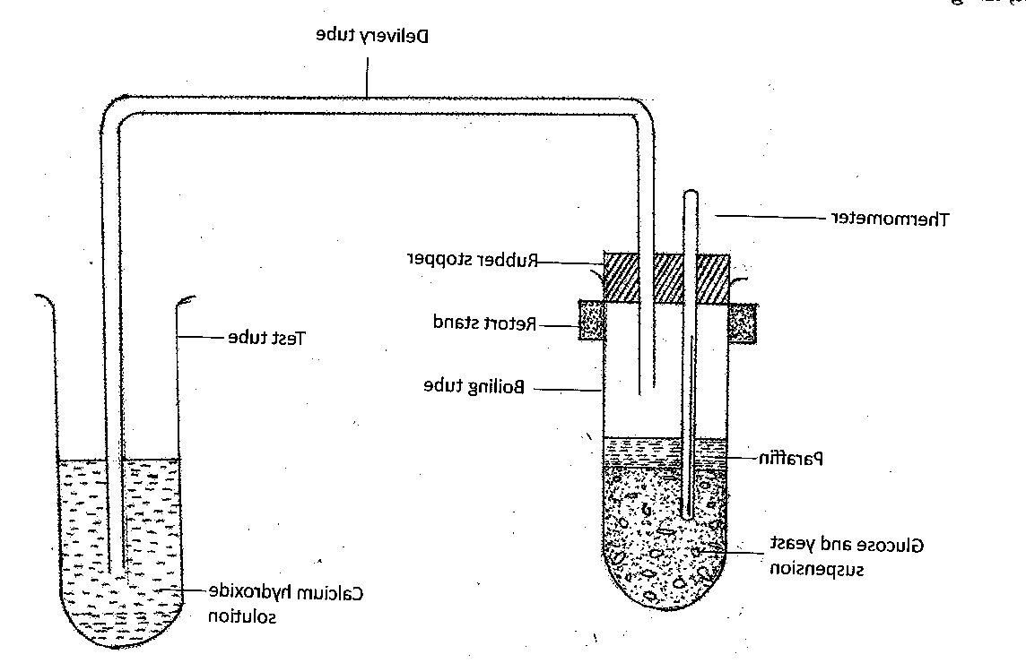
a) What was the aim of the experiment? (1mk)
………………………………………………………………………………………………
b) What observations would you make in the tubes a few minutes after the experiment begun (2mks)
………………………………………………………………………………………………
………………………………………………………………………………………………………………………………………………………………………………………………
c) Explain the observations made in (b) above (2mks)
………………………………………………………………………………………………………………………………………………………………………………………………………………………………………………………………………………………………
d) Why was glucose solution boiled before cooling at 40ºC (1mk)
………………………………………………………………………………………………
e) How can you set up a control experiment for the above (1mk)
………………………………………………………………………………………………

- The following are short messages (sms) on cell phone communication between Mrs. Mkenzie and her husband. They can be used as analogies of gene mutation
 | Intentended message | Actual message
1. | I want a drive | I want a driver
2. | Yesterday was my shopping day | Yesterday was my hopping day
3 | My skirt was stolen | My shirt was stolen
4 | Tommorrow I will be visiting my team | Tommorow I will be visitng my mate

a) For each of these messages identify the type of gene mutation illustrated (4mks)
1……………………………………………………………………………………………
2……………………………………………………………………………………………
3……………………………………………………………………………………………
4……………………………………………………………………………………………
b) State one example of chromosomal mutation that lead to
i) Change in chromosome structure (1mk)
………………………………………………………………………………………………
ii) Change in chromosomal number (1mk)
………………………………………………………………………………………………
c) Explain why genetic counseling is termed as one practical application of genetics
(2mks)
………………………………………………………………………………………………………………………………………………………………………………………………………………………………………………………………………………………………

- The following is a photograph of s dissected mammal. Study the photograph and answer the questions that follows

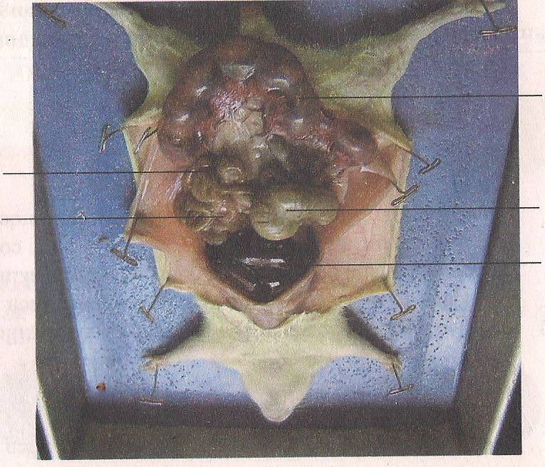

R

T S

a) Name the structures labeled R,S and T (3mks)
R…………………………………………………………………………………………………….
S…………………………………………………………………………………………………….
T…………………………………………………………………………………………………….
b) On the photograph, label and name the site of production of vitamin K (1mk)
………………………………………………………………………………………………………
c) State one function of the following parts (2mks)
S……………………………………………………………………………………………………………………………………………………………………………………………………………
T……………………………………………………………………………………………………………………………………………………………………………………………………………
d) i) State the sex of the dissected mammal (1mk)
………………………………………………………………………………………………………
ii) Give a reason for your answer in d (i) above (1mk)
……………………………………………………………………………………………………..

SECTION B (40 MARKS)

Answer question 6(compulsory) then choose any between question 7 and 8

- The figure below shows the changes in the concentration of various substances in a river following the discharge of untreated sewage into it. Study it and answer the questions that follow
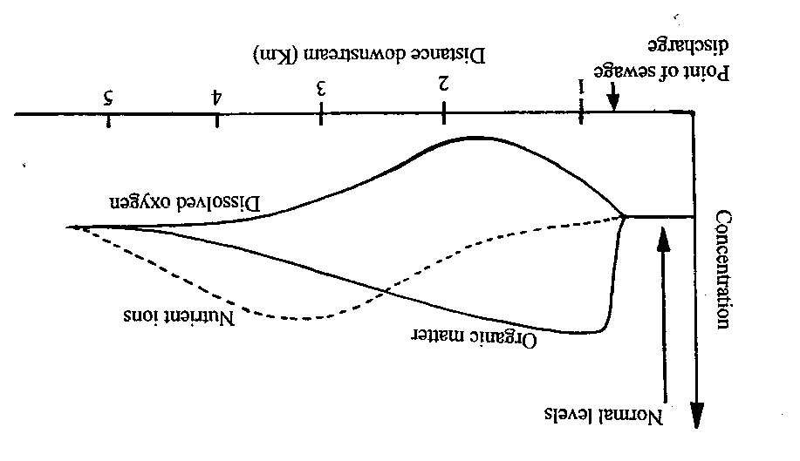
a) Account for the changes in the concentration of:
i) Organic matter (3mks)
………………………………………………………………………………………………………………………………………………………………………………………………………………………………………………………………………………………………………………………………………………………………………………………………
ii) Nutrient ions (2mks)
………………………………………………………………………………………………………………………………………………………………………………………………………………………………………………………………………………………………
iii) Dissolved oxygen (4mks)
…………………………………………………………………………………………………………………………………………………………………………………………………………………………………………………………………………………………………………………………………………………………………………………………………………………………………………………………………………………………….
………………………………………………………………………………………………………………………………………………………………………………………………
b) Describe the changes you would expect to observe with respect to:
i) Fish population (3mks)
………………………………………………………………………………………………………………………………………………………………………………………………………………………………………………………………………………………………………………………………………………………………………………………………
………………………………………………………………………………………………………………………………………………………………………………………………………………………………………………………………………………………………
ii) Water plants and photosynthetic algae (4mks)
………………………………………………………………………………………………………………………………………………………………………………………………………………………………………………………………………………………………………………………………………………………………………………………………………………………………………………………………………………………………
………………………………………………………………………………………………………………………………………………………………………………………………………………………………………………………………………………………………
c) State four ways of controlling the type of pollution illustratted above (4mks)
………………………………………………………………………………………………………………………………………………………………………………………………………………………………………………………………………………………………………………………………………………………………………………………………………………………………………………………………………………………………
………………………………………………………………………………………………………………………………………………………………………………………………………………………………………………………………………………………………………………………………………………………………………………………………

- Describe how the following types of plants are adapted to their habitats:

a) Mesophytes (10mks)

b) Halophytes (5mks)

c) Hydrophytes (5mks)

8. Discuss the adaptations of the human eye to its functions (20mks)
…………………………………………………………………………………………………………………………
…………………………………………………………………………………………………………………………………………………………………………………………………………………………………………………………………………………………………………………………………………………………………………………………………………………………………………………………………………………………………………………………………………………………………………………………………………………………………………………………………………………………………………………………………………………………………………………………………………………………………………………………………………………………………………………………………………………………………………………………………………………………………………………………………………………………………………………………………………………………………………………………………………………………………………………………………………………………………………………………………………………………………………………………………………………………………………………………………………………………………………………………………………………………………………………………………………………………………………………………………………………………………………………………………………………………………………………………………………………………………………………………………………………………………………………………………………………………………………………………………………………………………………………………………………………………………………………………………………………………………………………………………………………………………………………………………………………………………………………………………………………………………………………………………………………………………………………………………………………………………………………………………………………………………………………………………………………………………………………………………………………………………………………………………………………………………………………………………………
………………………………………………………………………………………………………………………………………………………………………………………………………………………………………………………………………………………………………………………………………………………………………………………………………………………………………………………………………………………………………………………………………………………………………………………………………………………………………………………………………………………………………………………………………………………………………………………………………………………………………………………………………………………………………………………………………………………………………………………………………………………………………………………………………………………………………………………………………………………………………………………………………………………………………………………………………………………………………………………………………………………………………………………………………………………………………………………………………………………………………………………………………………………………………………………………………………………………………………………………………………………………………………………………………………………………………………………………………………………………………………………………………………………………………………………………………………………………………………………………………………………………………………………………………………………………………………………………………………………………………………………………………………………………………………………………………………………………………………………………………………………………………………………………………………………………………………………………………………………………………………………………………………………………………………………………………………………………………………………………………………
………………………………………………………………………………………………………………………….
…………………………………………………………………………………………………………………………
…………………………………………………………………………………………………………………………
…………………………………………………………………………………………………………………………
…………………………………………………………………………………………………………………………
…………………………………………………………………………………………………………………………
…………………………………………………………………………………………………………………………
…………………………………………………………………………………………………………………………
…………………………………………………………………………………………………………………………
…………………………………………………………………………………………………………………………
…………………………………………………………………………………………………………………………
…………………………………………………………………………………………………………………………
…………………………………………………………………………………………………………………………
…………………………………………………………………………………………………………………………
…………………………………………………………………………………………………………………………
…………………………………………………………………………………………………………………………
…………………………………………………………………………………………………………………………
…………………………………………………………………………………………………………………………
…………………………………………………………………………………………………………………………
…………………………………………………………………………………………………………………………
…………………………………………………………………………………………………………………………
…………………………………………………………………………………………………………………………
…………………………………………………………………………………………………………………………
…………………………………………………………………………………………………………………………

