Name................................................................................................ Index Number........................
Student’s Signature..........................

231/2
BIOLOGY
PAPER 3
PRACTICAL
JULY/AUG , 2014
1 hr. 45 Mins

BUSIA COUNTY JOINT EXAMINATION-2014
Kenya Certificate of Secondary Education
BIOLOGY
Paper 3
Practical
TIME: 1hr. 45 mins.

FOR EXAMINER’S USE ONLY
QUESTION | MAXIMUM SCORE | STUDENT SCORE
1 | 15
2 | 14
3 | 11
TOTAL | 40
Question 1 (15 marks)

1. You are provided with a specimen labelled Q and hydrogen peroxide.
(a)(i) What part of plant is specimen Q? (1 mark)

....................................................................................................................................................
(ii) Give a reason for your answer. (1 mark)

....................................................................................................................................................

(b) Cut two equal cubes whose sides are about 1cm from specimen Q. Place one of the cubes into a boiling tube labelled A. Crush the other cube using a mortar and pestle. Place the crushed material in another boiling tube labelled B. To each boiling tube add 4ml hydrogen peroxide.
(i) Record your observations. (2 marks)
................................................................................................................................................................
................................................................................................................................................................
................................................................................................................................................................

(ii) Account for your results in (c) (i) above. (2 marks)
................................................................................................................................................................
................................................................................................................................................................
................................................................................................................................................................
................................................................................................................................................................

(d) Peel half of specimen Q and crush in a mortar. Use the reagents provided to test for the various food substances in the extract obtained from the crushed material.
Record the procedures, observations and conclusions in the table below.
(9 marks)

Food Substance | Procedure | Observations | Conclusions

Question 2 ( 13 marks)

2. The photograph below shows a tooth from a carnivore and tooth from a herbivore.
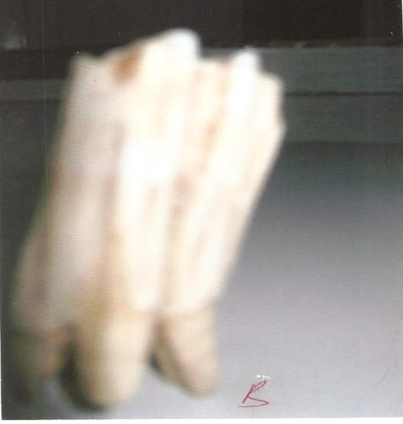
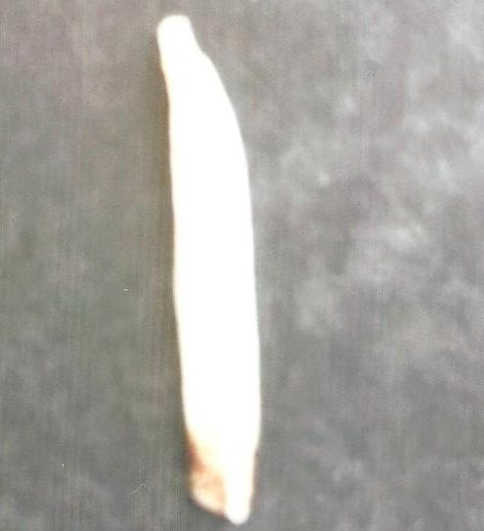
B
A
(a) Which tooth is from a carnivore and which tooth is from a herbivore?
From a carnivore - (4 marks)
...............................................................................................................................................................
Reason -
...............................................................................................................................................................
...............................................................................................................................................................
From a herbivore –
...............................................................................................................................................................
Reason -
...............................................................................................................................................................
...............................................................................................................................................................

(b) Identity the type of teeth shown by the photograph B.
Type - (1 mark)
...............................................................................................................................................................
Reason - (2 marks)
...............................................................................................................................................................
...............................................................................................................................................................

(c) State the functions of the tooth B shown. Give reasons for your answer.
Functions - (2 marks)
...............................................................................................................................................................
................................................................................................................................................................
Reasons - (2 marks)
...............................................................................................................................................................
...............................................................................................................................................................
(d) Distinguish between homodont and heterodont teeth. (1 marks)
................................................................................................................................................................
...............................................................................................................................................................
................................................................................................................................................................

(e) Explain any two general adaptations of tooth to its functions.
(2 marks)
...............................................................................................................................................................
................................................................................................................................................................ ...............................................................................................................................................................
Question 3 (12 Marks)

3. The diagram below shows part of a mammalian skeleton, Study it and use it to answer the questions that follow.
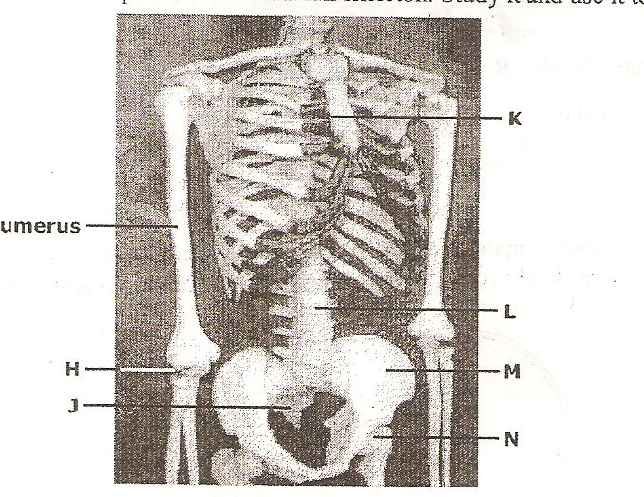

(a) Name each of the parts of the skeleton marked H, J, K and N. (2 marks)
...............................................................................................................................................................
................................................................................................................................................................ ...............................................................................................................................................................
................................................................................................................................................................

(b) Name each of the parts of the human skeleton described below.
(i) The part on which the anterior portion of N articulates. (1 mark)
...............................................................................................................................................................
...............................................................................................................................................................

(ii) The three bones that together fuse to form bone M. (1mark)
...............................................................................................................................................................
................................................................................................................................................................

(c) State any two adaptations of each of the following structures:
(i) Structure M (2 marks)
...............................................................................................................................................................
................................................................................................................................................................ ...............................................................................................................................................................

(ii) Structure L (2 marks)
...............................................................................................................................................................
................................................................................................................................................................ ...............................................................................................................................................................

(d) On the diagram label each of the following parts using the letters in brackets.
(i) the pubis symphysis (P). (1 mark)
(ii) the part where intercostals muscles attach (I) (1 mark) (iii) a joint that can turn through 180⁰ only. (1 mark)

