Name .................................................................................Index Number...........................................................
Candidate’s Signature .....................................................Date…...................................................................................
231/1
BIOLOGY Paper 1
2017
2 hours
EXAM CODE: 1001/2017

BRILLIANT KENYA CERTIFICATE OF SECONDARY EDUCATION PREPARATORY EXAMINATION 2017
Kenya Certificate of Secondary Education
BIOLOGY
Paper 1
2 hours

INSTRUCTIONS TO CANDIDATES

Write your name and index number in the spaces provided above.
- Sign and write the date of the examination in the spaces provided above.
- Answer all the questions in this question paper.
- Answers must be written in the spaces provided in this booklet.
- Additional pages must not be inserted.
- This paper consists of 11 printed pages.
- Candidates should check the question paper to ascertain that all the pages are printed as indicated and that no questions are missing.
- Candidates should answer the questions in English.

FOR EXAMINER’S USE ONLY
Question Number | Maximum Score | Candidate’s Score
1 – 28 | 80

Answer all the questions.
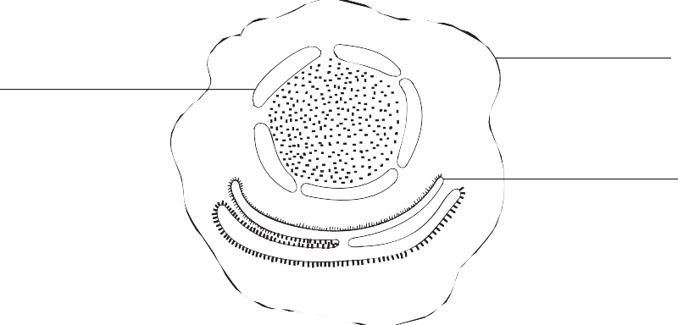
- The diagram below illustrates a cell.

K
J

L

  - State the functions of the parts labelled J and L. (2 marks)

J .........................................................................................................................................................................

L ........................................................................................................................................................................

  - Describe the structure of the part marked K. (1 mark)
……………………………………………………………………………......………………..................................
- State the functions of the following parts of a root:
  - Piliferous layer (1 mark)
……………………………………………………………………………......…………….….................................
  - Endodermis (1 mark)
……………………………………………………………………………......…….………….................................
- The diagram below shows a structure found in the mammalian digestive system.

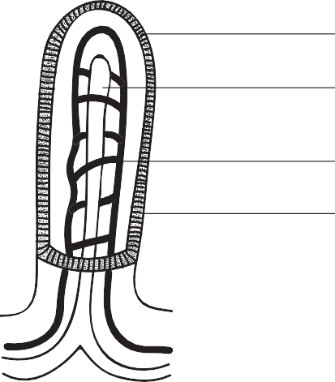
K L
M N

  - What is the name of the structure? (1 mark)
………………………………………………………….............…………………......……………….....................
  - State the role of the part marked L. (2 marks)
…………………………………………………………………............…………......………………............ ........

……………………………………………………………………………......………………......... ........................
  - Name the parts marked K and N. (2 marks)
.............................................................................................................................................................................

..............................................................................................................................................................................
- State the uses of the following plant excretory wastes:
  - Gum Arabica (1 mark)
……………………………………………………………………………......…………............……......................
  - Tannins (1 mark)
……………………………………………………………………………......………….............…….....................
- The diagram below shows part of the human breathing system.

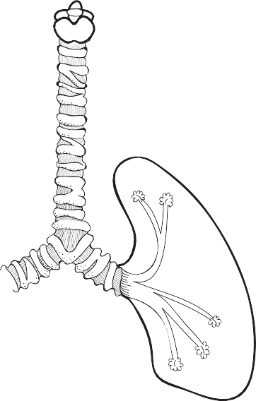A B
C

  - Name the parts labelled A and C. (2 marks)

A .........................................................................................................................................................................

C .........................................................................................................................................................................

  - State one function of the part marked B. (1 mark)
……………………………………………………………………………......……………...............…....................
- A visking tubing is selectively permeable. In the experiment shown below to demonstrate osmosis, the following results were obtained.

Visking tubing

Solution S

Solution R

Initial mass of visking tubing + contents = 10.0 g

Mass of visking tubing + contents after experiment =11.8 g

Account for the results of the experiment. (3 marks)

…………………………………………………………………......…………......………………...................................

………………………………………………………………………......……......………………....................................

…………………………………………………………………......…………......………………....................................
- In mice, the coat colour is determined by the dominant allele for brown colour B and recessive allele for white colour b. What proportion of the offspring produced from a cross between two mice of heterozygous colour would have brown coats? (1 mark)
……………………………………………………………………………......………………..........................................
- Distinguish between convergent evolution and divergent evolution. (2 marks)
……………………………………………………………………………......……………….........................................

……………………………………………………………………………......………………..........................................

……………………………………………………………………………......………………..........................................

……………………………………………………………………………......………………..........................................

- (a) What is double fertilization? (1 mark)
……………………………………………………………………..............………......………………....................

………………………………………………………………..............……………......………………....................
(b) The diagram below shows the chromosome complement of cells during the development of abnormal sperms.

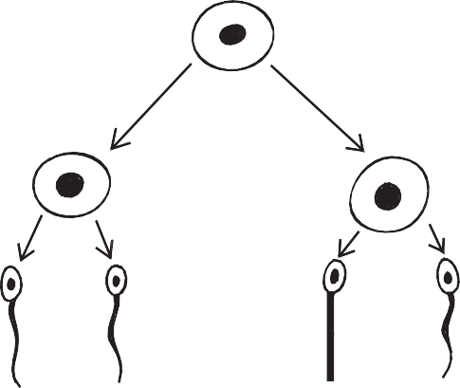
44 + XY

23 + X 21 + Y

23 + X
23 + X
21 + Y
21 + Y

A sperm with chromosome complement 23 + X fertilizes a normal haploid egg. What is the chromosome number and sex of the resulting zygote? (1 mark)
……………………………………………………………………………......……… ………........................................

…………........…………………………………………………………………......………………..................................
- The illustration below shows the cross section of a stem of a hydrophyte.

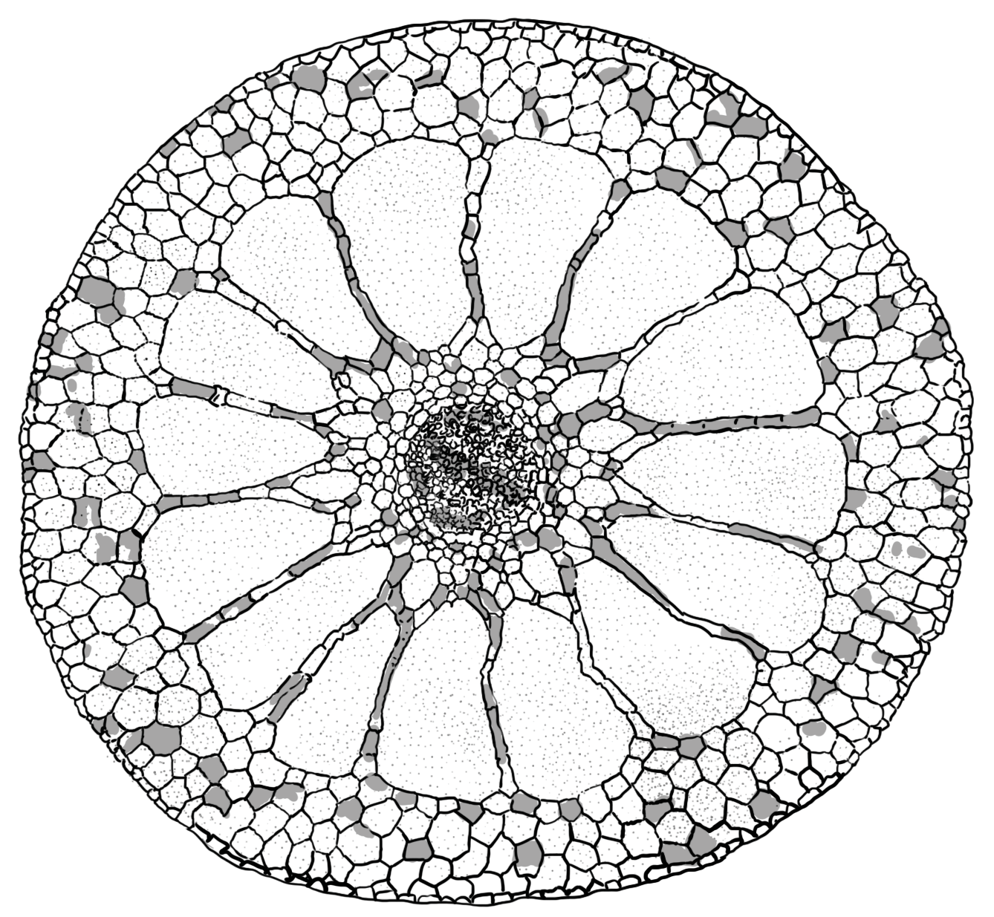S

T

V

U

  - Name the parts marked S and U. (2 marks)

S .........................................................................................................................................................................

U .........................................................................................................................................................................

  - State one function of the part labelled U. (1 mark)
…………........…………………………………………………………………......……………..............….............

…………........…………………………………………………………………......………………..........................
- The diagram below shows part of a nephron from the human kidney.

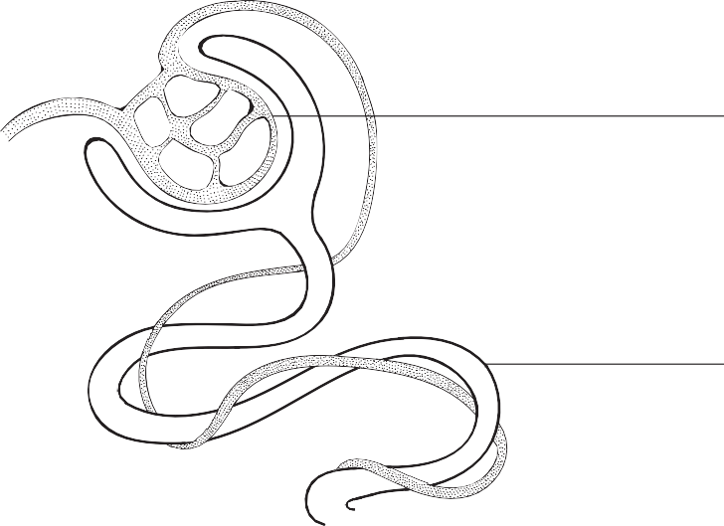
R

P

  - (i) Name the structure labelled R. (1 mark)

......................................................................................................................................................................
(ii) Name the process carried out at P. (1 mark)

......................................................................................................................................................................
  - The hormone ADH affects water reabsorption from the nephron.
    - Which part of the brain releases ADH? (1 mark)

......................................................................................................................................................................

......................................................................................................................................................................

    - Name a part of the nephron where water is reabsorbed. (1 mark)

......................................................................................................................................................................

......................................................................................................................................................................
- The illustration below represents part of a cell organelle.

T

N

  - Name the organelle. (1 mark)
…………........……………………………..............……………………………………......……………….............
  - Name the structure labelled N. (1 mark)
…………........……………………………..............……………………………………......……………….............
  - Which stage of photosynthesis takes place in the part labelled T? (1 mark)
…………........……………………………..............……………………………………......……………….............
- Herbivores have bacteria in their rumen and caecum that digest cellulose.
  - What type of relationship is shown by the two organisms? (1 mark)
…………........……………………………..............……………………………………......……………….............
  - State how each organism benefits from the relationship.
    - Bacteria (1 mark)

......................................................................................................................................................................
    - Herbivore (1 mark)

......................................................................................................................................................................

- How is the skin of a frog adapted to gaseous exchange? (2 marks)
……………………………………………..............………………………………......………………...........................

……………………………………………………………………………......……………….........................................
- Name three classes of animals that excrete their nitrogenous waste in the form of uric acid.
(3 marks)

……………………………………………………………………………......………………..........................................

……………………………………………………………………………......………………..........................................

……………………………………………………………………………......………………..........................................
- A student observed the chromosomes shown below under a microscope.

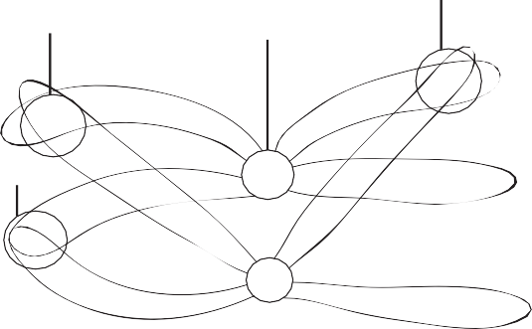
A
A B

A

  - What process is taking place at point A? (1 mark)
…………........…………………………………….............……………………………......……………….............
  - Name the parts labelled A and B. (2 marks)

A .........................................................................................................................................................................

B ..........................................................................................................................................................................

- List three advantages of asexual reproduction. (3 marks)
……………………………………………………………………………....................………………............................

……………………………………………………………………………......…………..............……............................

……………………………………………………………………………......………………..........................................

- Use the diagram below to answer the questions that follow.

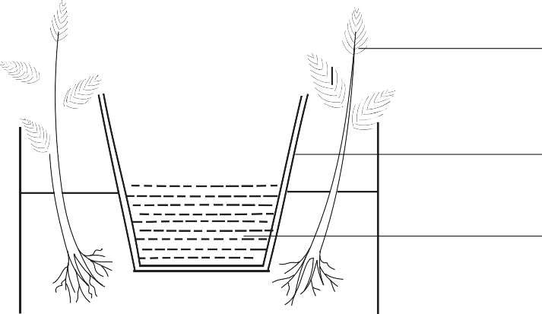Plant

Porous pot

Water

  - What type of response is demonstrated in the diagram? (1 mark)
…………........…………………………………….............…………….………………......……………….............
  - What is the significance of the type of response shown above? (1 mark)
…………........…………………………………….............……….……………………......……………….............
- Name a sex-linked human disorder located on the:
  - X-chromosome. (1 mark)
..............................................................................................................................................................................
  - Y-chromosome. (1 mark)
.............................................................................................................................................................................
- Name the tissues in plants responsible for:
  - transport of water and mineral salts. (1 mark)
…………........…………………….……………………………………………..................……………….............
  - transport of carbohydrates. (1 mark)
…………........……………………………………………………..............……………......……………….............
  - primary growth. (1 mark)
…………........…………………………………………………..............………………......……………….............

- Give three factors that determine the amount of energy a human being requires in a day.
(3 marks)

……………………………………………………………………………....................………………............................

……………………………………………………………………………....................………………............................

……………………………………………………………………………....................………………............................
- Account for the following phases of a sigmoid curve representing the growth of an organism.
  - Lag phase (2 marks)
…………........……………………….............…………………………………………......……………….............

…………........……………………….............…………………………………………......……………….............
  - Plateau phase (2 marks)
…………........……………………….............…………………………………………......……………….............

…………........……………………….............…………………………………………......……………….............
- (a) What is a single circulatory system? (1 mark)
…………........……………………….............…………………………………………......……………….............
- Name an organism which has a single circulatory system. (1 mark)
…………........……………………….............…………………………………………......……………….............
- Name the opening to the chamber of the heart of an insect. (1 mark)
…………........……………………….............…………………………………………......……………….............
- Giving a reason in each case, name the class to which each of the following organisms belongs.
(4 marks)
Bean plant
…………........……………………….............…………........………………………………......………………............. Reason
…………........……………………….............………………........…………………………......………………............. Bat
…………........……………………….............………………………........…………………......………………............. Reason
…………........……………………….............……………………………….......…………......……………….............

- The diagram below represents a nerve cell. Use it to answer the questions that follow.
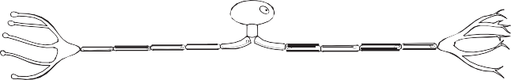
  - What type of nerve cell is shown in the diagram above? (1 mark)
…………........……………………….............…………………………………………......……………….............
  - Give a reason for your answer in (a) above. (1 mark)
…………........……………………….............…………………………………………......……………….............
  - Name the nerve cell located in the grey matter of the spinal cord. (1 mark)
…………........……………………….............…………………………………………......……………….............
- State the significance of the following parts of a sperm cell.
  - Acrosome (1 mark)
…………........……………………….............…………………………………………......……………….............
  - Mitochondria (1 mark)
…………........……………………….............…………………………………………......……………….............
  - Tail (1 mark)
…………........……………………….............…………………………………………......……………….............
- State one function of each of the following hormones:
  - Insulin (1 mark)
…………........……………………….............…………………………………………......……………….............
  - Glucagon (1 mark)
…………........……………………….............…………………………………………......……………….............
- A woman of blood group O has four children. All the children are of blood group A.
  - What is the blood group of the father of the children? (1 mark)
…………........……………………….............…………………………………………......……………….............
  - Use a genetic cross to show your working. (3 marks)

