Name: ………………………………………………………………………………………. Class: ………… Adm.No. ……………

CHEMISTRY
Paper 1
June 2014
Time: 2 hours

BUSIA COUNTY JOINT EVALUATION TEST-2014
JULY 2014
Kenya Certificate of Secondary Education
CHEMISTRY
PAPER 1

INSTRUCTIONS TO CANDIDATES
- Answer ALL the questions in the spaces provided.
- Scientific calculators may be used.

MARKS SCORED

80
OUT OF

1. Consider the diagram below.
a
b
c

Name the regions labeled a, b, c. (3 marks)

a ……………………………………………………………………….
b ……………………………………………………………………….
c ……………………………………………………………………….
2. Some moist iron wool was placed in a test tube and the tube was inverted and set up as shown below.

y cm
x cm

The apparatus was left for one week. The water level rose and iron wool turned red-brown.

(i) Write the chemical equation to show the rusting of iron. (1 mark)
……………………………………………………………………………………………………………………………….
(ii) Write the expression for an approximate percentage. (1 mark)
……………………………………………………………………………………………………………………………….

(iii) State two similarities between rusting and combustion.
(a) ………………………………………………………………………………………….. (1 mark)
(b) ………………………………………………………………………………………….. (1 mark)
3. Paper chromatography is a method of separating colours or dyes.
What two properties should the components of a mixture have that would make the separation possible. (2 marks)

…………………………………………………………………………………………………………………………………………..
…………………………………………………………………………………………………………………………………………..
4. A student was asked to prepare Lead (II) chloride salt using the following ingredients; Nitric (V) acid, lead (II) oxide and hydrochloric acid. Using ionic equations only explain how the salt can be prepared. (2 marks)

…………………………………………………………………………………………………………………………………………..
…………………………………………………………………………………………………………………………………………..
…………………………………………………………………………………………………………………………………………..
…………………………………………………………………………………………………………………………………………..
5. The nitrates of the following metals were heated strongly and observation made accordingly. The nitrate of metal P produced the metallic oxide, Nitrogen (IV) oxide and oxygen gas; and that of metal Q produced the metallic nitrite and oxygen gas. The nitrate of R produced metal R, nitrogen (IV) oxide and oxygen gas. Arrange the metals in order of reactivity beginning with the most reactive. (2 marks)

…………………………………………………………………………………………………………………………………………..
6. A student added barium hydroxide drop wise into a beaker containing dilute sulphuric (VI) acid.
B
x
y
Conc. of ions in solution
Conductivity
A

C

(a) What is the significance of point B? (1 mark)

……………………………………………………………………………………………………………………………..

(b) Explain why point B does not touch the x-axis? (1 mark)

…………………………………………………………………………………………………………………………….

(c) Explain what happens between

- A and B (1 mark)
…………………………………………………………………………………………………………………………….
…………………………………………………………………………………………………………………………….
- B and C (1 mark)
…………………………………………………………………………………………………………………………….
…………………………………………………………………………………………………………………………….
7. In an experiment it was found that 40.0cm³ of 0.2M sodium hydroxide solution just neutralized 0.2g of a dibasic acid Q. Calculate the relative molecular mass of acid Q.
(2 marks)

8. Give two reasons why during preparation of salt, it is advisable to heat the solution to concentration allowing it to cool in order to crystallize instead of heating to dryness.
(2 marks)
……………………………………………………………………………………………………………………………………….
……………………………………………………………………………………………………………………………………….
9. The following is a nuclear equation.
X
y

233
91
Ac + a
Pa

- Calculate the value of
x ……………………………………………………………………………………………… ( ½ mark)
y ……………………………………………………………………………………………… ( ½ mark)

(b) State two differences between a nuclear reaction and a chemical reaction. (2 marks)
…………………………………………………………………………………………………………………………………………..
…………………………………………………………………………………………………………………………………………..
…………………………………………………………………………………………………………………………………………..
…………………………………………………………………………………………………………………………………………..
10. (a) Distinguish between a strong acid and a concentrated acid. (1 mark)
…………………………………………………………………………………………………………………………………………..
…………………………………………………………………………………………………………………………………………..
…………………………………………………………………………………………………………………………………………..
- Giving a reason in each case, identity an acid and a base in the equation.

H₃O⁺_{(aq)} + NH_{3(g)} NH₄⁺_{(aq)} + H₂O_{(l)}

Acid: …………………………………………………………………. (1 mark)
Reason: ……………………………………………………………………………………………. (1 mark)
Base: ………………………………………………………………… (1 mark)
Reason: ……………………………………………………………………………………………. (1 mark)
11. Study the following information and answer the question that follows.

Heat of hydration of x²⁺ = -1480 kJ/mol
Heat of hydration y⁻ = -364 kJ/mol
Lattice energy of XY₂ = +2112 kJ/mol

Determine the heat evolved when 31.8g of XY_{2(s)} is dissolved in water to give an infinitely dilute solution. (RAM of Z = 88, Y = 35.5) (2 marks)

12. The apparatus below was set up to show the catalytic oxidation of ammonia.

Water

Hot platinum wire

Gas jar Y

Solid B
Conc. Ammonia solution

(a) Write the equation between water and solid B. (1 mark)

………………………………………………………………………………………………………………………………

(b) State and explain two observations made in gas jar Y. (2 marks)

- ……………………………………………………………………………………………………………………
……………………………………………………………………………………………………………………
- ……………………………………………………………………………………………………………………
……………………………………………………………………………………………………………………
13. (a) You are provided with a nickel rod, copper rod, connecting wires and a U-tube,
potassium nitrate solution, nickel sulphate solution, copper sulphate solution and a voltameter. With a well labeled diagram show how you will use the apparatus and materials provided to construct an electrochemical cell. Oxidation potential of the metals are shown below:-

Cu_{(s)} Cu²⁺ + 2e─ E^{ϑ} = +0.34V
Ni_{(s)} Ni²⁺ + 2e─ E^{ϑ} = ─0.23V

(b) (i) Give the cell representation of the above cell. (1 mark)

………………………………………………………………………………………………………………………………
(ii) Work out the cell e.m.f of the cell above. (1 mark)

14. The sulphur (IV) oxide can be converted to sulphur (VI) oxide as shown in the equation below.
2SO_{2(g)} + O_{2(g)} 2SO_{3(g)}

The energy level diagram for the above reaction is as shown below.

x

Reactants
Energy

Products

Reaction y

(a) What would be the effect of increase in temperature? (2 marks)
……………………………………………………………………………………………………………………………….
……………………………………………………………………………………………………………………………….……………………………………………………………………………………………………………………………….
(b) On the same energy level diagram above sketch the energy level diagram that would be obtained if the reaction is carried out in presence of vanadium (V) oxide.
(1 mark)

15. On complete combustion of a hydrocarbon gas X, 1.32g of carbon (IV) oxide and 0.54g of water. Calculate the empirical formula of X (C = 12.0, H = 1, O = 16.0) (3 marks)

16. Calculate the oxidation number of nitrogen in the following species.

NO₂ (1 mark)

NH₄⁺ (1 mark)

17. In an experiment to determine the relative formula mass of gas P; the time taken for equal volumes of oxygen and gas P under identical conditions of temperature and pressure was measured and the results were shown in the table below. (O = 16.0) (3 marks)

Gas | Oxygen | P
Time in seconds | 20.3 | 30.3

18. Using dots and crosses to represent electrons, show bonding in

(a) Sulphur (IV) oxide (1 mark)

(b) Structure of an ion illustrated by the formula $\begin{matrix}14 \\ 7\end{matrix}$N^{3─} (1 mark)

19. Calculate the number of chloride ions in a 250cm³ of 1M solution calcium chloride (Avogadro’s number is 6.0 $×$ 10²³) (2 marks)

20. A compound Y reacts with bromine to form another compound, whose formula is:
H Br
CH₃ CH₂ C C CH₃
Br H
What is the formula and name of the compound Y? (2 marks)

21. Study the diagram below and answer the questions that follow. (3 marks)
Gas jar

Dilute
Hydrochloric acid

Clamp

Zinc granules
Liquid Z

(a) Write an equation for the reaction between zinc granules and dilute hydrochloric acid. (1 mark)

…………………………………………………………………………………………………………………………

(b) What property of hydrogen is demonstrated by the method of collection shown on the diagram? ( ½ mark)

…………………………………………………………………………………………………………………………

- Hydrogen gas passed through liquid Z. What is the name of liquid Z and what is the purpose of liquid Z? (1 mark)

…………………………………………………………………………………………………………………………
…………………………………………………………………………………………………………………………
- Name one industrial use of hydrogen. ( ½ mark)

…………………………………………………………………………………………………………………………
…………………………………………………………………………………………………………………………

22. Three liquids were mixed together accidentally and this included lubricating oil, kerosene and water. The table below gives information about the properties of the liquids.

Constituent | Boiling point in ⁰C | Solubility in water | Solubility kerosene
Lubricating oil | 350 – 400 | Insoluble | Soluble
Kerosene oil | 175 – 250 | Insoluble
Water | 100 |  | Insoluble

Suggest a method you would use to separate the three liquids. (2 marks)
…………………………………………………………………………………………………………………………………….
…………………………………………………………………………………………………………………………………….
23. The diagrams below represent two iron nails with some parts wrapped tightly with zinc strips, respectively.

A Zinc strip Iron nail B Copper strip Iron nail

What observations would be made at the exposed points A and B if the wrapped nails are
left in the open for several months? Explain.

Observation at A. ………………………………………………………………………………… ( ½ mark)
Explanation: ………………………………………………………………………………………………………………….....
………………………………………………………………………………………………………………………………………… ( ½ mark)

Observation at B. ………………………………………………………………………………… ( ½ mark)
Explanation: ………………………………………………………………………………………………………………….....
………………………………………………………………………………………………………………………………………… ( ½ mark)
24. RCOO─ Na⁺ and RC₆H₅SO₃─ Na⁺, represent two cleansing agents where R is a long hydrocarbon chain.

(a) Write the formulae of the salts that would be formed when each of these cleansing agents is added to water containing calcium ions. (1 mark)

…………………………………………………………………………………………………………………………………….
……………………………………………………………………………………………………………………………………
(b) Explain how the solubilities of the calcium ions in (a) above affect the cleansing properties of each of the cleansing agents. (2 marks)

…………………………………………………………………………………………………………………………………………
…………………………………………………………………………………………………………………………………………
…………………………………………………………………………………………………………………………………………
………………………………………………………………………………………………………………………………………….
………………………………………………………………………………………………………………………………………….
25. The grid below represents part of the periodic table. Study it and answer the questions that follow. The letters are not the actual symbols.

 |  |  |  | Q
W |  |  | Y |  |  | R | S
T |  |  |  |  |  | K | U
V |  |  |  |  |  |  | Z

(a) Hydrogen can be placed in group I or group VII. Explain. (1 mark)
…………………………………………………………………………………………………………………………………………. ………………………………………………………………………………………………………………………………………….
(b) Write the formula of the compound formed between element Y and R. (1 mark)
………………………………………………………………………………………………………………………………………….
(c) How does the atomic radii of T and K compare. Explain. (1 mark)
………………………………………………………………………………………………………………………………………….
………………………………………………………………………………………………………………………………………….………………………………………………………………………………………………………………………………………….
26. Dilute sulphuric (VI) acid reacts with aqueous sodium hydroxide to form a salt. Give the formula and name of the anion in the salt.

Name: ………………………………………………………………………………….. (1 mark)

Formula: ……………………………………………………………………………… (1 mark)

27. The molecular formula of a hydrocarbon is C₆ H₁₄. The hydrocarbon can be converted into two other hydrocarbons as shown by the equation below.

C₆ H₁₄ X + C₃ H₈

- Name and draw the possible structure of formula of x.

Name: ………………………………………………………….. (1 mark)
Structure: (1 mark)

- State and explain the observation that would be made if a few drops of bromine water were added to sample of x. (1 mark)

………………………………………………………………………………………………………………………………………….
………………………………………………………………………………………………………………………………………….
28. A condensation polymer formed by loss of water molecules has the following structure.
O O
‖ ‖
$- O –$CH₂ $–$CH₂$– C – O –$CH₂$–$CH₂$– C –$
n

- State two advantages of using natural polymers over synthenic ones. (2 marks)
………………………………………………………………………………………………………………………………………….
………………………………………………………………………………………………………………………………………….………………………………………………………………………………………………………………………………………….
- Draw the structure of the monomer. (1 mark)

29. The diagram below is of the apparatus used to measure the volumes of reacting gases.
SYRINGE A
SYRINGE B
TAP

50cm³ of Oxygen
50cm³ of Nitrogen monoxide
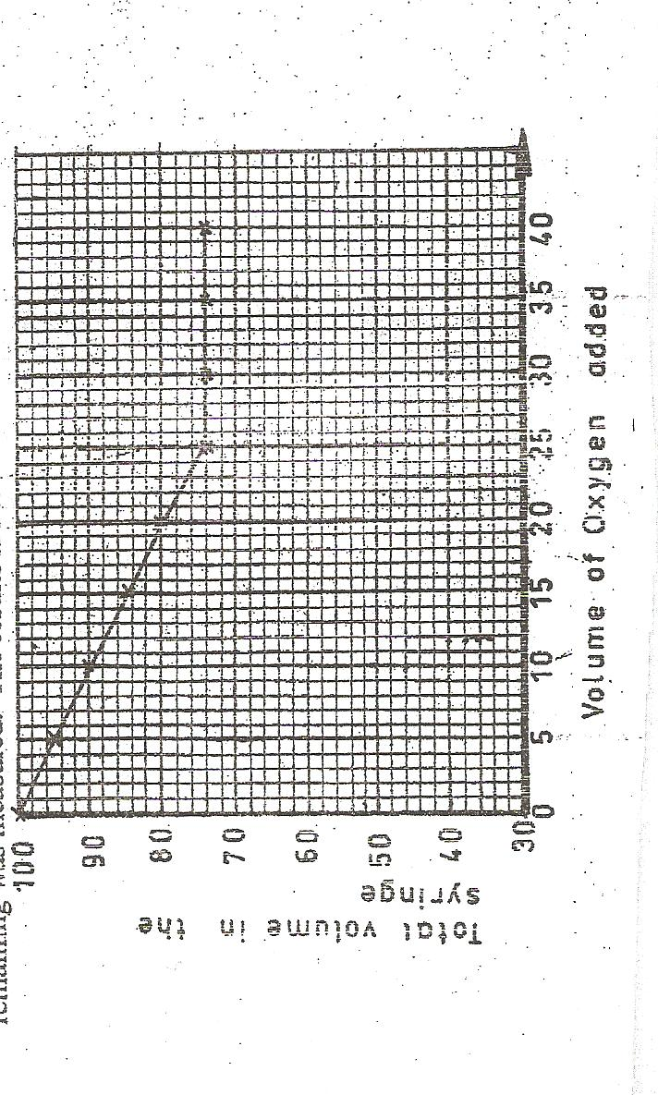
Now, Nitrogen (II) oxide reacts with oxygen to form only one gaseous product. In the above experiment, 5.0cm³ portions of oxygen were pushed from syringe B into syringe A. After each addition, the tap was closed and after cooling, the total volume of gases remaining was measured. The results are shown below.
(a) What is observed in syringe A during the experiment? Explain using a chemical equation. (1 mark)

………………………………………………………………………………………………………………………………………….
………………………………………………………………………………………………………………………………………….
(b) Determine from the graph above.

- the total volume of gases when the reaction is complete. ( ½ mark)

……………………………………………………………………………………………………………………

- the volume of oxygen which reacts with 50cm³ of nitrogen monoxide.
(½ mark)
……………………………………………………………………………………………………………………

(c) Using the results to (b) (i) and (ii) determine the formula of the gaseous product formed. (1 mark)

………………………………………………………………………………………………………………………………
………………………………………………………………………………………………………………………………
………………………………………………………………………………………………………………………………

