Computer Studies
451/2
COMPUTER STUDIES
Paper 2
(PRACTICAL)
June/July 2014
2½ hours

BUSIA COUNTY JOINT EVALUATION EXAMINATION-2014
Kenya national examination council
Computer Studies pp2

Instructions to candidates

- Write your name and admission number at the right hand corner of each print out.
- Write your name and admission number on the CD/removable medium provided.
- Write the name and version of the software used for each question attempted in the answer sheet
- Answer all the questions
- Passwords should not be used while saving in the CD/removable medium provided.
- All answers must be saved in your CD/removable medium provided.
- Arrange your printouts and tie/staple them together
- Hand in all the printouts and the CD/removable medium used
- This paper consists of 4 printed pages.
- Candidates should check the question paper to ascertain that all the pages are printed as indicated and that no questions are missing.

QUESTION 1
- Use a DTP software to design the publication as shown below (1 mark)

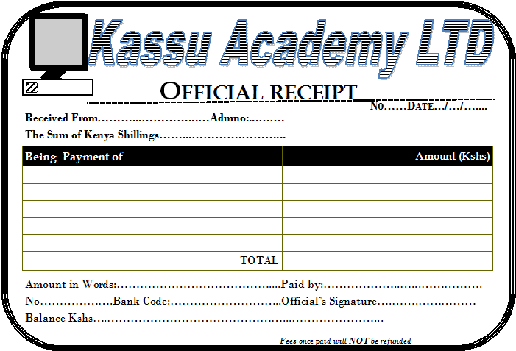
- Prepare the page layout as follows:
  - Paper size A4 portrait. (2 marks)
  - Set the margins to 0.5 inches all round. (2 marks)
  - Divide the page into TWO equal horizontal parts using a ruler. (2 marks)
  - The border should occupy half the page from the margins. (2 marks)
- Create the logo to occupy between 0.8’’ to 1.80’’ left and 0.70’’ to 1.85’’ from top. (9 marks)
- The title should occupy between 1.70’’ to 7.50’’ across and 0.75’’ to 1.45’’ from top. Font Arial black with italics and fill effect pattern of dark horizontal. (7 marks)
- The OFFICIAL RECEIPT should occupy 2.50’’ to 5.70’’ acrossand 1.50’’ to 2.00 from top. Font Book antique size 26, bold and centered. (4 marks)
- The rest of the text is in font Bodoni MT size 12, except for the footer which is size 9. (9 marks)
  - Align all the text as shown. (2 marks)
  - Group the publication as one. (2 marks)
  - Fit TWO copies of the design into a single page. (1 mark)
- Include a page header with your name, class and index. (4 marks)
- Save as INVOICE. (1 mark)
- Print the publication. (2 marks)

Question 2.
The table below shows records extracted from KASSU MOTORS. Create a database and name it KASSU MOTORS. (1 mark)

Customer  Name | Customer  Address | Customer  Town | Car  Reg NO | Car  Type | Car  Make | Car  price | Customer  ID | Amount  paid
Oguttu | 254 | Nakuru | KAJ 001 | Truck | Nissan | 1,100,000 | B001 | 800,000
John | 678 | Eldoret | KAM 002 | Bus | Mazda | 2,400,000 | B002 | 2,000,000
Uhuru | 963 | Nairobi | KBB 003 | Saloon | Toyota | 800,000 | B003 | 800,000
Oguttu | 147 | Nakuru | KAJ 004 | Pick up | Peugeot | 1,000,000 | B004 | 700,000
Chumba | 456 | Bungoma | KBH678 | Lorry | Isuzu | 3,000,000 | B005 | 2,000,000
Kariuki | 789 | Webuye | KAB 006 | Pick up | Toyota | 1,800,000 | B006 | 1,600,000
John | 678 | Eldoret | KAJ 007 | Bus | Scania | 7,500,000 | B002 | 7,500,000
Uhuru | 963 | Nairobi | KBC678 | Truck | Toyota | 1,800,000 | B003 | 1,800,000
Phillip | 159 | Kisumu | KAJ 009 | Saloon | Nissan | 9,00,000 | B007 | 900,000
Oguttu | 254 | Nakuru | KBH 010 | Pick up | Isuzu | 1,500,000 | B001 | 1,200,000
Uhuru | 357 | Kisumu | KBJ 011 | Saloon | Peugeot | 600,000 | B008 | 600,000
Kariuki | 789 | Webuye | KBG 012 | Bus | Isuzu | 10,000,000 | B006 | 9,500,000
Oguttu | 147 | Nakuru | KBG 013 | Truck | Nissan | 2,700,000 | B004 | 2,700,000

- Using the dataabove, create a table that will hold Car details and another table to hold Customer details. Name them TBLCARandTBLCUSTOMERrespectively and set appropriate primary keys
(4 marks)

- Enforce referential integrity between two tables. (2 marks)
- Create different input forms for each table.Name them FRMCARandFRMCUSTOMER. Use them to enter data into the tables. (12marks)

- Display a report only showing the details of the Customers who have cleared paying for the Car. Name the report RPTCLEARED. Add ‘’CLEARED CUSTOMERS’’ as the title of the report. (7 marks)

- Using the two tables create an outlined report showing the customer details, the total amount paid by each customer and the total amount received by KASSU MOTORS. Name the report SUMMARY and the title as ‘OVERALLCUSTOMERSREPORT.’’ (8 marks)

- Create a query to display the Car details with balances of less than 500,000 but not less than 300,000. Name the query as BALQUERY. (5marks)

- Create a report showing the Car type, the total sales for each type and the grand total. Name the report as RPTGRAND. (4 marks)
- Using landscape orientation, print RPTCLEARED, SUMMARYandRPTGRANDwithfooters bearing your lastname and index number at the center of the page. (7 marks).
Total (50 Marks)

