312/1
GEOGRAPHY
Paper 1
Time: 2¾ hours

BUSIA COUNTY JOINT EVALUATION EXAMINATION-2014
Kenya Certificate of Secondary Education
312/1
Paper 1
GEOGRAPHY

INSTRUCTIONS TO CANDIDATES
- This paper has two sections A and B.
- Answer all the questions in section A.
- Answer question 6 and any other two questions from section B.
- All answers must be written in separate answer sheets.

SCORE SHEET

SECTION A
QUESTIONS 6
QUESTION 7
QUESTION 8
QUESTION 9
QUESTION 10
TOTAL | %

SECTION A.
Answer all the questions in the section.

1. (a) State three characteristics of sial. (3 marks)

(b) Outline two characteristics of the troposphere. (3 marks)

2. (a) What is a longitude? (2 marks)

(b) What is the longitude of station X when it is 8.00 a.m. while in Nairobi at longitude 37⁰E the time is 12.00 noon? (2 marks)

3. (a) State three causes of earth movements. (3 marks)

(b) Name two main earthquake zones in the world. (2 marks)

4. (a) Name two features that are found on emerged highland coasts. (2 marks)

(b) State three conditions necessary for the formation of a spit. (3 marks)

5. (a) The diagram below shows a barchan.

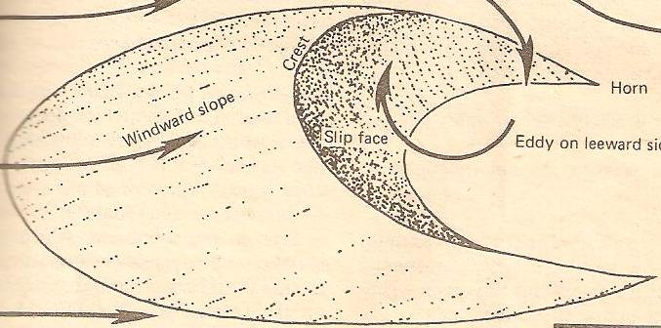
P
Q

Name;
(i) the feature marked P. (1 mark)

(ii) the wind marked Q. (1 mark)

(b) How is a deflation hollow formed? (3 marks)

SECTION B

Answer question 6 and any other two questions from this section

6. Study the map of Nkubu 1:50,000 (sheet 122/1) provided and answer the following questions.

(a) (i) Give the latitudinal extent of the area covered by the map. (1 mark)

(ii) What is the approximate height of Rurie swamp? (1 mark)

(iii) Calculate the area of the land covered by the forest to the south of Northing 85. (Give your answer in square kilometres). (2 marks)

(iv) Measure the distance of the Dry Weather Road E778 from the road junction at Kanyakine to Easting 60. (Give your answer in kilometres). (1 mark)

(b) (i) Using a vertical scale of 1cm represents 100 metres, draw a cross- section from grid reference 380910 to grid reference 450910. (3 marks)
(ii) On the cross-section, mark and name the following;
- A depression
- Loose surface road
- River
(3 marks)
(iii) Calculate the vertical exaggeration (VE) of the section. (2 marks)

(c) Deacribe the relief of the area covered by the map. (4 marks)

(d) Citing evidence from the map explain two;

(i) physical factors that may have influenced the location of Nkubu town. (4 marks)

(ii) factors that favour trading in the area covered by the map. (4 marks)

7. (a) (i) Differentiate betweeen weather and climate. (2 marks)

(ii) Explain how the following factors influence climate.
- Warm ocean currents (4 marks)
- Latitude (4 marks)

(b) The graph below represents the climate for a station in Kenya.

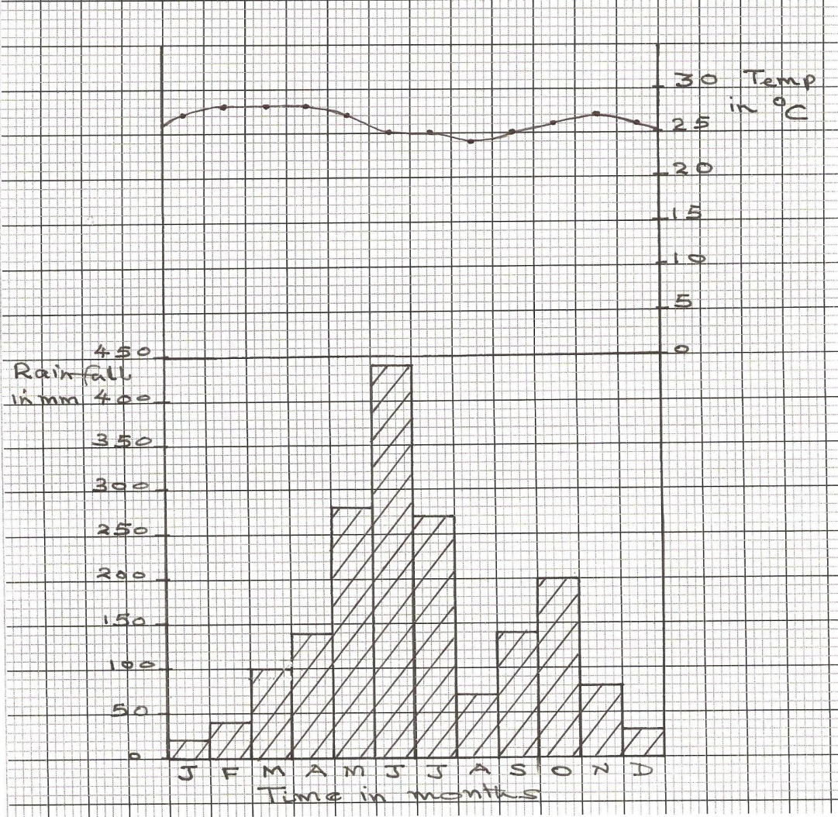

Describe the characteristics of climate represented by the graph. (5 marks)

(c) Explain how tropical savanna vegetation is adapted to the climatic conditions. (6 marks)

(d) Form Four Geography students in your school are planning to carry out a field study on forest vegetation around the school.

(i) Give two abjectives for their study. (2 marks)

(ii) Give two follow-up activities they would be involved in. (2 marks)

8. (a) (i) What is folding? (1 mark)

(ii) Apart from recumbent fold, name two other types of folds. (2 marks)

(iii) With the aid of labelled diagrams, describe how a recumbent fold is formed. (6 marks)

(b) The map below shows some features in East Africa. Use it to answer question (i).

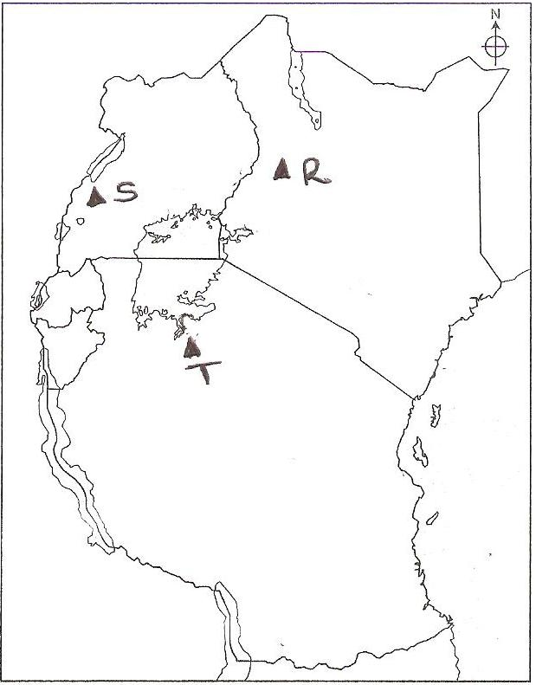
R
Q
S

Name;

(i) the mountains marked Q and R. (2 marks)

(ii) the lake marked S. (1 mark)

(c) (i) Give two differences between a normal and a reverse fault. (2 marks)

(ii) Describe how fault block is formed. (5 marks)

(d) Explain three negative effect of faulting on human activities. (6 marks)

9. (a) (i) Differentiate between a drainage basin and a watershed. (2 marks)

(ii) Identify two types of river erosion. (2 marks)

(b) Describe two processes through which a river transports its load. (4 marks)

(c) (i) Explain two causes of river rejuvenation. (4 marks)

(ii) Describe how an ox-bow lake is formed. (5 marks)

(d) (i) The diagram given shows a floodplain.
K
River
J
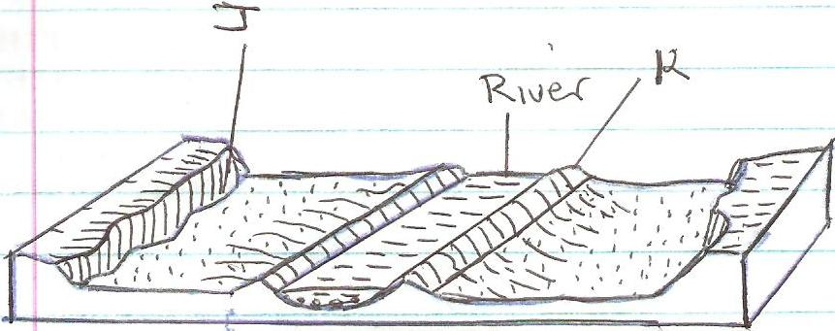

Name the the features marked J and K. (2 marks)

(ii) Explain three posive effects of floodplains to human activities. (6 marks)

10. (a) (i) State two conditions necessary for the formation of ice. (2 marks)

(ii) Name three processes of ice movement. (3 marks)

(b) Explain three factors which influence the rate glacial erosion. (6 marks)

(c) With the aid of well labelled diagrams, describe how a corrie lake is formed. (8 marks)

(d) Suppose students from your school were to carry out a field study on features of glaciation in low lands areas.

(i) Name two depositional features they are likely to study. (2 marks)

(ii) State two problems they are likely to experience during the field study. (2 marks)

(iii) State two methods that they will use to present data. (2 marks)

